Cornerstone
Presbyterian Church

Service of Celebration and Gospel Renewal
Pentecost Sunday
09 June 2019

God Calls His People and Reveals Himself

God calls His people to worship and come before Him. The Creator of all things reveals Himself through His Word and calls us into His presence.

Prelude, Announcements & Preparation

Introit—Come, O Creator Spirit Blest, Vs 1
Text: Rhabanus Maurus, circa 800, Trans by Edward Caswall, 1849; Music: Truro, Psalmodia Evangelica, 1789.

Call to Worship—from Psalm 104: 24, 27, 30-31, 33-34
Pastor: O Lord, how manifold are your works! In wisdom have You made them all;
the earth is full of Your creatures.
All: These all look to You, to give them food in due season.
Pastor: When You send forth Your Spirit, they are created,
and You renew the face of the ground.
All: May the glory of the Lord endure forever; may the Lord rejoice in His works.
Pastor: I will sing to the Lord as long as I live;
I will sing praise to my God while I have being.
All: May my meditation be pleasing to him, for I rejoice in the Lord.

Hymn of Praise—Come, Thou Almighty King
Text: Anonymous, 1757; Music: Trinity, Felice de Giardini, 1769.

Hymn of Praise—Come Down, O Love Divine
Text: Bianco da Siena, d. 1434, Tr Richard Littledale, 1867; Music: Down Ampney, Ralph Vaughan Williams, 1906.

+++Latecomers Please Wait to be Seated+++

New Testament Reading—Acts 2:1-4, 14-21
The Birth of the Church and the Coming of the Kingdom on the Day of Pentecost

When the day of Pentecost arrived, they were all together in one place. 2 And suddenly there came from heaven a sound like a mighty rushing wind, and it filled the entire house where they were sitting. 3 And divided tongues as of fire appeared to them and rested on each one of them. 4 And they were all filled with the Holy Spirit and began to speak in other tongues as the Spirit gave them utterance.

14 But Peter, standing with the eleven, lifted up his voice and addressed them: “Men of Judea and all who dwell in Jerusalem, let this be known to you, and give ear to my words. 15 For these people are not drunk, as you suppose, since it is only the third hour of the day. 16 But this is what was uttered through the prophet Joel:
17 “‘And in the last days it shall be, God declares, that I will pour out my Spirit on all flesh, and your sons and your daughters shall prophesy, and your young men shall see visions, and your old men shall dream dreams; 18 even on my male servants and female servants in those days I will pour out my Spirit, and they shall prophesy. 19 And I will show wonders in the heavens above and signs on the earth below, blood, and fire, and vapor of smoke; 20 the sun shall be turned to darkness and the moon to blood, before the day of the Lord comes, the great and magnificent day. 21 And it shall come to pass that everyone who calls upon the name of the Lord shall be saved.’”

Elder: This is the Word of the Lord. All: Thanks be to God.

God Calls His People to Confession, Repentance & Reconciliation
The People of God respond to His Word by confessing their sins, repenting of their sinful ways, and seeking God’s favor through the reconciling work of Jesus, the Son of God.

Sung Preparation—Come, O Redeemer, Come

CCLI #11121087 ©1996 Metro One, Inc. Text and Music: Fernando Ortega, 1996.

Corporate Confession of Sin—based on Ephesians 4:1-4, 14-16
Pastor: Lord, we come confessing that you have made us to be one body, in one Spirit,
called to one hope.
But our pride and impatience have spawned only dissension and division.
All: We have not been strong in the strength of your might
and have not readied ourselves for the daily work of reconciliation.
Pastor: We have neglected the grace given to us by Christ’s gift
and have failed to maintain the unity of the Spirit in the bond of peace.
All: Forgive us for being tossed to and fro by selfish whims,
for building our own kingdoms
rather than living in submission to Christ’s Kingdom.
Pastor: Help us to speak the truth in love, and walk in it.
Rescue us and fill us with the Spirit, that Christ may be formed in us.

Silent Prayers of Confession

Assurance of Pardon—I Colossians 1:13-14
He has delivered us from the domain of darkness and transferred us to the kingdom of his beloved Son, in whom we have redemption, the forgiveness of sins.
+++Latecomers are Welcome to be Seated+++

Hymn of Praise—Holy Spirit, Living Breath of God

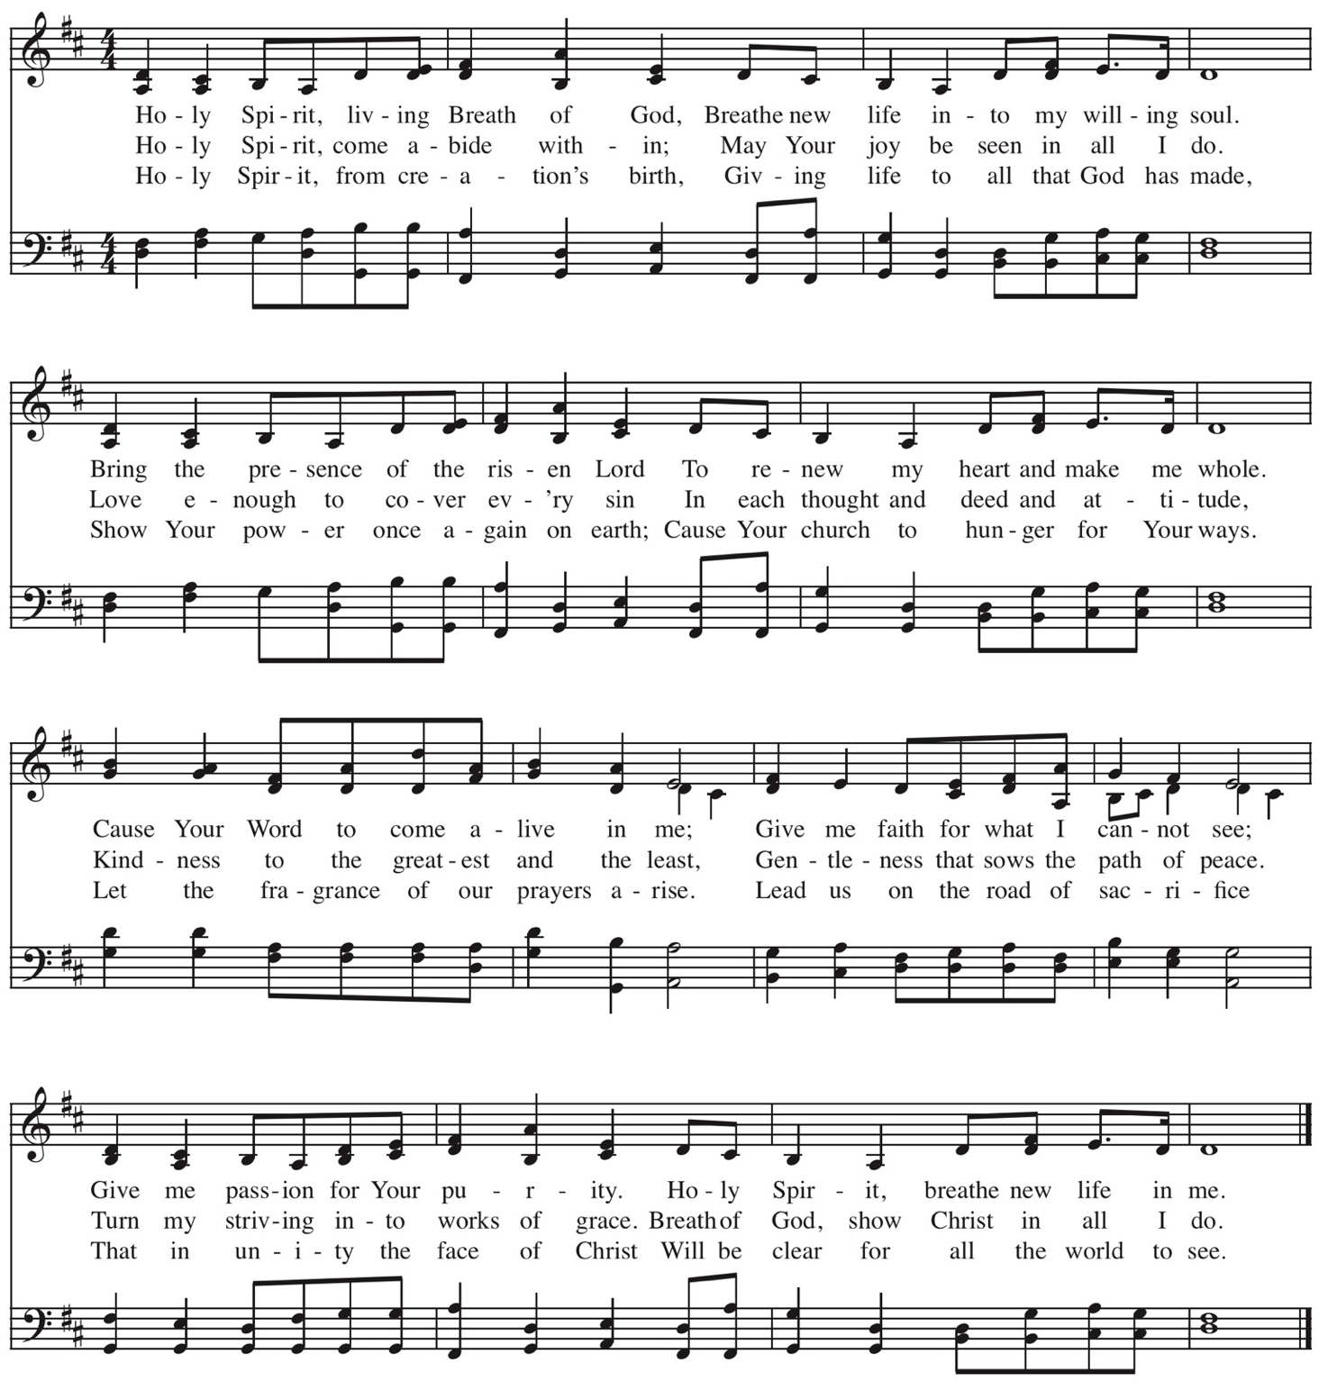
CCLI #11121087 © 2006 Thankyou Music Text ad Music: Keith Getty and Stuart Townend.

Missions Report—Brent & Andrea Roberts

God Teaches Us Through His Word

The Reading of the Word—Matthew 5:1-3

Seeing the crowds, he went up on the mountain, and when he sat down, his disciples came to him.
² And he opened his mouth and taught them, saying:
³ “Blessed are the poor in spirit, for theirs is the kingdom of heaven.

Leader: The grass withers, the flower fades;
All: But the Word of our God will stand forever.

Sermon—Blessed: Life in the Kingdom of God, Part 2
Blessed are the Poor in Spirit —Nate Shurden, Pastor

Sung Response—O Praise the Father
Text: John Mason, 1683; Music: Gregory Wilbur, 2011.

Profession of Faith—The Apostles’ Creed

We believe in God, the Father Almighty, the Creator of heaven and earth,

And in Jesus Christ, His only Son, our Lord,
who was conceived of the Holy Spirit, born of the Virgin Mary,
suffered under Pontius Pilate, was crucified, died, and was buried.
He descended into hell. On the third day He rose again from the dead.
He ascended into Heaven
and now sits at the right hand of God the Father Almighty,
from whence He shall come to judge the living and the dead.

We believe in the Holy Spirit, the holy catholic* church,
The communion of saints, the forgiveness of sins,
The resurrection of the body, and the life everlasting. Amen.

* “Catholic” refers to the universal church of God’s people throughout all time and from all places

Sung Response—Holy God We Praise Your Name, Vs 4
Text: Based on Te Deum, 4th c., Attr Ignace Franz, 1774; Music: Groser Gott, Katholisches Gesangbuch, 1774.

Words of Institution and the Lord’s Table

Guidelines for the Lord’s Supper
The Lord’s Supper is the family meal for Christians. We invite all baptized Christians who are members of a congregation that proclaims the gospel, and who are at peace with God and with their neighbor, and who seek strength to live more faithfully for Christ to join us.

If you are not a Christian, or if you are not prepared to share in this meal, we encourage you to spend this time in prayer. You can find some sample prayers on the next page. We hope that this time is helpful to you as you consider your relationship with Jesus Christ and with His people, the church.

At Cornerstone, we come forward to receive communion. You may take the bread at the first table and then proceed to either side for the wine/grape juice.

Prayers for Those Not Taking the Lord’s Supper

If you are not able to partake in the Lord’s Supper today, please use this time to meditate on one of the following prayers.

Prayer for Those Searching for Truth. Lord Jesus, you claim to be the way, the truth, and the life. Grant that I might be undaunted by the cost of following you as I consider the reasons for doing so. If what you claim is true, please guide me, teach me, and open me to the reality of who you are. Give me an understanding of you that is coherent, convincing, and that leads to the life you promise. Amen.

Prayer of Belief. Lord Jesus Christ, I admit that I am weaker and more sinful than I ever dared admit, but through you I am more loved and accepted than I ever dared hope. I thank you for paying my debt on the cross, taking what I deserved in order to offer me complete forgiveness. Knowing that you have been raised from the dead, I turn from my sins and receive you as my Savior and Lord. Amen.

Prayer of Commitment. Lord Jesus, you have called us to follow you in baptism and in a life of committed discipleship through membership in your church. Grant that I may take the necessary steps to be one with your people, and live in the fullness of your Spirit. Amen.

Psalm for June—Psalm 125: All You, With Heart Confiding
Text: Psalm 125, The Psalter, 1912; Music: Gregory D Wilbur, 2017

Hymn of Communion—O God, the Holy Spirit

CCLI #11121087 ©2006 Hope Publishing Company; Text and Music: David L. Ward, 2006.

God’s People Respond in Grateful Praise

Prayer of Thanksgiving and Intercession

The Lord’s Prayer
Our Father, who art in heaven, Hallowed be thy Name.
Thy kingdom come.
Thy will be done, On earth as it is in heaven.
Give us this day our daily bread.
And forgive us our debts, As we forgive our debtors.
And lead us not into temptation,
But deliver us from evil.
For Thine is the Kingdom, and the power, and the glory, forever. Amen.

Hymn of Praise—Breathe on Me, Breath of God
Text: Edwin Hatch, 1878, Music: Trentham, Robert Jackson, 1888, Mod. 2007. Used by Permission.

God Sends His People Out to Be Light in the Darkness

After calling His people into His presence, forgiving their sins, instructing them in His Word, and providing a foretaste of the marriage supper of the Lamb, God sends His people into the world to show His light in the darkness.

Benediction—John 14:25-27a
“These things I have spoken to you while I am still with you. But the Helper, the Holy Spirit, whom the Father will send in my name, he will teach you all things and bring to your remembrance all that I have said to you. Peace I leave with you; my peace I give to you.” Amen.

Sung Response—There is a Redeemer
CCLI #11121087 ©1982 Birdwing Music. Text and Music: Melody Green-Sievright.

Prayer Focus—Weston Duke is the Reformed University Fellowship (RUF) campus minister for Middle Tennessee State University, Murfreesboro, Tennessee. RUF is the campus ministry organization of the Presbyterian Church in America, and this coming year, RUF is celebrating 20 years of being on MTSU's campus! More than just a ministry on the university campus, RUF seeks to be a ministry for the university campus. It strives to serve in this unique stage of a student’s life in the world they live in, exploring together how the Lordship of Christ informs every area of life.
Prayer Requests:
- Pray for incoming students. MTSU will have roughly 5,000 new students starting this fall, both freshmen and transfers. Pray that RUF would be bold in reaching out to them and hospitable in welcoming them to campus.
- Pray for our new intern, Emily Tomlin. Pray for her as she fundraises and transitions to Murfreesboro this fall.
- Pray for our students who are battling anxiety, depression, and eating disorders, which are debilitating in their daily life. Pray they would experience peace and healing.
- Pray for Weston as he spends the summer preparing for the fall. Pray that he would both rest and use his time wisely in studying and planning.

Taking the Message Home

Today’s message, “Blessed are the Poor in Spirit” is taken from Matthew 5:1-3. Please take time to discuss the questions below with your family, friends, or Home Fellowship Group (HFG).

- Biblically speaking, what does it mean to be blessed? How is blessedness related to but different from happiness?

- What does it mean to be poor in spirit? How does the idea of blessed and poor in spirit fit together?

- Read Luke 18:9-14. How does this parable illustrate being poor in spirit as well as its opposite?

- What are the evidences of being poor in spirit? Reflecting on those evidences, are you poor in spirit?

- How does one become poor in spirit? What steps could you be take to grow toward the blessing of being poor in spirit?

Cornerstone Presbyterian Church
Presbyterian Church in America
Pastor: Nate Shurden (618-4707 Office) or nate@cstonepres.org
Assistant Pastor: Tony Giles (430-8801) or tony@cstonepres.org
Worship and Chief Musician: Greg Wilbur (512-4156) or greg@cstonepres.org
Office Administrator: Susan Bumpus (618-4707) or office@cstonepres.org
Home Fellowship Coordinator: Bob Wolk or HFG@cstonepres.org
Women’s Ministry: Martha Brooks and Julie Kesler at women@cstonepres.org
Men’s Ministry: Ron Moffat or men@cstonepres.org
Acting Youth Director: Taylor Thompson (717-371-0848) or youth@cstonepres.org
Children’s Director: Meredith Suits (865-250-3579) or elementary@cstonepres.org
Nursery Coordinator: Christy Shurden or nursery@cstonepres.org
Prayer Requests: prayer@cstonepres.org

Ruling Elders
Randy Allen (260-1884) Chuck Emerson: Emeritus (943-8443) Jim Payne (497-0613)
Terry Cheney (579-7089) Joe Haworth (289-7543) Jim Smith (347-4188)

Deacons
Mark Elliott (477-1041) Kevin McClung (243-9228) Larry Thompson (901-734-1520)
Gene King (806-3726)* Jim Robinson (587-0442) Bob Vermilye (599-9577)
Mike Payne (579-6453) Todd Russell (319-4803) David Steffens (557-5316)
Marty Smith (767-2240)°

*On Sabbatical °Leave of Absence

Post Office Box 407 Franklin, Tennessee 37065
www.cornerstonepresfranklin.org (615) 618-4707

All Scripture quotations from the English Standard Version

