Cornerstone   
Presbyterian Church



Service of Celebration and Gospel Renewal

*Resurrection Sunday*

01 April 2018

*Welcome to Worship*

If you are reading this in worship, I want you to know something—*you are an answer to prayer*. Each Sunday before worship, I ask God to bring into our midst exactly who He desires would be there. Since you are with us today, I believe God has a blessing in store for you. I am prayerful as we worship together today, that blessing will be received and enjoyed.

To that end, this service of worship has been designed that we might know God and the glory of the gospel of Jesus Christ. From the summons to worship at the beginning to the sending out into the world at the benediction, that you might know God, the truth and joy of salvation, and be equipped to answer the call to be a disciple of Jesus Christ.

Following the service, feel free to approach one of our elders (the men who help serve the Lord’s Supper) with any prayer needs or questions you may have. I believe you will find them to be warm, inviting, and eager to serve. Please know I would personally enjoy getting to meet you this morning following the service, so please stop by and see me at the front door of the chapel.

It is my sincere prayer that your experience today at Cornerstone Presbyterian Church is one that blesses you spiritually and strengthens your faith in the Lord.

Grace & Peace,

Rev. Nate Shurden

*Sunday School Schedule*

**Nursery** (basement)

**PreK:** Room 104 (basement)

Joe and Joy Marlo; Assistant: Kristin Lee

**K/1st Grade**: Room 103 (basement)

Teacher: Michelle Marshall; Assistant: Mark Elliott

**2nd/3rd Grade:** Room 101 (basement)

Teacher: Bob Wolk; Assistant: Anneke Seely

**4th/5th Grade:** Comenius Room (third floor)

Teacher: Ronda Laventure; Assistant: Julia Grounds

**6th Grade:** Schaeffer Room (third floor)

Teacher: Charlotte Robinson; Assistant: Mary Lynn Giles

**Youth** (7th-9th and 10th-12th) at Merridees

**Adult**

The Chapel Class: *Discerning and Exercising Your Spiritual Gifts* (Chapel)

Koinonia Class: *The Westminster Confession of Faith* (Kuyper Room 3rd Floor)

God Calls His People and Reveals Himself

*God calls His people to worship and come before Him. The Creator of all things reveals Himself through His Word and calls us into His presence.*

**Choral Prelude—Christ is Arisen**

Christ is arisen, alleluia! This day is Christ arisen, alleluia.

This day is Christ arisen truly from the dead. Alleluia!

Text: from Easter Vespers, Trans by Richard Proulx; Music: Giovanni Battista Pergolsei (1710-1736), Ed by Rihcard Proulx.

**Announcements & Preparation**

**Introit—I Know that My Redeemer Lives, Vs 1**

**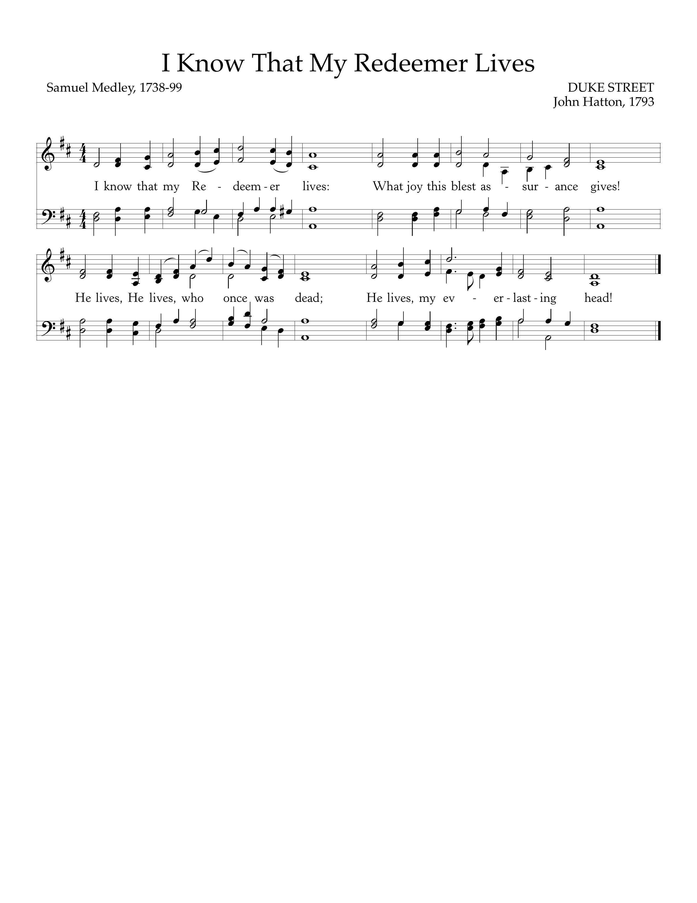**

Text: Samuel Medley, 1738-99; Music: Duke Street, John Hatton, 1793.

**Call to Worship—Romans 1:3-5; Job 19:25**

Pastor: Christ is risen!

**All: He is risen indeed!**

Pastor: For Jesus Christ our Lord is declared to be the Son of God in power according to the Spirit of holiness by His resurrection from the dead—through whom we have received grace.

**All: I know that my Redeemer lives, and at the last He will stand upon the earth.**

Pastor: Christ is risen!

**All: He is risen indeed!**

**Hymn of Praise—Christ the Lord is Risen Today**

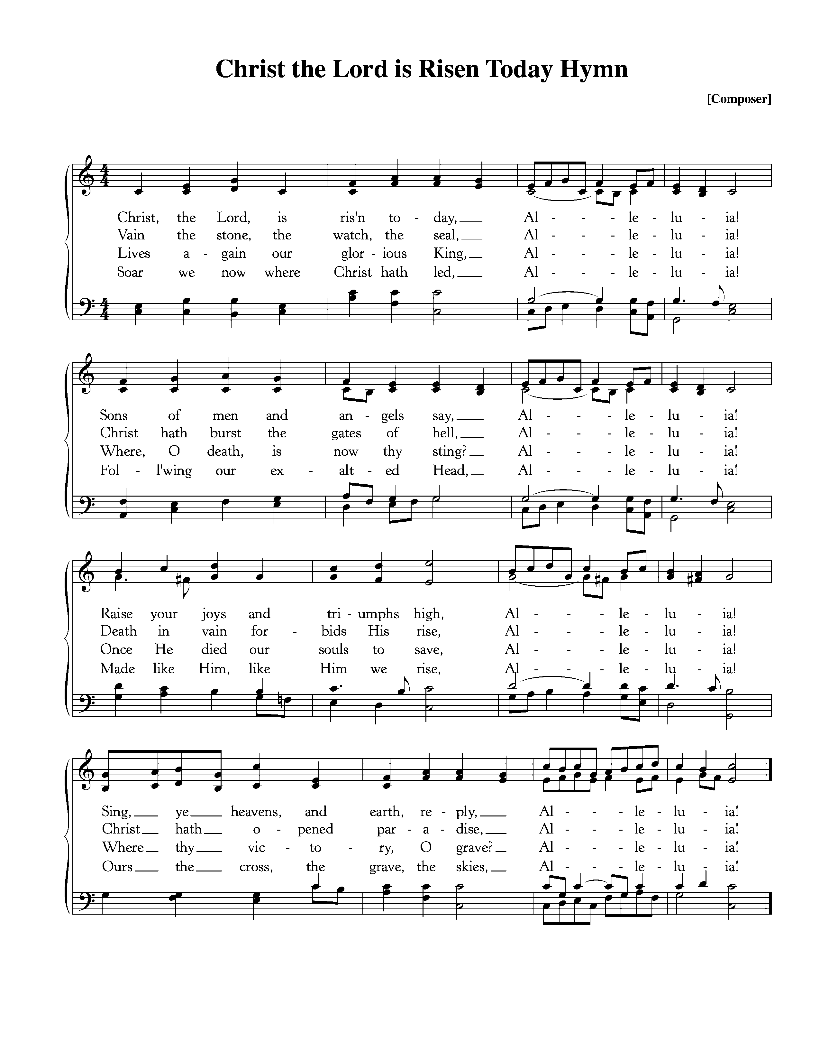

Text: Charles Wesley, 1739; Music: Easter Hymn, *Lyra Davidica,* 1708.

**Hymn of Praise—Glory to God! The Morn Appointed Breaks**

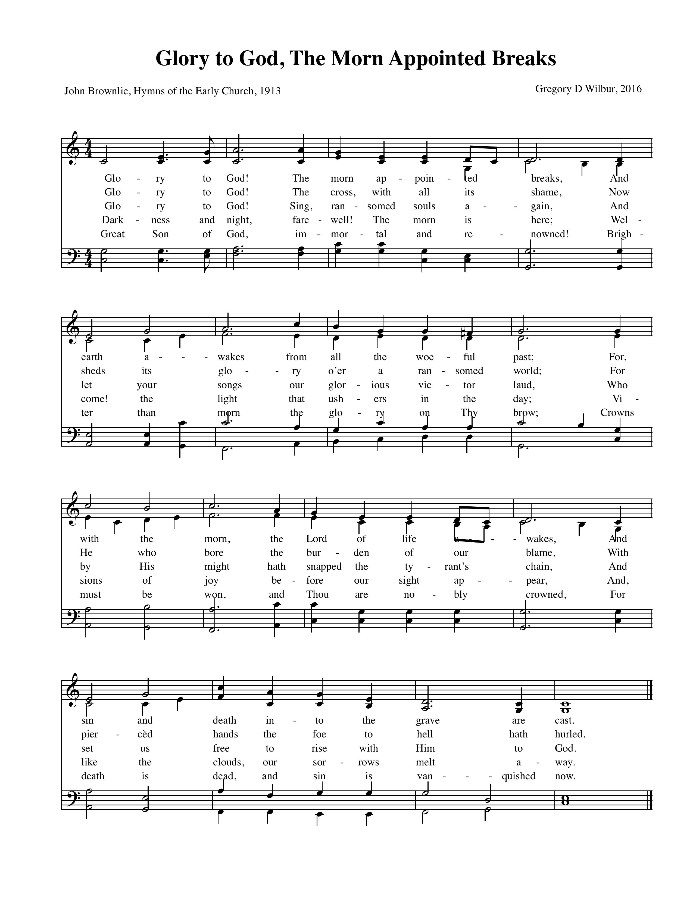



Text: John Brownlie, *Hymns of the Early Church*, 1913; Music: Greyfriars, 2016

*+++Latecomers Please Wait to be Seated+++*

**New Testament Reading—Luke 24:1-12**

But on the first day of the week, at early dawn, they went to the tomb, taking the spices they had prepared. 2And they found the stone rolled away from the tomb, 3but when they went in they did not find the body of the Lord Jesus. 4While they were perplexed about this, behold, two men stood by them in dazzling apparel. 5And as they were frightened and bowed their faces to the ground, the men said to them, “Why do you seek the living among the dead? 6He is not here, but has risen. Remember how he told you, while he was still in Galilee, 7that the Son of Man must be delivered into the hands of sinful men and be crucified and on the third day rise.” 8And they remembered his words, 9and returning from the tomb they told all these things to the eleven and to all the rest. 10Now it was Mary Magdalene and Joanna and Mary the mother of James and the other women with them who told these things to the apostles, 11but these words seemed to them an idle tale, and they did not believe them. 12But Peter rose and ran to the tomb; stooping and looking in, he saw the linen cloths by themselves; and he went home marveling at what had happened.

Elder: This is the Word of the Lord.

**All: Thanks be to God.**

God Calls His People to Confession, Repentance & Reconciliation

*The People of God respond to His Word by confessing their sins, repenting of their sinful ways, and seeking God’s favor through the reconciling work of Jesus, the Son of God.*

**Sung Response—Lamb of God**

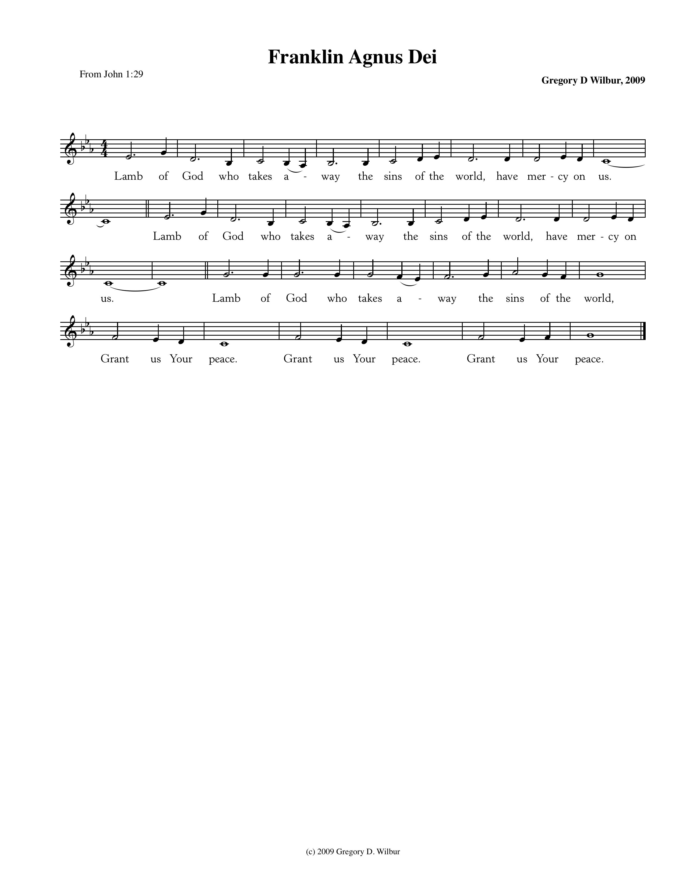

Text: John 1:29; Music: Franklin Agnus Dei, Gregory D Wilbur, 2009. ©2009 Greyfriars Press.

**Corporate Prayer of Confession—based on I Corinthians 15:12-20**

Pastor: Lord, we come confessing. Christ is proclaimed as risen from the dead.

**All: But we act as if there was no resurrection of the dead.**

Pastor: But if there is no resurrection of the dead then not even Christ has been raised.

**All: Our faith is in vain because we act as if Christ has not been raised.**

Pastor: We misrepresent God because we testify that He raised Christ from the grave,

**All: But we live functionally like there is no resurrection.**

Pastor: For if the dead are not raised, not even Christ has been raised.

**All: And if Christ has not been raised, our faith is futile and we are still in our sins.**

Pastor: If in Christ we have hope in life only,

**All: We are of all people most to be pitied.**

Pastor: But in fact, Christ has been raised from the dead,

the firstfruits of them who have fallen asleep.

**Silent Prayers of Confession**

**Assurance of Pardon—II Corinthians 5:14-15**

For the love of Christ controls us, because we have concluded this: that one has died for all, therefore all have died; and he died for all, that those who live might no longer live for themselves but for him who for their sake died and was raised.

*+++Latecomers are Welcome to be Seated+++*

**Hymn of Praise—How Deep the Father’s Love For Us**



CCLI #11121087 ©1995 Thankyou Music; Text and Music: Stuart Townend, 1995.

**Sacrament of Baptism**  ***John Rhoades Lilly,*** *Son of Tom & Lucy Lilly*

“For to you is the promise, and to your children, and to all that are afar off, even as many as the Lord our God shall call unto him. ‘And I will establish my covenant between me and you and your seed after you throughout their generations for an everlasting covenant, to be a God unto you and to your seed after you.’ Therefore, believe on the Lord Jesus, and you shall be saved, you and your house.” (Acts 2:39; Gen. 17:7; Acts 16:31)

**Parental Vows:**

1. Do you acknowledge your own, as well as your child’s, need of the cleansing blood of Jesus Christ and the renewing grace of the Holy Spirit?
2. Do you claim God’s covenant promises for him, and do you look in faith to the Lord Jesus—and only to the Lord Jesus—for his salvation, just as you do for your own?
3. Do you now consecrate your child to God; will you in humble reliance upon His sovereign grace set before him a godly example—praying with and for him, teaching him the good hope of the Gospel, opening to him the truth of the Scriptures, and striving by every means of grace God provides, to bring him up in the nurture and admonition of the Lord?

**Congregational Vow:**

Will you as a covenant community joyously commit to assisting these parents in the Christian nurture of this child?

God Teaches Us Through His Word

**The Reading of the Word—from Philippians 3:7-11**

**7**But whatever gain I had, I counted as loss for the sake of Christ.**8**Indeed, I count everything as loss because of the surpassing worth of knowing Christ Jesus my Lord. For his sake I have suffered the loss of all things and count them as rubbish, in order that I may gain Christ **9**and be found in him… **10**that I may know him and the power of his resurrection, and may share his sufferings, becoming like him in his death, **11**that by any means possible I may attain the resurrection from the dead.

Leader: This is the Word of the Lord.

**All: Thanks be to God.**

**Sermon—**

*The Power of the Resurrection*—Nate Shurden, *Pastor*

**Sung Response—O Praise the Father**

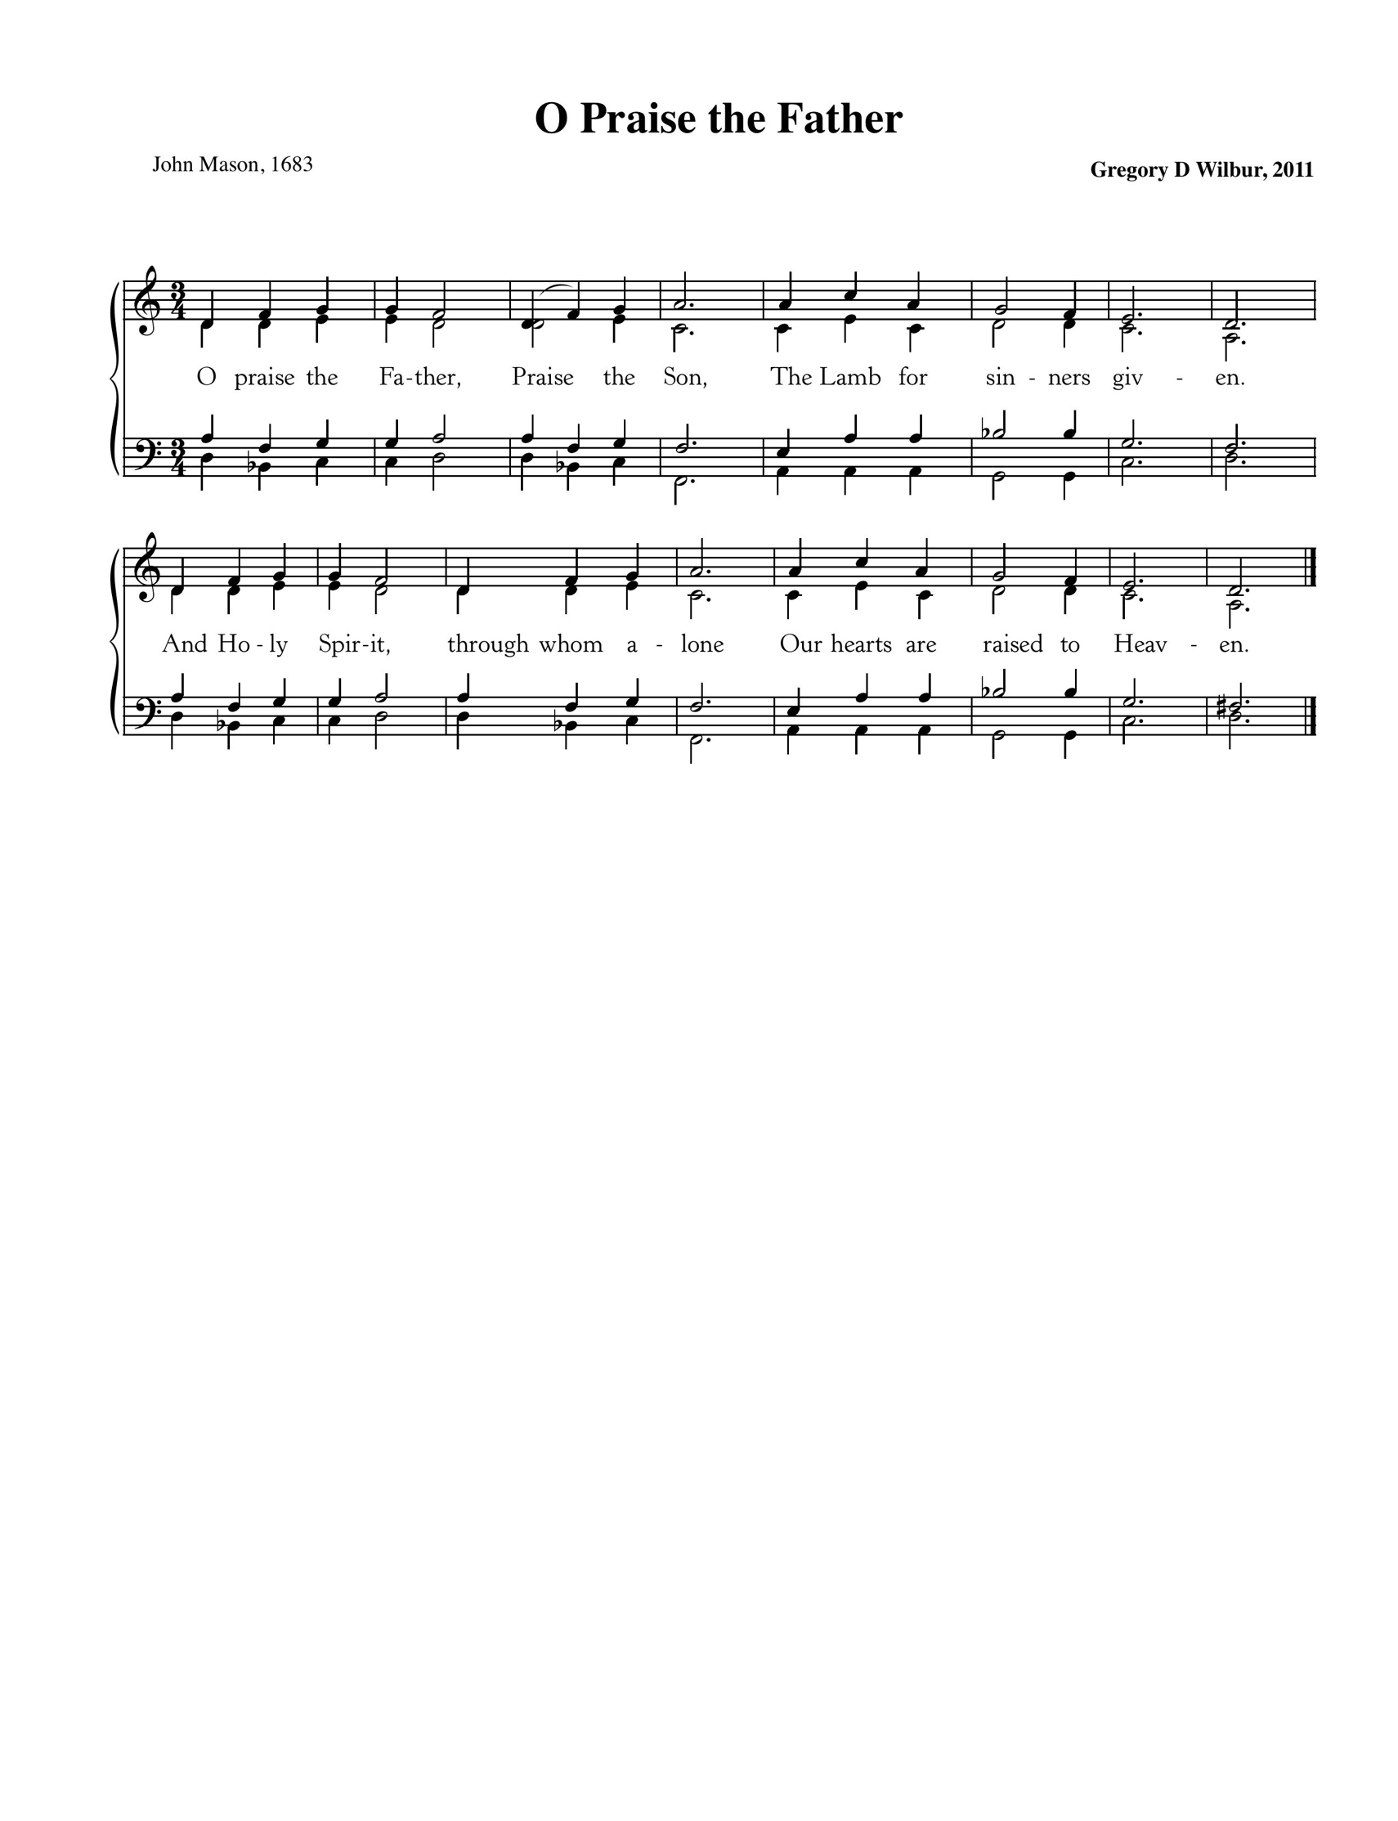

Text: John Mason, 1683; Music: Gregory Wilbur, 2011.

**Profession of Faith—The Apostles’ Creed**

We believe in God, the Father Almighty, the Creator of heaven and earth,

And in Jesus Christ, His only Son, our Lord,

who was conceived of the Holy Spirit, born of the Virgin Mary,

suffered under Pontius Pilate, was crucified, died, and was buried.

He descended into hell. On the third day He rose again from the dead.

He ascended into Heaven

and now sits at the right hand of God the Father Almighty,

from whence He shall come to judge the living and the dead.

We believe in the Holy Spirit, the holy catholic\* church,

The communion of saints, the forgiveness of sins,

The resurrection of the body, and the life everlasting. Amen.

*\* “Catholic” refers to the universal church of God’s people throughout all time and from all places*

**Matthew 11:28-30 & Psalm 34:8**

Pastor: Jesus said: Come to me, all who labor and are heavy laden, and I will give you rest. Take my yoke upon you, and learn from me, for I am gentle and lowly in heart, and you will find rest for your souls. For my yoke is easy, and my burden is light.”

**All: Oh, taste and see that the Lord is good!**

**Blessed is the man who takes refuge in him!**

Women

Men

**Sung Response—Sanctus**

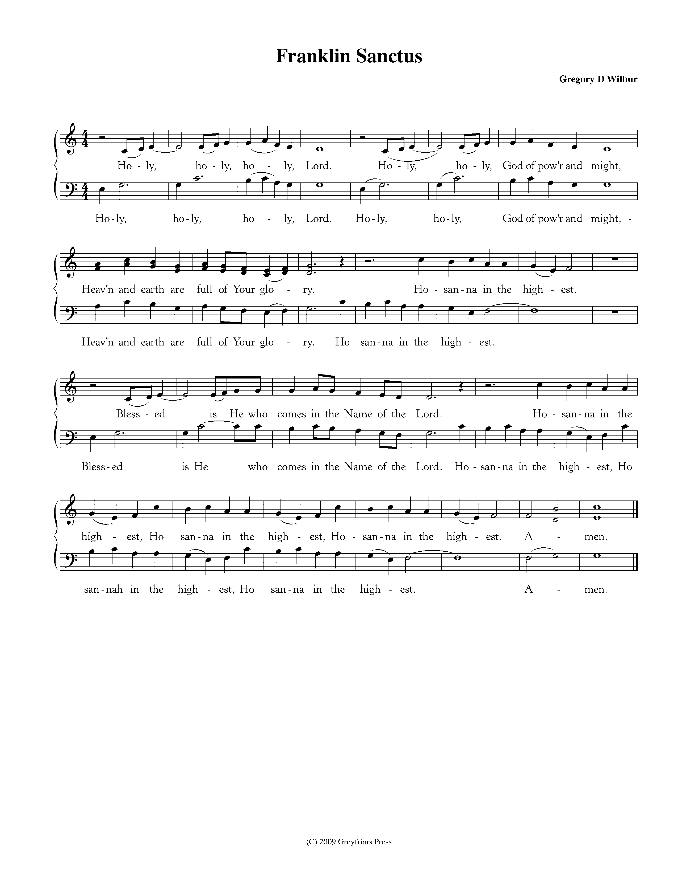

CCLI #11121087 Text: Is 6:3, Rev 4:8, Mt 21:9; Music: Franklin Sanctus, Gregory D Wilbur, 2009. ©2009 Greyfriars Press.

**Words of Institution and the Lord’s Table**

**Guidelines for the Lord’s Supper**

*The Lord’s Supper is the family meal for Christians. We invite all baptized Christians who are members of a congregation that proclaims the gospel, and who are at peace with God and with their neighbor, and who seek strength to live more faithfully for Christ to join us.*

*If you are not a Christian, or if you are not prepared to share in this meal, we encourage you to spend this time in prayer. You can find some sample prayers on the next page. We hope that this time is helpful to you as you consider your relationship with Jesus Christ and with His people, the church.*

*At Cornerstone, we come forward to receive communion. You may take the bread at the first table and then proceed to either side for the wine/grape juice.*

**Choral Hymn of Communion—Lamb of God**

Lamb of God, I fall before Thee, Humbly trusting in Thy Cross;

That alone be all my glory, All things else I count but loss.

Jesu, all my hope and joy Flow from Thee, Thou sovereign good.

Hope and love and faith and patience, All were purchased by Thy Blood.

Words: Joseph Hart, 1712-1768; Music: harmonized by J.S. Bach (1685-1750) in St. Matthew Passion, 1727.

**Prayers for Those Not Taking the Lord’s Supper**

If you are not able to partake in the Lord’s Supper today, please use this time to meditate on one of the following prayers.

*Prayer for Those Searching for Truth.* Lord Jesus, you claim to be the way, the truth, and the life. Grant that I might be undaunted by the cost of following you as I consider the reasons for doing so. If what you claim is true, please guide me, teach me, and open me to the reality of who you are. Give me an understanding of you that is coherent, convincing, and that leads to the life you promise. Amen.

*Prayer of Belief.* Lord Jesus Christ, I admit that I am weaker and more sinful than I ever dared admit, but through you I am more loved and accepted than I ever dared hope. I thank you for paying my debt on the cross, taking what I deserved in order to offer me complete forgiveness. Knowing that you have been raised from the dead, I turn from my sins and receive you as my Savior and Lord. Amen.

*Prayer of Commitment.* Lord Jesus, you have called us to follow you in baptism and in a life of committed discipleship through membership in your church. Grant that I may take the necessary steps to be one with your people, and live in the fullness of your Spirit. Amen.

**Hymn of Promise—What Wondrous Love is This**

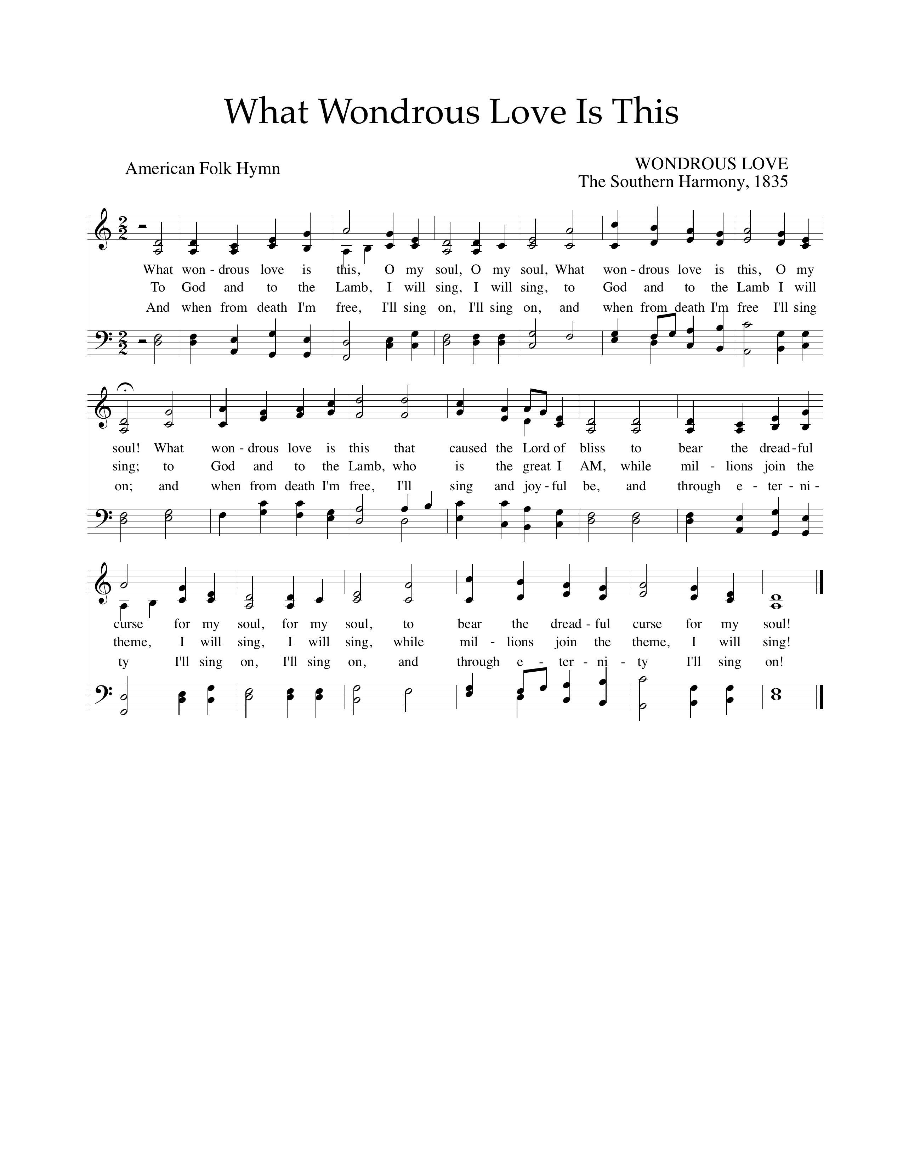

Text: American Folk Hymn; Music: Wondrous Love, *Southern Harmony,* 1835.

God’s People Respond in Grateful Praise

**Prayer of Thanksgiving and Intercession**

The Lord’s Prayer

Our Father, who art in heaven, Hallowed be thy Name.

Thy kingdom come. Thy will be done, On earth as it is in heaven.

Give us this day our daily bread. And forgive us our debts, As we forgive our debtors.

And lead us not into temptation, But deliver us from evil.

For Thine is the Kingdom, and the power, and the glory, forever. Amen.

**Hymn of Praise—Christ Is Risen! Hallelujah!**

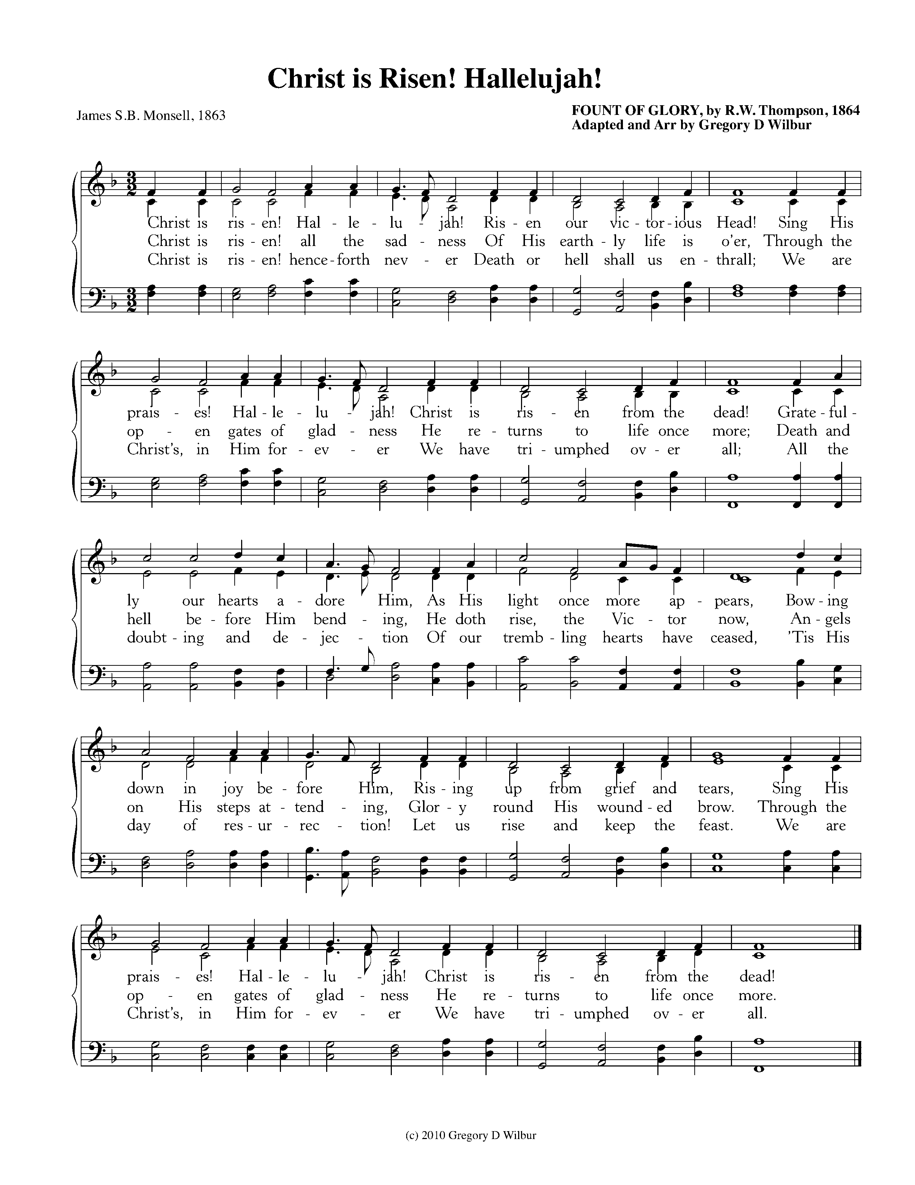

Text: James S.B. Monsell, 1863;

Music: Fount of Glory, R.W. Thompson, 1864, Adapted Gregory Wilbur. ©2010 Gregory D Wilbur

God Sends His People Out to Be Light in the Darkness

*After calling His people into His presence, forgiving their sins, instructing them in His Word, and providing a foretaste of the marriage supper of the Lamb, God sends His people into the world to show His light in the darkness.*

**Benediction—Revelation 5:11-12**

Pastor : I looked, and I heard around the throne and the living creatures and the elders the voice of many angels, numbering myriads of myriads and thousands of thousands, saying with a loud voice, “Worthy is the Lamb who was slain, to receive power and wealth and wisdom and might and honor and glory and blessing!”

Christ is risen!

**All: He is risen indeed!**

**Sung Response—When I Survey the Wondrous Cross, Vs 2 & 4**

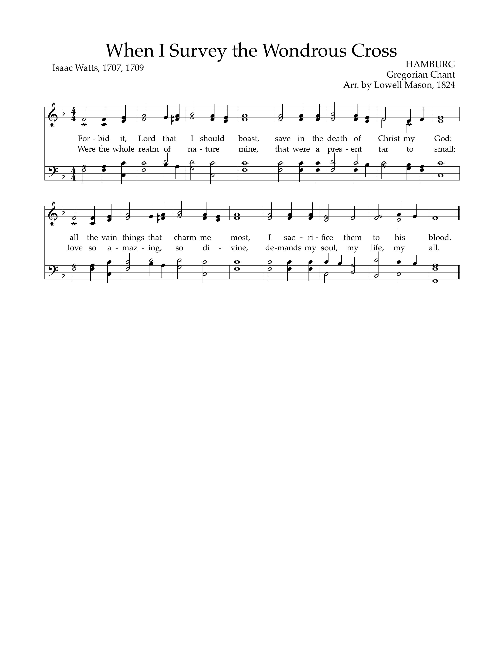

Text: Isaac Watts, 1707, 1709; Music: Hamburg, Gregorian Chant, Arr. by Lowell Mason, 1824.

**Prayer Focus—**Colleen McGarry is the local programs coordinator as well as the director of communications for SGI in Nashville. She organizes local volunteer opportunities, specifically English classes for women. She loves to help people overcome their fears and love those that are different than they are. She is also responsible for managing the social media and website for SGI.

• Pray that Colleen and SGI are able to find creative onramps for helping people to engage with the refugee and Muslim community bringing the hope of the gospel.

• Pray for B, N, and H as they study the Bible here in Nashville and for the dozens of other Muslim women that Colleen is able to love and serve each week.

• Pray for regular monthly supporters to come alongside her in her work.

• Pray for the small group of Kurdish believers now beginning to meet together in Nashville.

• If you would like to be added to Colleen’s regular update email or mailing list, email her at [abundantblessing@gmail.com](mailto:abundantblessing@gmail.com).

**Home Fellowship Groups**

**River Landing**—Jim & Gwen Smith

Second and Fourth Sundays, 6:00pm, Smith’s house, Book discussion

**West Nashville**—Andy & Katie Patton

Every other Sunday, 5:00pm, Patton’s house, Sermon discussion

**Upper Room**—Bob & Cindi Wolk

First and Third Sundays after Second service at Cornerstone, Sermon discussion

**Liberty Pike**—Dan Fiedler & Carl Ware

Second and Fourth Sundays, 4:30-6:30pm, Ware’s house, Sermon discussion

**Grassland**—Steve Green & John Marquardt

First and Third Tuesdays, 6:30pm, Green’s house, sermon discussion and studying James

**South Franklin**—John & Allison Millard

Every other Sunday, 5:00pm, Millard’s House, Sermon discussion

**East Franklin**—Mark & Lindsey Elliott

First, Second, and Third Sundays after the Second Service, Elliott’s house, Sermon discussion

**Fieldstone/Cottonwood**—Greg & Sophia Wilbur

Second, Third, and Fourth Sundays, 5:00pm, Wilbur’s house, Sermon discussion

**Downtown**—Joe & Josephine Haworth

Second and Fourth Mondays, 6:30-8:00pm, Cornerstone Third Floor, Sermon discussion

Taking the Message Home

Cornerstone Presbyterian Church

**Presbyterian Church in America**

**Pastor**: Nate Shurden (618-4707 Office) or nate@cstonepres.org

**Assistant Pastor**: Tony Giles (430-8801) or tony@cstonepres.org

**Worship and Chief Musician**: Greg Wilbur (512-4156) or greg@cstonepres.org

**Office Administrator:** Susan Bumpus (618-4707) or office@cstonepres.org

**Home Fellowship Coordinator:** Bob Wolk or HFG@cstonepres.org

**Women’s Ministry:** Marijean Green and Mary Lynn Giles at women@cstonepres.org

**Men’s Ministry:** Terry Cheney (579-7089) or men@cstonepres.org

**Youth Director:** Christian Brewer (887-9576) or youth@cstonepres.org

**Children’s Director:** Martha Brooks (591-1683) or elementary@cstonepres.org

**Nursery Coordinator:** Christy Shurden or [nursery@cstonepres.org](mailto:vangordenlinda@yahoo.com)

**Prayer Requests:** prayer@cstonepres.org

**Ruling Elders**

Randy Allen (260-1884) Steve Green (504-8733) Brian Phillips (429-8125)

Terry Cheney (579-7089) Joe Haworth (289-7543) Jim Smith (347-4188)

Chuck Emerson: *Emeritus* (943-8443) Jim Payne (497-0613) Greg Wilbur (512-4156)\*

**Deacons**

Clint Branch (516-9855) Jim Robinson (587-0442) David Steffens (557-5316)\*

Gene King (806-3726) Todd Russell (319-4803) Larry Thompson (901-734-1520)

cornerstone_C-cross Crimson Gold Sm.tifKevin McClung (243-9228) Marty Smith (767-2240)Bob Vermilye (599-9577)

\*On Sabbatical

Post Office Box 407 Franklin, Tennessee 37065

www.cornerstonepresfranklin.org (615) 618-4707

*All Scripture quotations from the English Standard Version*