Service of Celebration and Gospel Renewal

Ordinary Time—Sundays of Pentecost
22 September 2013
Worship Notes

Abiding in the love of Christ leads us to a gratitude expressed in obedience—obedience to the commandments of God (John 15:10). We will respond to the love of God this morning in thankfulness for His Word and the desire to be more like Christ. The Call to Worship from Psalm 119 expresses the longing to seek after God by means of His Word and the delight we should have in His precepts. We continue by singing O Shine Upon Us, Lord that He would display Himself through His Word to us. Psalm 138: With Grateful Hearts remind us that grace and truth are together found in the holy Word of God alone.
The Old Testament Reading from Psalm 1 speaks of the blessed one who meditates on the law of God and who bears fruit in season. The Prayer of Confession from Romans 1 calls us to repent from suppressing the truth of God and trying to supplant it with our own truth designed for our own glory. The hymn Abide, O Dearest Jesus connects the desire for the abiding work of Christ with the response of gratitude in growing daily in the Word.
The Hymns of Communion bring us to the realization of needing to feed on Christ as our only true source of sustenance and strength. We see this theme in both Bread of Heaven and Jesus, Thou Joy of Loving Hearts. The final hymn, May the Mind of Christ My Savior, is a prayer for the indwelling of the Spirit to live in us day by day such that the Word of God would dwell in us richly.
—Greg Wilbur

God Calls His People to Worship

It is God Himself who calls His people to worship. We do not call ourselves, but it is the King who opens His gates and beckons us into his courts.

Prelude. Announcements & Preparation

Introit—Crown Him with Many Crowns, Vs 7
Text: Matthew Bridges, 1852; Music: Diademata, George J. Elvey, 1868.

Call to Worship—from Psalm 119:10-16

Pastor: With our whole hearts we seek You; let us not wander from your commandments!

All: We have stored up Your Word in our hearts, that we might not sin against You.

Pastor: Blessed are You, O Lord; teach us Your statutes!

All: With our lips we will declare the rules of Your mouth.

Pastor: We will delight in the way of Your testimonies as much as in all riches.

All: We will meditate on Your precepts and fix our eyes on Your ways.

Pastor: We will delight in Your statutes; We will not forget Your Word.

Hymn of Praise—O Shine Upon Us Lord
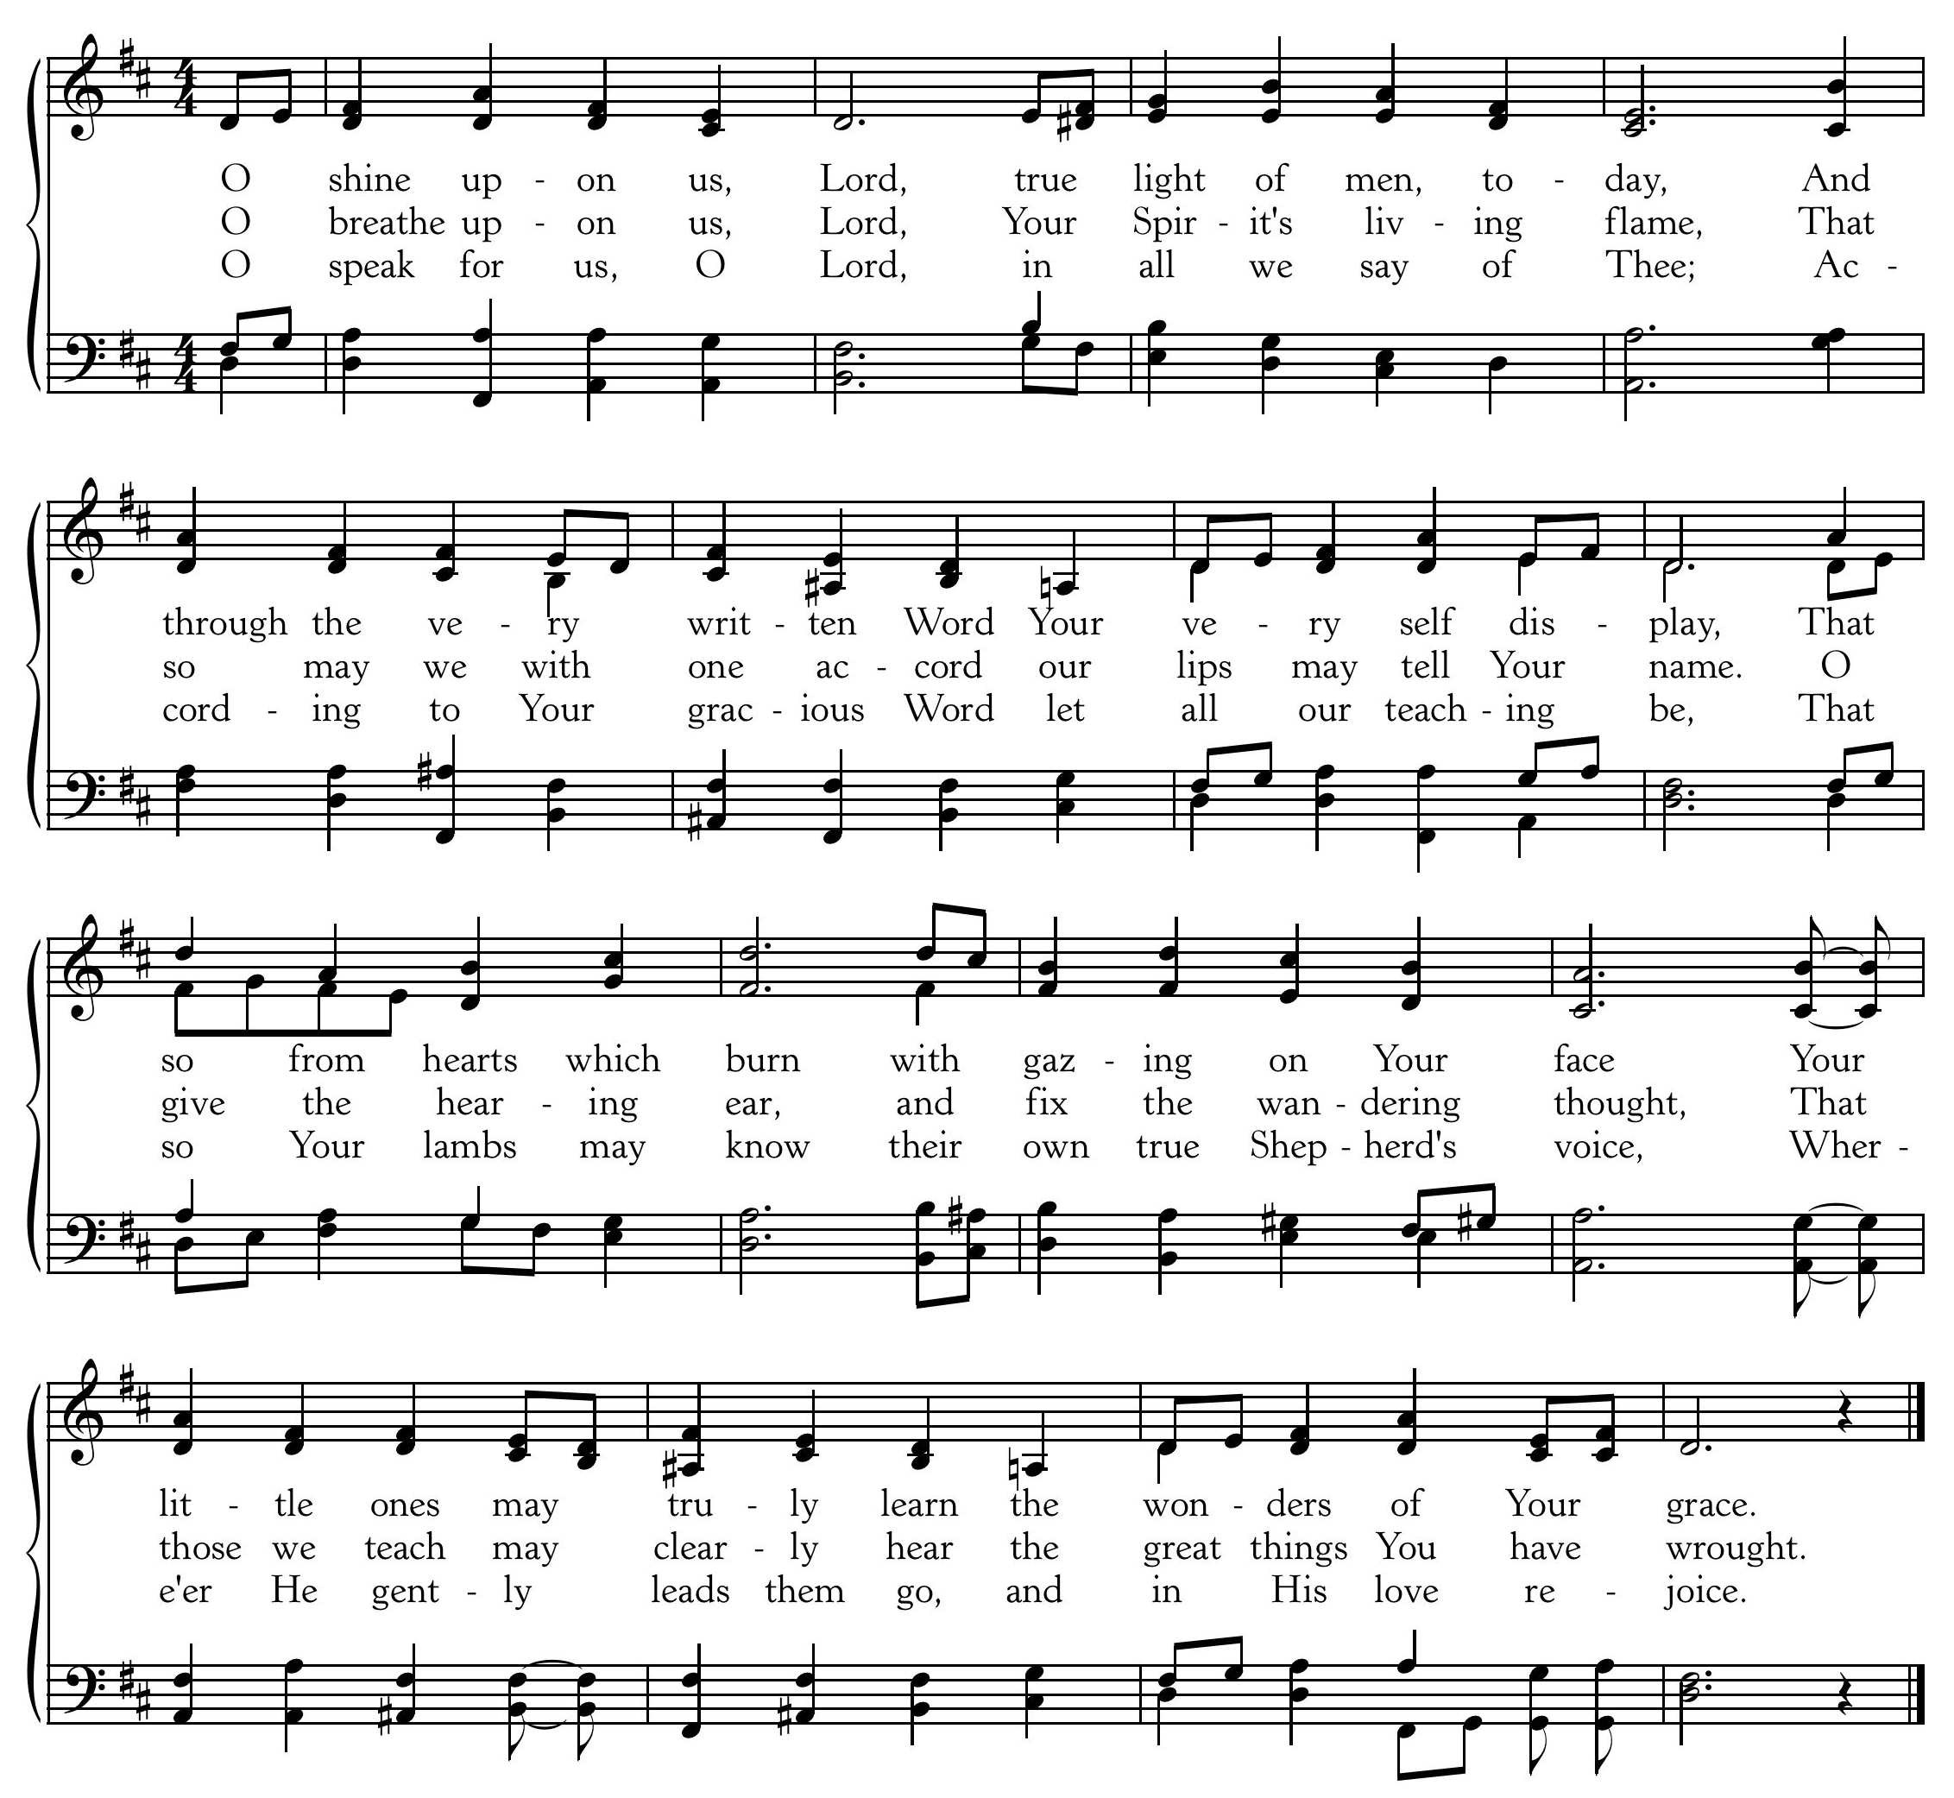
Text: John Ellerton, in Hymns Ancient and Modern, 1889; Music: Terra Beata, Franklin Sheppard, 1915
Psalm of Praise—Psalm 138: With Grateful Heart
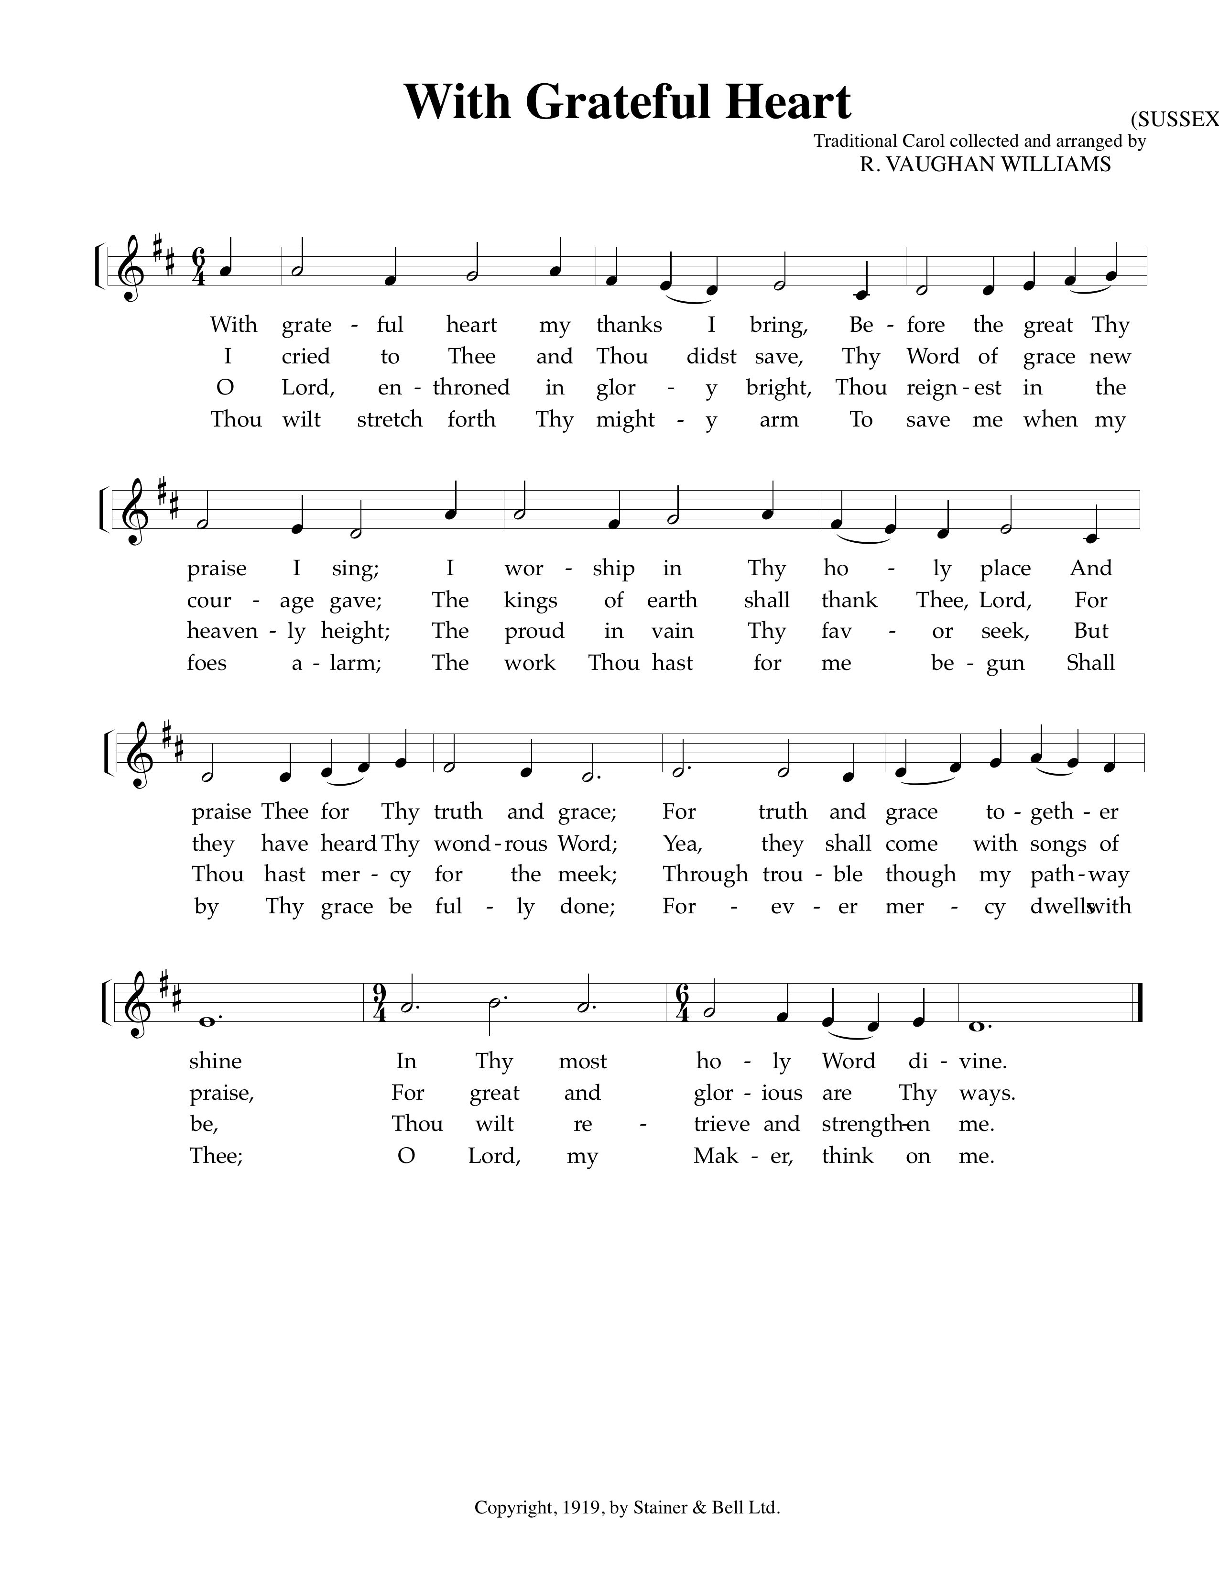

Text: Psalm 138, The Psalter, 1912; Music: Sussex Carol, Traditional English Tune.

(Please be seated)

Old Testament Reading—Psalm 1
Blessed is the man who delights in the low of the Lord

1 Blessed is the man who walks not in the counsel of the wicked,
nor stands in the way of sinners, nor sits in the seat of scoffers;
2 but his delight is in the law of the Lord, and on his law he meditates day and night.

3 He is like a tree planted by streams of water that yields its fruit in its season,
and its leaf does not wither. In all that he does, he prospers.
4 The wicked are not so, but are like chaff that the wind drives away.

5 Therefore the wicked will not stand in the judgment,
nor sinners in the congregation of the righteous;
6 for the Lord knows the way of the righteous, but the way of the wicked will perish.

Elder: This is the Word of the Lord.
All: Thanks be to God.

God Calls His People to Confession, Repentance, and Reconciliation
The People of God respond to His Word by confessing their sins, repenting of their sinful ways, and seeking God’s favor through the reconciling work of Jesus, the Son of God.

Sung Response—Hear My Prayer (from Psalm 86)

Text & Music: Greyfriars Press, 2013. Used by permission.

Corporate Confession of Sin—based on Romans 1:18-23, 25

Pastor: Lord, we come confessing. Your wrath is revealed from heaven against all ungodliness
and unrighteousness of man, who by their unrighteousness suppress the truth.

All: What can be known about You is plain because You have shown it to us.

Pastor: Your invisible attributes—Your eternal power and divine nature—have been clearly perceived
ever since the creation of the world in the things that have been made.

All: We are without excuse, for although we knew You,
we did not honor You or give thanks to You.

Pastor: We became futile in our thinking and our foolish hearts were darkened.

All: Claiming to be wise, we became fools and exchanged the glory of the immortal God
for earthly things.

Pastor: We have exchanged the truth of about You, O God, for a lie and worshipped the creature
rather than the Creator, who is blessed forever!

Sung Response—Kyrie

Silent Prayers of Confession

Assurance of Pardon—Romans 8:1-2
There is therefore now no condemnation for those who are in Christ Jesus. For the law of the Spirit of life has set you free in Christ Jesus from the law of sin and death.

Hymn of Praise—Abide, O Dearest Jesus
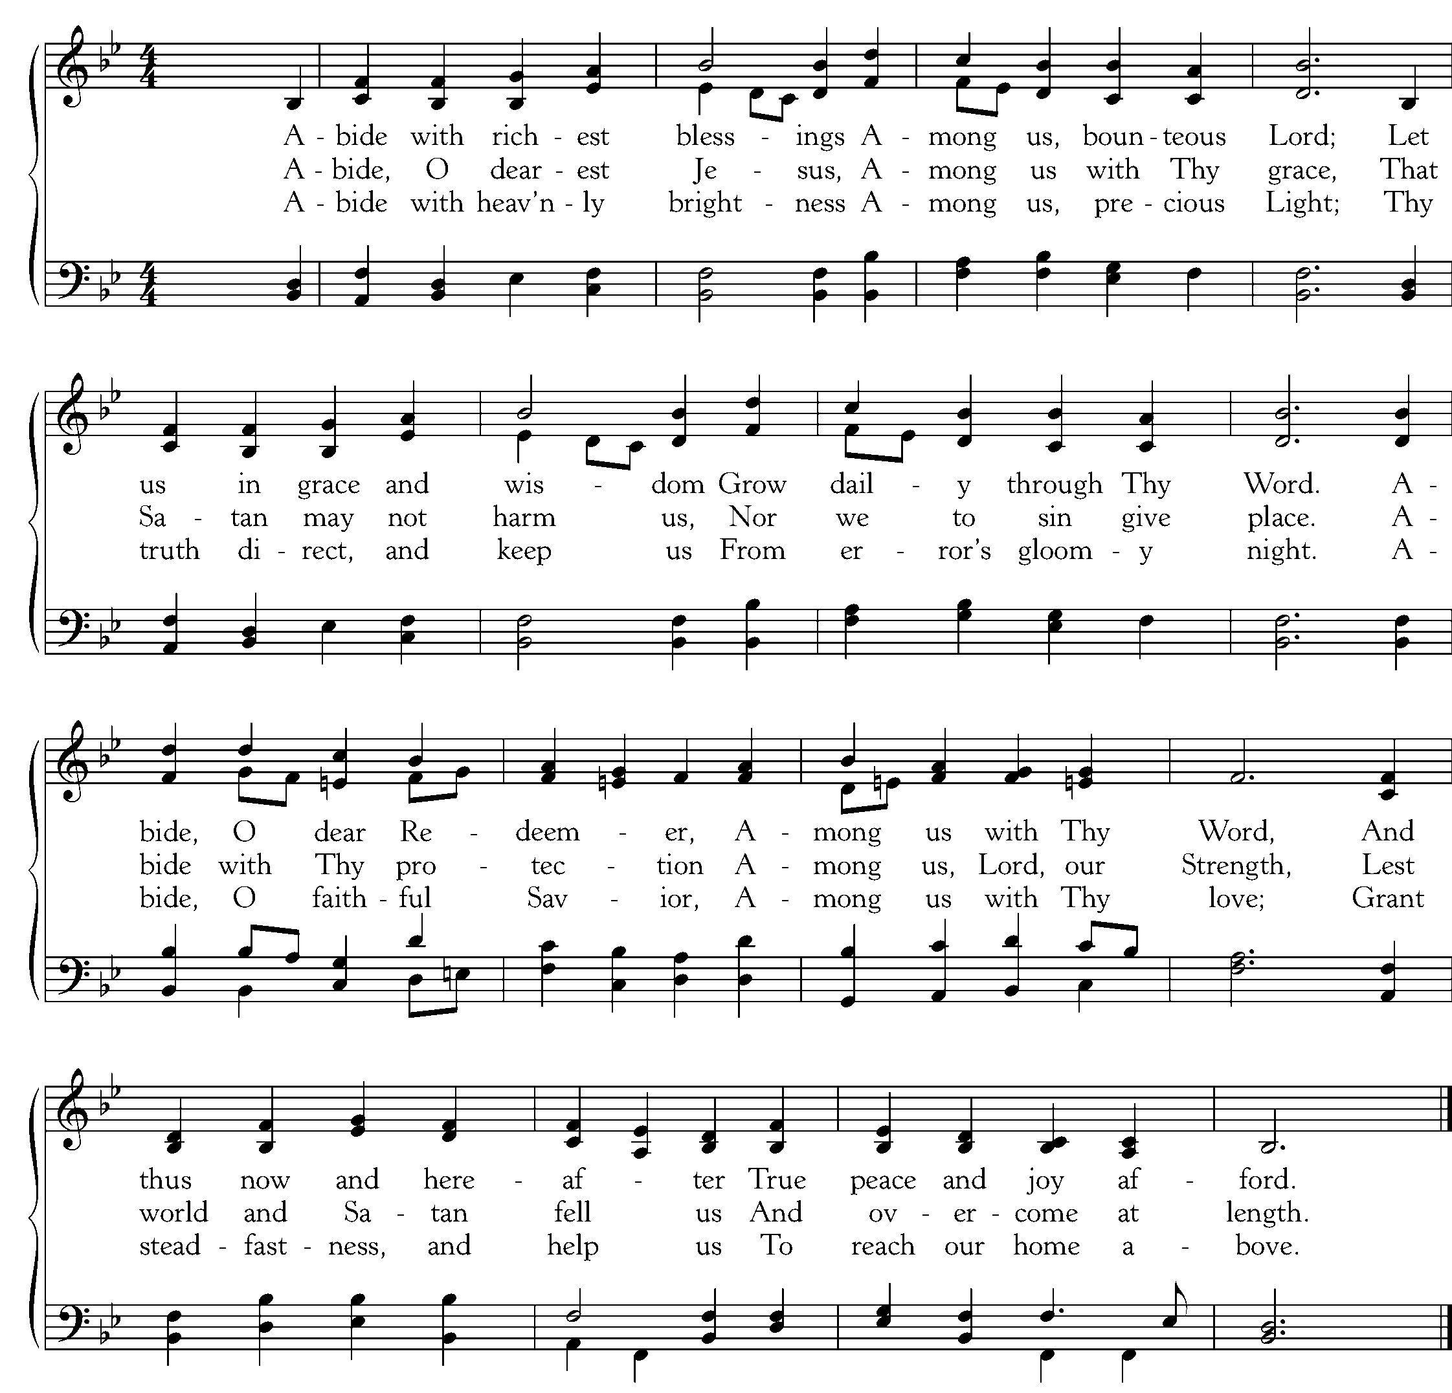
Text: Joshua Stegmann, 1628, Trans August Crull, c. 1892; Music: St. Theodulph, Melchoir Teschner, ca. 1615.

The Reading of the Word—John 15:1-11

“I am the true vine, and my Father is the vinedresser. 2 Every branch in me that does not bear fruit he takes away, and every branch that does bear fruit he prunes, that it may bear more fruit. 3 Already you are clean because of the word that I have spoken to you. 4 Abide in me, and I in you. As the branch cannot bear fruit by itself, unless it abides in the vine, neither can you, unless you abide in me. 5 I am the vine; you are the branches. Whoever abides in me and I in him, he it is that bears much fruit, for apart from me you can do nothing. 6 If anyone does not abide in me he is thrown away like a branch and withers; and the branches are gathered, thrown into the fire, and burned. 7 If you abide in me, and my words abide in you, ask whatever you wish, and it will be done for you. 8 By this my Father is glorified, that you bear much fruit and so prove to be my disciples. 9 As the Father has loved me, so have I loved you. Abide in my love. 10 If you keep my commandments, you will abide in my love, just as I have kept my Father’s commandments and abide in his love. 11 These things I have spoken to you, that my joy may be in you, and that your joy may be full.

Elder: The grass withers, the flower fades;
All: But the Word of our God will stand forever.

Sermon—Abiding in Christ: Three Essential Marks for Maturing Christians, Pt 4
How the Word Gives Shape to Our Prayers —Nate Shurden, Pastor

Sung Response—Doxology
Text: Thomas Ken, 1709; Music: Old Hundredth, Louis Bourgeois’s Genevan Psalter, 1551.

The Sacrament of the Lord’s Supper
God offers to His people the gift of communion with Him through the grace of the sacrament and we respond in thanksgiving.

Sursum Corda
Elder: The Lord be with you. People: And also with you.
Elder: Lift up your hearts. People: We lift them up to the Lord.
Elder: Let us give thanks to the Lord our God. People: It is right to give Him thanks and praise.
Elder: It is right, and a good and joyful thing, always and everywhere to give thanks to You,
Father Almighty, Creator of heaven and earth.
Sung Response—Sanctus

Women

Men
CCLI #11121087 Text: Is 6:3, Rev 4:8, Mt 21:9; Music: Franklin Sanctus, Gregory D Wilbur, 2009. ©2009 Greyfriars Press.

Profession of Faith—The Apostles’ Creed

We believe in God, the Father Almighty, the Creator of Heaven and Earth,

And in Jesus Christ, His only Son, our Lord: who was conceived of the Holy Spirit,
Born of the Virgin Mary, Suffered under Pontius Pilate,
Was crucified, died and was buried. He descended into Hell.
On the third day he rose again from the dead.
He ascended into Heaven and now sits at the right hand of God the Father Almighty;
From whence He shall come to judge the living and the dead.

We believe in the Holy Spirit; The one holy Church—both visible and invisible;
The communion of saints; the forgiveness of sins;
The resurrection of the body; and the life everlasting. Amen.

Words of Institution and the Lord’s Table
Having confessed our sins and made a good profession of faith, God's Table is open to all those “faithfully-fenced" members of the covenant community. Please come forward to partake of this means of grace. You may take the bread at the first table and then proceed to either side for the wine/grape juice.

Hymn of Communion—Bread of Heaven
CCLI #11121087 © Copyright 2013 Allen House Productions (ASCAP) www.songsforthechurchyear.com and Greyfriars Press.
Text: Nan Allen, 2013; Music: Greyfriars Press, 2013.

Hymn of Communion—Jesus, Thou Joy of Loving Hearts

Text: St. Bernard of Clairvaux, 1091-1153, Tr. Ray Palmer, 1808-87; Music: Folk Melody
God’s People Respond in Grateful Praise

Prayer of Thanksgiving and Intercession

The Lord’s Prayer
Our Father, who art in heaven, Hallowed be thy Name.
Thy kingdom come. Thy will be done, On earth as it is in heaven.
Give us this day our daily bread. And forgive us our debts, As we forgive our debtors.
And lead us not into temptation, But deliver us from evil.
For Thine is the Kingdom, and the power, and the glory, forever. Amen.

May the Mind of Christ, Vs 1-5
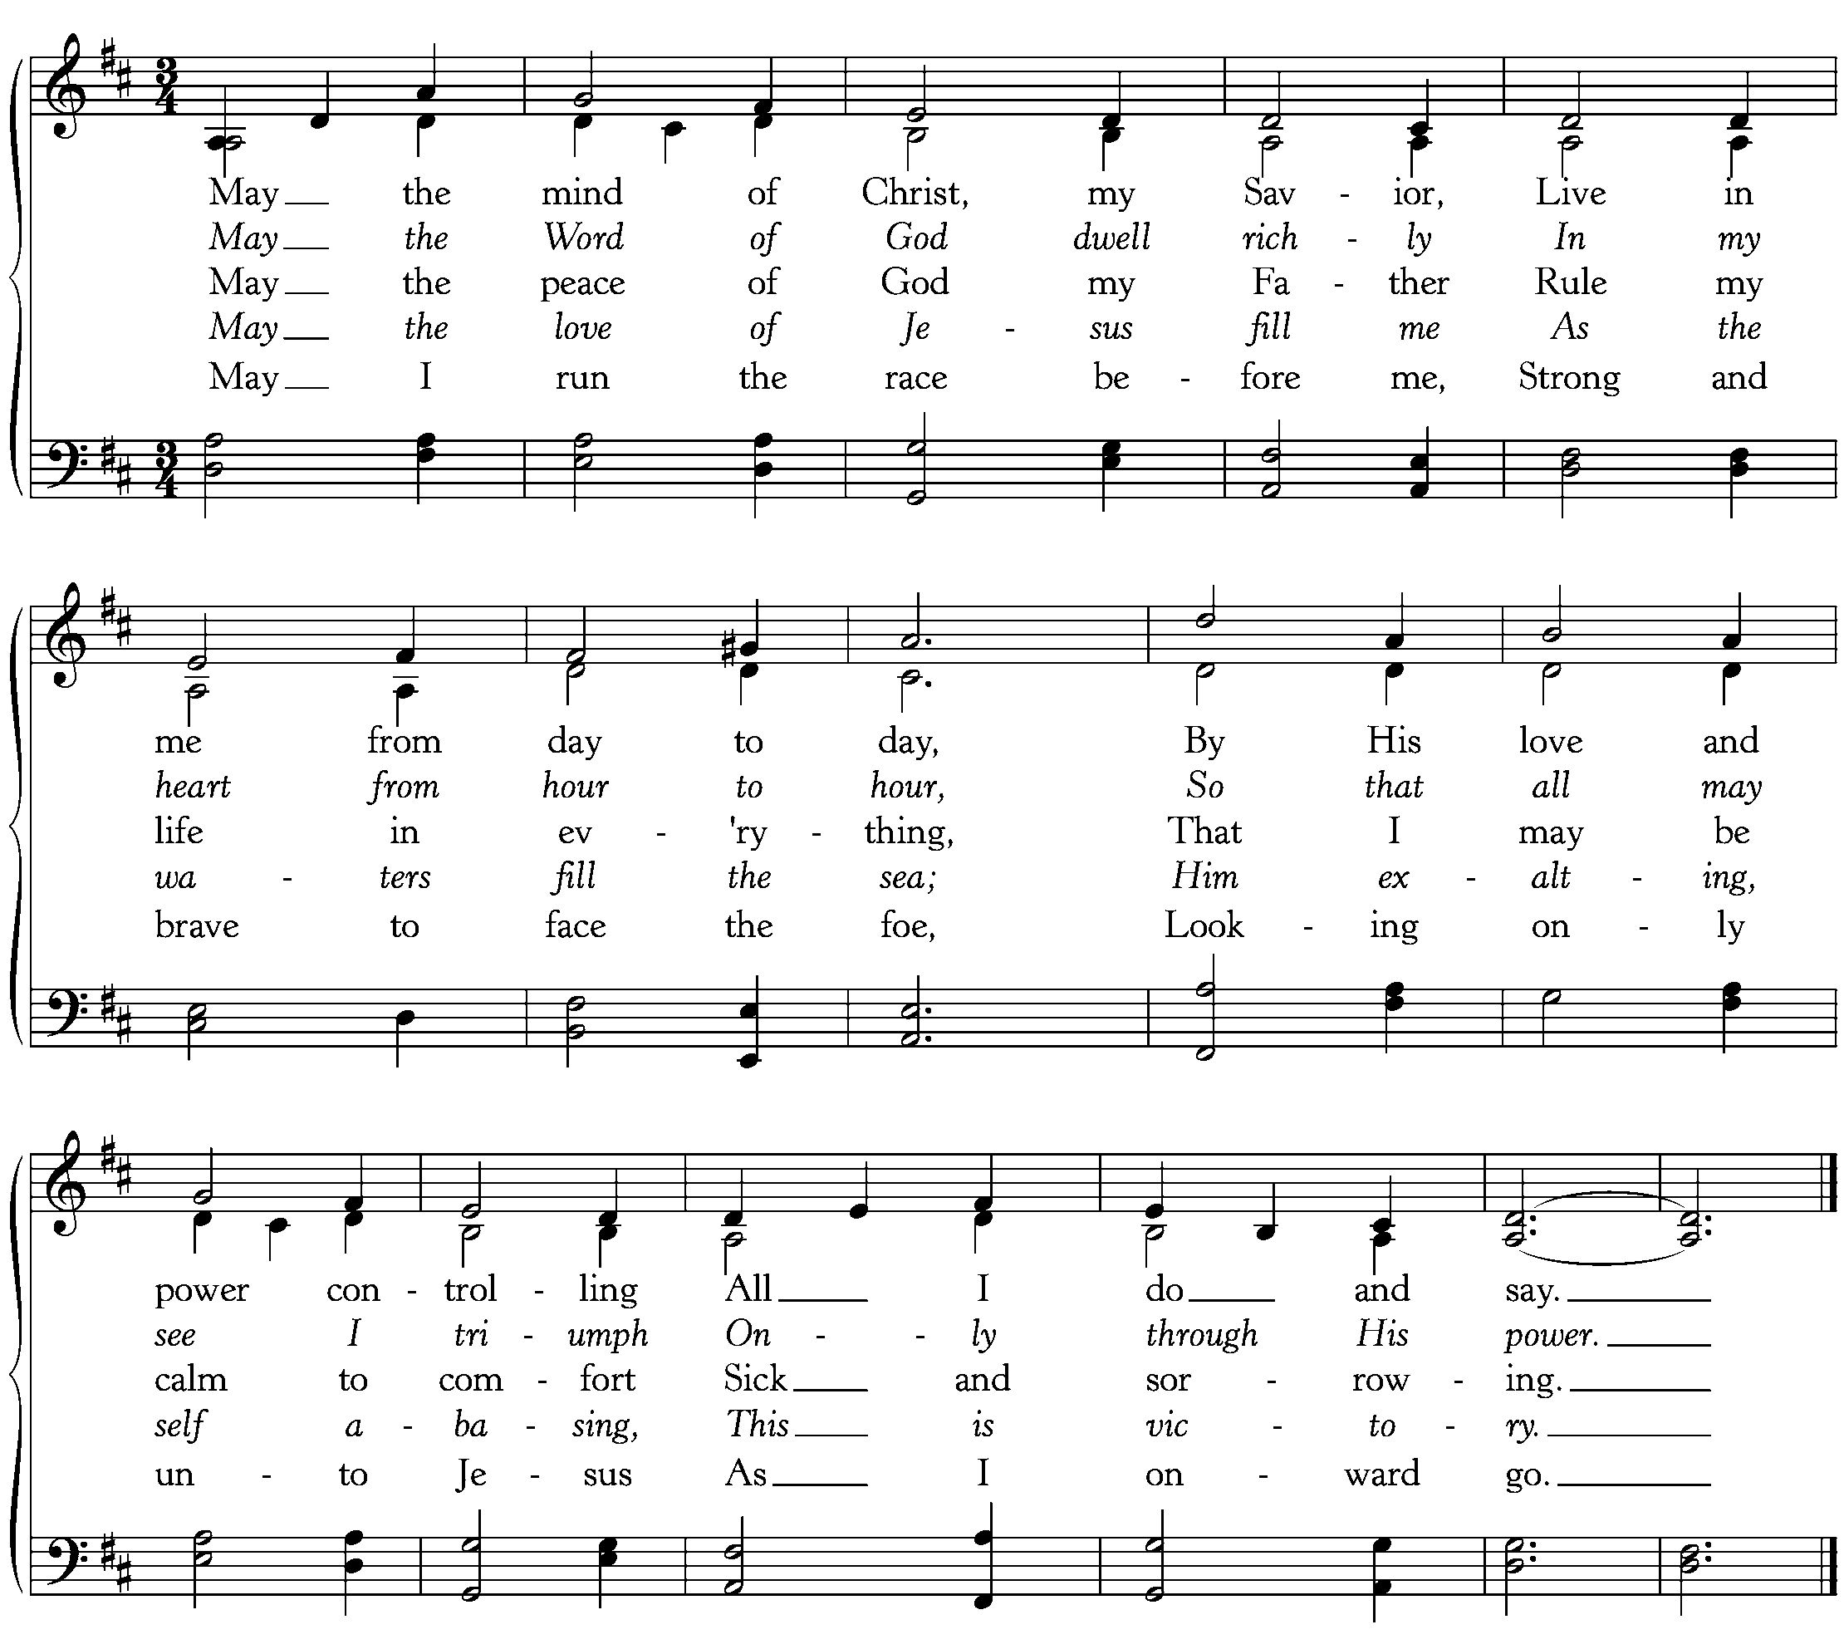
Text: Kate B. Wilkinson, 1925; Music: St. Leonards, A. Cyril Barham-Gould, 1925.
God Sends His People out
After calling His people into His presence, forgiving their sins, instructing them in His Word, and providing a foretaste of the marriage supper of the Lamb, God sends His people into the world to show His light in the darkness.

Benediction—II John 1:5-6

Love one another. And this is love, that we walk according to his commandments; this is the commandment, just as you have heard from the beginning, so that you should walk in it. Amen.

Sung Response—Christ Be With Me (from St. Patrick’s Breastplate)
Text: Atomriug indui niurt tren, St. Patrick, 372-466, Trans by Cecil Frances Alexander, 1818-95;
Music: St. Patrick Clonmacnoise, Traditional Irish Hymn Melody.

Home Fellowship Groups
Chuck Emerson 943-8443 or emersonbrntwd@aol.com, 2nd and 4th Sundays 5:00 p.m., Steffens’ house.
Cy Fenton 500-5304 or cyfenton@gmail.com, Sundays after church, Fenton’s house.
Stacy McGuire 591-9462 or stacy.a.mcguire@gmail.com, Sundays after church, upstairs at Cornerstone.
Greg Wilbur 512-4156 or greg@cstonepres.org, 2nd, 3rd, and 4th Sundays at 5:00 p.m., Wilbur’s house.
Jim Smith 491-8855 or jims@svmic.com, 2nd and 4th Sundays at 6:00 p.m., Smith’s house.
***New Group: Mike and Mel Payne, 615-618-3299 or meljpayne@gmail.com

Today, in our fourth installment of the series “Abiding in Christ: Three Essential Marks for Maturing Christian” from John 15:1-11, we are considering two of the leading means for growing Christians, Scripture and Prayer.

- Jesus says that abiding in him includes abiding in His Word (v.7). What does it mean to abide in Jesus’ Word?

- Taking into account the teaching of John 15:1-11, what is God’s purpose for you in Bible reading and meditation?

- What is your regular pattern of Bible intake?

- What challenges are you presently experiencing in reading and meditating on God’s Word? What help do you need in meeting those challenges?

- How does Bible reading and prayer work together as a practice for abiding in Christ?

- When Jesus says, “…ask whatever you wish and it will be done for you” (v.7), what does he mean?

- What is your regular pattern of prayer to God?

- What challenges are you presently experiencing in praying to God? What help do you need in meeting those challenges?

Cornerstone Presbyterian Church
Presbyterian Church in America
Pastor: Nate Shurden (618-4707 Office) or nate@cstonepres.org
Worship and Chief Musician: Greg Wilbur (512-4156) or greg@cstonepres.org
Administrative Assistant: Susan Bumpus (618-4707) or office@cstonepres.org
Home Fellowship Coordinator: Randy Allen (260-1884) or randmanrx@gmail.com
Nursery Coordinator: Linda VanGorden (406-4431) or vangordenlinda@yahoo.com
Elementary Discipleship Coordinator: Lorrie Mathews (429-8355) or lorriegm@gmail.com

Ruling Elders
Terry Cheney (579-7089) Cy Fenton (500-5304) Jim Smith (347-4188)
Chuck Emerson: Emeritus (661-9273) Stacy McGuire (339-3900) Greg Wilbur (512-4156)

Deacons
Clint Branch (516-9855) Kevin McClung (243-9228) Larry Thompson (901-734-1520)
Joe Haworth (289-7543) David Steffens (513-4873) Bob Vermilye (599-9577)
Riley May (866-8662)

Post Office Box 407 h Franklin, Tennessee 37065 h
www.cornerstonepresfranklin.org h (615) 618-4707

All Scripture quotations from the English Standard Version

