Service of Celebration and Gospel Renewal

Ordinary Time—Sundays of Pentecost

08 September 2013

Worship Notes

We continue our focus this morning from John 15 and *Abiding in Christ* with an emphasis on what Christ is calling us to as His people grafted into the true Vine. We begin with the **Call to Worship** from **Psalm 105** as hearts that seek the Lord, His strength, and His presence. The opening hymn, **Come, Thou Almighty King**, is a song of eternal praise to our great triune God who reigns over us but who also dwells among us as the Incarnate Word. **There’s a Wideness in God’s Mercy** sings of the welcome, grace, mercy, healing, love and kindness of our God who calls us as His own.

The **New Testament Reading** from **Galatians 5** is the fruit of the Spirit that are part of walking in the Spirit and living by the Spirit. The **Prayer of Confession** from **Hebrews 5** reminds of the call to maturity in Christ—of growing in discernment and understanding truth.

The first communion hymn, **Bread of Heaven,** prays for our hunger and thirst to be satisfied by Christ alone. **Jesus, Let Us Come to Know You** shows our longing to live in Christ that He may draw us ever nearer to use us and mold us after His image. We conclude the service by singing **O Christ, the Way, the Truth, the Life** as a prayer to live in God’s presence such that our life shall be in Him.

*—Greg Wilbur*

**God Calls His People to Worship**

*It is God Himself who calls His people to worship. We do not call ourselves, but it is the King who opens His gates and beckons us into his courts.*

**Prelude. Announcements & Preparation**

**Introit—Crown Him with Many Crowns, Vs 7**

**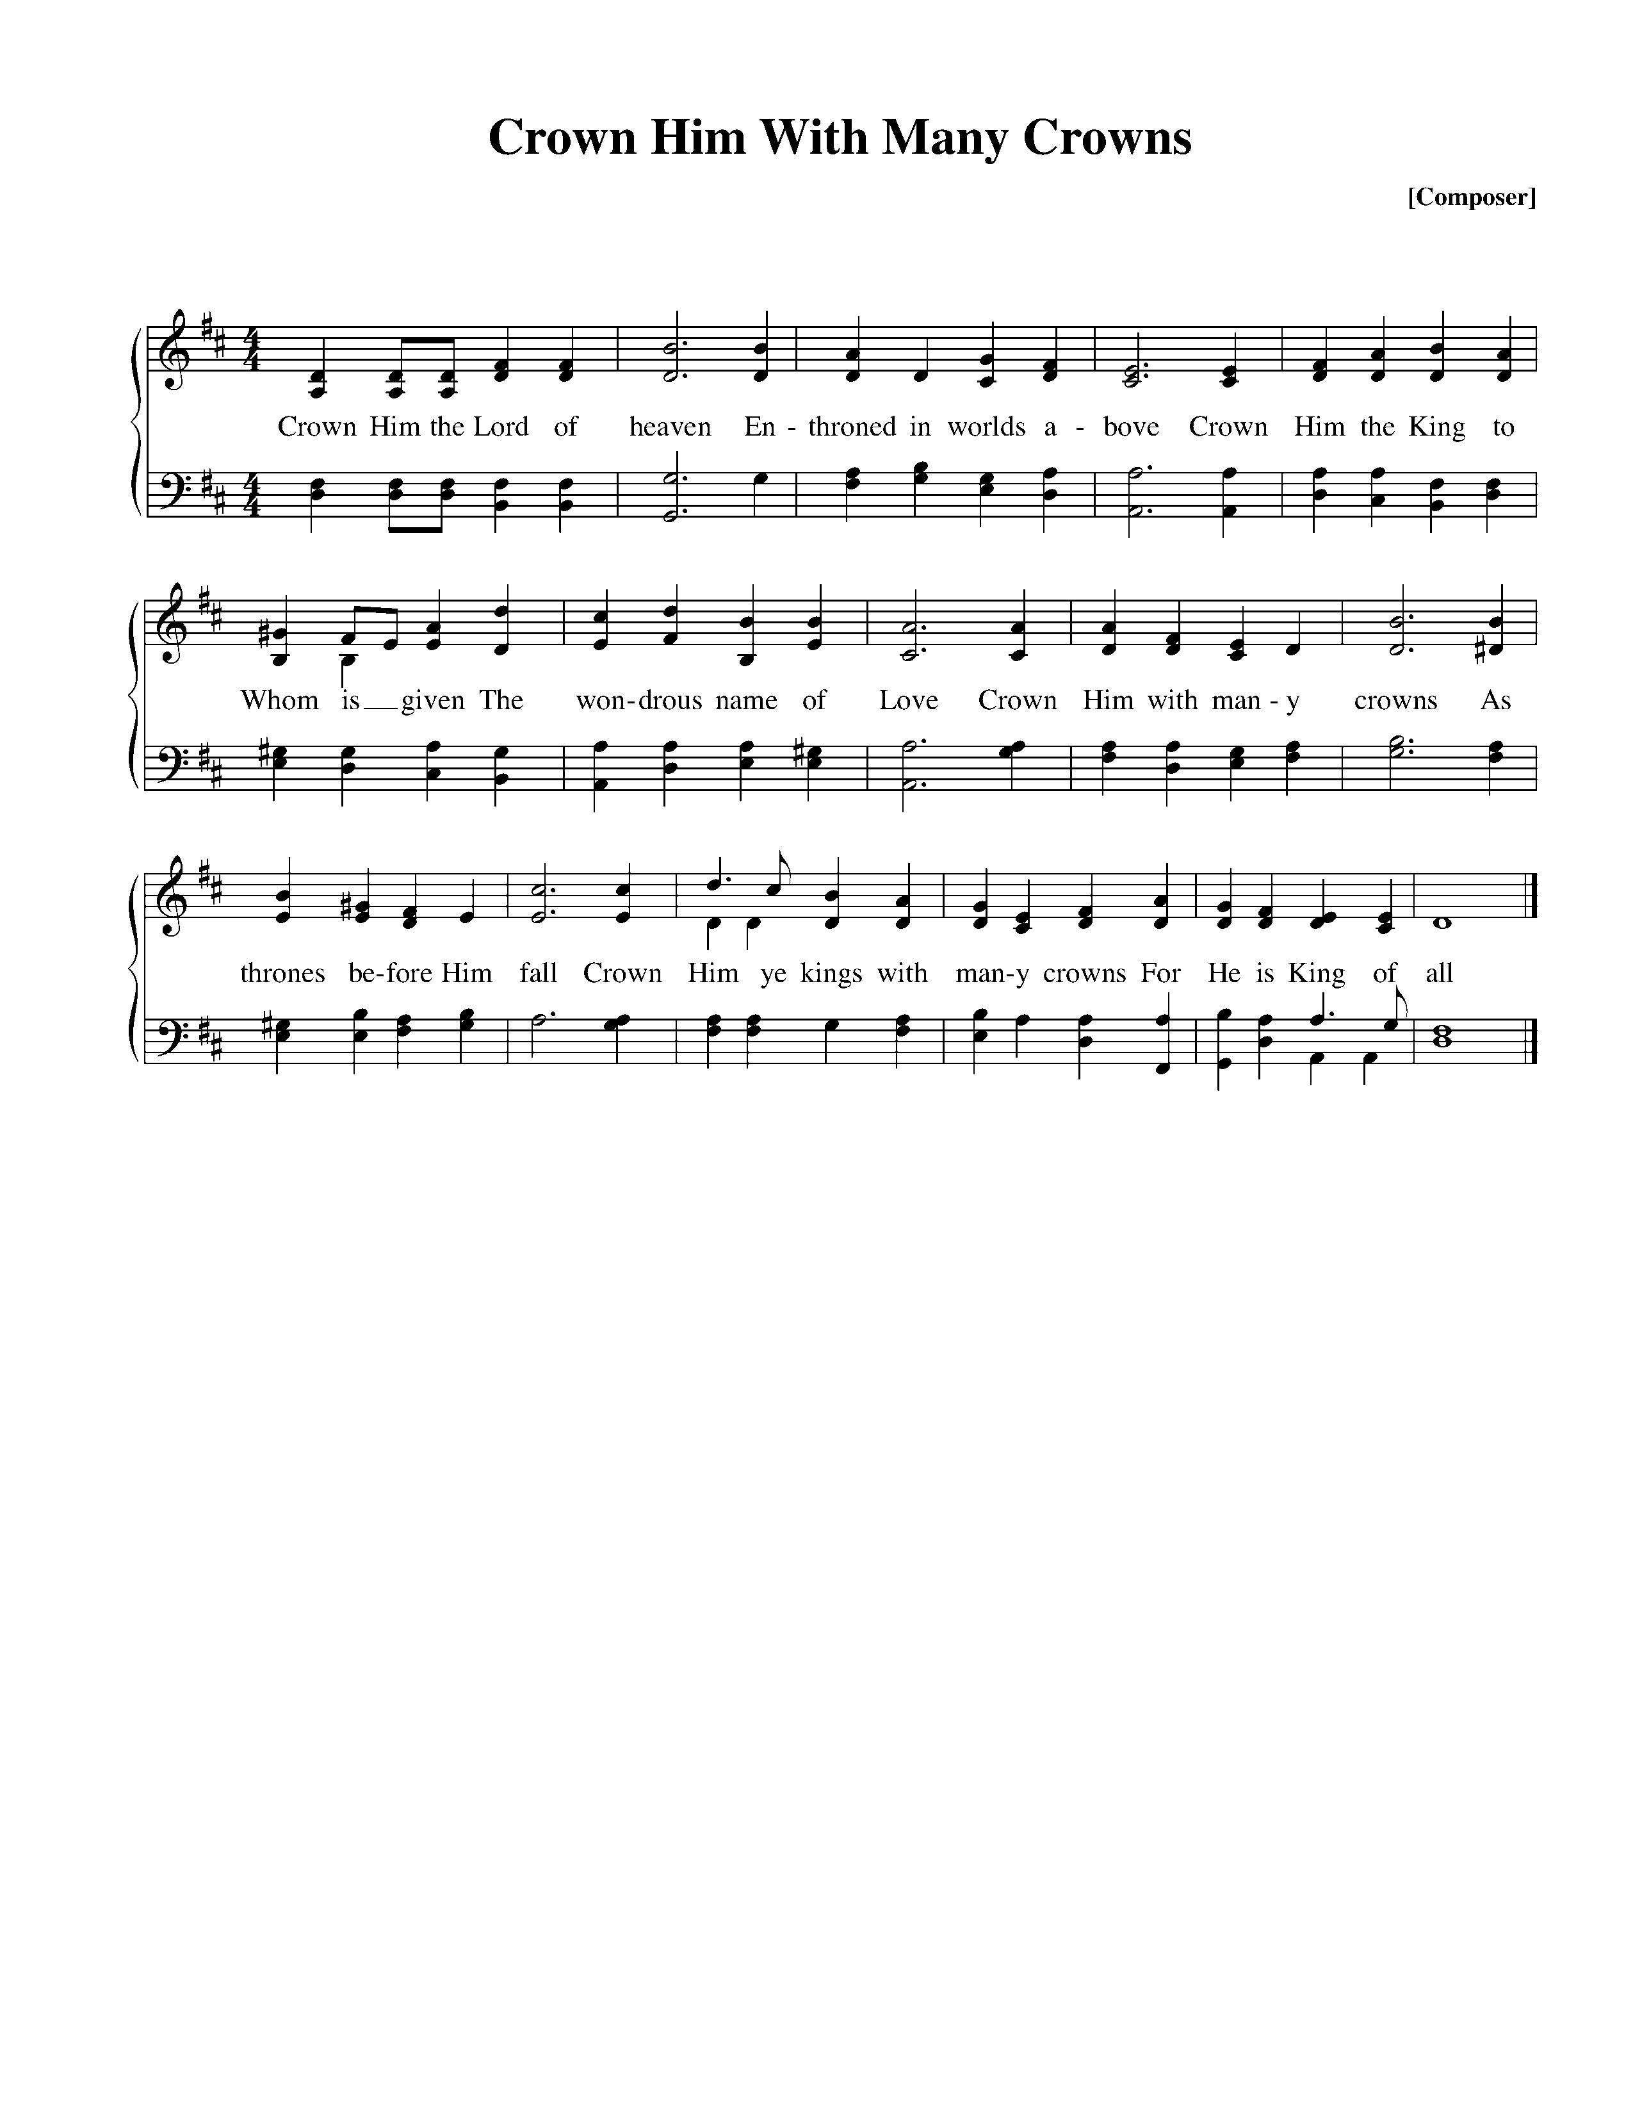**

Text: Matthew Bridges, 1852; Music: Diademata, George J. Elvey, 1868.

**Call to Worship—from Psalm 105:1-6**

Pastor: Oh give thanks to the Lord; call upon his name; make known his deeds among the peoples!

**All: Sing to him, sing praises to him; tell of all his wondrous works!**

Pastor: Glory in his holy name; let the hearts of those who seek the Lord rejoice!

**All: Seek the Lord and his strength; seek his presence continually!**

Pastor: Remember the wondrous works that he has done,

his miracles, and the judgments he uttered.

**Hymn of Praise—Come, Thou Almighty King**

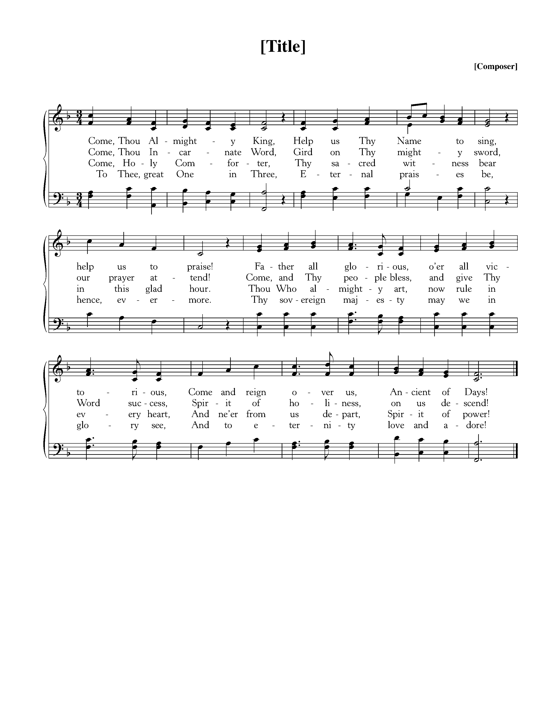

Text: Anonymous, 1757; Music: Trinity, Felice de Giardini, 1769.

**Hymn of Praise—There’s a Wideness in God’s Mercy**

**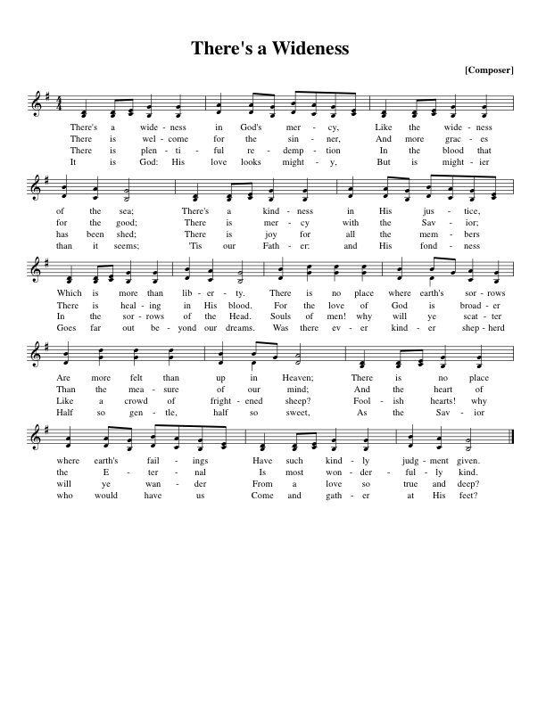**

Text: Frederick W. Faber, 1854; Music: Holy Manna, Attr. To William Moore, 1825.

*(Please be seated)*

**New Testament Reading—Galatians 5:16-18, 22-25**

*The Fruit of walking by the Spirit*

**16**But I say, walk by the Spirit, and you will not gratify the desires of the flesh. **17**For the desires of the flesh are against the Spirit, and the desires of the Spirit are against the flesh, for these are opposed to each other, to keep you from doing the things you want to do. **18**But if you are led by the Spirit, you are not under the law.

**22**But the fruit of the Spirit is love, joy, peace, patience, kindness, goodness, faithfulness, **23**gentleness, self-control; against such things there is no law. **24**And those who belong to Christ Jesus have crucified the flesh with its passions and desires.

**25**If we live by the Spirit, let us also keep in step with the Spirit.

Elder: This is the Word of the Lord.

**All: Thanks be to God.**

God Calls His People to Confession, Repentance, and Reconciliation

*The People of God respond to His Word by confessing their sins, repenting of their sinful ways, and seeking God’s favor through the reconciling work of Jesus, the Son of God.*

**Sung Response—Hear My Prayer (from Psalm 86)**

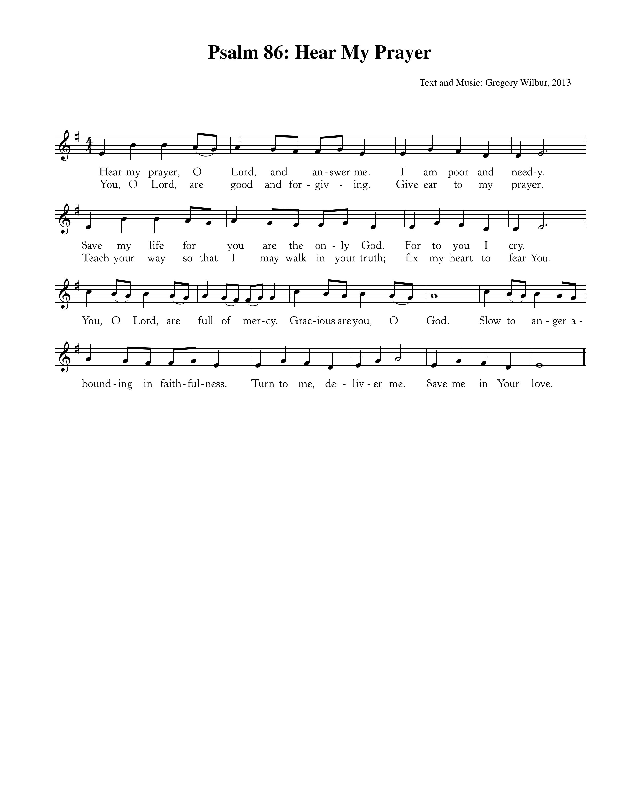

Text & Music: Greyfriars Press, 2013. Used by permission.

**Corporate Confession of Sin—based on Hebrews 5:11-14**

Pastor: Lord, we come confessing. We confess that too often we are unable to understand truth

because we have become dull of hearing.

**All: Instead of being wise and able to teach,**

**we need someone to teach us again the basic principles of your Word.**

Pastor: Because we are still like children, we need milk instead of solid food.

**All: We try to live on milk since we are unskilled in the word of righteousness.**

Pastor: Mature us so that we are able to eat solid food and have our powers of discernment trained.

**All: And may this constant practice equip us to distinguish good from evil.**

**Sung Response—Kyrie**

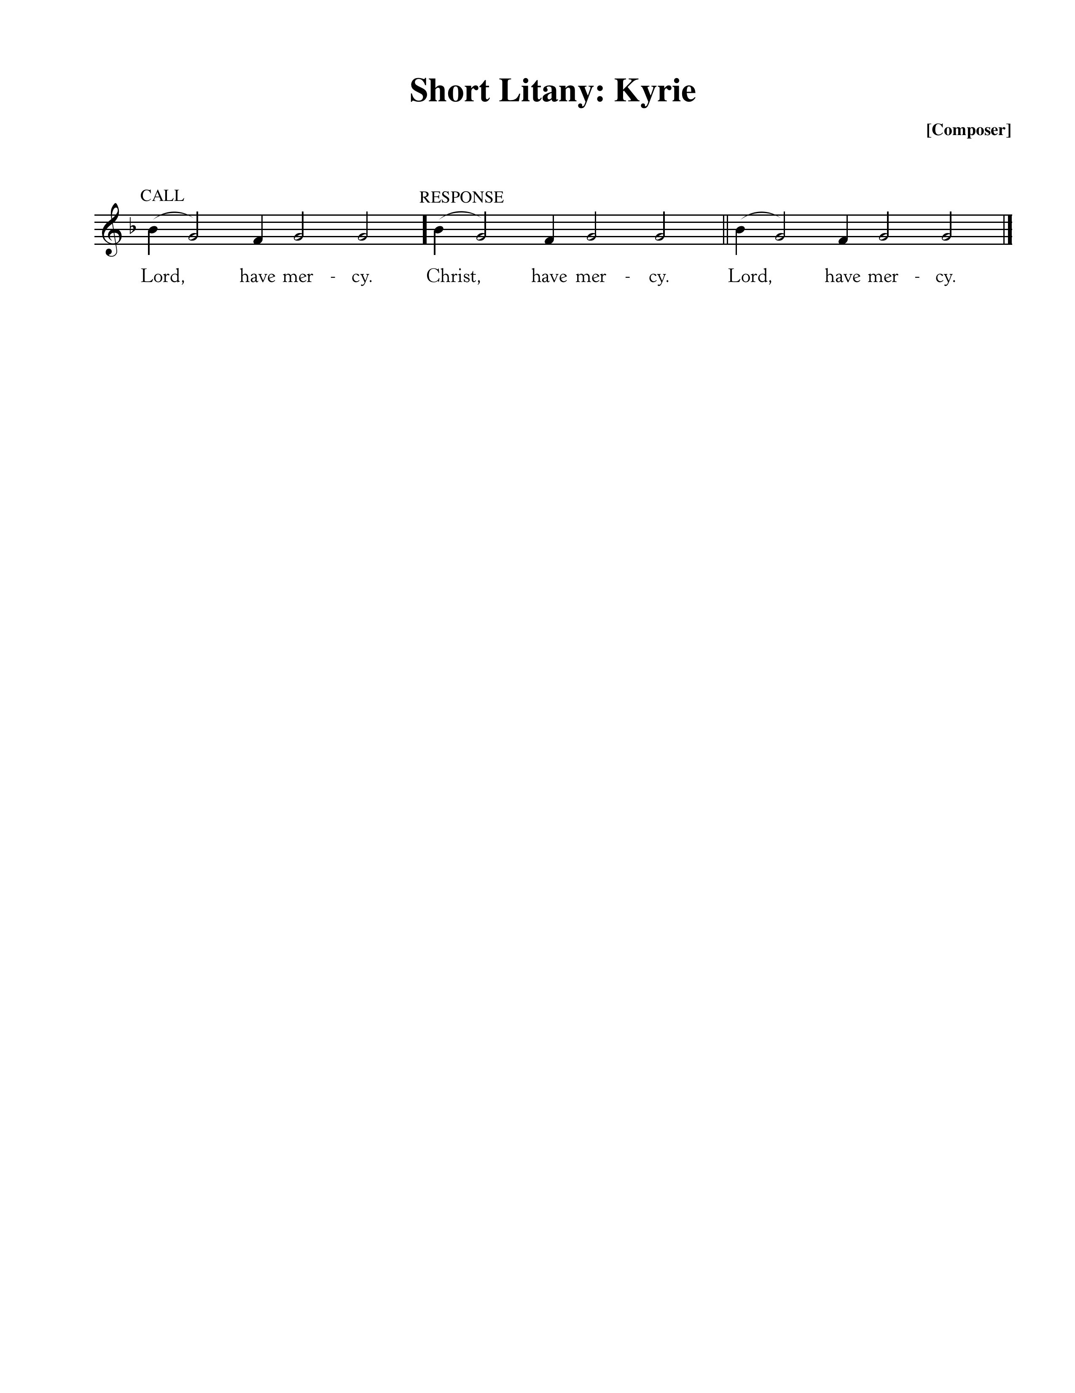

**Silent Prayers of Confession**

**Assurance of Pardon—Ephesians 2:4-7**

**4**But God, being rich in mercy, because of the great love with which he loved us, **5**even when we were dead in our trespasses, made us alive together with Christ—by grace you have been saved—**6**and raised us up with him and seated us with him in the heavenly places in Christ Jesus, **7**so that in the coming ages he might show the immeasurable riches of his grace in kindness toward us in Christ Jesus.

**Hymn of Praise—There is a Fountain Filled with Blood**

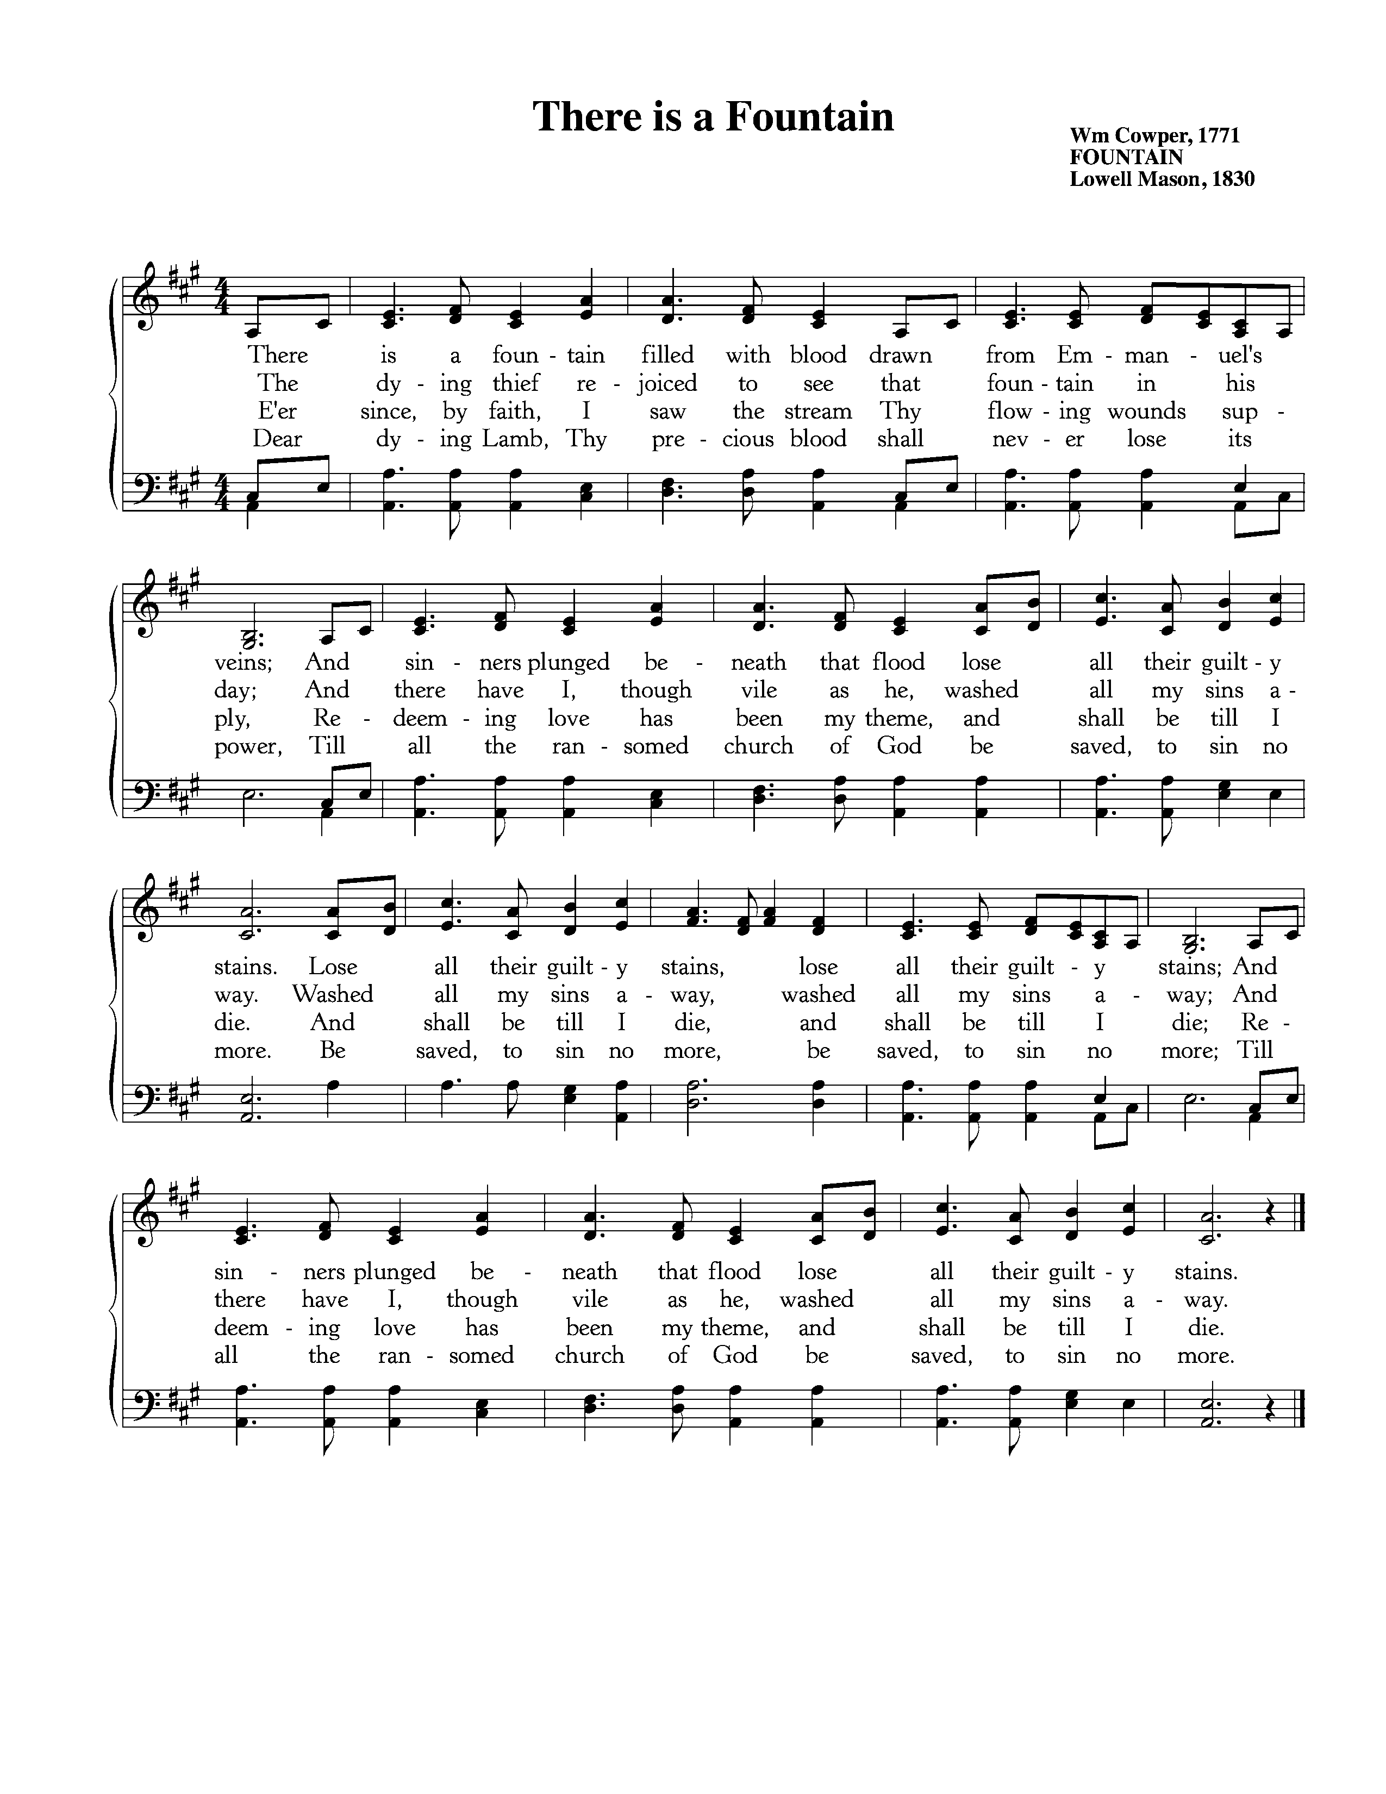

Text: William Cowper, 1771; Music: Fountain, Lowell Mason, 1830.

**The Reading of the Word—John 15:1-11**

“I am the true vine, and my Father is the vinedresser. **2**Every branch in me that does not bear fruit he takes away, and every branch that does bear fruit he prunes, that it may bear more fruit. **3**Already you are clean because of the word that I have spoken to you. **4**Abide in me, and I in you. As the branch cannot bear fruit by itself, unless it abides in the vine, neither can you, unless you abide in me. **5**I am the vine; you are the branches. Whoever abides in me and I in him, he it is that bears much fruit, for apart from me you can do nothing. **6**If anyone does not abide in me he is thrown away like a branch and withers; and the branches are gathered, thrown into the fire, and burned. **7**If you abide in me, and my words abide in you, ask whatever you wish, and it will be done for you. **8**By this my Father is glorified, that you bear much fruit and so prove to be my disciples. **9**As the Father has loved me, so have I loved you. Abide in my love. **10**If you keep my commandments, you will abide in my love, just as I have kept my Father’s commandments and abide in his love. **11**These things I have spoken to you, that my joy may be in you, and that your joy may be full.

Elder: The grass withers, the flower fades;

**All: But the Word of our God will stand forever.**

**Sermon—Abiding in Christ: Three Essential Marks for Maturing Christians, Pt 2**

*Abiding in Christ* **,** *Pt 2* **—**Nate Shurden, Pastor

**Sung Response—Doxology**

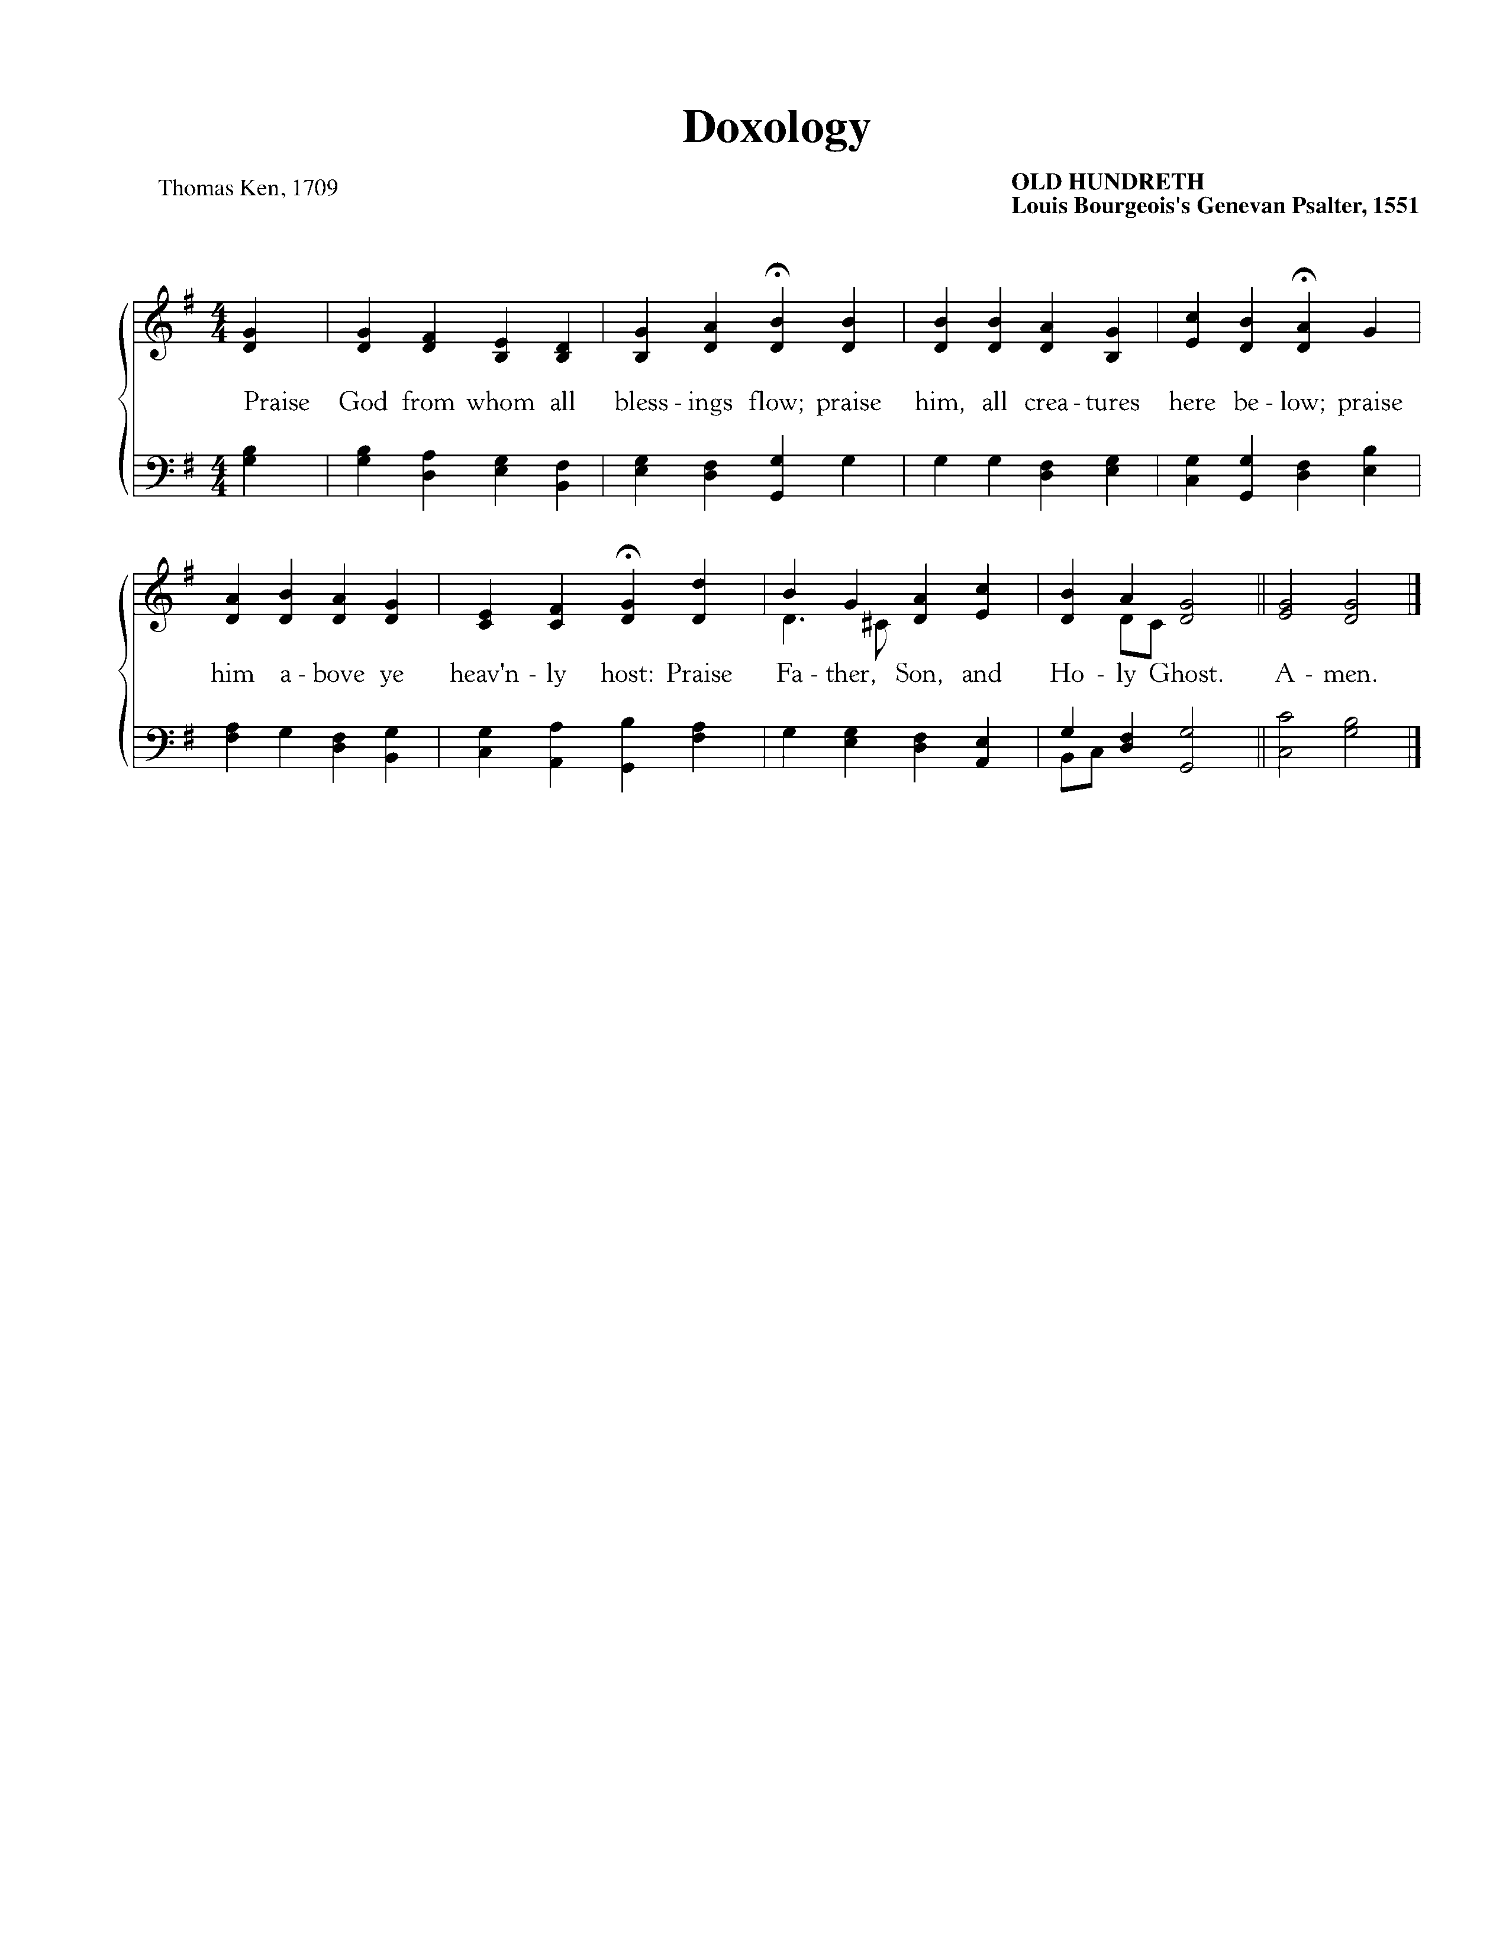

Text: Thomas Ken, 1709; Music: Old Hundredth, Louis Bourgeois’s *Genevan Psalter*, 1551.

The Sacrament of the Lord’s Supper

*God offers to His people the gift of communion with Him through the grace of the sacrament and we respond in thanksgiving.*

**Sursum Corda**

Elder: The Lord be with you. **People: And also with you.**

Elder: Lift up your hearts. **People: We lift them up to the Lord.**

Elder: Let us give thanks to the Lord our God. **People: It is right to give Him thanks and praise.**

Elder: It is right, and a good and joyful thing, always and everywhere to give thanks to You,

Father Almighty, Creator of heaven and earth.

**Sung Response—Sanctus**

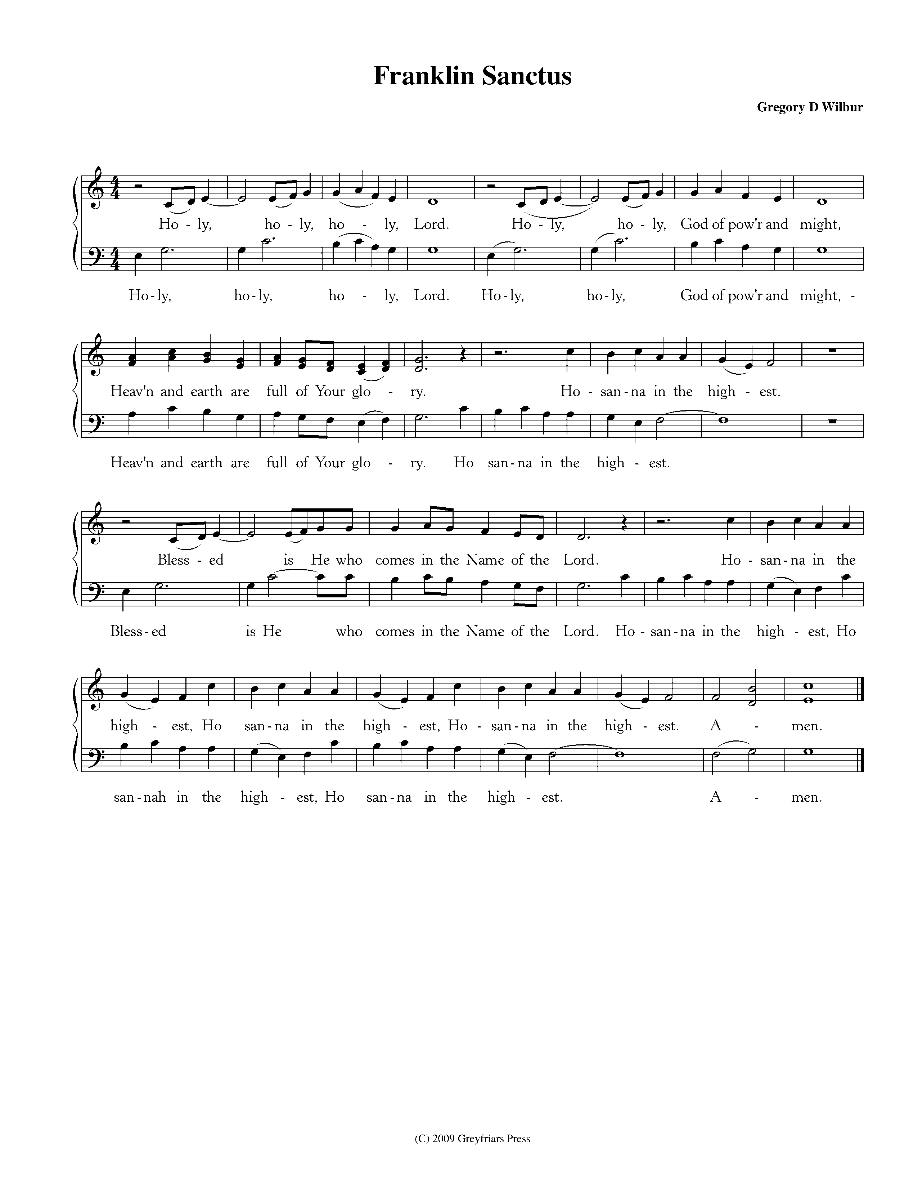

Women

Men

CCLI #11121087 Text: Is 6:3, Rev 4:8, Mt 21:9; Music: Franklin Sanctus, Gregory D Wilbur, 2009. ©2009 Greyfriars Press.

**Profession of Faith—The Apostles’ Creed**

We believe in God, the Father Almighty, the Creator of Heaven and Earth,

And in Jesus Christ, His only Son, our Lord: who was conceived of the Holy Spirit,

Born of the Virgin Mary, Suffered under Pontius Pilate,

Was crucified, died and was buried. He descended into Hell.

On the third day he rose again from the dead.

He ascended into Heaven and now sits at the right hand of God the Father Almighty;

From whence He shall come to judge the living and the dead.

We believe in the Holy Spirit; The one holy Church—both visible and invisible;

The communion of saints; the forgiveness of sins;

The resurrection of the body; and the life everlasting. Amen.

**Words of Institution and the Lord’s Table**

*Having confessed our sins and made a good profession of faith, God's Table is open to all those “faithfully-fenced" members of the covenant community. Please come forward to partake of this means of grace. You may take the bread at the first table and then proceed to either side for the wine/grape juice.*

**Hymn of Communion—Bread of Heaven**

**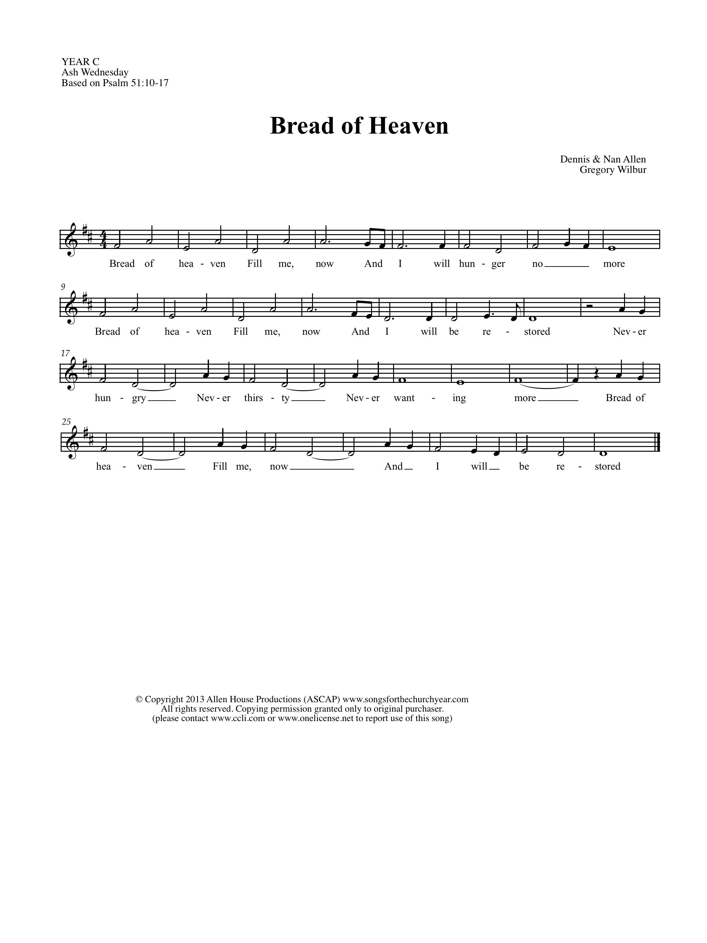**

© Copyright 2013 Allen House Productions (ASCAP) www.songsforthechurchyear.com and Greyfriars Press.

Text: Nan Allen, 2013; Music: Greyfriars Press, 2013.

**Hymn of Communion—Jesus Let Us Come to Know You**

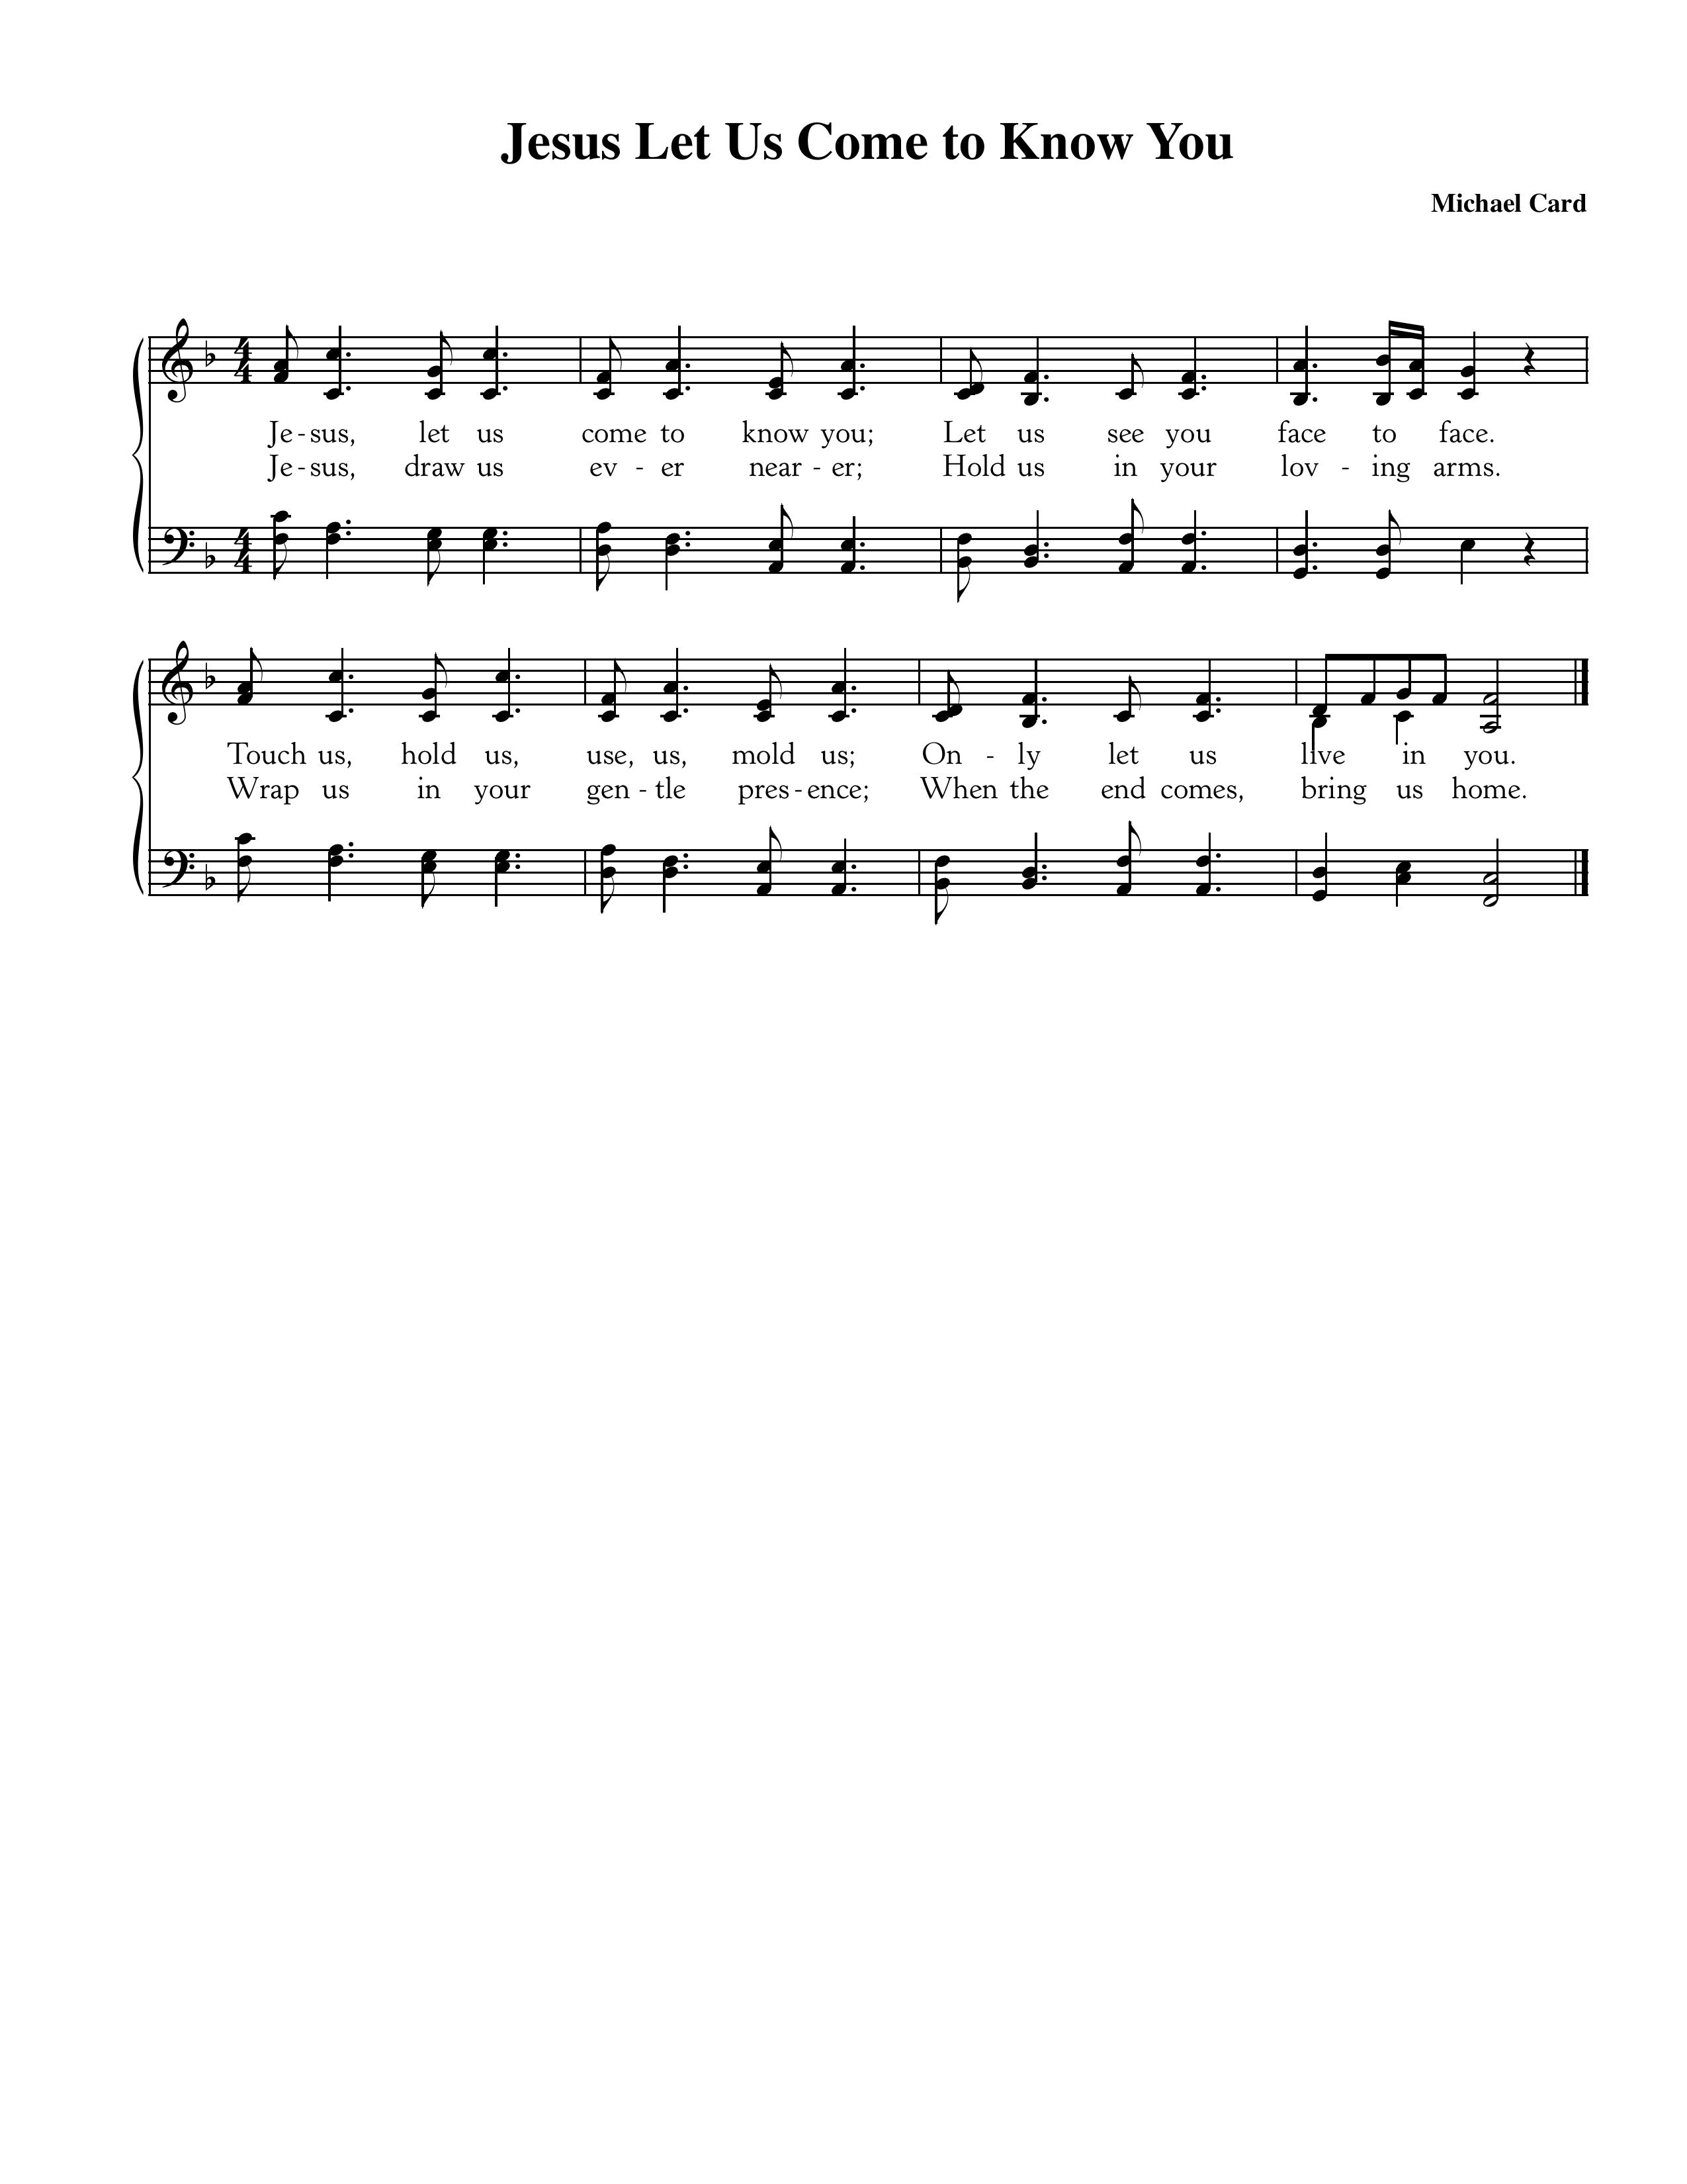

CCLI #11121087 ©1987 Mole End Music, Text and Music: Michael Card, 1987.

God’s People Respond in Grateful Praise

**Prayer of Thanksgiving and Intercession**

The Lord’s Prayer

Our Father, who art in heaven, Hallowed be thy Name.

Thy kingdom come. Thy will be done, On earth as it is in heaven.

Give us this day our daily bread. And forgive us our debts, As we forgive our debtors.

And lead us not into temptation, But deliver us from evil.

For Thine is the Kingdom, and the power, and the glory, forever. Amen.

**Hymn of Praise—O Christ, the Way, the Truth, the Life**

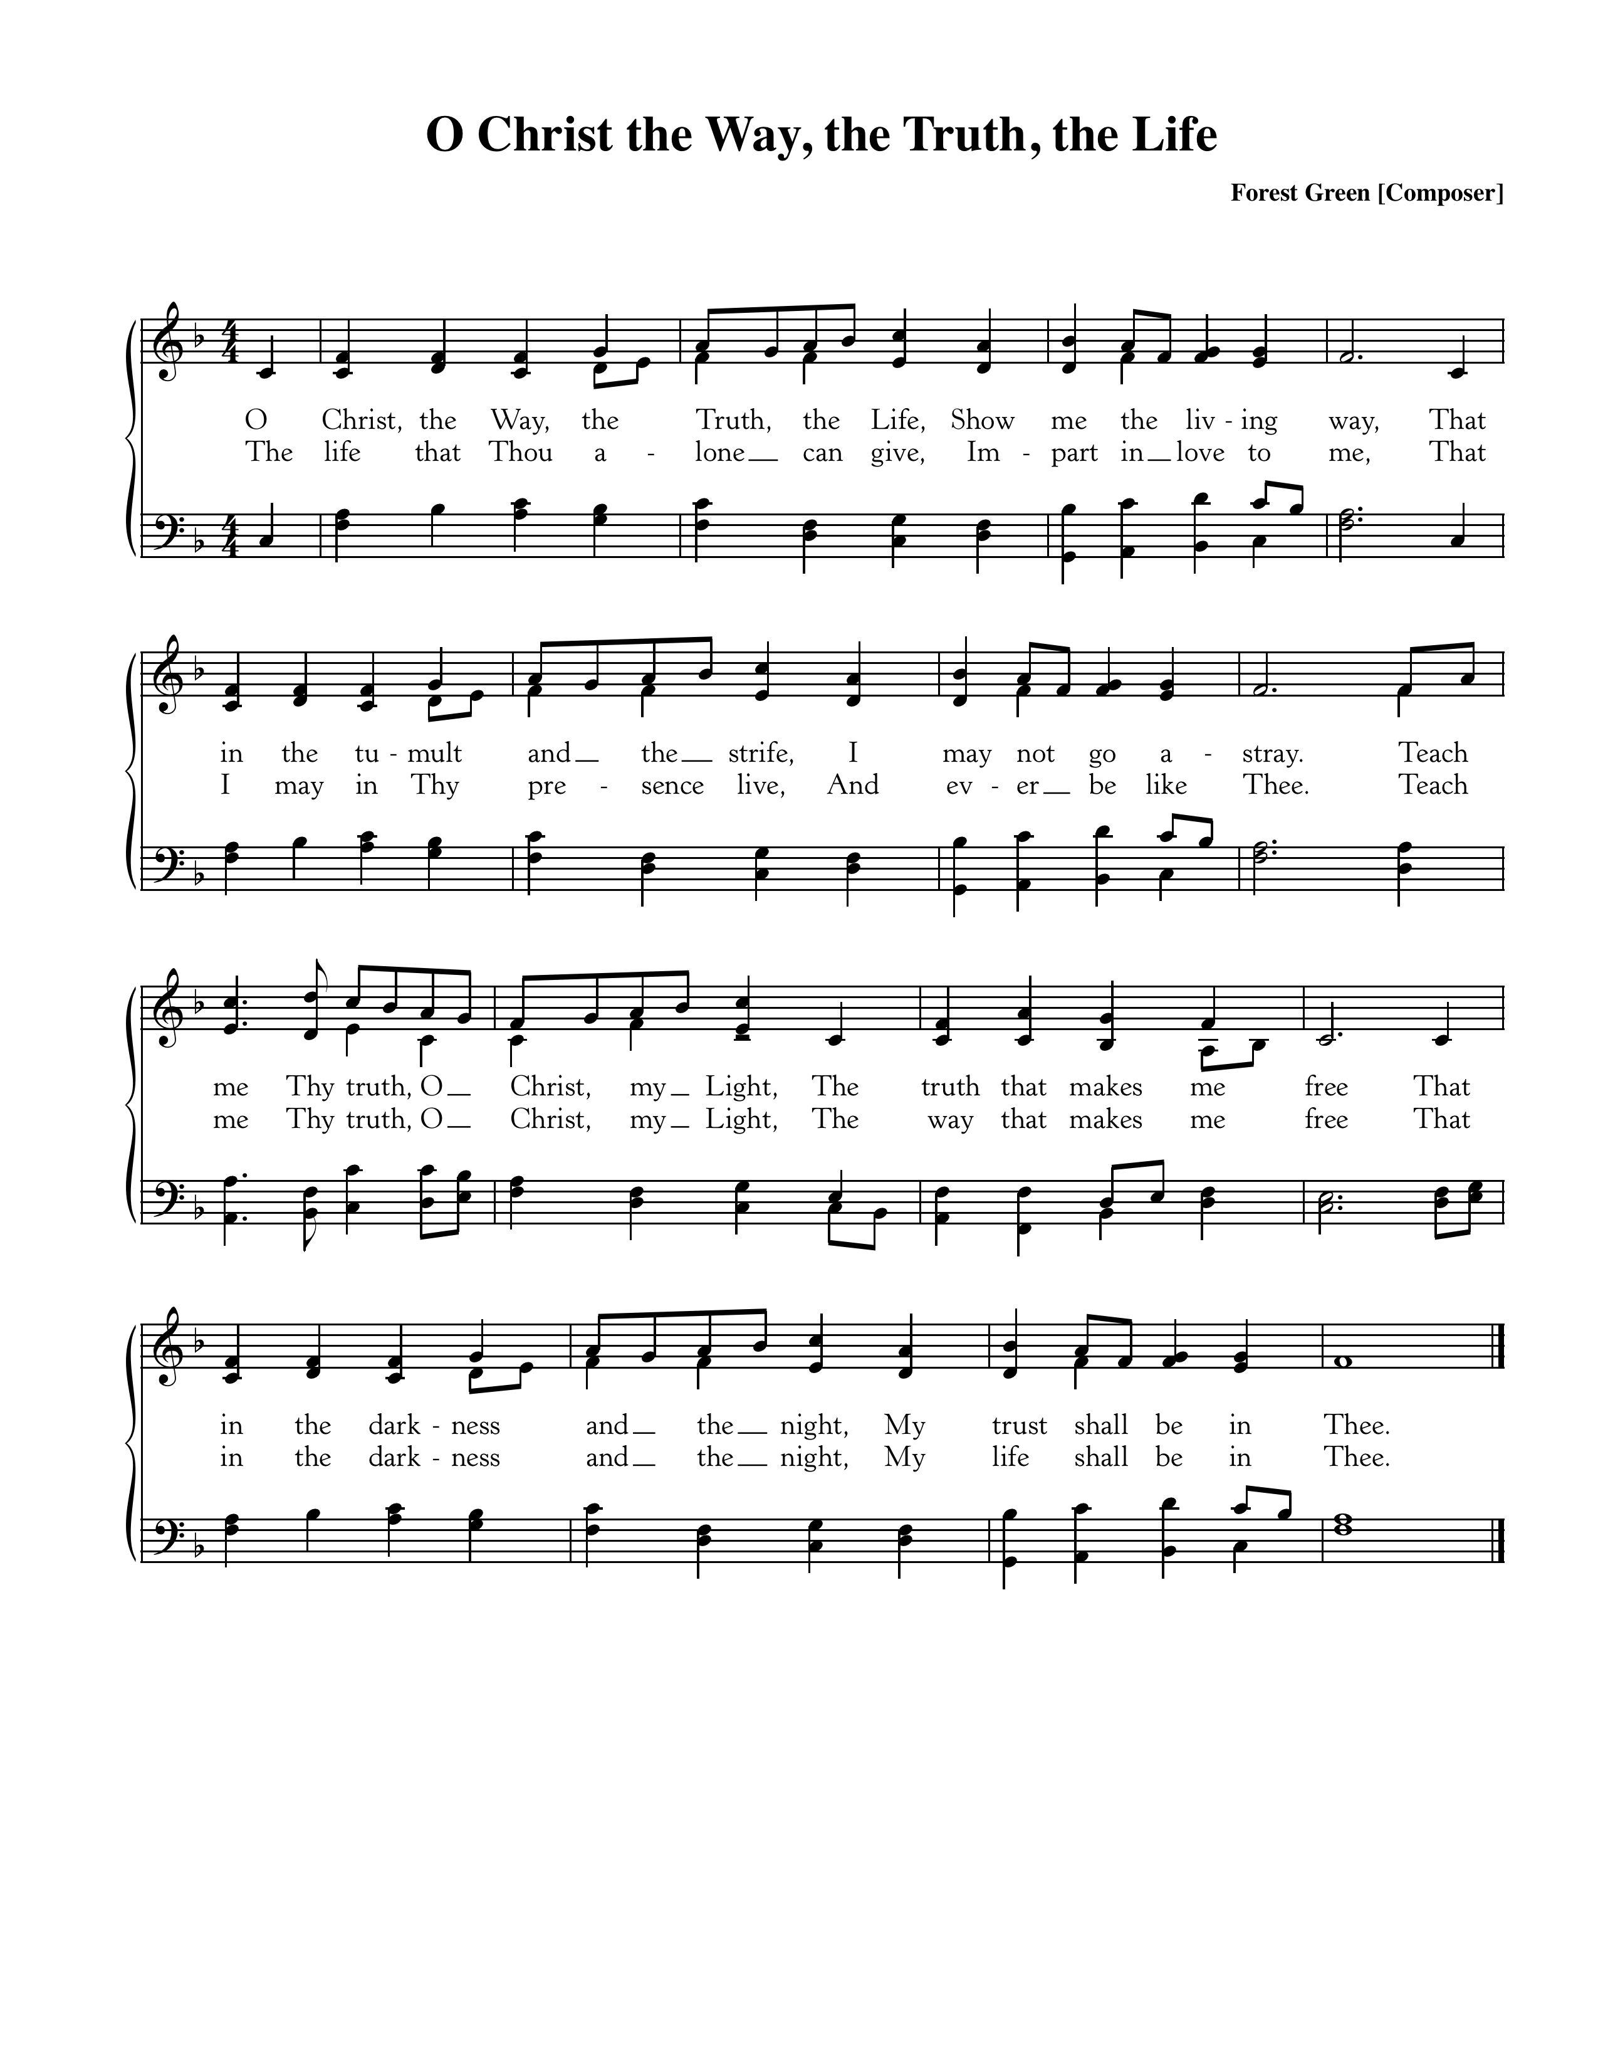

Text: George L. Squier, 1907; Music: Forest Green, English Folk Song.

God Sends His People out

*After calling His people into His presence, forgiving their sins, instructing them in His Word, and providing a foretaste of the marriage supper of the Lamb, God sends His people into the world to show His light in the darkness.*

**Benediction—based on I Timothy 1:13-14**

Follow the pattern of the sound words that you have head, in the faith and love that are in Christ Jesus. By the Holy Spirit who dwells within us, guard the good deposit entrusted to you. *Amen.*

**Sung Response—Christ Be With Me (*from* St. Patrick’s Breastplate)**

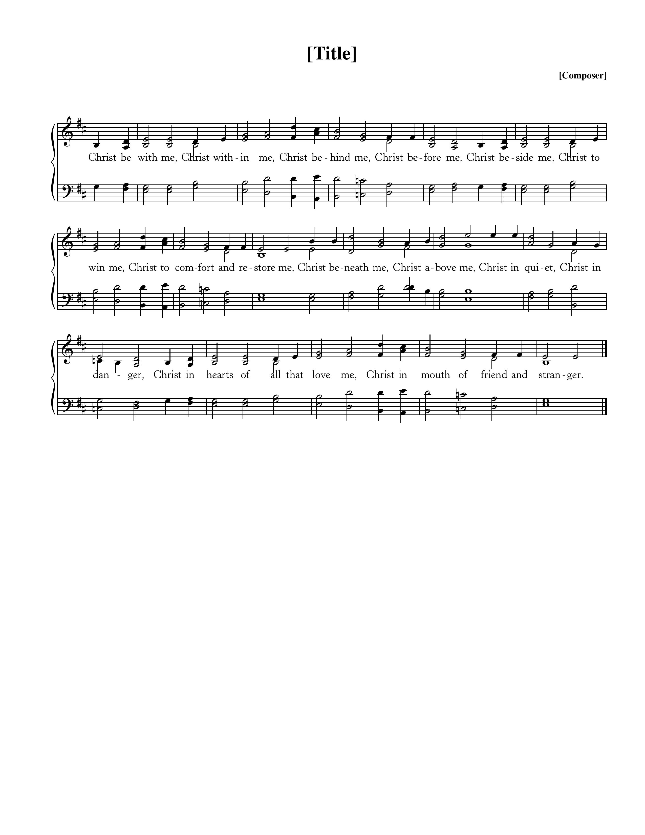

Text: *Atomriug indui niurt tren,* St. Patrick, 372-466, Trans by Cecil Frances Alexander, 1818-95;

Music: St. Patrick Clonmacnoise, Traditional Irish Hymn Melody.

**Home Fellowship Groups—Starting September 8**

[Chuck Emerson](mailto:emersonbrntwd@aol.com?subject=HFG" \t "_blank) 943-8443 or emersonbrntwd@aol.com, 2nd and 4th Sundays 5:00 p.m., Steffens’ house.

[Cy Fenton](mailto:cyfenton@gmail.com?subject=HFG" \t "_blank) 500-5304 or cyfenton@gmail.com, Sundays after church, Fenton’s house.

[Stacy McGuire](mailto:stacy.a.mcguire@gmail.com?subject=HFG" \t "_blank) 591-9462 or stacy.a.mcguire@gmail.com, Sundays after church, upstairs at Cornerstone.

[Greg Wilbur](mailto:greg.wilbur@gmail.com?subject=HFG" \t "_blank) 512-4156 or greg@cstonepres.org, 2nd, 3rd, and 4th Sundays at 5:00 p.m., Wilbur’s house.

[Jim Smith](mailto:Jims@svmic.com?subject=HFG" \t "_blank) 491-8855 or jims@svmic.com, 2nd and 4th Sundays at 6:00 p.m., Smith’s house.

\*\*\*New Group: Mike and Mel Payne, 615-618-3299 or meljpayne@gmail.com

Last week we began a new sermon series entitled, “Abiding in Christ: Three Essential Marks for Maturing Christians.” In this series, we are exploring together John 15:1-11 and learning what it means to be mature in Christ. Today’s message will explore the true source of Christian growth and maturity, the gospel of the Lord Jesus Christ.

* Think back on an experience in your life where you learned that you were not as mature as you thought? If you’re in a HFG and brave enough, share that story with the group.
* If you’ve been a Christian for a while, take a few minutes and scan back over your life. Based on that quick scan of life, where can you see fruit in your life?
* How would you like to grow in fruitfulness and maturity in your life presently?
* According to the sermon today, Jesus Christ is the source of Christian maturity. What does that mean? How do you need to know or relate to Jesus Christ in order to grow in maturity?
* What steps are you going to take to pursue Christ this week and the Christian maturity that comes in Him?

Cornerstone Presbyterian Church

**Presbyterian Church in America**

**Pastor**: Nate Shurden (618-4707 Office) or nate@cstonepres.org

**Worship and Chief Musician**: Greg Wilbur (512-4156) or greg@cstonepres.org

**Administrative Assistant:** Susan Bumpus (618-4707) or office@cstonepres.org

**Home Fellowship Coordinator:** Randy Allen (260-1884) or randmanrx@gmail.com

**Nursery Coordinator:** Linda VanGorden (406-4431) or [vangordenlinda@yahoo.com](mailto:vangordenlinda@yahoo.com" \t "_blank)

**Elementary Discipleship Coordinator:** Lorrie Mathews (429-8355) or lorriegm@gmail.com

**Ruling Elders**

Terry Cheney (579-7089) Cy Fenton (500-5304) Jim Smith (347-4188)

Chuck Emerson: *Emeritus* (661-9273) Stacy McGuire (339-3900) Greg Wilbur (512-4156)

**Deacons**

Clint Branch (516-9855) Kevin McClung (243-9228) Larry Thompson (901-734-1520)

Joe Haworth (289-7543) David Steffens (513-4873) Bob Vermilye (599-9577)

Riley May (866-8662)

Post Office Box 407 h Franklin, Tennessee 37065 h

www.cornerstonepresfranklin.org h (615) 618-4707

*All Scripture quotations from the English Standard Version*