Service of Celebration and Gospel Renewal

Ordinary Time—Sundays of Pentecost
01 September 2013
Worship Notes

As we start this mini series on Abiding in Christ, we’ll focus on various aspects of our relationship to Christ and what it means to be his disciples—especially with regard to bearing fruit. We begin with the Call to Worship from Psalm 91 that reminds us that the Almighty shelters, delivers, and protects us even as He shows us His salvation. We continue by singing All Hail the Power of Jesus’ Name as the chosen seed that He has saved by His grace. Psalm 91: Call Jehovah Your Salvation follows and links us back to the Call to Worship and the wings of protection for those who rest beneath His love.
The Old Testament Reading from Psalm 80 shows us a picture of a vine that bears fruit but is then ravaged and falls away. It concludes with the desire to be restored. It is that desire that leads us to the Prayer of Confession from I John 2 and the many ways in which we allow the love of the world and the desires of the flesh to supplant the truth of the Word and what it means to abide and be His disciples.
As we sing Before the Throne of God Above, we sing of Christ as our Mediator and of our names graven upon His hands and written on His heart. One in Him, we cannot die for our life is hid in Him. Our second Communion Hymn is Not What My Hands Have Done for “He calls me His, I call Him mine…I live because He lives.” Our final hymn is O the Deep, Deep Love of Jesus and His love which is underneath us, over us, and all around us and which calls us His own. We conclude the service with Christ Be With Me as a final affirmation of the abiding presence of Christ.
—Greg Wilbur

God Calls His People to Worship

It is God Himself who calls His people to worship. We do not call ourselves, but it is the King who opens His gates and beckons us into his courts.

Prelude. Announcements & Preparation

Introit—Crown Him with Many Crowns, Vs 7
Text: Matthew Bridges, 1852; Music: Diademata, George J. Elvey, 1868.

Call to Worship—from Psalm 91:1-2, 14-16

Pastor: He who dwells in the shelter of the Most High

All: Will abide in the shadow of the Almighty.

Pastor: I will say to the Lord, “My refuge and my fortress, my God, in whom I trust.”

All: You will deliver and protect us, for we hold fast to You in love and we know Your name.

Pastor: When we call to You, You will answer; You will be with us in trouble.

All: You will rescue and honor us.

Pastor: You will satisfy us with long life and You will show us Your salvation.

Hymn of Praise—All Hail the Power of Jesus’ Name
Text: Edward Perronet, 1779; alt. St. 4 John Rippon, 1787; Music: Coronation, Oliver Holden, 1793.
Hymn of Refuge—Call Jehovah, Your Salvation
Text: Psalm 91, James Montgomery, 1822; Music: Call Jehovah, Gregory Wilbur, 1996.
©1996 Greyfriars Press, Used by Permission.

(Please be seated)

Old Testament Reading—Psalm 80:7-19
Restore us, O Lord God of hosts!

7 Restore us, O God of hosts; let your face shine, that we may be saved!
8 You brought a vine out of Egypt; you drove out the nations and planted it.
9 You cleared the ground for it; it took deep root and filled the land.
10 The mountains were covered with its shade, the mighty cedars with its branches.
11 It sent out its branches to the sea and its shoots to the River.
12 Why then have you broken down its walls, so that all who pass along the way pluck its fruit?
13 The boar from the forest ravages it, and all that move in the field feed on it.

14 Turn again, O God of hosts! Look down from heaven, and see; have regard for this vine,
15 the stock that your right hand planted, and for the son whom you made strong for yourself.
16 They have burned it with fire; they have cut it down; may they perish at the rebuke of your face!
17 But let your hand be on the man of your right hand,
the son of man whom you have made strong for yourself!
18 Then we shall not turn back from you; give us life, and we will call upon your name!

19 Restore us, O Lord God of hosts! Let your face shine, that we may be saved!

Elder: This is the Word of the Lord.
All: Thanks be to God.

God Calls His People to Confession, Repentance, and Reconciliation
The People of God respond to His Word by confessing their sins, repenting of their sinful ways, and seeking God’s favor through the reconciling work of Jesus, the Son of God.

Sung Response—Hear My Prayer (from Psalm 86)

Text & Music: Greyfriars Press, 2013. Used by permission.

Corporate Confession of Sin—based on I John 2:15-17, 21-22 & John 8:31

Pastor: Lord, we come confessing. We confess that too often we love the world
or the things in the world.

All: We know that if anyone loves the world, Your love is not in them.

Pastor: For all that is in the world—the desires of the flesh and the desires of the eyes
and pride of life—is not from the Father but is from the world.

All: And the world is passing away with its desires,
but whoever does the will of God abides forever.

Pastor: You speak to us because we know the truth and because no lie is of the truth.

All: Who is a liar? He who denies You as Father and Savior—in thought, word or deed.

Pastor: But if we abide in Your word, we will truly be Your disciples.
We will know the truth, and the truth will set us free.

Sung Response—Kyrie

Silent Prayers of Confession

Assurance of Pardon—Ephesians 2:4-7

4 But God, being rich in mercy, because of the great love with which he loved us, 5 even when we were dead in our trespasses, made us alive together with Christ—by grace you have been saved—6 and raised us up with him and seated us with him in the heavenly places in Christ Jesus, 7 so that in the coming ages he might show the immeasurable riches of his grace in kindness toward us in Christ Jesus.

Hymn of Praise—Before the Throne of God Above
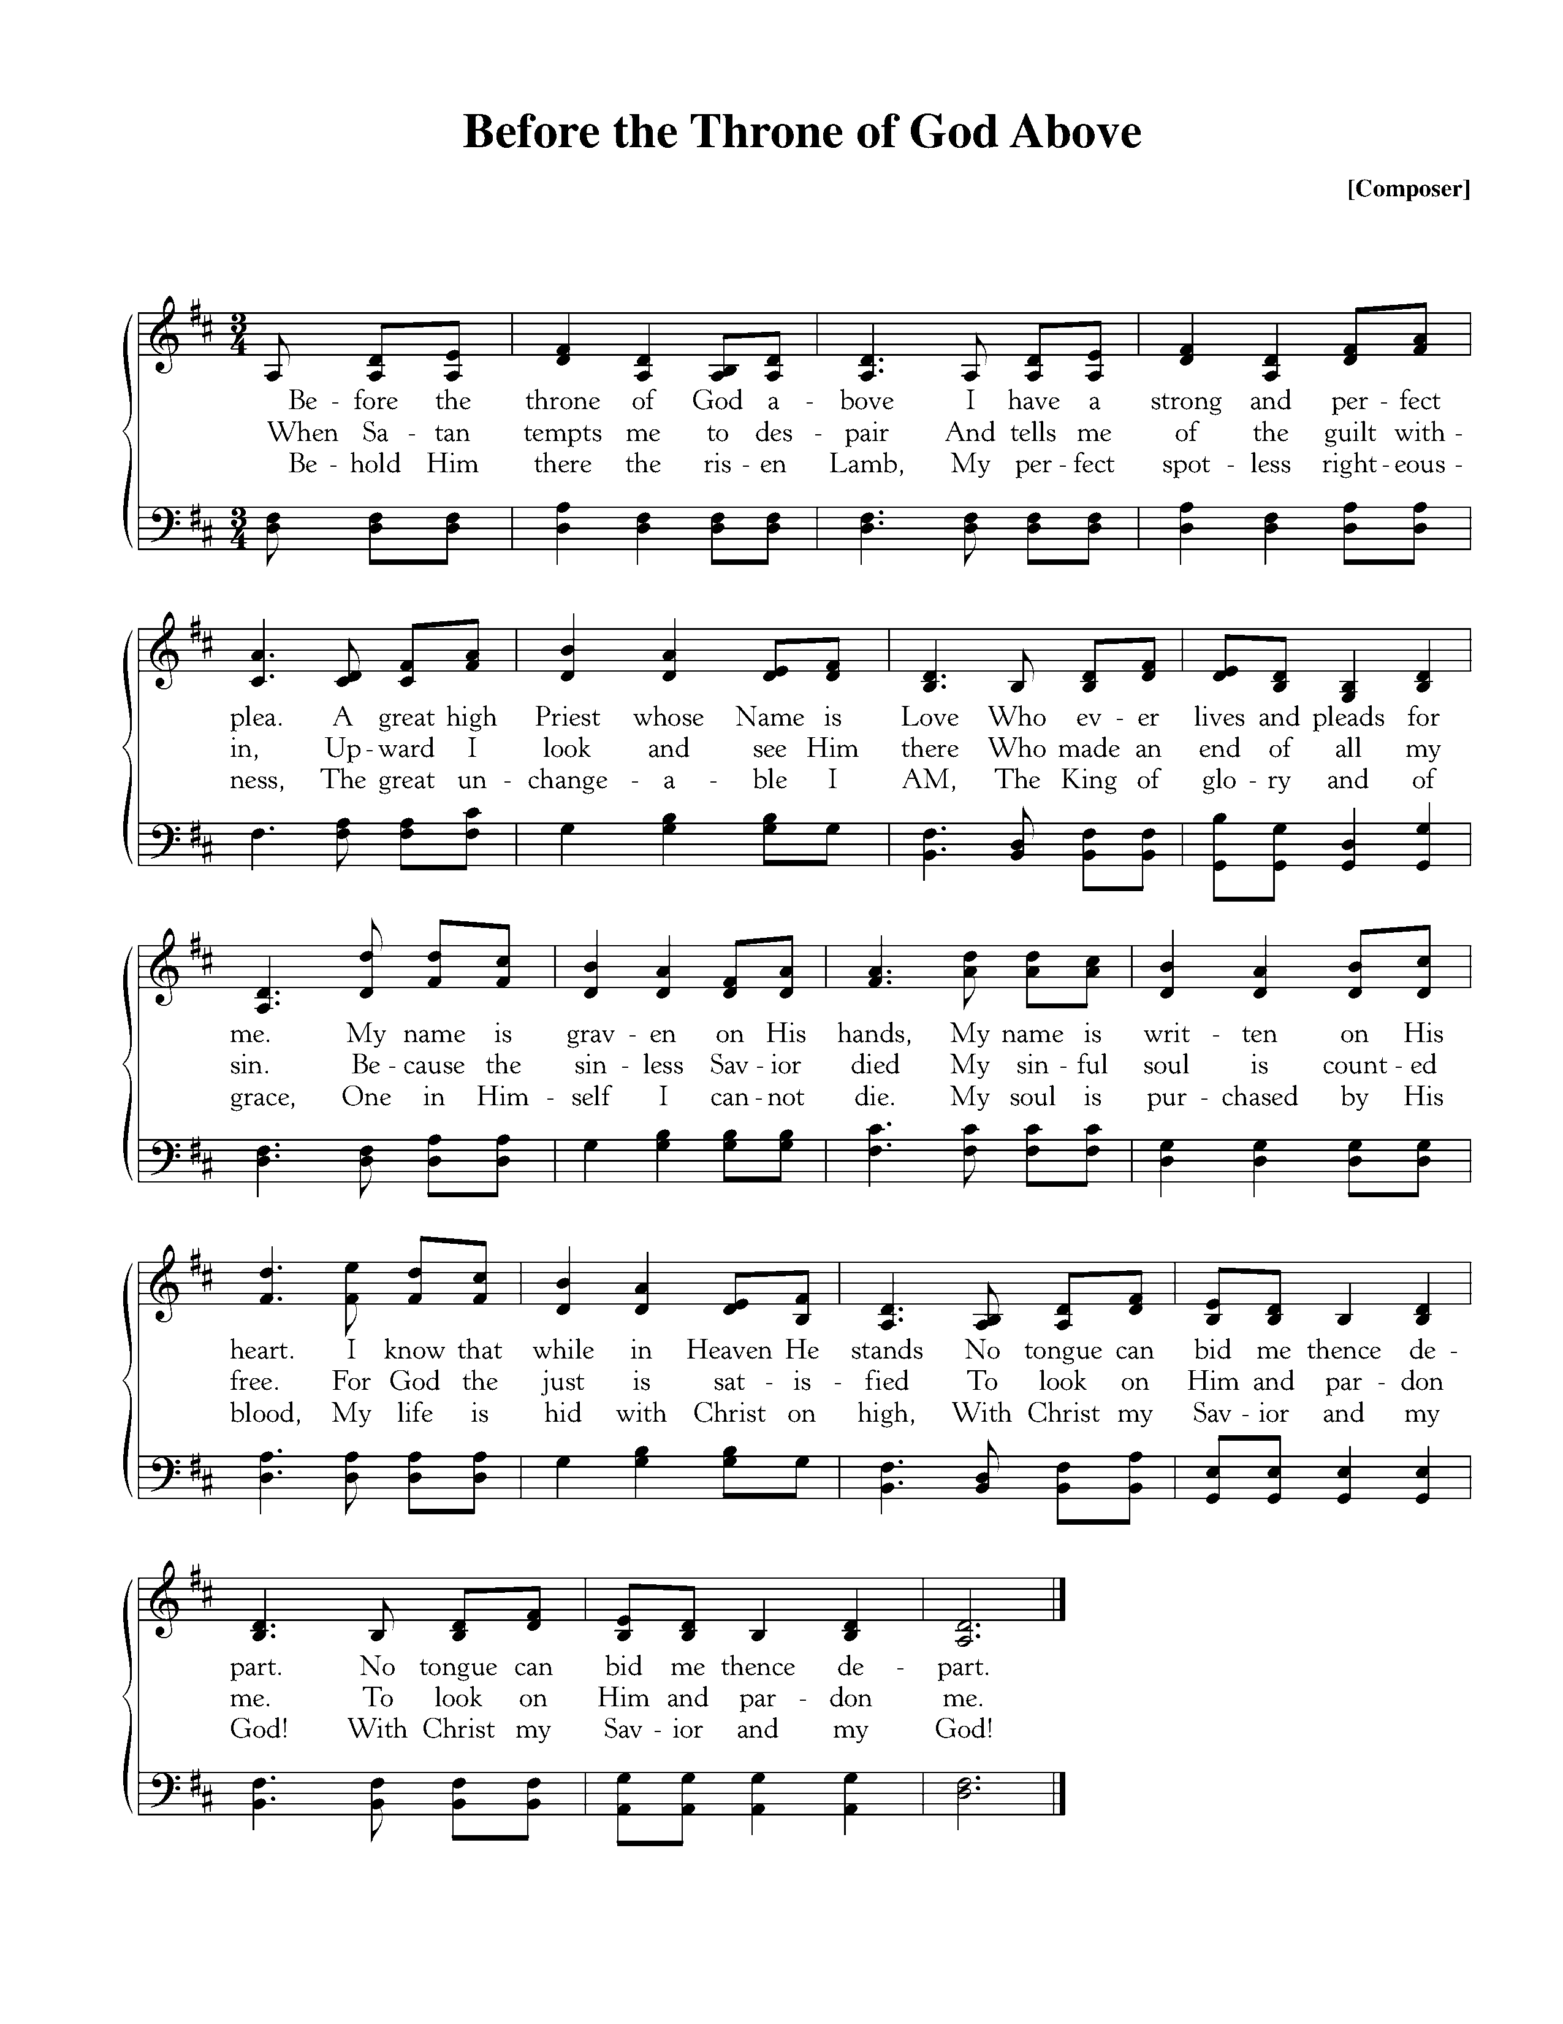
CCLI #11121087 ©1997 Sovereign Grace Worship; Text: Charitie Bancroft, 1863; Music: Vikki Cook, 1997

Missions Report—Elizabeth Branch, Ecuador
The Reading of the Word—John 15:1-11

“I am the true vine, and my Father is the vinedresser. 2 Every branch in me that does not bear fruit he takes away, and every branch that does bear fruit he prunes, that it may bear more fruit. 3 Already you are clean because of the word that I have spoken to you. 4 Abide in me, and I in you. As the branch cannot bear fruit by itself, unless it abides in the vine, neither can you, unless you abide in me. 5 I am the vine; you are the branches. Whoever abides in me and I in him, he it is that bears much fruit, for apart from me you can do nothing. 6 If anyone does not abide in me he is thrown away like a branch and withers; and the branches are gathered, thrown into the fire, and burned. 7 If you abide in me, and my words abide in you, ask whatever you wish, and it will be done for you. 8 By this my Father is glorified, that you bear much fruit and so prove to be my disciples. 9 As the Father has loved me, so have I loved you. Abide in my love. 10 If you keep my commandments, you will abide in my love, just as I have kept my Father’s commandments and abide in his love. 11 These things I have spoken to you, that my joy may be in you, and that your joy may be full.

Elder: The grass withers, the flower fades;
All: But the Word of our God will stand forever.

Sermon—Abiding in Christ: Three Essential Marks for Maturing Christians, Pt 1
Abiding in Christ —Nate Shurden, Pastor

Sung Response—O Praise the Father
Text: John Mason, 1683; Music: Gregory Wilbur, 2011.

The Sacrament of the Lord’s Supper
God offers to His people the gift of communion with Him through the grace of the sacrament and we respond in thanksgiving.

Sursum Corda
Elder: The Lord be with you. People: And also with you.
Elder: Lift up your hearts. People: We lift them up to the Lord.
Elder: Let us give thanks to the Lord our God. People: It is right to give Him thanks and praise.
Elder: It is right, and a good and joyful thing, always and everywhere to give thanks to You,
Father Almighty, Creator of heaven and earth.
Sung Response—Sanctus

Women

Men
CCLI #11121087 Text: Is 6:3, Rev 4:8, Mt 21:9; Music: Franklin Sanctus, Gregory D Wilbur, 2009. ©2009 Greyfriars Press.

Profession of Faith—The Apostles’ Creed

We believe in God, the Father Almighty, the Creator of Heaven and Earth,

And in Jesus Christ, His only Son, our Lord: who was conceived of the Holy Spirit,
Born of the Virgin Mary, Suffered under Pontius Pilate,
Was crucified, died and was buried. He descended into Hell.
On the third day he rose again from the dead.
He ascended into Heaven and now sits at the right hand of God the Father Almighty;
From whence He shall come to judge the living and the dead.

We believe in the Holy Spirit; The one holy Church—both visible and invisible;
The communion of saints; the forgiveness of sins;
The resurrection of the body; and the life everlasting. Amen.

Words of Institution and the Lord’s Table
Having confessed our sins and made a good profession of faith, God's Table is open to all those “faithfully-fenced" members of the covenant community. Please come forward to partake of this means of grace. You may take the bread at the first table and then proceed to either side for the wine/grape juice.

Hymn of Communion—Give Me Jesus

Text and Music: African-American Spiritual.

Hymn of Communion—Not What My Hands Have Done
Text: Horatius Bonar, 1861; Music: Greyfriars Press, 2013.
God’s People Respond in Grateful Praise

Prayer of Thanksgiving and Intercession

The Lord’s Prayer
Our Father, who art in heaven, Hallowed be thy Name.
Thy kingdom come. Thy will be done, On earth as it is in heaven.
Give us this day our daily bread. And forgive us our debts, As we forgive our debtors.
And lead us not into temptation, But deliver us from evil.
For Thine is the Kingdom, and the power, and the glory, forever. Amen.

Hymn of Praise—O the Deep, Deep Love of Jesus
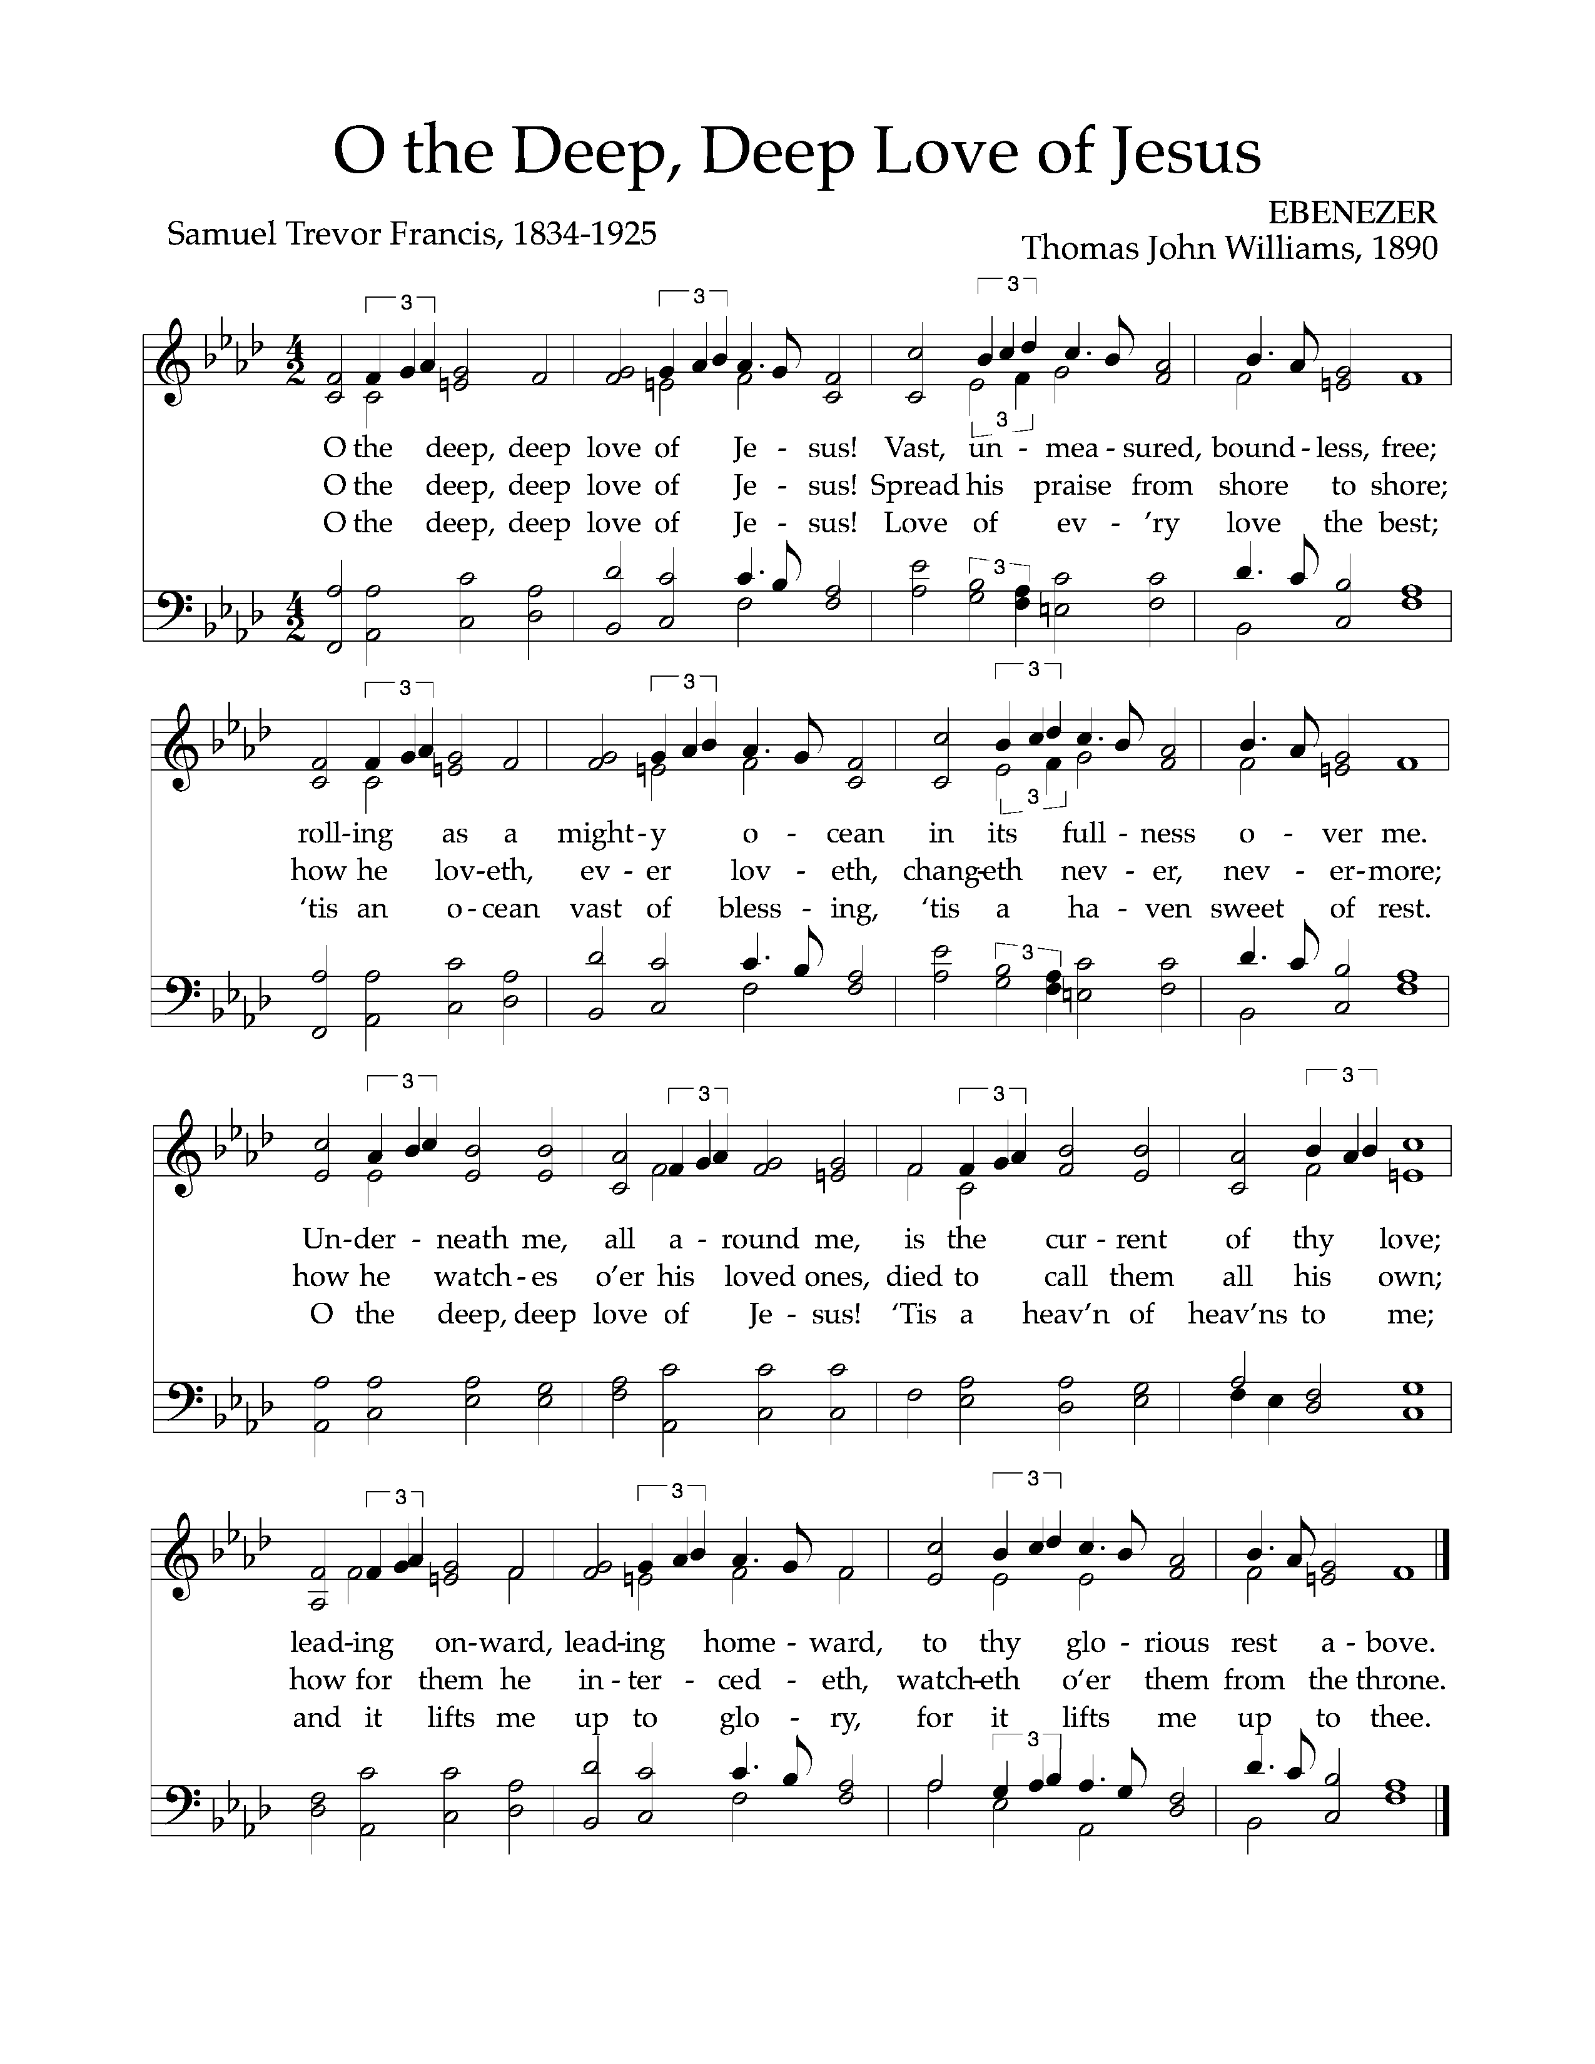
Text: Samuel Trevor Francis, 1834-1925; Music: Ebenezer, Thomas John Williams, 1890.
God Sends His People out
After calling His people into His presence, forgiving their sins, instructing them in His Word, and providing a foretaste of the marriage supper of the Lamb, God sends His people into the world to show His light in the darkness.

Benediction—I John 4:15-16

Whoever confesses that Jesus is the Son of God, God abides in him, and he in God. So we have come to know and to believe the love that God has for us. God is love, and whoever abides in love abides in God, and God abides in him.

Sung Response—Christ Be With Me (from St. Patrick’s Breastplate)
Text: Atomriug indui niurt tren, St. Patrick, 372-466, Trans by Cecil Frances Alexander, 1818-95;
Music: St. Patrick Clonmacnoise, Traditional Irish Hymn Melody.

Home Fellowship Groups—Starting September 8
Chuck Emerson, 2nd and 4th Sundays 5:00 p.m., Steffens’ house.
Cy Fenton, Sundays after church, Fenton’s house.
Stacy McGuire, Sundays after church, upstairs at Cornerstone.
Greg Wilbur, 2nd, 3rd, and 4th Sundays at 5:00 p.m., Wilbur’s house.
Jim Smith, 2nd and 4th Sundays at 6:00 p.m., Smith’s house.
***New Group: Mike and Mel Payne, 615-618-3299 or meljpayne@gmail.com

We’re taking a short break from the Gospel of Luke to begin a four week mini-series entitled, “Abiding in Christ: Three Essential Marks for Maturing Christians.” In this series, we will consider what it means to know God’s love, hear God’s Word, and obey God’s commands.

- What is the current state of your relationship with Christ?

- Looking over your recent past, what would you point to as contributing to the current state of your relationship with Christ?

- In today’s message from John 15:1-11, we are called to abide in Christ. How would you summarize abiding in Christ? Are you abiding in Christ?

- Also from today’s message, we learned that maturing Christians bear fruit. How can you tell if you are bearing fruit and thus maturing as a Christian?

- What ways would you like to mature as a Christian?

- What steps do you need to take to pursue maturity as a Christian?

Cornerstone Presbyterian Church
Presbyterian Church in America
Pastor: Nate Shurden (618-4707 Office) or nate@cstonepres.org
Worship and Chief Musician: Greg Wilbur (512-4156) or greg@cstonepres.org
Administrative Assistant: Susan Bumpus (618-4707) or office@cstonepres.org
Home Fellowship Coordinator: Randy Allen (260-1884) or randmanrx@gmail.com
Nursery Coordinator: Linda VanGorden (406-4431) or vangordenlinda@yahoo.com
Elementary Discipleship Coordinator: Lorrie Mathews (429-8355) or lorriegm@gmail.com

Ruling Elders
Terry Cheney (579-7089) Cy Fenton (500-5304) Jim Smith (347-4188)
Chuck Emerson: Emeritus (661-9273) Stacy McGuire (339-3900) Greg Wilbur (512-4156)

Deacons
Clint Branch (516-9855) Kevin McClung (243-9228) Larry Thompson (901-734-1520)
Joe Haworth (289-7543) David Steffens (513-4873) Bob Vermilye (599-9577)
Riley May (866-8662)

Post Office Box 407 h Franklin, Tennessee 37065 h
www.cornerstonepresfranklin.org h (615) 618-4707

All Scripture quotations from the English Standard Version

