Service of Celebration and Gospel Renewal

Ordinary Time—Sundays of Pentecost
25 August 2013
Worship Notes

We are pleased to welcome Stacey Croft to preach this Sunday from Luke 18. Stacey serves as the RUF minister at Vanderbilt University and is an active member of the Nashville Presbytery. We will be tracing the theme of faith like a child even as we consider the passage from Luke in which Christ welcomes the children to himself. The Call to Worship from Psalm 66 invites us to shout for joy and sing of His glory for He is awesome in His deeds towards the children of man. The opening hymns, Come Christians, Join to Sing and Glory Be to God the Father are both strong declarations of praise to God for who He is as Father, Son, and Holy Spirit, our Redeemer, King of the Church and of nations, and full of goodness.
The New Testament Reading from I John 5 reminds us of the role of love and faith towards the Father as fruit of our belief in Christ. The Prayer of Confession from I Corinthians 1 confronts our sinful proclivity to seek after reason and worldly wisdom to explain our faith as opposed to the “folly” of the cross and what appears to be weakness, but in reality shows the strength of God.
Our first Communion Hymn is I Will Praise Him Still which speaks of the child-like faith of trusting God beyond what appears to be our present circumstances. The second Communion Hymn is Holy Father, Hear My Cry as a simple but profound prayer of mercy with the desire to know the love, peace, and presence of God.
We conclude by singing Jesus, Draw Me Ever Nearer with the hope that we would ever rise on the wings of faith to be more and more like our Savior.
—Greg Wilbur

God Calls His People to Worship

It is God Himself who calls His people to worship. We do not call ourselves, but it is the King who opens His gates and beckons us into his courts.

Prelude. Announcements & Preparation

Introit—Crown Him with Many Crowns, Vs 7
Text: Matthew Bridges, 1852; Music: Diademata, George J. Elvey, 1868.

Call to Worship—from Psalm 66:1-5, 8

Elder: Shout for joy to God, all the earth; sing the glory of his name; give to him glorious praise!

All: Say to God, “How awesome are your deeds!

Elder: All the earth worships you and sings praises to you;

All: They sing praises to your name.”

Elder: Come and see what God has done:

All: He is awesome in his deeds toward the children of man.

Elder: Bless our God, O peoples;

All: Let the sound of his praise be heard!

Hymn of Praise—Come, Christians Join to Sing
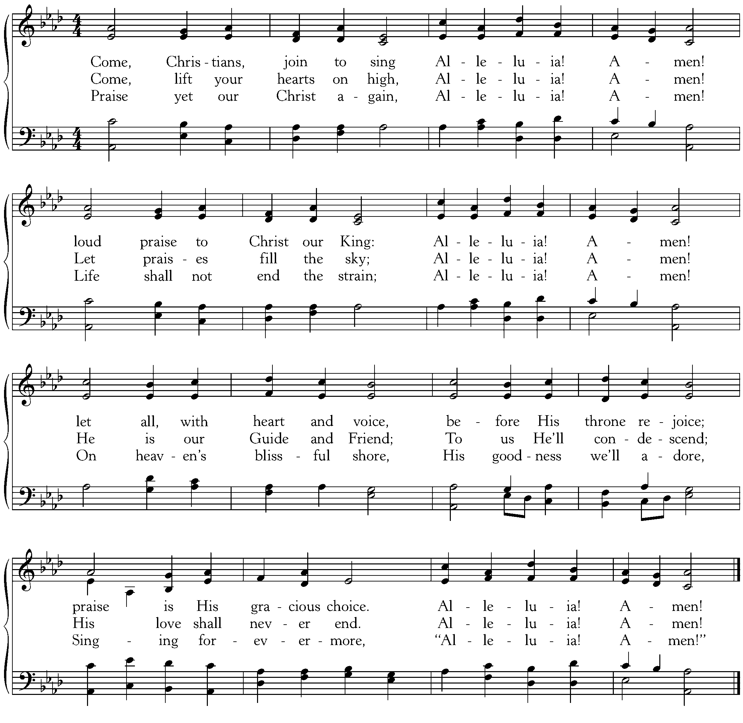
Text: Christian H. Bateman, 1843; Music: Madrid, Traditional Spanish Melody, Arr David Evans, 1927.
Hymn of Praise—Glory Be to the Father

Text: Horatius Bonar, 1868; Music: Gregory Wilbur, 2011. ©2011 Greyfriars Press

(Please be seated)

New Testament Reading—I John 5:1-5
Love for the Father expressed in love for His children and in faith.

1 Everyone who believes that Jesus is the Christ has been born of God, and everyone who loves the Father loves whoever has been born of him. 2 By this we know that we love the children of God, when we love God and obey his commandments. 3 For this is the love of God, that we keep his commandments. And his commandments are not burdensome. 4 For everyone who has been born of God overcomes the world. And this is the victory that has overcome the world—our faith. 5 Who is it that overcomes the world except the one who believes that Jesus is the Son of God?

Elder: This is the Word of the Lord.
All: Thanks be to God.

God Calls His People to Confession, Repentance, and Reconciliation
The People of God respond to His Word by confessing their sins, repenting of their sinful ways, and seeking God’s favor through the reconciling work of Jesus, the Son of God.

Sung Response—God, Be Merciful to Me, Vs 1
Text: Psalm 51, The Psalter, 1912; Music: Redhead, Richard Redhead, 1853, Adapted 2007.

Corporate Confession of Sin—based on I Corinthians 1:18-27

Elder: Lord, we come confessing. We often think we are wise or skillful in debating spiritual matters.

All: But You have made foolish the wisdom of the world.

Elder: You are pleased to make Yourself known not through wisdom
but through the folly of what we preach in order to save those who believe.

All: We demand signs or seek after rational wisdom,

Elder: But we preach Christ crucified—for the word of the cross is folly to those who are perishing,
but to us who are being saved it is the power of God.

All: Yet, it is often a stumbling block to what we think the gospel should look like
or it is folly to our rational minds.

Elder: But to those You have called, it is Christ the power of God and the wisdom of God.
For what is foolishness to You is wiser than men and Your weakness is stronger than men.

All: As we consider our callings, we wrestle with our own lack of wisdom, our weakness,
and our humble positions.

Elder: But You have chosen what is foolish in the world to shame the wise
and what is weak in the world to shame the strong.

Sung Response—Kyrie

Silent Prayers of Confession

Assurance of Pardon—based on Colossians 1:19-22
For in Christ all the fullness of God was pleased to dwell, and through him to reconcile to himself all things, whether on earth or in heaven, making peace by the blood of his cross. And you, who once were alienated and hostile in mind, doing evil deeds, he has now reconciled in his body of flesh by his death, in order to present you holy and blameless and above reproach before him.

Hymn of Praise—Speak O Lord
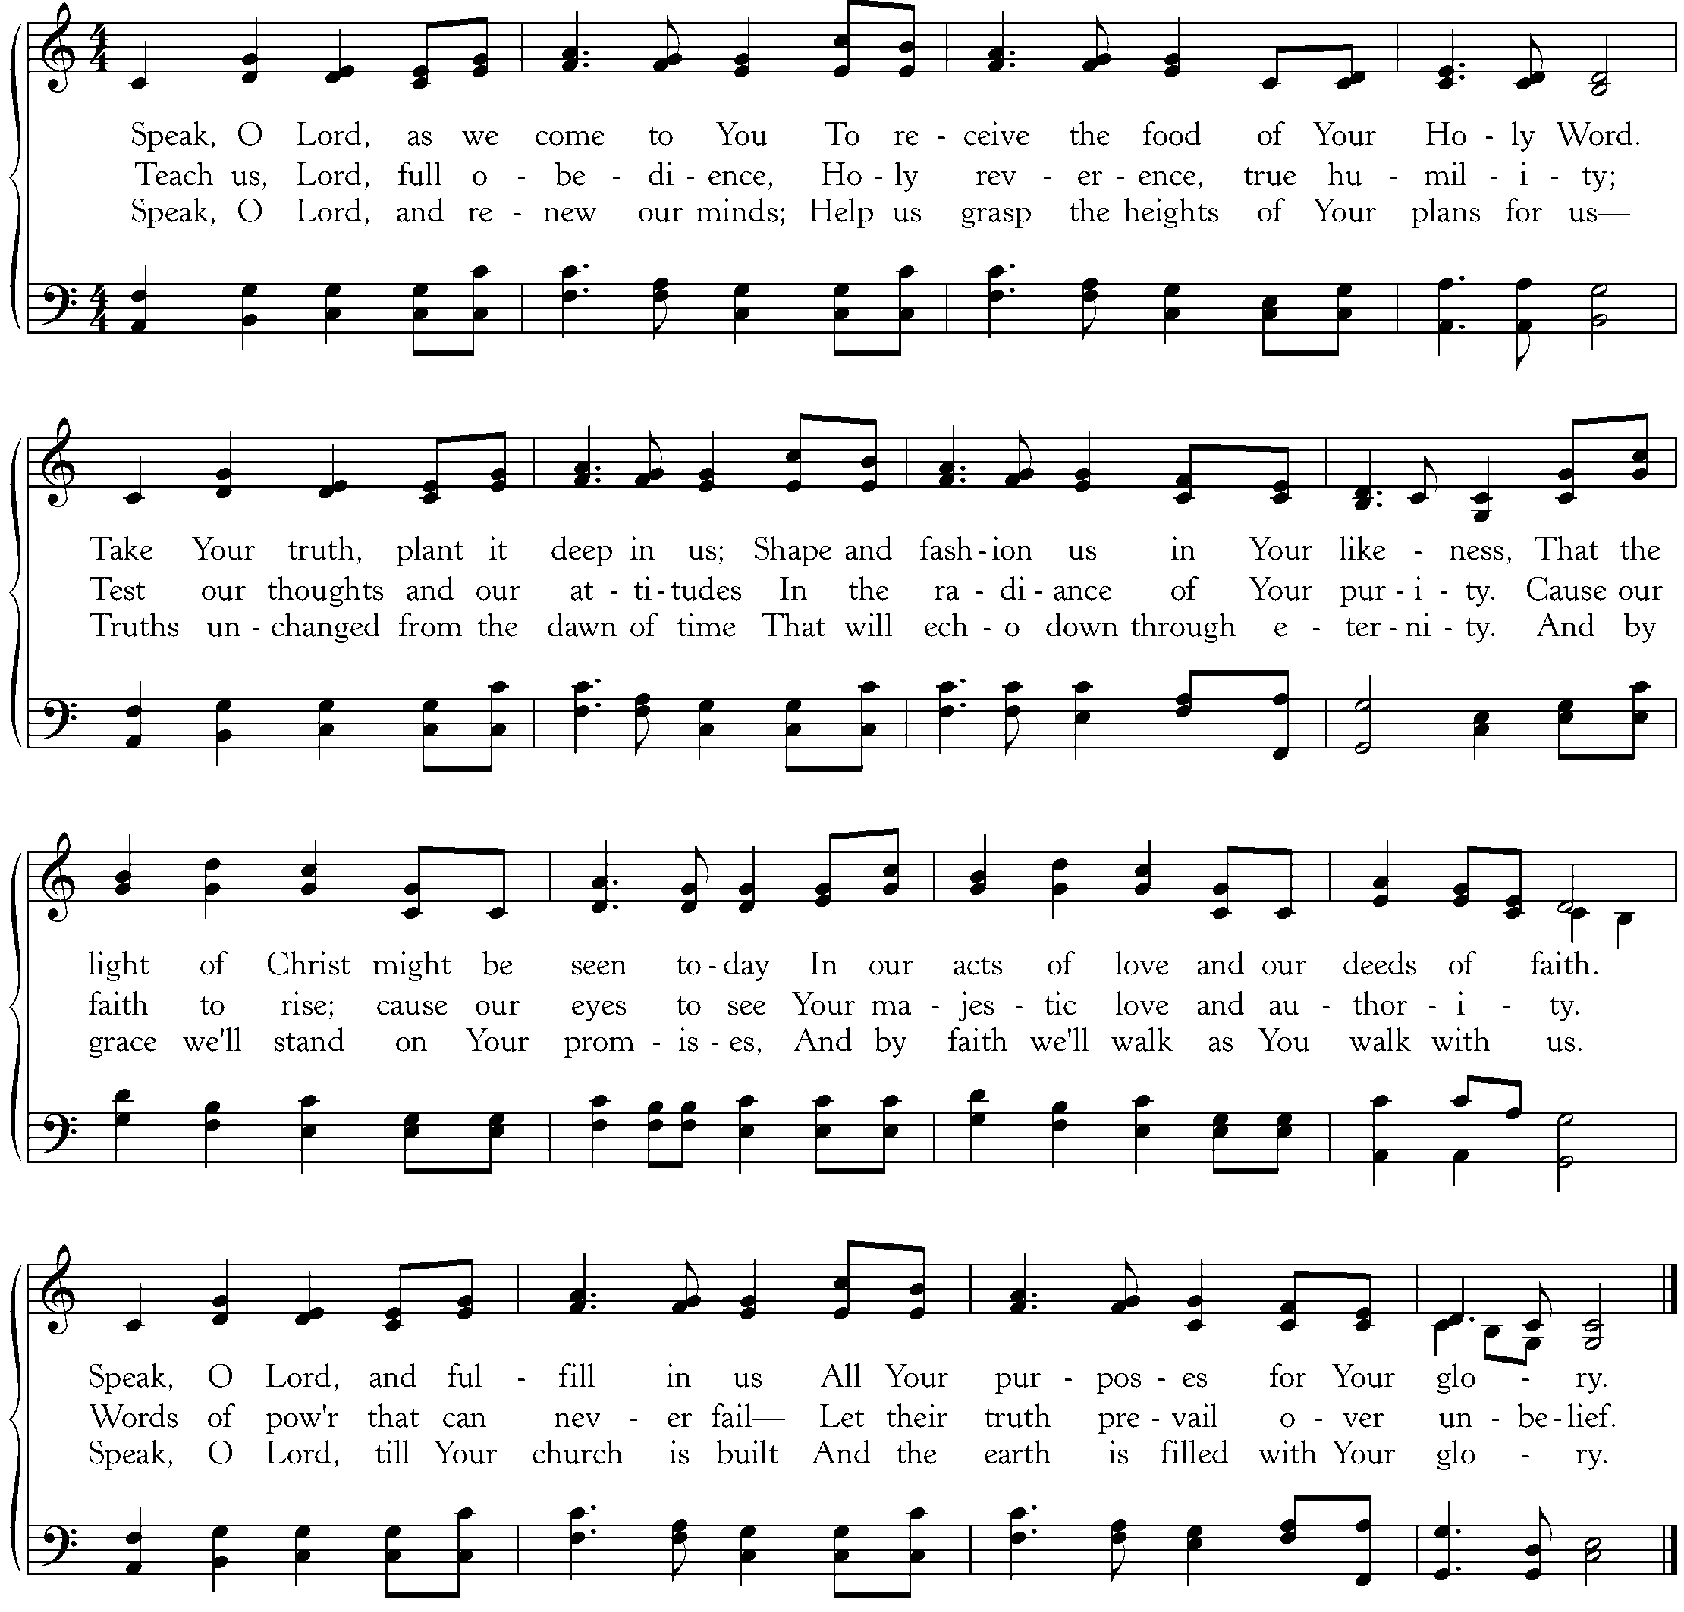
CCLI #11121087 ©2005 Thankyou Music, Text and Music: Keith Getty and Stuart Townend, 2005.

The Reading of the Word—Luke 18:15-17

15 Now they were bringing even infants to him that he might touch them. And when the disciples saw it, they rebuked them. 16 But Jesus called them to him, saying, “Let the children come to me, and do not hinder them, for to such belongs the kingdom of God. 17 Truly, I say to you, whoever does not receive the kingdom of God like a child shall not enter it.”

Elder: This is the Word of the Lord.
All: Thanks be to God.

Sermon—Faith Like a Child
—Stacey Croft, Reformed University Fellowship (RUF) Minister at Vanderbilt University

Profession of Faith—The Apostles’ Creed

We believe in God, the Father Almighty, the Creator of Heaven and Earth,

And in Jesus Christ, His only Son, our Lord: who was conceived of the Holy Spirit,
Born of the Virgin Mary, Suffered under Pontius Pilate,
Was crucified, died and was buried. He descended into Hell.
On the third day he rose again from the dead.
He ascended into Heaven and now sits at the right hand of God the Father Almighty;
From whence He shall come to judge the living and the dead.

We believe in the Holy Spirit; The one holy Church—both visible and invisible;
The communion of saints; the forgiveness of sins;
The resurrection of the body; and the life everlasting. Amen.

Sung Response—O Praise the Father
Text: John Mason, 1683; Music: Gregory Wilbur, 2011.

The Sacrament of the Lord’s Supper
God offers to His people the gift of communion with Him through the grace of the sacrament and we respond in thanksgiving.

Words of Institution and the Lord’s Table
Having confessed our sins and made a good profession of faith, God's Table is open to all those “faithfully-fenced" members of the covenant community. Please come forward to partake of this means of grace. You may take the bread at the first table and then proceed to either side for the wine/grape juice.

Hymn of Communion—I Will Praise Him, Still

CCLI #11121087 © 1998 MargeeDays Music; Text and Music: Fernando Ortega, 1998.

Hymn of Communion—Holy Father, Hear My Cry

CCLI #11121087 Text: Horatius Bonar, 1843; Music: Gregory D Wilbur, 2010.

God’s People Respond in Grateful Praise

Prayer of Thanksgiving and Intercession

The Lord’s Prayer
Our Father, who art in heaven, Hallowed be thy Name.
Thy kingdom come. Thy will be done, On earth as it is in heaven.
Give us this day our daily bread. And forgive us our debts, As we forgive our debtors.
And lead us not into temptation, But deliver us from evil.
For Thine is the Kingdom, and the power, and the glory, forever. Amen.

Hymn of Praise—Jesus, Draw Me Ever Nearer
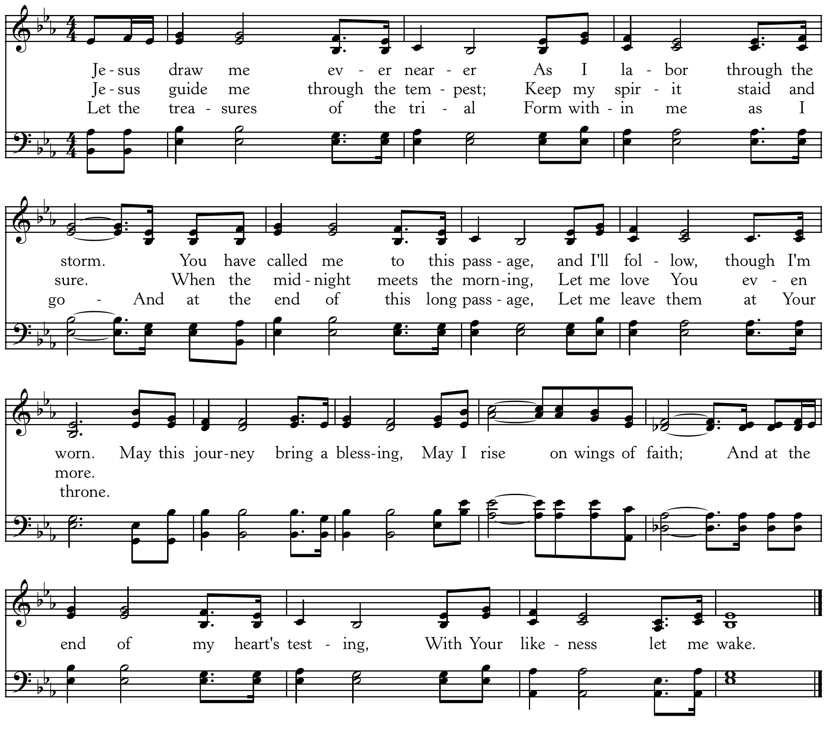
CCLI #11121087 ©2002 Thankyou Music, Text: Margaret Becker, 2002; Music: Keith Getty, 2002
God Sends His People out
After calling His people into His presence, forgiving their sins, instructing them in His Word, and providing a foretaste of the marriage supper of the Lamb, God sends His people into the world to show His light in the darkness.

Benediction—from I Thessalonians 2:11-12

Like a father with his children, I exhort each one of you and encourage you and charge you to walk in a manner worthy of God, who calls you into his own kingdom and glory. Amen.

Sung Response—O Thou In Whose Presence, Vs 11
Text: Joseph Swain, 1791; Music: Davis, 1813.

Home Fellowship Groups—Starting September 8
Chuck Emerson, 2nd and 4th Sundays 5:00 p.m., Steffens’ house.
Cy Fenton, Sundays after church, Fenton’s house.
Stacy McGuire, Sundays after church, upstairs at Cornerstone.
Greg Wilbur, 2nd, 3rd, and 4th Sundays at 5:00 p.m., Wilbur’s house.
Jim Smith, 2nd and 4th Sundays at 6:00 p.m., Smith’s house.
***New Group: Mike and Mel Payne, 615-618-3299 or meljpayne@gmail.com

Cornerstone Presbyterian Church
Presbyterian Church in America
Pastor: Nate Shurden (618-4707 Office) or nate@cstonepres.org
Worship and Chief Musician: Greg Wilbur (512-4156) or greg@cstonepres.org
Administrative Assistant: Susan Bumpus (618-4707) or office@cstonepres.org
Home Fellowship Coordinator: Randy Allen (260-1884) or randmanrx@gmail.com
Nursery Coordinator: Linda VanGorden (406-4431) or vangordenlinda@yahoo.com
Elementary Discipleship Coordinator: Lorrie Mathews (429-8355) or lorriegm@gmail.com

Ruling Elders
Terry Cheney (579-7089) Cy Fenton (500-5304) Jim Smith (347-4188)
Chuck Emerson: Emeritus (661-9273) Stacy McGuire (339-3900) Greg Wilbur (512-4156)

Deacons
Clint Branch (516-9855) Kevin McClung (243-9228) Larry Thompson (901-734-1520)
Joe Haworth (289-7543) David Steffens (513-4873) Bob Vermilye (599-9577)
Riley May (866-8662)

Post Office Box 407 h Franklin, Tennessee 37065 h
www.cornerstonepresfranklin.org h (615) 618-4707

All Scripture quotations from the English Standard Version

