Service of Celebration and Gospel Renewal

Ordinary Time—Sundays of Pentecost
18 August 2013
Worship Notes

Watching, waiting in hope, and being prepared are all themes coming from what is a challenging passage in Luke 12. The Call to Worship from Psalm 62 calls us to wait for God alone for our hope is in Him. We then sing O God Our Help in Ages Past for He is our hope for years to come and our eternal home. Continuing in the service we sing of our great Redeemer who has ransomed us and called us to glory in the hymn I Will Glory in My Redeemer.
The New Testament Reading from II Peter 3 reminds us that we are waiting for a new heavens and a new earth and calls us to holy living as we wait for and hasten the day of the Lord. The Prayer of Confession from II Timothy 4 speaks of what happens to our wandering hearts when we wander away from being vigilant to the truth.
My Hope is Built on Nothing Less leads us through the foundation of our confidence in Christ where our trust, rest, support, and righteousness are all found. Our Communion Hymns continue this theme of longing and waiting for the Lord. Psalm 42: As Pants the Deer asks, “When shall I see Thy gracious face?” even as we wait by day and night for the coming of the Lord. O Thou in Whose Presence also speaks of our delight and yearning for He who is our comfort and hope.
Our final hymn, O Christ, Our Hope, places our security and hope in the death, resurrection, ascension, and future return of our Lord Jesus Christ. The desire of the ages and the nations is fulfilled in the redemptive work of Christ and in the glorification of His people.
—Greg Wilbur

God Calls His People to Worship

It is God Himself who calls His people to worship. We do not call ourselves, but it is the King who opens His gates and beckons us into his courts.

Prelude. Announcements & Preparation

Introit—Crown Him with Many Crowns, Vs 7
Text: Matthew Bridges, 1852; Music: Diademata, George J. Elvey, 1868.

Call to Worship—from Psalm 62:5-8

Pastor: For God alone, O my soul, wait in silence, for our hope is from him.

All: He only is our rock and our salvation, our fortress; we shall not be shaken.

Pastor: On God rests my salvation and my glory;

All: Our mighty rock, our refuge is God.

Pastor: Trust in him at all times, O people; pour out your heart before him;

All: God is a refuge for us.

Hymn of Praise—O God Our Help in Ages Past, Vs 1-4, 7

Text: Psalm 90, Isaac Watts, 1719; Music: St. Anne, William Croft, 1678-1727.
Hymn of Praise—I Will Glory in My Redeemer
CCLI #11121087 ©2001 Sovereign Grace Worship (ASCAP). Text and Music: Steve and Vikki Cook, 2001.

(Please be seated)

New Testament Reading—II Peter 3:8-13
Waiting for a new heavens and a new earth.

8 But do not overlook this one fact, beloved, that with the Lord one day is as a thousand years, and a thousand years as one day. 9 The Lord is not slow to fulfill his promise vas some count slowness, but is patient toward you, not wishing that any should perish, but that all should reach repentance. 10 But the day of the Lord will come like a thief, and then the heavens will pass away with a roar, and the heavenly bodies will be burned up and dissolved, and the earth and the works that are done on it will be exposed.
11 Since all these things are thus to be dissolved, what sort of people ought you to be in lives of holiness and godliness, 12 waiting for and hastening the coming of the day of God, because of which the heavens will be set on fire and dissolved, and the heavenly bodies will melt as they burn! 13 But according to his promise we are waiting for new heavens and a new earth in which righteousness dwells.

Elder: This is the Word of the Lord.
All: Thanks be to God.

God Calls His People to Confession, Repentance, and Reconciliation
The People of God respond to His Word by confessing their sins, repenting of their sinful ways, and seeking God’s favor through the reconciling work of Jesus, the Son of God.

Sung Response—God, Be Merciful to Me, Vs 1
Text: Psalm 51, The Psalter, 1912; Music: Redhead, Richard Redhead, 1853, Adapted 2007.

Corporate Confession of Sin—based on II Timothy 4:1-8

Pastor: Lord, we come confessing that we are often less than vigilant in following you.
In light of Christ, who is to judge the living and the dead,
and by His appearing and His kingdom, we ought to be ready in season and out of season.

All: With patience and teaching, we should be prepared to preach the word, to reprove, rebuke
and exhort one another.

Pastor: We fear that we will be like the people who will not endure sound teaching,
but having itching ears will only listen to teachers that suit our own passions.

All: We are too prone to turn away from listening to the truth and to wander off into myths.

Pastor: Lord, give us the continuing grace to always be sober-minded, to endure suffering,
to do the work of an evangelist and to fulfill the ministry to which You have called us.

All: May we use up this life in service to You.

Pastor: With Paul, may we be able to say that we have fought the good fight,
we have finished the race, and that we have kept the faith.

All: For You have prepared a crown of righteousness for those who watch for You
and who have loved Your appearing.

Sung Response—Kyrie

Silent Prayers of Confession

Assurance of Pardon—from Psalm 103:8-13

The Lord is merciful and gracious, slow to anger and abounding in steadfast love.
He will not always chide, nor will he keep his anger forever.
He does not deal with us according to our sins, nor repay us according to our iniquities.
For as high as the heavens are above the earth, so great is his steadfast love toward those who fear him;
as far as the east is from the west, so far does he remove our transgressions from us.
As a father shows compassion to his children, so the Lord shows compassion to those who fear him.

Hymn of Praise—My Hope is Built on Nothing Less
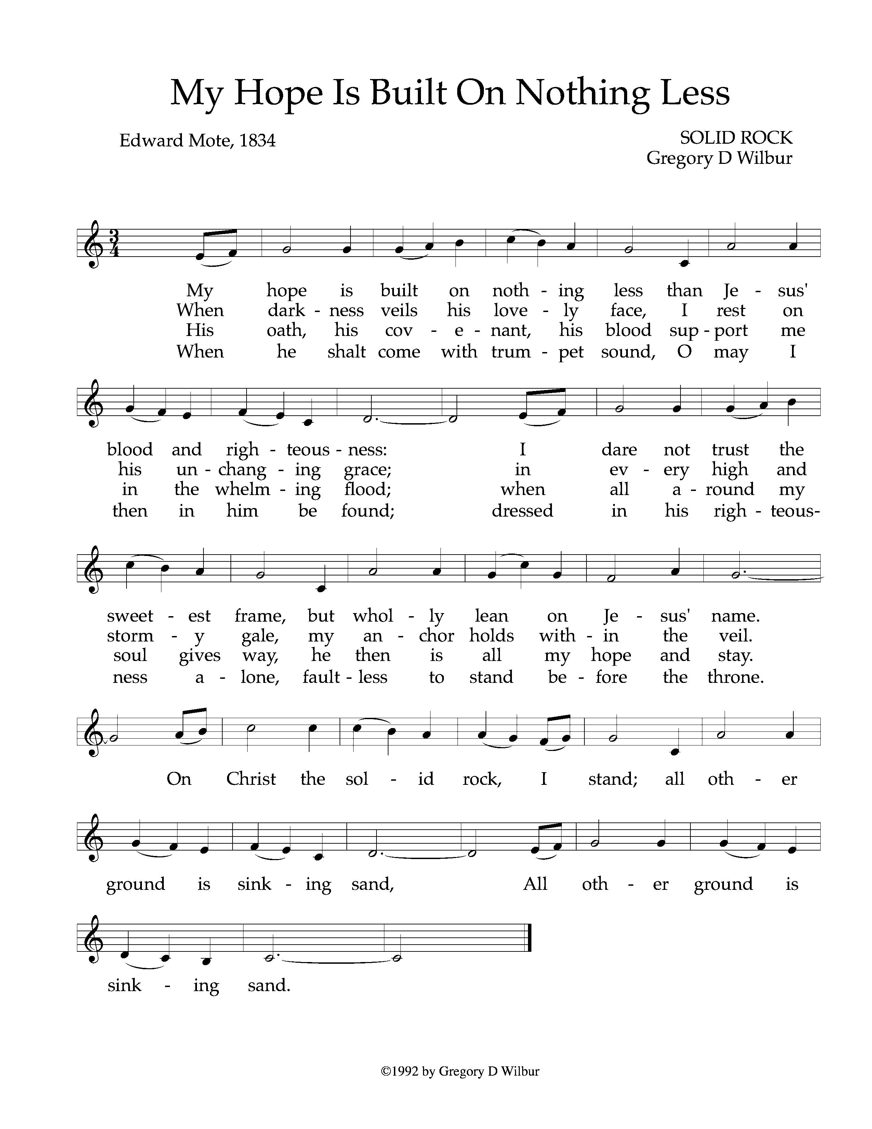
Text: Edward Mote, 1834: Music: Solid Rock, Gregory Wilbur, 1992. © 1992 Greyfriars Press. Used by Permission.
Discipleship Ministry Report—Greg Wilbur
Commissioning of Sunday School Teachers

The Reading of the Word—Luke 12:35-48

35 “Stay dressed for action and keep your lamps burning, 36 and be like men who are waiting for their master to come home from the wedding feast, so that they may open the door to him at once when he comes and knocks. 37 Blessed are those servants whom the master finds awake when he comes. Truly, I say to you, he will dress himself for service and have them recline at table, and he will come and serve them. 38 If he comes in the second watch, or in the third, and finds them awake, blessed are those servants! 39 But know this, that if the master of the house had known at what hour the thief was coming, he8 would not have left his house to be broken into. 40 You also must be ready, for the Son of Man is coming at an hour you do not expect.”
41 Peter said, “Lord, are you telling this parable for us or for all?” 42 And the Lord said, “Who then is the faithful and wise manager, whom his master will set over his household, to give them their portion of food at the proper time? 43 Blessed is that servant whom his master will find so doing when he comes. 44 Truly, I say to you, he will set him over all his possessions. 45 But if that servant says to himself, ‘My master is delayed in coming,’ and begins to beat the male and female servants, and to eat and drink and get drunk, 46 the master of that servant will come on a day when he does not expect him and at an hour he does not know, and will cut him in pieces and put him with the unfaithful. 47 And that servant who knew his master’s will but did not get ready or act according to his will, will receive a severe beating. 48 But the one who did not know, and did what deserved a beating, will receive a light beating. Everyone to whom much was given, of him much will be required, and from him to whom they entrusted much, they will demand the more.

Elder: This is the Word of the Lord.
All: Thanks be to God.

Sermon—The Gospel of Luke, Part 60

Awake & Waiting: Living for the Master’s Return —Nate Shurden, Pastor

Profession of Faith—The Apostles’ Creed

We believe in God, the Father Almighty, the Creator of Heaven and Earth,

And in Jesus Christ, His only Son, our Lord: who was conceived of the Holy Spirit,
Born of the Virgin Mary, Suffered under Pontius Pilate,
Was crucified, died and was buried. He descended into Hell.
On the third day he rose again from the dead.
He ascended into Heaven and now sits at the right hand of God the Father Almighty;
From whence He shall come to judge the living and the dead.

We believe in the Holy Spirit; The one holy Church—both visible and invisible;
The communion of saints; the forgiveness of sins;
The resurrection of the body; and the life everlasting. Amen.

Response of Praise—Glory Be to the Father, Vs 1

Text: Horatius Bonar, 1868; Music: Gregory Wilbur, 2011. ©2011 Greyfriars Press

The Sacrament of the Lord’s Supper
God offers to His people the gift of communion with Him through the grace of the sacrament and we respond in thanksgiving.

Words of Institution and the Lord’s Table
Having confessed our sins and made a good profession of faith, God's Table is open to all those “faithfully-fenced" members of the covenant community. Please come forward to partake of this means of grace. You may take the bread at the first table and then proceed to either side for the wine/grape juice.

Communion Hymn—Psalm 42: As Pants the Deer

Text: Anonymous, Psalm 42; Music: Greyfriars Press, 2013. Used by Permission

Communion Hymn—O Thou In Whose Presence
Text: Joseph Swain, 1791; Music: Davis, 1813.

God’s People Respond in Grateful Praise

Prayer of Thanksgiving and Intercession

The Lord’s Prayer
Our Father, who art in heaven, Hallowed be thy Name.
Thy kingdom come. Thy will be done, On earth as it is in heaven.
Give us this day our daily bread. And forgive us our debts, As we forgive our debtors.
And lead us not into temptation, But deliver us from evil.
For Thine is the Kingdom, and the power, and the glory, forever. Amen.

Hymn of Praise—O Christ, Our Hope

Text: Latin Hymn, 8th Century, Tr. By John Chandler, 1837; Music: Kingsfold, Old English Folk Song
God Sends His People out
After calling His people into His presence, forgiving their sins, instructing them in His Word, and providing a foretaste of the marriage supper of the Lamb, God sends His people into the world to show His light in the darkness.

Benediction—Jude 24-25

24 Now to him who is able to keep you from stumbling and to present you blameless before the presence of his glory with great joy, 25 to the only God, our Savior, through Jesus Christ our Lord, be glory, majesty, dominion, and authority, before all time and now and forever. Amen.

Sung Response—O Thou In Whose Presence, Vs 11
Text: Joseph Swain, 1791; Music: Davis, 1813.

After urging his disciples in wise stewardship of money and resources the last couple of weeks, Jesus turns his attention to stewardship of time and energy this week. He teaches that true disciples live wakeful and faithful lives in anticipation of Christ’s return.

- How do the images of “dressing for action” and keeping “lamps burning” express wakefulness or alertness in Jesus’ followers for his return?

- How is being awake for Jesus’ return tied to work and preparation in the present?

- What specific application should pastors/elders draw from this passage?

- According to the sermon, are we in the last days before Jesus’ return?

- Does Jesus teach that there will be a judgment by works in the end?

- How would deeper consideration of Jesus’ return change the way you are living in the present?

Cornerstone Presbyterian Church
Presbyterian Church in America
Pastor: Nate Shurden (618-4707 Office) or nate@cstonepres.org
Worship and Chief Musician: Greg Wilbur (512-4156) or greg@cstonepres.org
Administrative Assistant: Susan Bumpus (618-4707) or office@cstonepres.org
Home Fellowship Coordinator: Randy Allen (260-1884) or randmanrx@gmail.com
Nursery Coordinator: Linda VanGorden (406-4431) or vangordenlinda@yahoo.com
Elementary Discipleship Coordinator: Lorrie Mathews (429-8355) or lorriegm@gmail.com

Ruling Elders
Terry Cheney (579-7089) Cy Fenton (500-5304) Jim Smith (347-4188)
Chuck Emerson: Emeritus (661-9273) Stacy McGuire (339-3900) Greg Wilbur (512-4156)

Deacons
Clint Branch (516-9855) Kevin McClung (243-9228) Larry Thompson (901-734-1520)
Joe Haworth (289-7543) David Steffens (513-4873) Bob Vermilye (599-9577)
Riley May (866-8662)

Post Office Box 407 h Franklin, Tennessee 37065 h
www.cornerstonepresfranklin.org h (615) 618-4707

All Scripture quotations from the English Standard Version

