Service of Celebration and Gospel Renewal

Ordinary Time—Sundays of Pentecost
11 August 2013
Worship Notes

The cares of the world, especially the things that direct our heart’s desires, tend to bind us to this world instead of the freedom found in following Christ. The Father’s care and provision and our response to His goodness, are themes woven throughout the service this morning. The Call to Worship from Psalm 146 enjoins us to “Praise the Lord!” for His protection and care of prisoners, the ailing, the weary, the sojourners, widows, and fatherless. We respond by singing Praise My Soul the King of Heaven for the way He gently leads, tends, and spares us as a Father. We continue with Psalm 73: O God How Good Thou Art for when we are “burdened by anxious care” and fainting with fears, He guides our feet and brings us to Glory.
The New Testament Reading from II Corinthians 8 reminds us of the response to the Gospel in a wealth of generosity in giving beyond our means out of the abundance of joy. Our pattern for this is Christ himself. In our Prayer of Confession from Matthew 6, we confess the anxiety that often accompanies our life as we strive to figure out our needs on our own. But in Christ, we have an inheritance sealed by the Holy Spirit (Ephesians 1).
Lord Jesus, Think on Me is a prayer to release us from earthly passions and the oppression of cares and woes that we may rightly follow the “heavenly way” and praise the Father, Son and Spirit in joy. Our Communion Hymns continue this theme of treasure and anxiety in the singing of Deck Yourself My Soul With Gladness and If Thou But Suffer God to Guide Thee. We sing of the true treasure of the Body and Blood of Christ and our hunger and longing for those things that truly are rich beyond measure.
Our final hymn, Be Thou My Vision, prayerfully redirects our focus to what truly matters such that we heed not riches or the empty praise of this world but desire the inheritance that is Christ.
—Greg Wilbur

God Calls His People to Worship

It is God Himself who calls His people to worship. We do not call ourselves, but it is the King who opens His gates and beckons us into his courts.

Prelude. Announcements & Preparation

Introit—Crown Him with Many Crowns, Vs 7
Text: Matthew Bridges, 1852; Music: Diademata, George J. Elvey, 1868.

Call to Worship—from Psalm 146:1-2, 7b-10

Pastor: Praise the Lord! Praise the Lord, O my soul!

All: We will praise the Lord as long as we live;
We will sing praises to our God while we have our being.

Pastor: The Lord sets the prisoners free; the Lord opens the eyes of the blind.

All: The Lord lifts up those who are bowed down;
the Lord loves the righteous.

Pastor: The Lord watches over the sojourners; he upholds the widow and the fatherless,
but the way of the wicked he brings to ruin.

All: The Lord will reign forever, your God, O Zion, to all generations.
Praise the Lord!

Hymn of Praise—Praise My Soul the King of Heaven

Text: From Psalm 103, Henry F. Lyte, 1834; Music: Praise My Soul, John Goss, 1869.
Hymn of Praise—Psalm 73 O God, How Good Thou Art
CCLI #11121087 Text: Psalm 73, The Psalter, 1912: Music: Gregory Wilbur, 2012.

(Please be seated)

New Testament Reading—II Corinthians 8:1-9
Though he was rich, for our sake Christ became poor.

1 We want you to know, brothers, about the grace of God that has been given among the churches of Macedonia, 2 for in a severe test of affliction, their abundance of joy and their extreme poverty have overflowed in a wealth of generosity on their part. 3 For they gave according to their means, as I can testify, and beyond their means, of their own accord, 4 begging us earnestly for the favor of taking part in the relief of the saints—5 and this, not as we expected, but they gave themselves first to the Lord and then by the will of God to us. 6 Accordingly, we urged Titus that as he had started, so he should complete among you this act of grace. 7 But as you excel in everything—in faith, in speech, in knowledge, in all earnestness, and in our love for you—see that you excel in this act of grace also.
8 I say this not as a command, but to prove by the earnestness of others that your love also is genuine. 9 For you know the grace of our Lord Jesus Christ, that though he was rich, yet for your sake he became poor, so that you by his poverty might become rich.

Elder: This is the Word of the Lord.
All: Thanks be to God.

God Calls His People to Confession, Repentance, and Reconciliation
The People of God respond to His Word by confessing their sins, repenting of their sinful ways, and seeking God’s favor through the reconciling work of Jesus, the Son of God.

Sung Response—God, Be Merciful to Me, Vs 1
Text: Psalm 51, The Psalter, 1912; Music: Redhead, Richard Redhead, 1853, Adapted 2007.

Corporate Confession of Sin—based on Matthew 6:25-34

Pastor: Lord, we come confessing that we are anxious about our lives, about what we eat and drink,
about clothes and provisions.

All: We forget that life is more than food and the body is more than the clothes we wear.

Pastor: You feed the birds of the air who neither sow nor reap.
You clothe the lilies of the field who neither toil nor spin.

All: We are of more value than they, yet we are anxious about earthly things.

Pastor: Our lack of faith causes us to question Your provision, O Father.

All: The unbeliever seeks after providing food and drink and clothes,
yet it is You, our heavenly Father who knows that we need them.

Pastor: Give us the grace to seek after Your kingdom and Your righteousness,
and to rest in the assurance that You provide for our needs.

All: Help us not to be anxious about tomorrow.

Sung Response—Kyrie

Silent Prayers of Confession

Assurance of Pardon—from Ephesians 1:11-14
11 In Christ we have obtained an inheritance, having been predestined according to the purpose of him who works all things according to the counsel of his will, 12 so that we who were the first to hope in Christ might be to the praise of his glory. 13 In him you also, when you heard the word of truth, the gospel of your salvation, and believed in him, were sealed with the promised Holy Spirit, 14 who is the guarantee of our inheritance until we acquire possession of it, to the praise of his glory.

Hymn of Praise—Lord Jesus, Think on Me

Text: Synesius of Cyrene, c. 375-430, Tr Allen William Charfield, 1808-96; Music: Southwell, Damon’s Psalmes, 1579.
Adapted 1997. © 1997 Greyfriars Press. Used by permission.

Missions Report—Lincoln Pent, Nicaragua

The Reading of the Word—Luke 12:22-34

22 And he [Jesus] said to his disciples, “Therefore I tell you, do not be anxious about your life, what you will eat, nor about your body, what you will put on. 23 For life is more than food, and the body more than clothing. 24 Consider the ravens: they neither sow nor reap, they have neither storehouse nor barn, and yet God feeds them. Of how much more value are you than the birds! 25 And which of you by being anxious can add a single hour to his span of life? 26 If then you are not able to do as small a thing as that, why are you anxious about the rest? 27 Consider the lilies, how they grow: they neither toil nor spin, yet I tell you, even Solomon in all his glory was not arrayed like one of these. 28 But if God so clothes the grass, which is alive in the field today, and tomorrow is thrown into the oven, how much more will he clothe you, O you of little faith! 29 And do not seek what you are to eat and what you are to drink, nor be worried. 30 For all the nations of the world seek after these things, and your Father knows that you need them. 31 Instead, seek his kingdom, and these things will be added to you.
32 “Fear not, little flock, for it is your Father’s good pleasure to give you the kingdom. 33 Sell your possessions, and give to the needy. Provide yourselves with moneybags that do not grow old, with a treasure in the heavens that does not fail, where no thief approaches and no moth destroys. 34 For where your treasure is, there will your heart be also.

Elder: This is the Word of the Lord.
All: Thanks be to God.

Sermon—The Gospel of Luke, Part 59

Rich Toward God —Nate Shurden, Pastor

Profession of Faith—The Apostles’ Creed

We believe in God, the Father Almighty, the Creator of Heaven and Earth,

And in Jesus Christ, His only Son, our Lord: who was conceived of the Holy Spirit,
Born of the Virgin Mary, Suffered under Pontius Pilate,
Was crucified, died and was buried. He descended into Hell.
On the third day he rose again from the dead.
He ascended into Heaven and now sits at the right hand of God the Father Almighty;
From whence He shall come to judge the living and the dead.

We believe in the Holy Spirit; The one holy Church—both visible and invisible;
The communion of saints; the forgiveness of sins;
The resurrection of the body; and the life everlasting. Amen.

Sung Response—Holy God We Praise Your Name, Vs 4
Text: Based on Te Deum, 4th c., Attr Ignace Franz, 1774; Music: Groser Gott, Katholisches Gesangbuch, 1774.

The Sacrament of the Lord’s Supper
God offers to His people the gift of communion with Him through the grace of the sacrament and we respond in thanksgiving.

Words of Institution and the Lord’s Table
Having confessed our sins and made a good profession of faith, God's Table is open to all those “faithfully-fenced" members of the covenant community. Please come forward to partake of this means of grace. You may take the bread at the first table and then proceed to either side for the wine/grape juice.

Hymn of Communion—Deck Yourself My Soul With Gladness
Text: Johann Franck, 1649, Tr. Catherine Winkworth, 1858; Music: Schmücke dich, Johann Cruger, 1598-1662.

Communion Hymn—If Thou But Suffer God to Guide Thee
Georg Neumark, 1641, trans Catherine Winkworth, 1855; Music: Neumark, Georg Neumark, 1657, Mod. 2011.
God’s People Respond in Grateful Praise

Prayer of Thanksgiving and Intercession

The Lord’s Prayer
Our Father, who art in heaven, Hallowed be thy Name.
Thy kingdom come. Thy will be done, On earth as it is in heaven.
Give us this day our daily bread. And forgive us our debts, As we forgive our debtors.
And lead us not into temptation, But deliver us from evil.
For Thine is the Kingdom, and the power, and the glory, forever. Amen.

Hymn of Praise—Be Thou My Vision
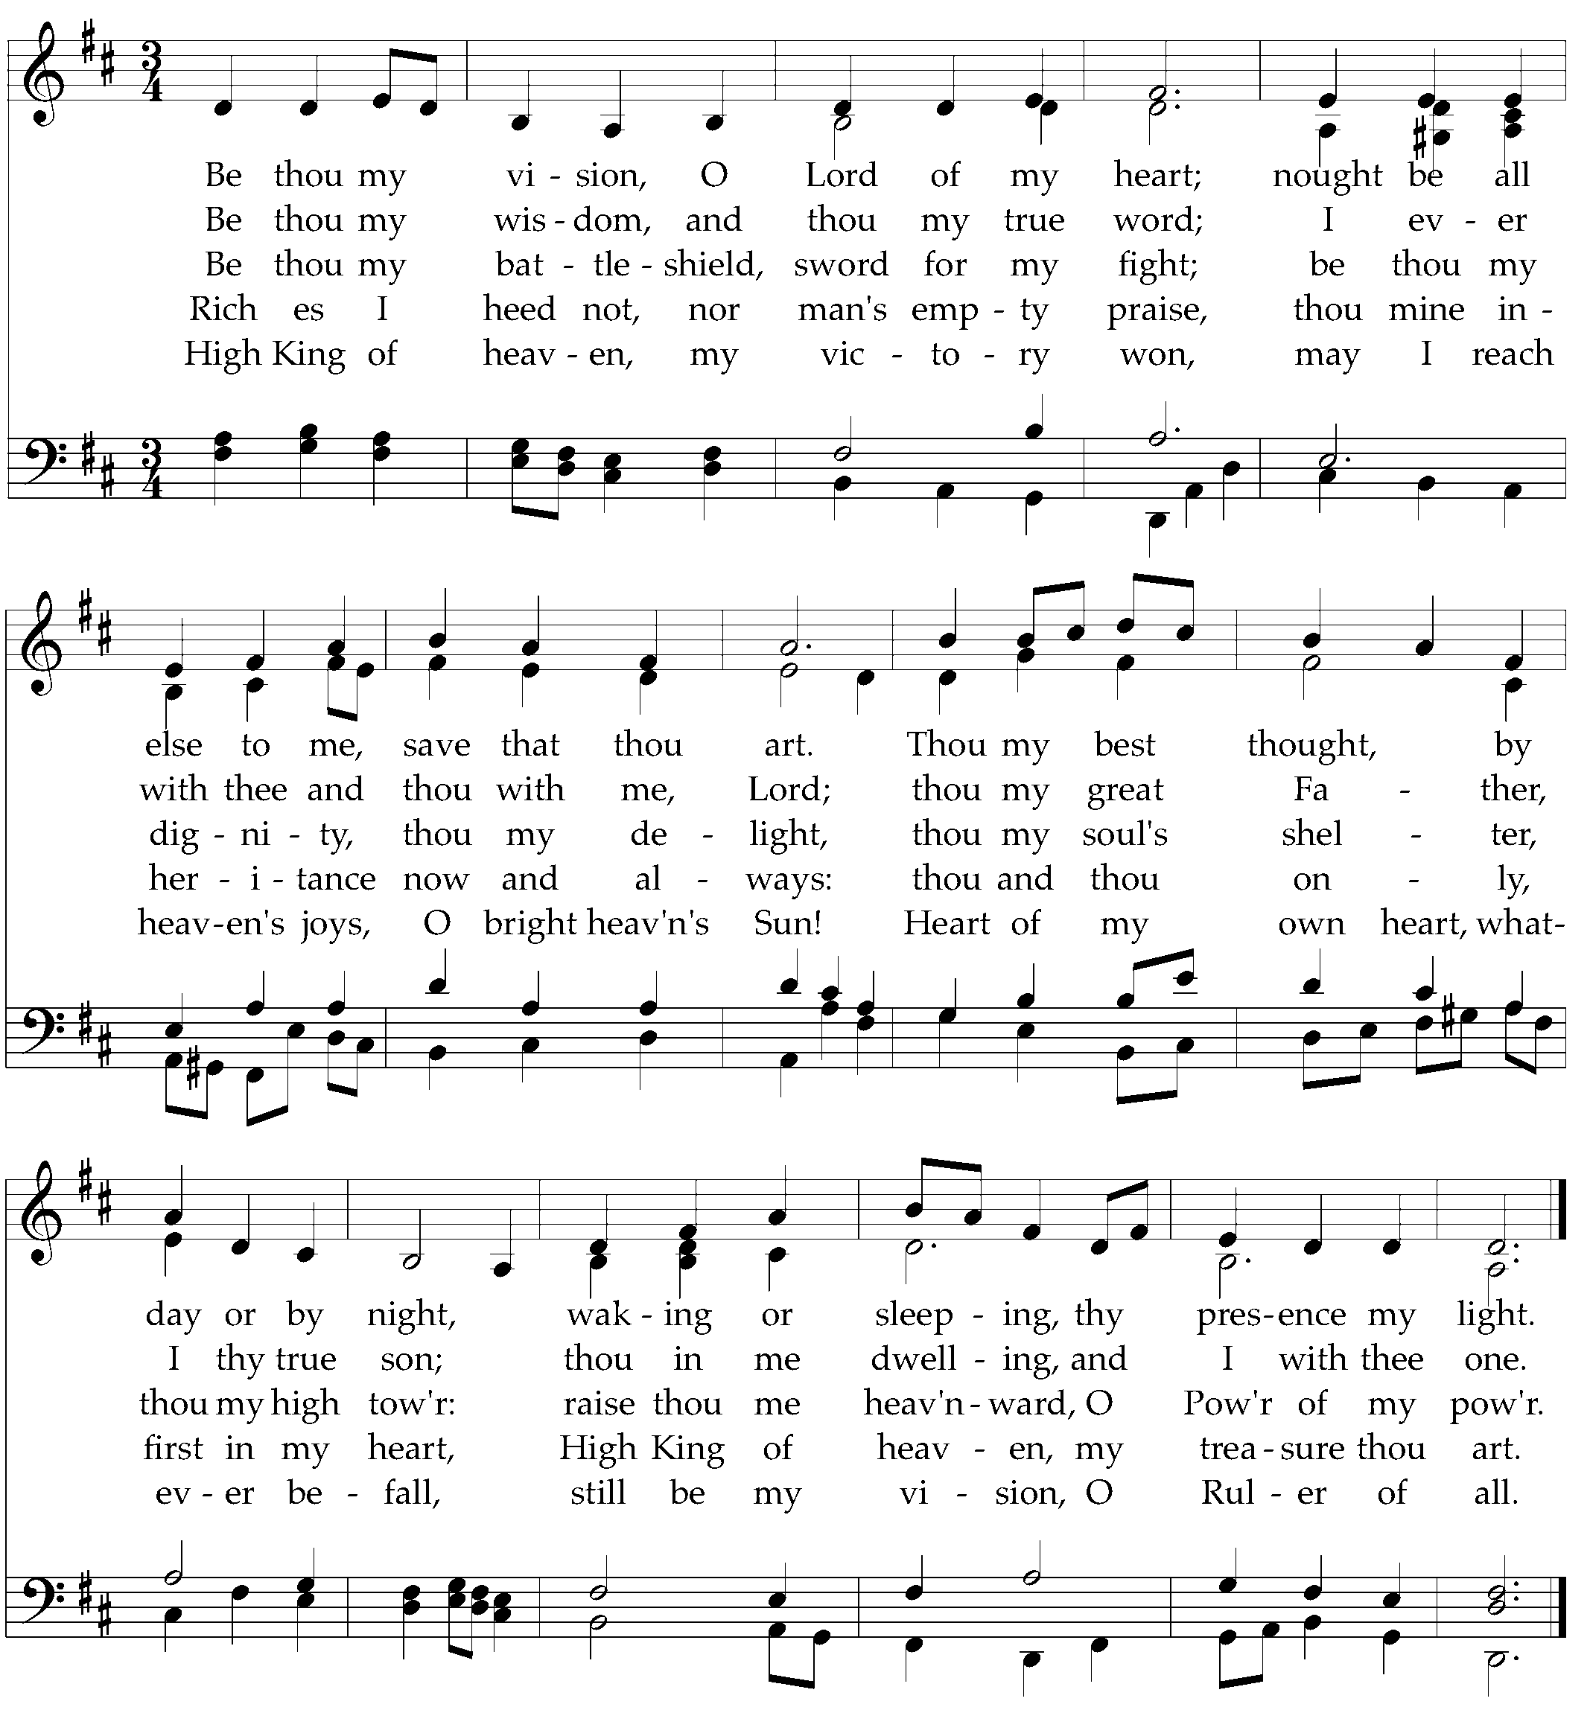
Text: Rob to mo bhoile, a Comdi cride, Ancient Irish Poem, 8th century, trans Mary Byrne, 1880-1931;
Music: Slane, Traditional Irish Melody.
God Sends His People out
After calling His people into His presence, forgiving their sins, instructing them in His Word, and providing a foretaste of the marriage supper of the Lamb, God sends His people into the world to show His light in the darkness.

Benediction—from I Peter 5:6-7, 10-11

Humble yourselves, therefore, under the mighty hand of God so that at the proper time he may exalt you, casting all your anxieties on him, because he cares for you. And after you have suffered a little while, the God of all grace, who has called you to his eternal glory in Christ, will himself restore, confirm, strengthen, and establish you. To him be the dominion forever and ever. Amen.

Sung Response—Barocha (Numbers 6:24)
CCLI #11121087 © 1989 Birdwing Music; Text and Music: Michael Card, 1989.

Cornerstone Presbyterian Church
Presbyterian Church in America
Pastor: Nate Shurden (618-4707 Office) or nate@cstonepres.org
Worship and Chief Musician: Greg Wilbur (512-4156) or greg@cstonepres.org
Administrative Assistant: Susan Bumpus (618-4707) or office@cstonepres.org
Home Fellowship Coordinator: Randy Allen (260-1884) or randmanrx@gmail.com
Nursery Coordinator: Linda VanGorden (406-4431) or vangordenlinda@yahoo.com
Elementary Discipleship Coordinator: Lorrie Mathews (429-8355) or lorriegm@gmail.com

Ruling Elders
Terry Cheney (579-7089) Cy Fenton (500-5304) Jim Smith (347-4188)
Chuck Emerson: Emeritus (661-9273) Stacy McGuire (339-3900) Greg Wilbur (512-4156)

Deacons
Clint Branch (516-9855) Kevin McClung (243-9228) Larry Thompson (901-734-1520)
Joe Haworth (289-7543) David Steffens (513-4873) Bob Vermilye (599-9577)
Riley May (866-8662)

Post Office Box 407 h Franklin, Tennessee 37065 h
www.cornerstonepresfranklin.org h (615) 618-4707

All Scripture quotations from the English Standard Version

