Service of Celebration and Gospel Renewal

Ordinary Time—Sundays of Pentecost
04 August 2013
Worship Notes

The snare of riches and the temptation to trust in our own strength help form the theme from this morning’s passage from Luke 12. Our accumulated wealth means nothing in the light of eternity. The Call to Worship from Psalm 16 reminds us that it is God who is our portion and that we have a beautiful inheritance that includes pleasures at His right hand forevermore. We sing praises with O for a Thousand Tongues to Sing and Worship the Lord in the Beauty of Holiness.
The Old Testament Reading from Psalm 49 confronts us with the sobering reality that wealth and an abundance of riches can neither ransom someone’s life or pay off God. We perish and leave our wealth to another. The Prayer of Confession from I Timothy 6 deals with our sources of contentment and what it means to store up Godly treasure. The Assurance of Pardon from Ephesians 1 states that we have obtained an inheritance in Christ that is guaranteed by the Holy Spirit.
Jesus, Draw Me Ever Nearer gives some perspective on the true blessings of our journey as we lay all our treasure at His throne. In the first Communion Hymn, Deck Yourself My Soul With Gladness, we sing of the priceless gifts of heaven that are offered to us through Christ—the vast and deep treasure of His love. Come Ye Disconsolate reminds us that the best of this world and the sorrows of this world are ultimately healed by the gift of heaven.
As our final hymn, Jesus, I am Resting, Resting, is a prayer for the sufficiency of Christ as our only joy.
—Greg Wilbur

God Calls His People to Worship

It is God Himself who calls His people to worship. We do not call ourselves, but it is the King who opens His gates and beckons us into his courts.

Prelude. Announcements & Preparation

Introit—Crown Him with Many Crowns, Vs 7
Text: Matthew Bridges, 1852; Music: Diademata, George J. Elvey, 1868.

Call to Worship—from Psalm 16:5-9, 11

Pastor: The Lord is our chosen portion and our cup; He holds our lot.
The lines have fallen for us in pleasant places; indeed, we have a beautiful inheritance.

All: We bless the Lord who gives us counsel; in the night also our heart instructs us.

Pastor: We have set the Lord always before us;
because he is at our right hand, we shall not be shaken.

All: Therefore our hearts our glad, and our whole beings rejoice; our flesh also dwells secure.

Pastor: You make known to us the path of life; in Your presence there is fullness of joy;

All: At Your right hand are pleasures forevermore.

Hymn of Praise—O For a Thousand Tongues to Sing
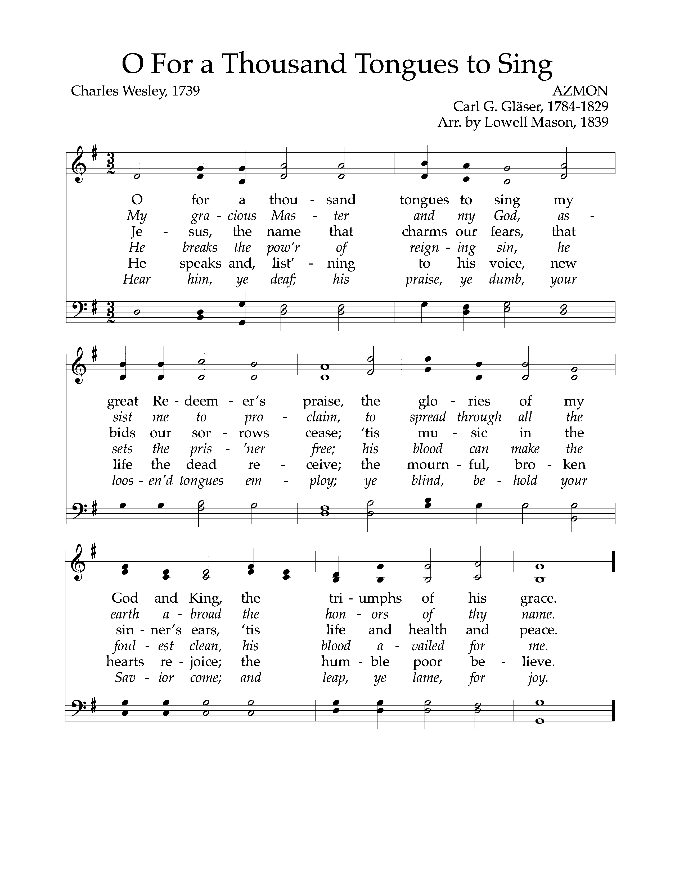
Text: Charles Wesley, 1739; Music: Azmon, Carl G. Gläser, 1784-1829, Arr. By Lowell Mason, 1839.
Hymn of Praise—Worship the Lord in the Beauty of Holiness
Text: J.S.B. Monsell, 1863; Music: Greyfriars Press, 2013. Used by permission.

(Please be seated)

Old Testament Reading—Psalm 49:5-12; 16-20
No man can ransom another or give God the price of his life.

5 Why should I fear in times of trouble,
when the iniquity of those who cheat me surrounds me,
6 those who trust in their wealth and boast of the abundance of their riches?
7 Truly no man can ransom another, or give to God the price of his life,
8 for the ransom of their life is costly and can never suffice,
9 that he should live on forever and never see the pit.

10 For he sees that even the wise die;
the fool and the stupid alike must perish and leave their wealth to others.
11 Their graves are their homes forever,
their dwelling places to all generations, though they called lands by their own names.
12 Man in his pomp will not remain; he is like the beasts that perish.

16 Be not afraid when a man becomes rich, when the glory of his house increases.
17 For when he dies he will carry nothing away; his glory will not go down after him.
18 For though, while he lives, he counts himself blessed
—and though you get praise when you do well for yourself—
19 his soul will go to the generation of his fathers, who will never again see light.
20 Man in his pomp yet without understanding is like the beasts that perish.

Elder: This is the Word of the Lord.
All: Thanks be to God.

God Calls His People to Confession, Repentance, and Reconciliation
The People of God respond to His Word by confessing their sins, repenting of their sinful ways, and seeking God’s favor through the reconciling work of Jesus, the Son of God.

Sung Response—God, Be Merciful to Me, Vs 1
Text: Psalm 51, The Psalter, 1912; Music: Redhead, Richard Redhead, 1853, Adapted 2007.

Corporate Prayer of Confession—based on I Timothy 6:6-11, 17-19

Pastor: Lord, we come confessing. You call us to contentment, for we brought nothing into the world,
and we cannot take anything out of the world.

All: Too often we fall into the snare and temptation of desiring
the perceived security of wealth.

Pastor: This craving has caused some to wander away from the faith
and pierce themselves with many pangs.

All: As Your people, help us to flee this temptation—to pursue righteousness, godliness,
faith, love, steadfastness, and gentleness.

Pastor: O Lord, by any worldly standard we are all rich. Let us not be haughty,
nor set our hopes on the uncertainty of riches,
but on You who richly provides us with everything to enjoy.

All: Help us to do good, to be rich in good works, to be generous and ready to share.

Pastor: Grant us the grace to be free to store up this Godly treasure
so that we may take hold of what is truly life.

Sung Response—Kyrie

Silent Prayers of Confession

Assurance of Pardon—from Ephesians 1:11-14
11 In Christ we have obtained an inheritance, having been predestined according to the purpose of him who works all things according to the counsel of his will, 12 so that we who were the first to hope in Christ might be to the praise of his glory. 13 In him you also, when you heard the word of truth, the gospel of your salvation, and believed in him, were sealed with the promised Holy Spirit, 14 who is the guarantee of our inheritance until we acquire possession of it, to the praise of his glory.

Hymn of Praise—Jesus, Draw Me Ever Nearer
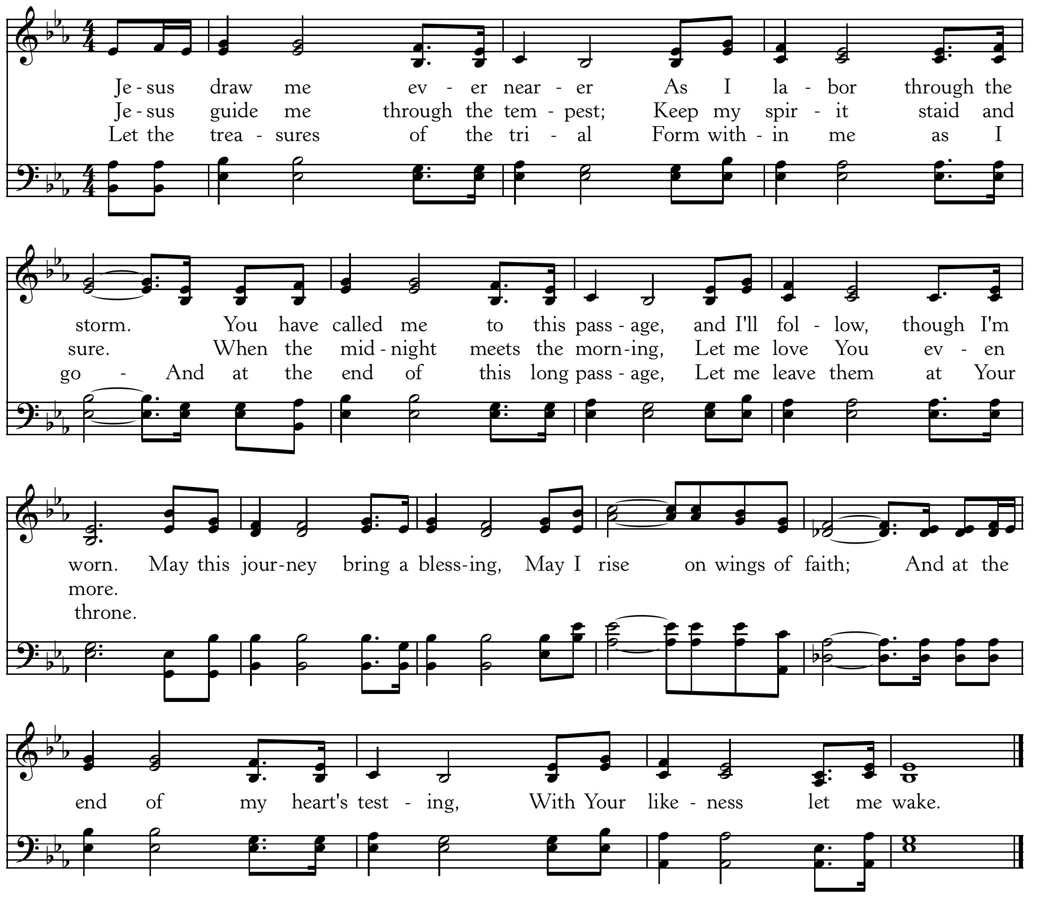
CCLI #11121087 ©2002 Thankyou Music, Text: Margaret Becker, 2002; Music: Keith Getty, 2002

The Reading of the Word—Luke 12:13-21

13 Someone in the crowd said to him [Jesus], “Teacher, tell my brother to divide the inheritance with me.” 14 But he said to him, “Man, who made me a judge or arbitrator over you?” 15 And he said to them, “Take care, and be on your guard against all covetousness, for one’s life does not consist in the abundance of his possessions.” 16 And he told them a parable, saying, “The land of a rich man produced plentifully, 17 and he thought to himself, ‘What shall I do, for I have nowhere to store my crops?’ 18 And he said, ‘I will do this: I will tear down my barns and build larger ones, and there I will store all my grain and my goods. 19 And I will say to my soul, “Soul, you have ample goods laid up for many years; relax, eat, drink, be merry.”’ 20 But God said to him, ‘Fool! This night your soul is required of you, and the things you have prepared, whose will they be?’ 21 So is the one who lays up treasure for himself and is not rich toward God.”

Elder: This is the Word of the Lord.
All: Thanks be to God.

Sermon—The Gospel of Luke, Part 58

Rich Toward God —Nate Shurden, Pastor

Profession of Faith—The Apostles’ Creed

We believe in God, the Father Almighty, the Creator of Heaven and Earth,

And in Jesus Christ, His only Son, our Lord: who was conceived of the Holy Spirit,
Born of the Virgin Mary, Suffered under Pontius Pilate,
Was crucified, died and was buried. He descended into Hell.
On the third day he rose again from the dead.
He ascended into Heaven and now sits at the right hand of God the Father Almighty;
From whence He shall come to judge the living and the dead.

We believe in the Holy Spirit; The one holy Church—both visible and invisible;
The communion of saints; the forgiveness of sins;
The resurrection of the body; and the life everlasting. Amen.

Sung Response—Holy God We Praise Your Name, Vs 4
Text: Based on Te Deum, 4th c., Attr Ignace Franz, 1774; Music: Groser Gott, Katholisches Gesangbuch, 1774.

The Sacrament of the Lord’s Supper
God offers to His people the gift of communion with Him through the grace of the sacrament and we respond in thanksgiving.

Words of Institution and the Lord’s Table
Having confessed our sins and made a good profession of faith, God's Table is open to all those “faithfully-fenced" members of the covenant community. Please come forward to partake of this means of grace. You may take the bread at the first table and then proceed to either side for the wine/grape juice.

Hymn of Communion—Deck Yourself My Soul With Gladness
Text: Johann Franck, 1649, Tr. Catherine Winkworth, 1858; Music: Schmücke dich, Johann Cruger, 1598-1662.

Hymn of Communion—Come Ye Disconsolate

CCLI #11121087 Text: Thomas Moore, 1816; Music: Disconsolate, Gregory D Wilbur, 2007.

God’s People Respond in Grateful Praise

Prayer of Thanksgiving and Intercession

The Lord’s Prayer
Our Father, who art in heaven, Hallowed be thy Name.
Thy kingdom come. Thy will be done, On earth as it is in heaven.
Give us this day our daily bread. And forgive us our debts, As we forgive our debtors.
And lead us not into temptation, But deliver us from evil.
For Thine is the Kingdom, and the power, and the glory, forever. Amen.

Hymn of Praise—Jesus, I am Resting, Resting
CCLI #11121087 © 1998 New Spring Music; Text: Jean S. Pigott, 1876; Music: David Hampton, 1998.
God Sends His People out
After calling His people into His presence, forgiving their sins, instructing them in His Word, and providing a foretaste of the marriage supper of the Lamb, God sends His people into the world to show His light in the darkness.

Benediction—from I Peter 5:6-7, 10-11

Humble yourselves, therefore, under the mighty hand of God so that at the proper time he may exalt you, casting all your anxieties on him, because he cares for you. And after you have suffered a little while, the God of all grace, who has called you to his eternal glory in Christ, will himself restore, confirm, strengthen, and establish you. To him be the dominion forever and ever. Amen.

Sung Response—Christ Be With Me (from St. Patrick’s Breastplate)
Text: Atomriug indui niurt tren, St. Patrick, 372-466, Trans by Cecil Frances Alexander, 1818-95;
Music: St. Patrick Clonmacnoise, Traditional Irish Hymn Melody.

Cornerstone Presbyterian Church
Presbyterian Church in America
Pastor: Nate Shurden (618-4707 Office) or nate@cstonepres.org
Worship and Chief Musician: Greg Wilbur (512-4156) or greg@cstonepres.org
Administrative Assistant: Susan Bumpus (618-4707) or office@cstonepres.org
Home Fellowship Coordinator: Randy Allen (260-1884) or randmanrx@gmail.com
Nursery Coordinator: Linda VanGorden (406-4431) or vangordenlinda@yahoo.com
Elementary Discipleship Coordinator: Lorrie Mathews (429-8355) or lorriegm@gmail.com

Ruling Elders
Terry Cheney (579-7089) Grant Hensley (390-8828) Jim Smith (347-4188)
Chuck Emerson: Emeritus (661-9273) Stacy McGuire (339-3900) Greg Wilbur (512-4156)
Cy Fenton (500-5304)

Deacons
Clint Branch (516-9855) Kevin McClung (243-9228) Larry Thompson (901-734-1520)
Joe Haworth (289-7543) David Steffens (513-4873) Bob Vermilye (599-9577)
Riley May (866-8662)

Post Office Box 407 h Franklin, Tennessee 37065 h
www.cornerstonepresfranklin.org h (615) 618-4707

All Scripture quotations from the English Standard Version

