Service of Celebration and Gospel Renewal

Ordinary Time—Sundays of Pentecost
28 July 2013
Worship Notes

The fear of the Lord, fear of man, and the godly comfort of “Do not fear” along with the boldness of acknowledging Christ before men form some of the backdrop of our passage from Luke 12. The service begins with godly fear from Psalm 22 in the Call to Worship—You who fear the Lord, praise Him! We continue with singing Holy, Holy, Holy! and God is My Strong Salvation—What foe have I to fear?
The New Testament Reading from I John 4 reminds us that we have confidence on the day of judgment because the perfect love of the Father as expressed in Christ casts out all fear. The Prayer of Confession from II Corinthians 6 and 7 this love is expounded in being called the sons and daughters of God and “holiness comes to completion in the fear” of the Lord.
The freedom from fear as expressed in Isaiah 43 becomes both our Assurance of Pardon and our next hymn of praise. The Communion Hymns include Approach My Soul, the Mercy Seat where we come for rest from the war without and the fears within and My Faith has Found a Resting Place in the blood of Christ that ends our fears and doubts.
We conclude the service with In Christ Alone and the power of Christ in us that frees us from guilt in life and fear in death.
—Greg Wilbur

God Calls His People to Worship

It is God Himself who calls His people to worship. We do not call ourselves, but it is the King who opens His gates and beckons us into his courts.

Prelude. Announcements & Preparation

Introit—Crown Him with Many Crowns, Vs 7
Text: Matthew Bridges, 1852; Music: Diademata, George J. Elvey, 1868.

Call to Worship—from Psalm 22:22-24

Pastor: We will tell of your name to the peoples; in the midst of the congregation we will praise you:

All: You who fear the Lord, praise him!

Pastor: All you offspring of Jacob, glorify him,

All: Stand in awe of him, all you offspring of Israel!

Pastor: For he has not despised or abhorred the affliction of the afflicted,
and he has not hidden his face from us,

All: But he has heard, when we cried to him.

Hymn of Praise—Holy, Holy, Holy
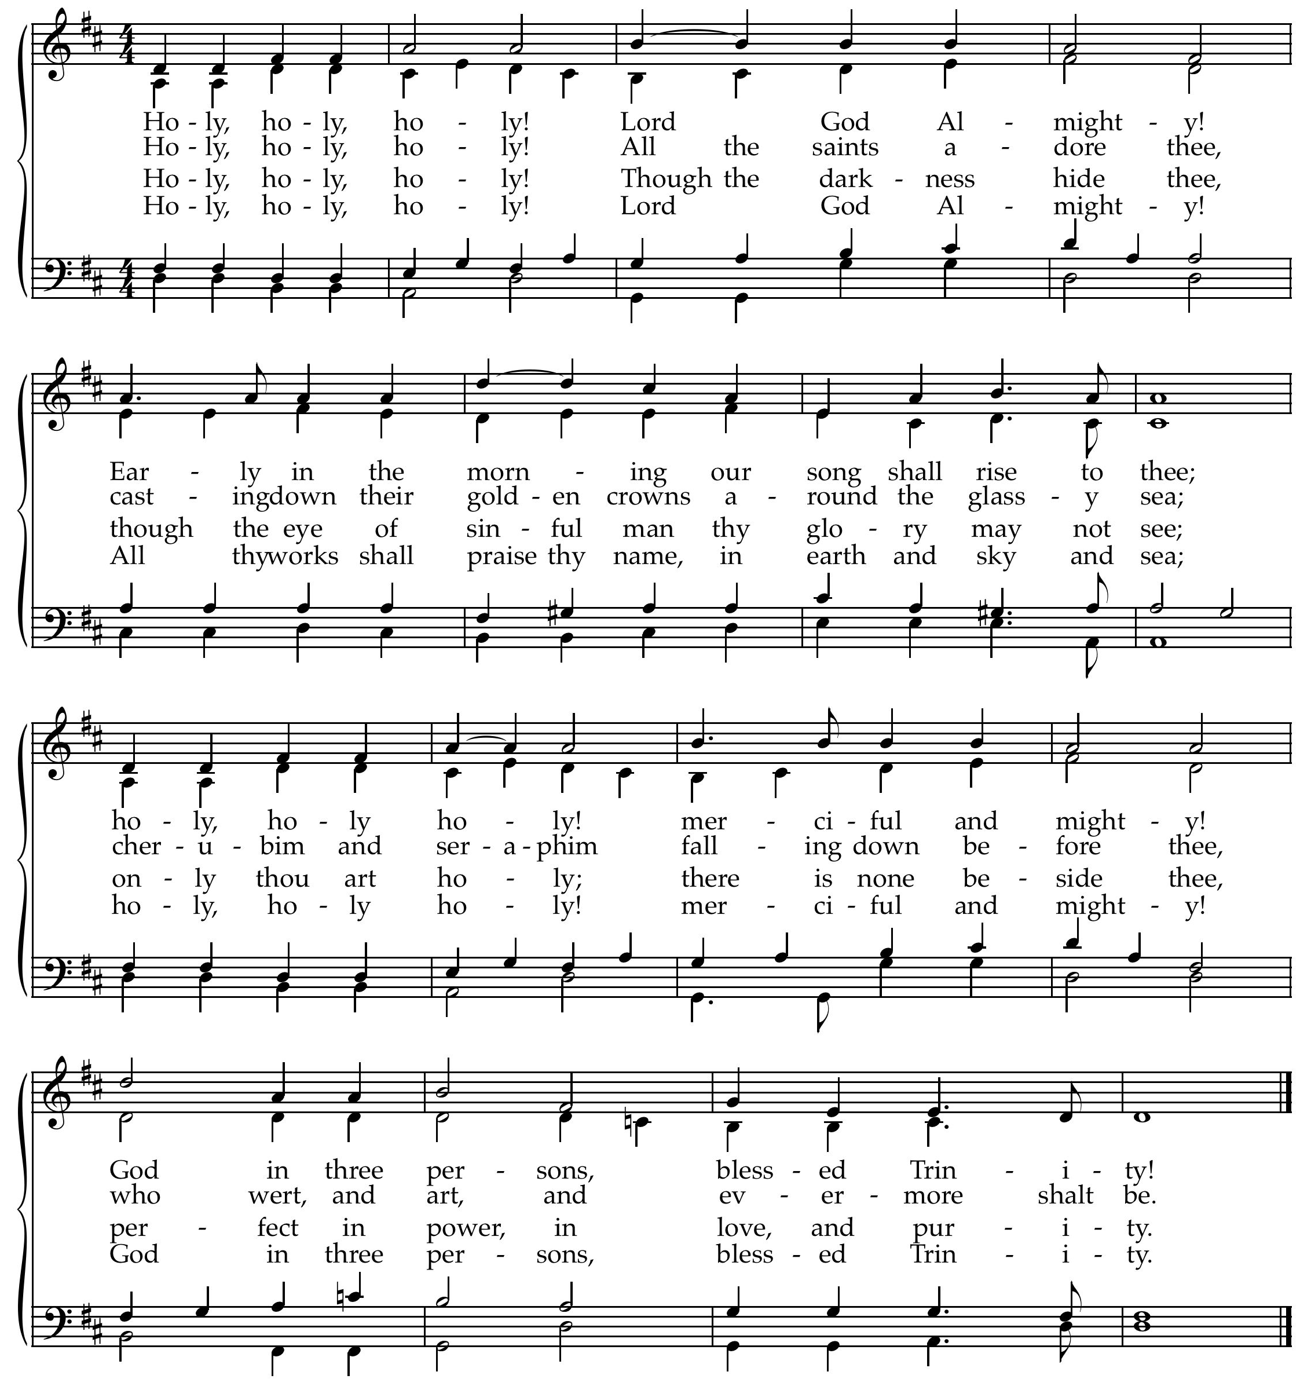
Text: Reginald Heber, 1783-1826; Music: Nicaea, John B. Dykes, 1861.
Hymn of Praise—God is My Strong Salvation: Psalm 27
Text: Psalm 27, James Montgomery, 1822; Music: Aurelia, Samuel S. Wesley, 1864.

(Please be seated)

New Testament Reading—I John 4:13-21
Perfect love casts out fear.

13 By this we know that we abide in him and he in us, because he has given us of his Spirit. 14 And we have seen and testify that the Father has sent his Son to be the Savior of the world. 15 Whoever confesses that Jesus is the Son of God, God abides in him, and he in God. 16 So we have come to know and to believe the love that God has for us. God is love, and whoever abides in love abides in God, and God abides in him. 17 By this is love perfected with us, so that we may have confidence for the day of judgment, because as he is so also are we in this world. 18 There is no fear in love, but perfect love casts out fear. For fear has to do with punishment, and whoever fears has not been perfected in love. 19 We love because he first loved us. 20 If anyone says, “I love God,” and hates his brother, he is a liar; for he who does not love his brother whom he has seen cannot love God whom he has not seen. 21 And this commandment we have from him: whoever loves God must also love his brother.

Elder: This is the Word of the Lord.
All: Thanks be to God.

God Calls His People to Confession, Repentance, and Reconciliation
The People of God respond to His Word by confessing their sins, repenting of their sinful ways, and seeking God’s favor through the reconciling work of Jesus, the Son of God.

Sung Response—Come, O Redeemer, Come

CCLI #11121087 ©1996 Metro One, Inc. Text and Music: Fernando Ortega, 1996.

Corporate Prayer of Confession—based on II Corinthians 6:16-18, 7:1, 10-11

Pastor: Lord, we come confessing. You have said that we should be as sons and daughters to You.
That You would make Your dwelling with us and walk among us.
That You would be our God.

All: Since we have these promises, let us cleanse ourselves
from every defilement of body and spirit.

Pastor: For holiness comes to completion in the fear of You, O God. Our sins grieve us.

All: Godly grief produces repentance that leads to salvation without regret.

Pastor: Whereas worldly grief produces death.

All: Stir up an earnestness in us through this godly grief.

Pastor: That with eagerness, indignation, fear, longing and zeal
we will seek repentance and be cleansed.

Sung Response—Kyrie

Silent Prayers of Confession

Assurance of Pardon—from Isaiah 43:1, 3

But now thus says the Lord, he who created you, O Jacob, he who formed you, O Israel:
“Fear not, for I have redeemed you; I have called you by name, you are mine.
For I am the Lord your God, the Holy One of Israel, your Savior.

Hymn of Promise—Isaiah 43
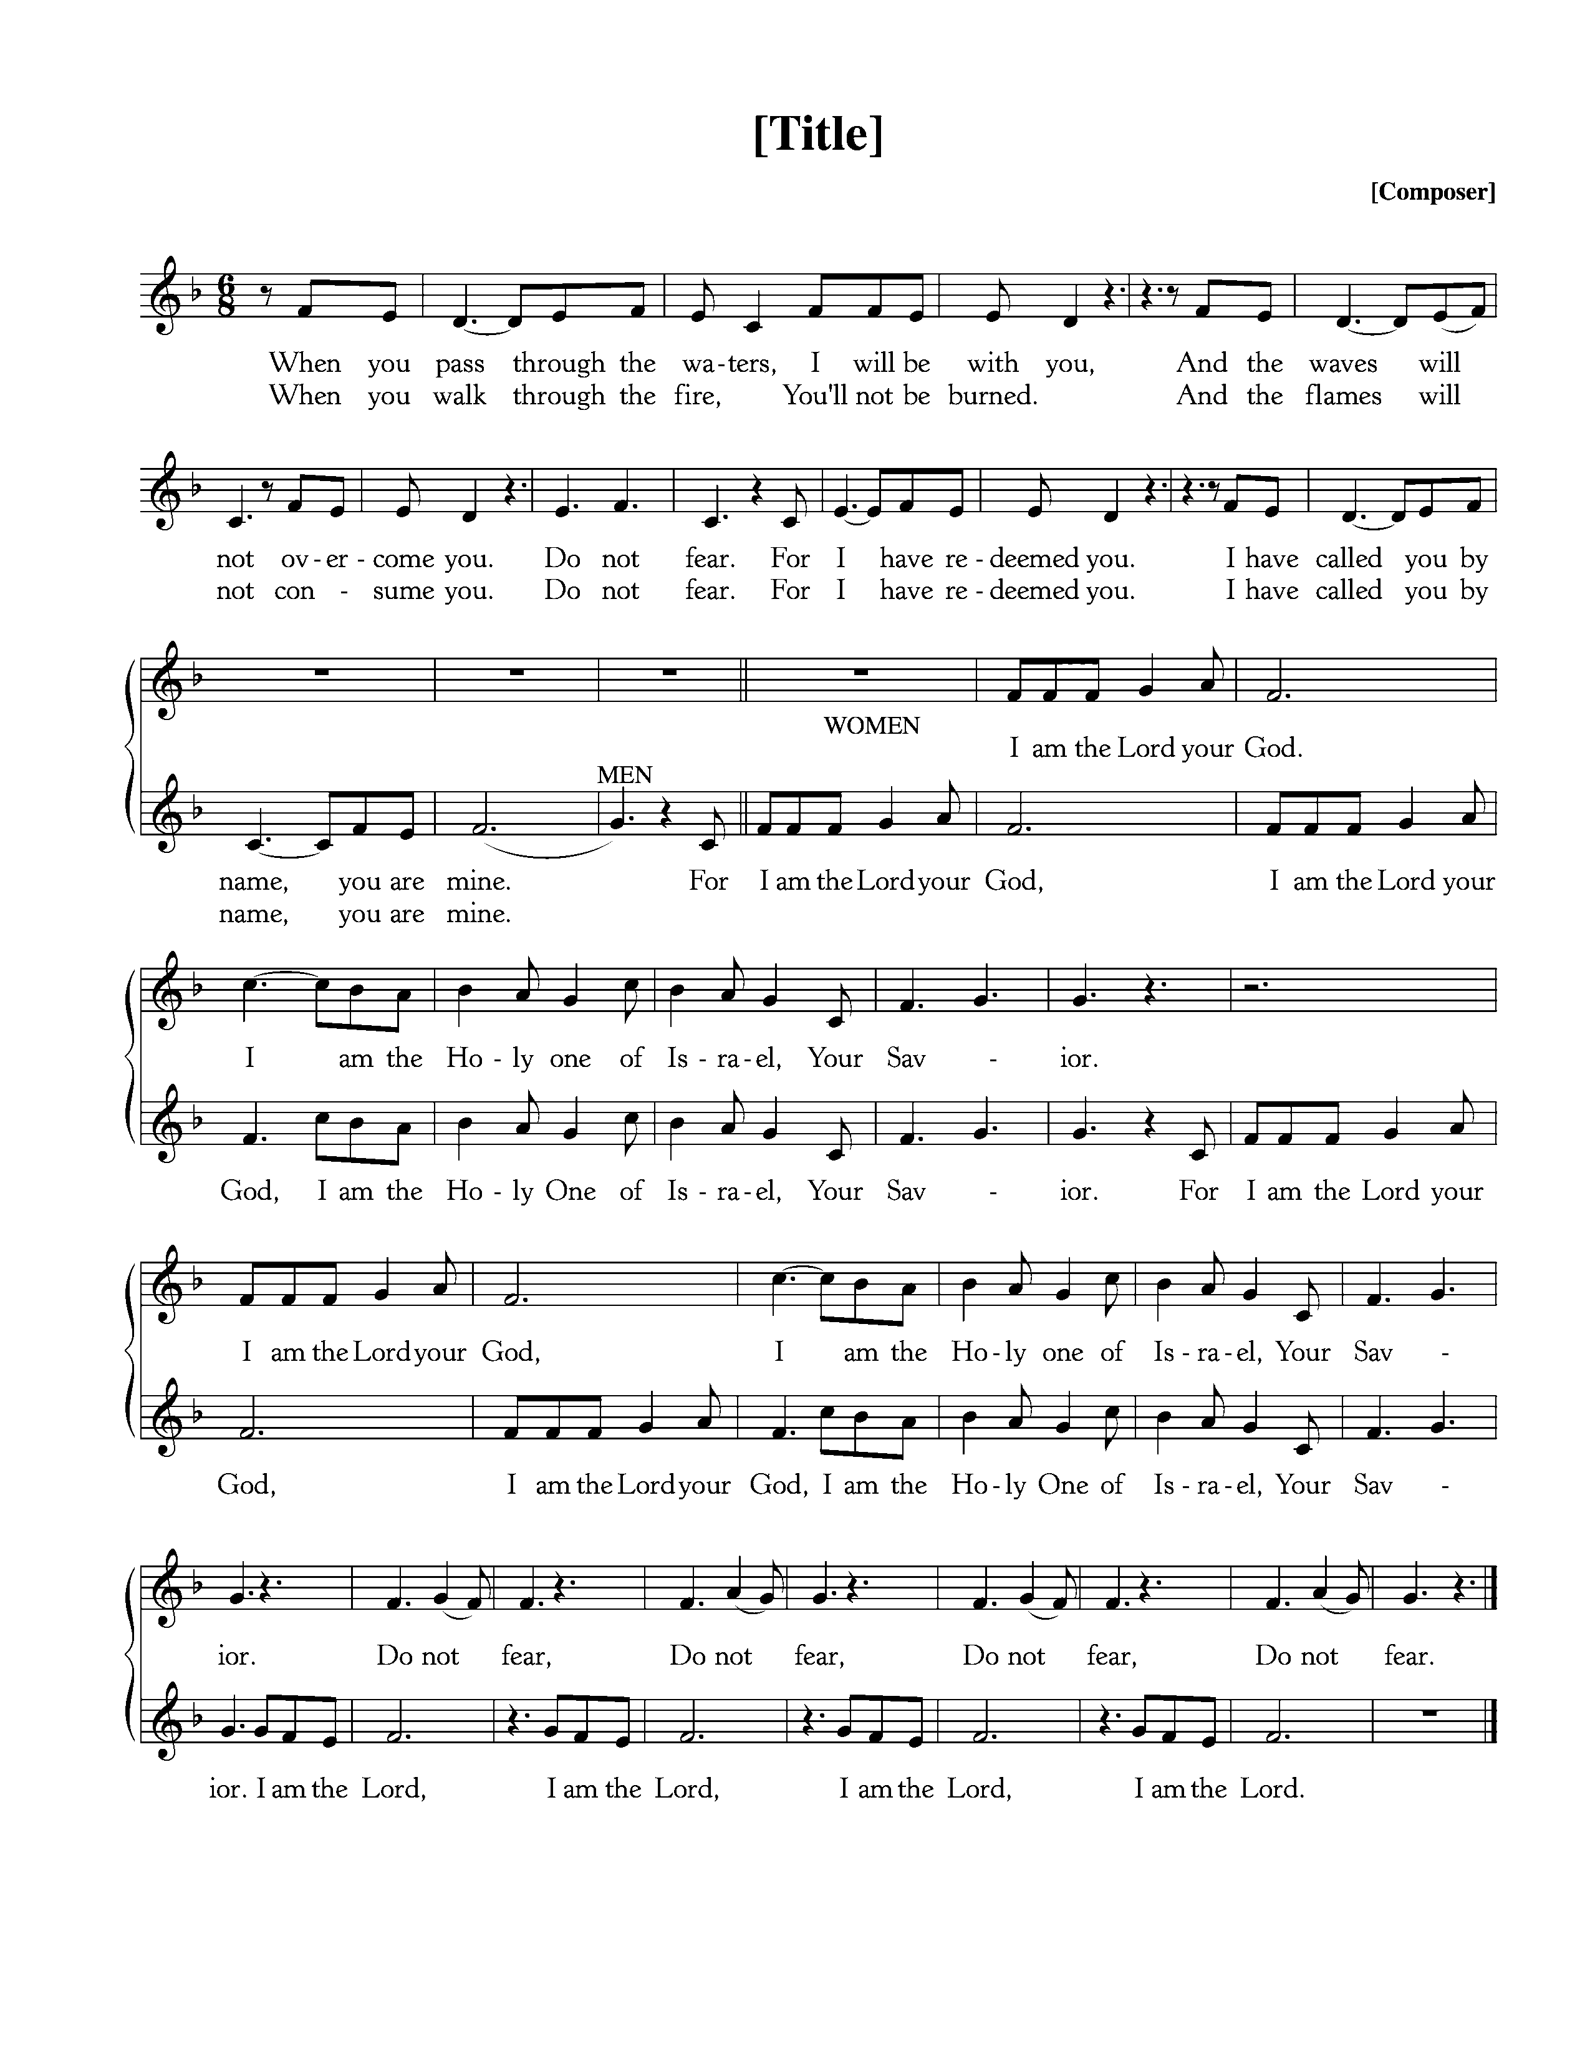
Text: Isaiah 43, Anonymous; Music: Anonymous.

Commissioning—Ryan and Raechel Myers to Guatemala

The Reading of the Word—Luke 12:4-12

4 “I tell you, my friends, do not fear those who kill the body, and after that have nothing more that they can do. 5 But I will warn you whom to fear: fear him who, after he has killed, has authority to cast into hell. Yes, I tell you, fear him! 6 Are not five sparrows sold for two pennies? And not one of them is forgotten before God. 7 Why, even the hairs of your head are all numbered. Fear not; you are of more value than many sparrows.
8 “And I tell you, everyone who acknowledges me before men, the Son of Man also will acknowledge before the angels of God, 9 but the one who denies me before men will be denied before the angels of God. 10 And everyone who speaks a word against the Son of Man will be forgiven, but the one who blasphemes against the Holy Spirit will not be forgiven. 11 And when they bring you before the synagogues and the rulers and the authorities, do not be anxious about how you should defend yourself or what you should say, 12 for the Holy Spirit will teach you in that very hour what you ought to say.”

Elder: This is the Word of the Lord.
All: Thanks be to God.

Sermon—The Gospel of Luke, Part 57

Fearing God, So As Not To Be Afraid —Nate Shurden, Pastor

Profession of Faith—The Apostles’ Creed

We believe in God, the Father Almighty, the Creator of Heaven and Earth,

And in Jesus Christ, His only Son, our Lord: who was conceived of the Holy Spirit,
Born of the Virgin Mary, Suffered under Pontius Pilate,
Was crucified, died and was buried. He descended into Hell.
On the third day he rose again from the dead.
He ascended into Heaven and now sits at the right hand of God the Father Almighty;
From whence He shall come to judge the living and the dead.

We believe in the Holy Spirit; The one holy Church—both visible and invisible;
The communion of saints; the forgiveness of sins;
The resurrection of the body; and the life everlasting. Amen.

Response of Praise—Glory Be to God the Father, Vs 1

Text: Horatius Bonar, 1868; Music: Gregory Wilbur, 2011. ©2011 Greyfriars Press

The Sacrament of the Lord’s Supper
God offers to His people the gift of communion with Him through the grace of the sacrament and we respond in thanksgiving.

Words of Institution and the Lord’s Table
Having confessed our sins and made a good profession of faith, God's Table is open to all those “faithfully-fenced" members of the covenant community. Please come forward to partake of this means of grace. You may take the bread at the first table and then proceed to either side for the wine/grape juice.

Hymn of Communion—Approach, My Soul, the Mercy Seat

Text: John Newton, 1779; Music: Approach My Soul, Gregory Wilbur, 2011. ©2011 Greyfriars Press

Hymn of Communion—My Faith Has Found a Resting Place

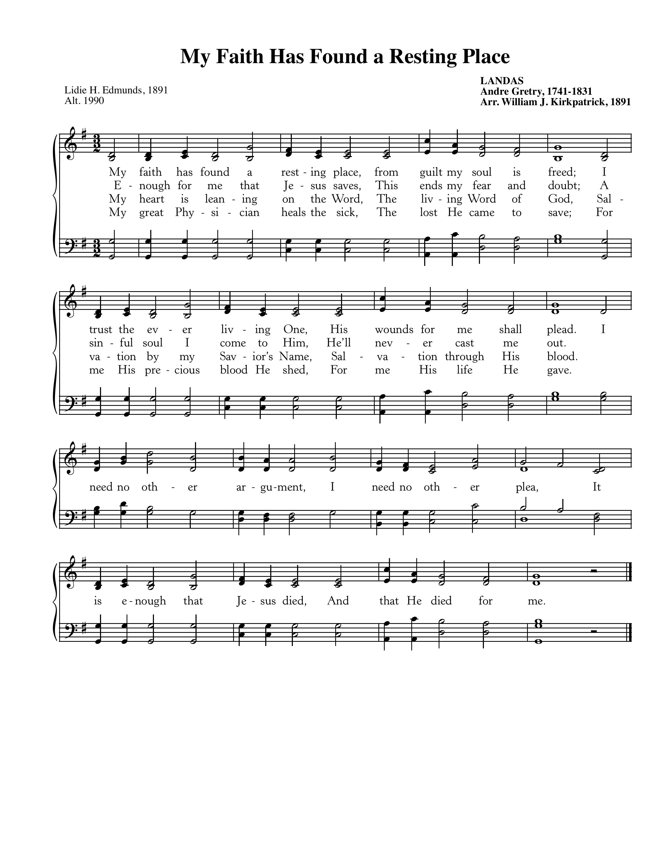

Text: Lidie H. Edmunds, 1891; Music: Landas, Andre Gretry, 1741-1831, Arr. by William J. Kirkpatrick, 1891.

God’s People Respond in Grateful Praise

Prayer of Thanksgiving and Intercession

The Lord’s Prayer
Our Father, who art in heaven, Hallowed be thy Name.
Thy kingdom come. Thy will be done, On earth as it is in heaven.
Give us this day our daily bread. And forgive us our debts, As we forgive our debtors.
And lead us not into temptation, But deliver us from evil.
For Thine is the Kingdom, and the power, and the glory, forever. Amen.

Hymn of Praise—In Christ Alone

CCLI #11121087 © 2002 Thankyou Music; Text and Music: Keith Getty and Stuart Townend.
God Sends His People out
After calling His people into His presence, forgiving their sins, instructing them in His Word, and providing a foretaste of the marriage supper of the Lamb, God sends His people into the world to show His light in the darkness.

Benediction—from Hebrews 13:15-16

Through Christ continually offer up a sacrifice of praise to God, that is, the fruit of lips that acknowledge his name. Do not neglect to do good and to share what you have, for such sacrifices are pleasing to God. Amen.

Sung Response—Christ Be With Me (from St. Patrick’s Breastplate)
Text: Atomriug indui niurt tren, St. Patrick, 372-466, Trans by Cecil Frances Alexander, 1818-95;
Music: St. Patrick Clonmacnoise, Traditional Irish Hymn Melody.

Today from Luke 12:4-12, Jesus distinguishes for us true and false fear and leads us to rest in His providence for whatever comes into our lives.

- What is the fear of man?

- How is hypocrisy (last week’s message) tied to fear of man?

- What are ways you evidence fear of man in your life?

- Why should God be feared? Do you fear God?

- How does the fear of God drive us to be a witness for God in the world?

- How does the gospel cause us to fear God enough to love him?

“No one can know the true grace of God who has not first known the true fear of God.”—A.W. Tozer

Cornerstone Presbyterian Church
Presbyterian Church in America
Pastor: Nate Shurden (618-4707 Office) or nate@cstonepres.org
Worship and Chief Musician: Greg Wilbur (512-4156) or greg@cstonepres.org
Administrative Assistant: Susan Bumpus (618-4707) or office@cstonepres.org
Home Fellowship Coordinator: Randy Allen (260-1884) or randmanrx@gmail.com
Nursery Coordinator: Linda VanGorden (406-4431) or vangordenlinda@yahoo.com
Elementary Discipleship Coordinator: Lorrie Mathews (429-8355) or lorriegm@gmail.com

Ruling Elders
Terry Cheney (579-7089) Grant Hensley (390-8828) Jim Smith (347-4188)
Chuck Emerson: Emeritus (661-9273) Stacy McGuire (339-3900) Greg Wilbur (512-4156)
Cy Fenton (500-5304)

Deacons
Clint Branch (516-9855) Kevin McClung (243-9228) Larry Thompson (901-734-1520)
Joe Haworth (289-7543) David Steffens (513-4873) Bob Vermilye (599-9577)
Riley May (866-8662)

Post Office Box 407 h Franklin, Tennessee 37065 h
www.cornerstonepresfranklin.org h (615) 618-4707

All Scripture quotations from the English Standard Version

