Service of Celebration and Gospel Renewal

Ordinary Time—Sundays of Pentecost
14 July 2013
Worship Notes

Continuing in Luke 11, we next come to the passage describing what it means to be full of light having no darkness as a lamp on a stand gives out light. The Call to Worship from Isaiah 42 speaks of the Lord giving His people as a light for the nations to bring out those who sit in darkness. We respond by singing Glory Be to God the Father and Immortal, Invisible.
The New Testament Reading from I Peter 2 reminds us that God has called us out of darkness into His marvelous light—what a fitting metaphor of conversion from stumbling in the darkness to walking in the light of the knowledge of the glory of God in the face of Christ. The Prayer of Confession from Isaiah 59 emphasizes this reality of the separation that sin has caused in darkness, gloom, and in stumbling. The Assurance of Pardon from I John 1 dispels this darkness and separation by the encouragement to walk in the light, in fellowship, in the forgiveness of our sins.
Come, Thou Fount of Every Blessing serves to remind us that we are prone to wander, but the Lord God seals our heart in His kingdom of light. The Hymns of Communion, Give, Me Jesus and It is Well, further emphasize our need for Christ and the assurance that He brings as light in our darkness.
We conclude by singing, Love Divine, All Love’s Excelling as a prayer for God to continue His work in us to finish us as new creations.
—Greg Wilbur

God Calls His People to Worship

It is God Himself who calls His people to worship. We do not call ourselves, but it is the King who opens His gates and beckons us into his courts.

Prelude

Announcements & Preparation

Introit—Jesus Shall Reign
Text: Isaac Watts, 1719; Music: Duke Street, John Hatton, 1793.

Call to Worship—from Isaiah 42:5-7, 10

Pastor: Thus says God, the Lord, who created the heavens and stretched them out,
who spread out the earth and what comes from it,
who gives breath to the people on it and spirit to those who walk in it:

All: “I am the Lord; I have called you in righteousness;

Pastor: I will take you by the hand and keep you;
I will give you as a covenant for the people, a light for the nations,

All: To open the eyes that are blind, to bring out the prisoners from the dungeon,
and those who sit in darkness.

Pastor: Sing to the Lord a new song,

All: Sing His praise from the end of the earth.

Hymn of Praise—Glory be to God the Father

Text: Horatius Bonar, 1868; Music: Gregory Wilbur, 2011. ©2011 Greyfriars Press. Used by Permission.
Hymn of Praise—Immortal, Invisible, God Only Wise
Text: Walter Chalmers Smith, 1867; Music: St. Denio, Traditional Welsh Melody.

(Please be seated)

New Testament Reading——I Peter 2:9-12

He has called us out of darkness into His marvelous light

9 But you are a chosen race, a royal priesthood, a holy nation, a people for his own possession, that you may proclaim the excellencies of him who called you out of darkness into his marvelous light. 10 Once you were not a people, but now you are God’s people; once you had not received mercy, but now you have received mercy.
11 Beloved, I urge you as sojourners and exiles to abstain from the passions of the flesh, which wage war against your soul. 12 Keep your conduct among the Gentiles honorable, so that when they speak against you as evildoers, they may see your good deeds and glorify God on the day of visitation.

Elder: This is the Word of the Lord.
All: Thanks be to God.

God Calls His People to Confession, Repentance, and Reconciliation
The People of God respond to His Word by confessing their sins, repenting of their sinful ways, and seeking God’s favor through the reconciling work of Jesus, the Son of God.

Sung Response—Come, O Redeemer, Come

CCLI #11121087 ©1996 Metro One, Inc. Text and Music: Fernando Ortega, 1996.

Corporate Confession of Sin—based on Isaiah 59:1-2, 9-13

Pastor: Lord, we come confessing. Behold, Your hand is not shortened, that it cannot save,
or Your ear dull, that it cannot hear;

All: But our iniquities have made a separation between us and our God,
and our sins have hidden His face from us.

Pastor: Therefore justice is far from us, and righteousness does not overtake us;

All: We hope for light, and behold, we get darkness.
We hope for brightness, but we walk in gloom.

Pastor: We grope for the wall like the blind; we grope like those who have no eyes;
we stumble at noon as in the twilight, among those in full vigor we are like dead men.

All: We hope for justice, but there is none; for salvation, but it is far from us.

Pastor: For our transgressions are multiplied before You, and our sins testify against us;

All: For our transgressions are with us, and we know our iniquities:

Pastor: We have sinned, and denied the Lord, and turned back from following our God.

Sung Response—Kyrie

Silent Prayers of Confession

Assurance of Pardon—I John 1:7-9

If we walk in the light, as he is in the light, we have fellowship with one another, and the blood of Jesus his Son cleanses us from all sin. If we say we have no sin, we deceive ourselves, and the truth is not in us. If we confess our sins, he is faithful and just to forgive us our sins and to cleanse us from all unrighteousness.

Hymn of Praise—Come, Thou Fount
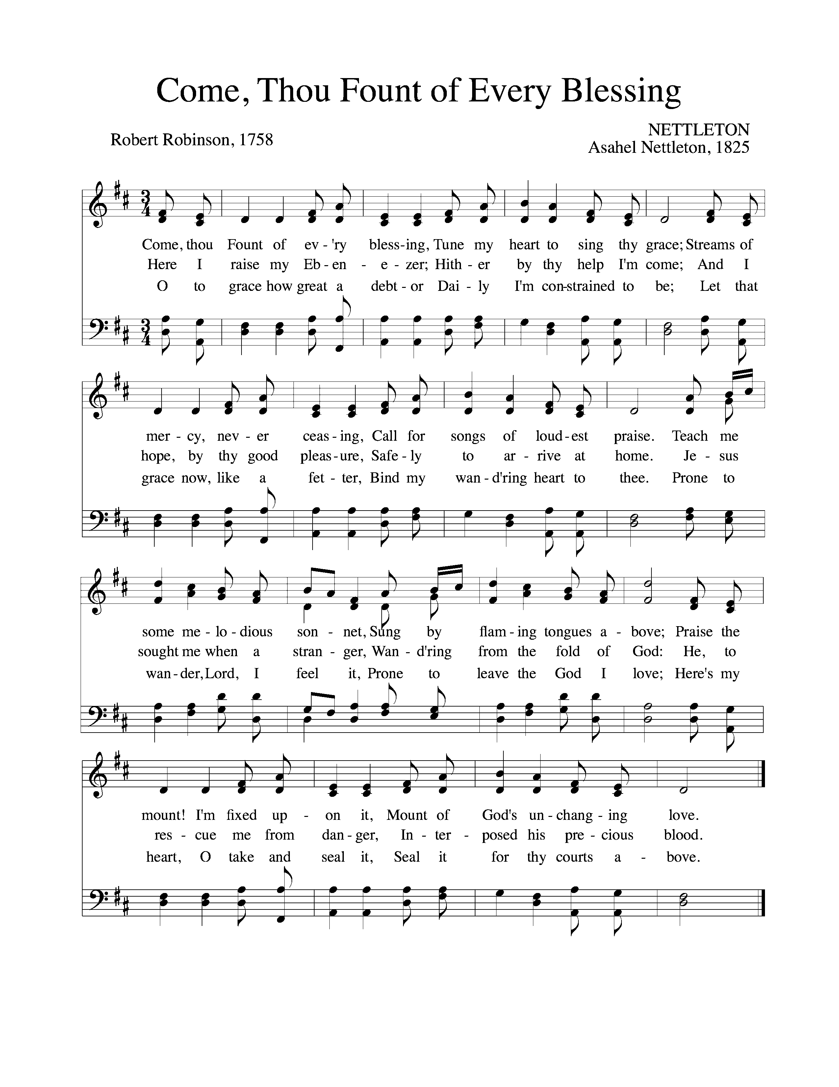
Text: Robert Robinson, 1758; Music: Nettleton, Asahel Nettleton, 1825.

Missions Report—Lincoln Pent, Nicaragua

The Reading of the Word—Luke 11:33-36

33 “No one after lighting a lamp puts it in a cellar or under a basket, but on a stand, so that those who enter may see the light. 34 Your eye is the lamp of your body. When your eye is healthy, your whole body is full of light, but when it is bad, your body is full of darkness. 35 Therefore be careful lest the light in you be darkness. 36 If then your whole body is full of light, having no part dark, it will be wholly bright, as when a lamp with its rays gives you light.”

Elder: This is the Word of the Lord.
All: Thanks be to God.

Sermon—The Gospel of Luke, Part 55
Seeing the Light —Nate Shurden, Pastor

Profession of Faith—The Apostles’ Creed

We believe in God, the Father Almighty, the Creator of Heaven and Earth,

And in Jesus Christ, His only Son, our Lord: who was conceived of the Holy Spirit,
Born of the Virgin Mary, Suffered under Pontius Pilate,
Was crucified, died and was buried. He descended into Hell.
On the third day he rose again from the dead.
He ascended into Heaven and now sits at the right hand of God the Father Almighty;
From whence He shall come to judge the living and the dead.

We believe in the Holy Spirit; The one holy Church—both visible and invisible;
The communion of saints; the forgiveness of sins;
The resurrection of the body; and the life everlasting. Amen.
Sung Response—O Praise the Father

Text: John Mason, 1683; Music: Gregory Wilbur, 2011.

The Sacrament of the Lord’s Supper
God offers to His people the gift of communion with Him through the grace of the sacrament and we respond in thanksgiving.

Words of Institution and the Lord’s Table
Having confessed our sins and made a good profession of faith, God's Table is open to all those “faithfully-fenced" members of the covenant community. Please come forward to partake of this means of grace. You may take the bread at the first table and then proceed to either side for the wine/grape juice.

Hymn of Communion—Give Me Jesus
Text and Music: African-American Spiritual.

Hymn of Communion—It is Well With My Soul
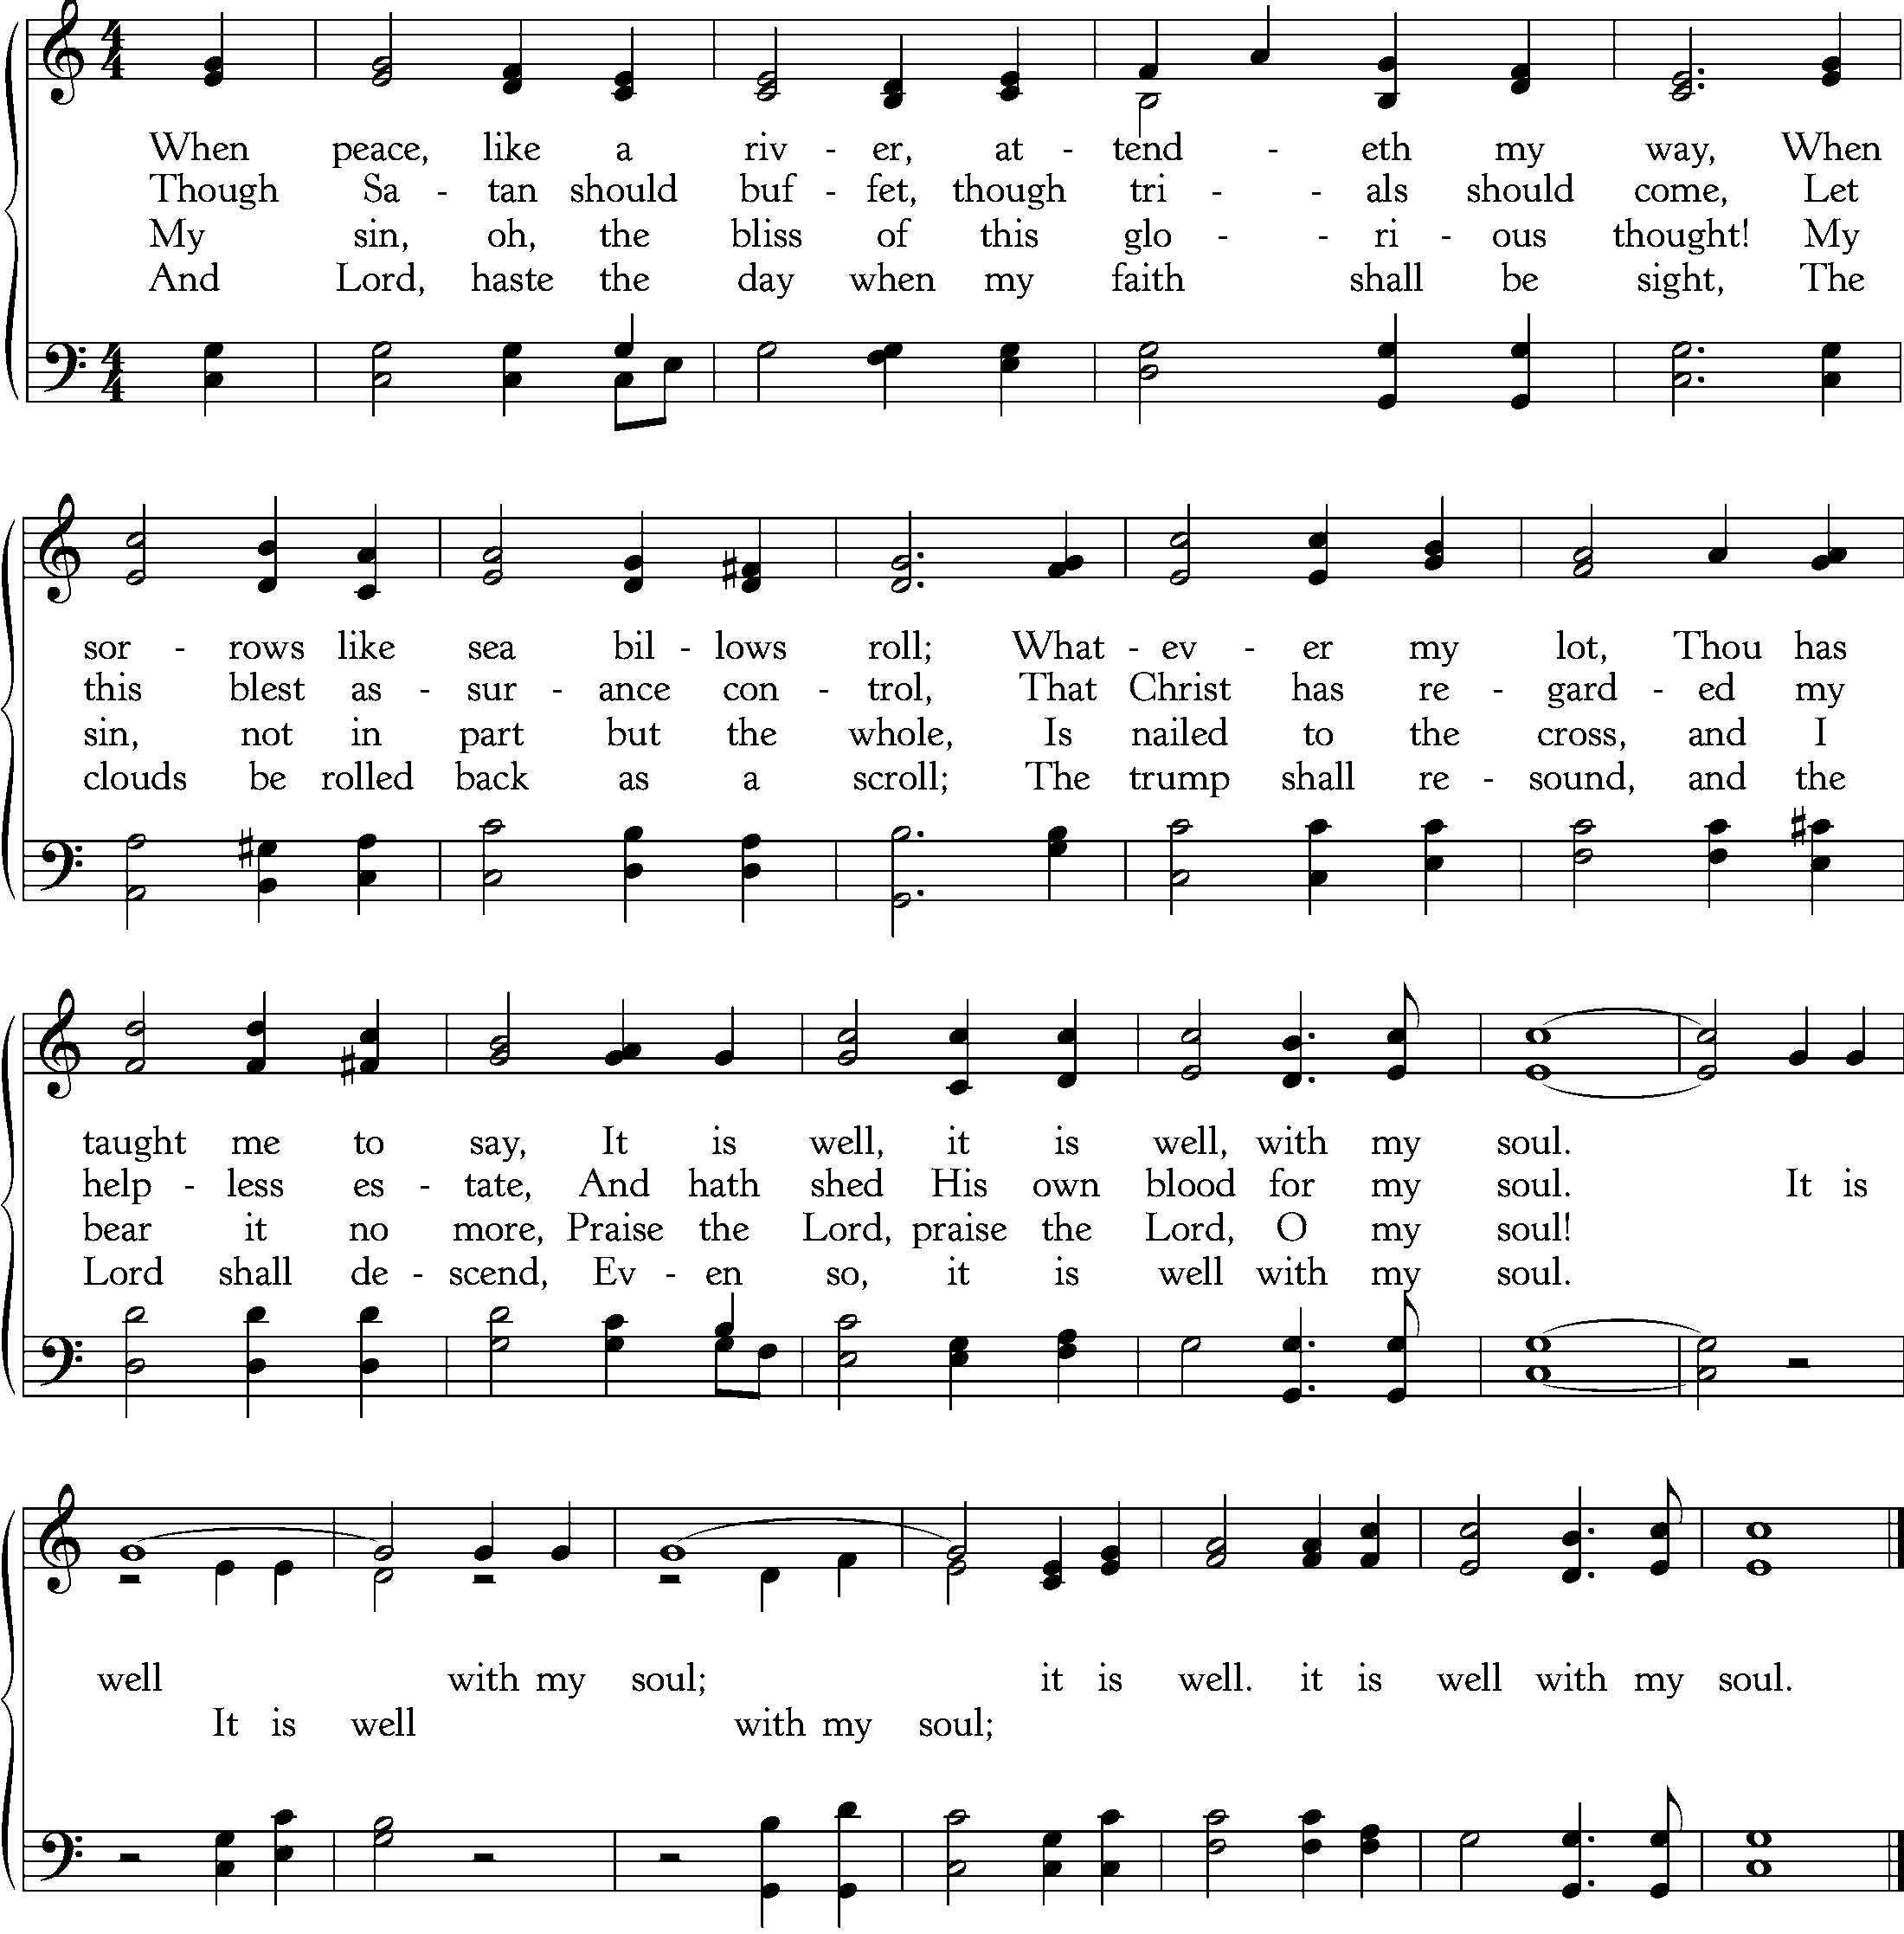
Text: Horatio G. Spafford, 1873; Music: Ville Du Havre, Philip P. Bliss, 1876.

God’s People Respond in Grateful Praise

Prayer of Thanksgiving and Intercession

The Lord’s Prayer
Our Father, who art in heaven, Hallowed be thy Name.
Thy kingdom come. Thy will be done, On earth as it is in heaven.
Give us this day our daily bread. And forgive us our debts, As we forgive our debtors.
And lead us not into temptation, But deliver us from evil.
For Thine is the Kingdom, and the power, and the glory, forever. Amen.

Hymn of Praise—Love Divine, All Loves Excelling
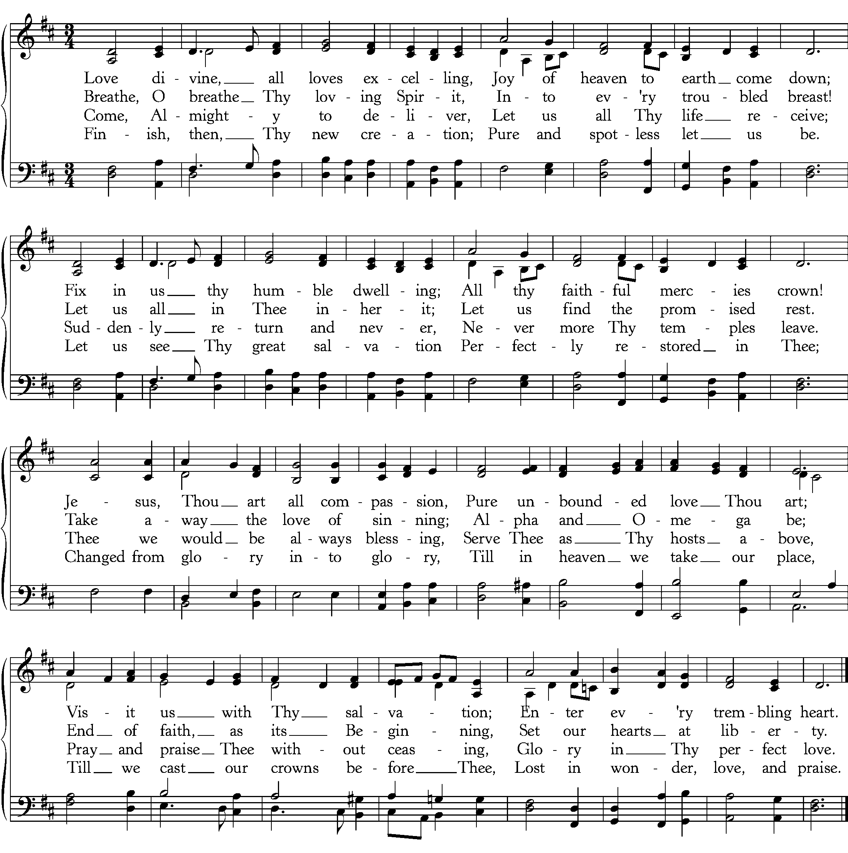
Text: Charles Wesley, 1747; Music: Hyfrydol, R.H. Prichard, 1831.
God Sends His People out
After calling His people into His presence, forgiving their sins, instructing them in His Word, and providing a foretaste of the marriage supper of the Lamb, God sends His people into the world to show His light in the darkness.

Benediction—2 Corinthians 4:6

For God, who said, “Let light shine out of darkness,” has shone in our hearts to give the light of the knowledge of the glory of God in the face of Jesus Christ. Amen.

Sung Response—Barocha (Numbers 6:24)
CCLI #11121087 © 1989 Birdwing Music; Text and Music: Michael Card, 1989.

Last week we saw the blindness of God’s people to see sign of Jonah, even though something much greater than Jonah was present—the Lord Jesus Christ. This week we see why that they cannot see, and we learn why Jesus is the only true lamp of our life.

What does the metaphor of “light” and “darkness” stand for in the passage? (v.33)

Taking in mind the answer above, what would it mean to hide the light in a cellar or under a basket? (v.33) Why would someone want to hide the light?

What does the sentence, “Your eye is the lamp of your body” (v.34) mean?

What are the qualities of a “healthy eye” (v.34)? What are the qualities of a “bad eye” (v.34)?

How can a certain light be darkness (v.35)?

Take time to pray the truth of this passage into your heart and life. Ask the Holy Spirit to illumine your life (v.36) that you might be bright with the light of Christ.

Cornerstone Presbyterian Church
Presbyterian Church in America
Pastor: Nate Shurden (618-4707 Office) or nate@cstonepres.org
Worship and Chief Musician: Greg Wilbur (512-4156) or greg@cstonepres.org
Administrative Assistant: Susan Bumpus (618-4707) or office@cstonepres.org
Home Fellowship Coordinator: Randy Allen (260-1884) or randmanrx@gmail.com
Nursery Coordinator: Linda VanGorden (406-4431) or vangordenlinda@yahoo.com
Elementary Discipleship Coordinator: Lorrie Mathews (429-8355) or lorriegm@gmail.com

Ruling Elders
Terry Cheney (579-7089) Grant Hensley (390-8828) Jim Smith (347-4188)
Chuck Emerson: Emeritus (661-9273) Stacy McGuire (339-3900) Greg Wilbur (512-4156)
Cy Fenton (500-5304)

Deacons
Clint Branch (516-9855) Kevin McClung (243-9228) Larry Thompson (901-734-1520)
Joe Haworth (289-7543) David Steffens (513-4873) Bob Vermilye (599-9577)
Riley May (866-8662)

Post Office Box 407 h Franklin, Tennessee 37065 h
www.cornerstonepresfranklin.org h (615) 618-4707

All Scripture quotations from the English Standard Version

