Cornerstone   
Presbyterian Church



Service of Celebration and Gospel Renewal

*Fifth Sunday of Easter*

29 April 2018

*Welcome to Worship*

If you are reading this in worship, I want you to know something—*you are an answer to prayer*. Each Sunday before worship, I ask God to bring into our midst exactly who He desires would be there. Since you are with us today, I believe God has a blessing in store for you. I am prayerful as we worship together today, that blessing will be received and enjoyed.

To that end, this service of worship has been designed that we might know God and the glory of the gospel of Jesus Christ. From the summons to worship at the beginning to the sending out into the world at the benediction, that you might know God, the truth and joy of salvation, and be equipped to answer the call to be a disciple of Jesus Christ.

Following the service, feel free to approach one of our elders (the men who help serve the Lord’s Supper) with any prayer needs or questions you may have. I believe you will find them to be warm, inviting, and eager to serve. Please know I would personally enjoy getting to meet you this morning following the service, so please stop by and see me at the front door of the chapel.

It is my sincere prayer that your experience today at Cornerstone Presbyterian Church is one that blesses you spiritually and strengthens your faith in the Lord.

Grace & Peace,

Rev. Nate Shurden

*Sunday School Schedule*

**Nursery** (basement)

**PreK:** Room 104 (basement)

Joe and Joy Marlo; Assistant: Kristin Lee

**K/1st Grade**: Room 103 (basement)

Teacher: Michelle Marshall; Assistant: Mark Elliott

**2nd/3rd Grade:** Room 101 (basement)

Teacher: Bob Wolk; Assistant: Anneke Seely

**4th/5th Grade:** Comenius Room (third floor)

Teacher: Ronda Laventure; Assistant: Julia Grounds

**6th Grade:** Schaeffer Room (third floor)

Teacher: Charlotte Robinson; Assistant: Mary Lynn Giles

**Youth** (7th-9th and 10th-12th) at Merridees

**Adult**

The Chapel Class: *Discerning and Exercising Your Spiritual Gifts* (Chapel)

Koinonia Class: *The Westminster Confession of Faith* (Kuyper Room 3rd Floor)

Exploring Cornerstone Class (Room 204)

Worship is a response to the love of God that brings us out of darkness into his light. The rhythm and flow of the service reflects this present reality as God calls his people and reveals himself, forgives their sins, teaches them from his Word, the Bible, feeds them, and then sends them out to live what they have learned.

This is the pattern of his love in redeeming and saving his people.

God Calls His People and Reveals Himself

*God calls His people to worship and come before Him. The Creator of all things reveals Himself through His Word and calls us into His presence.*

**Prelude, Announcements & Preparation**

**Introit—I Know that My Redeemer Lives, Vs 1**

**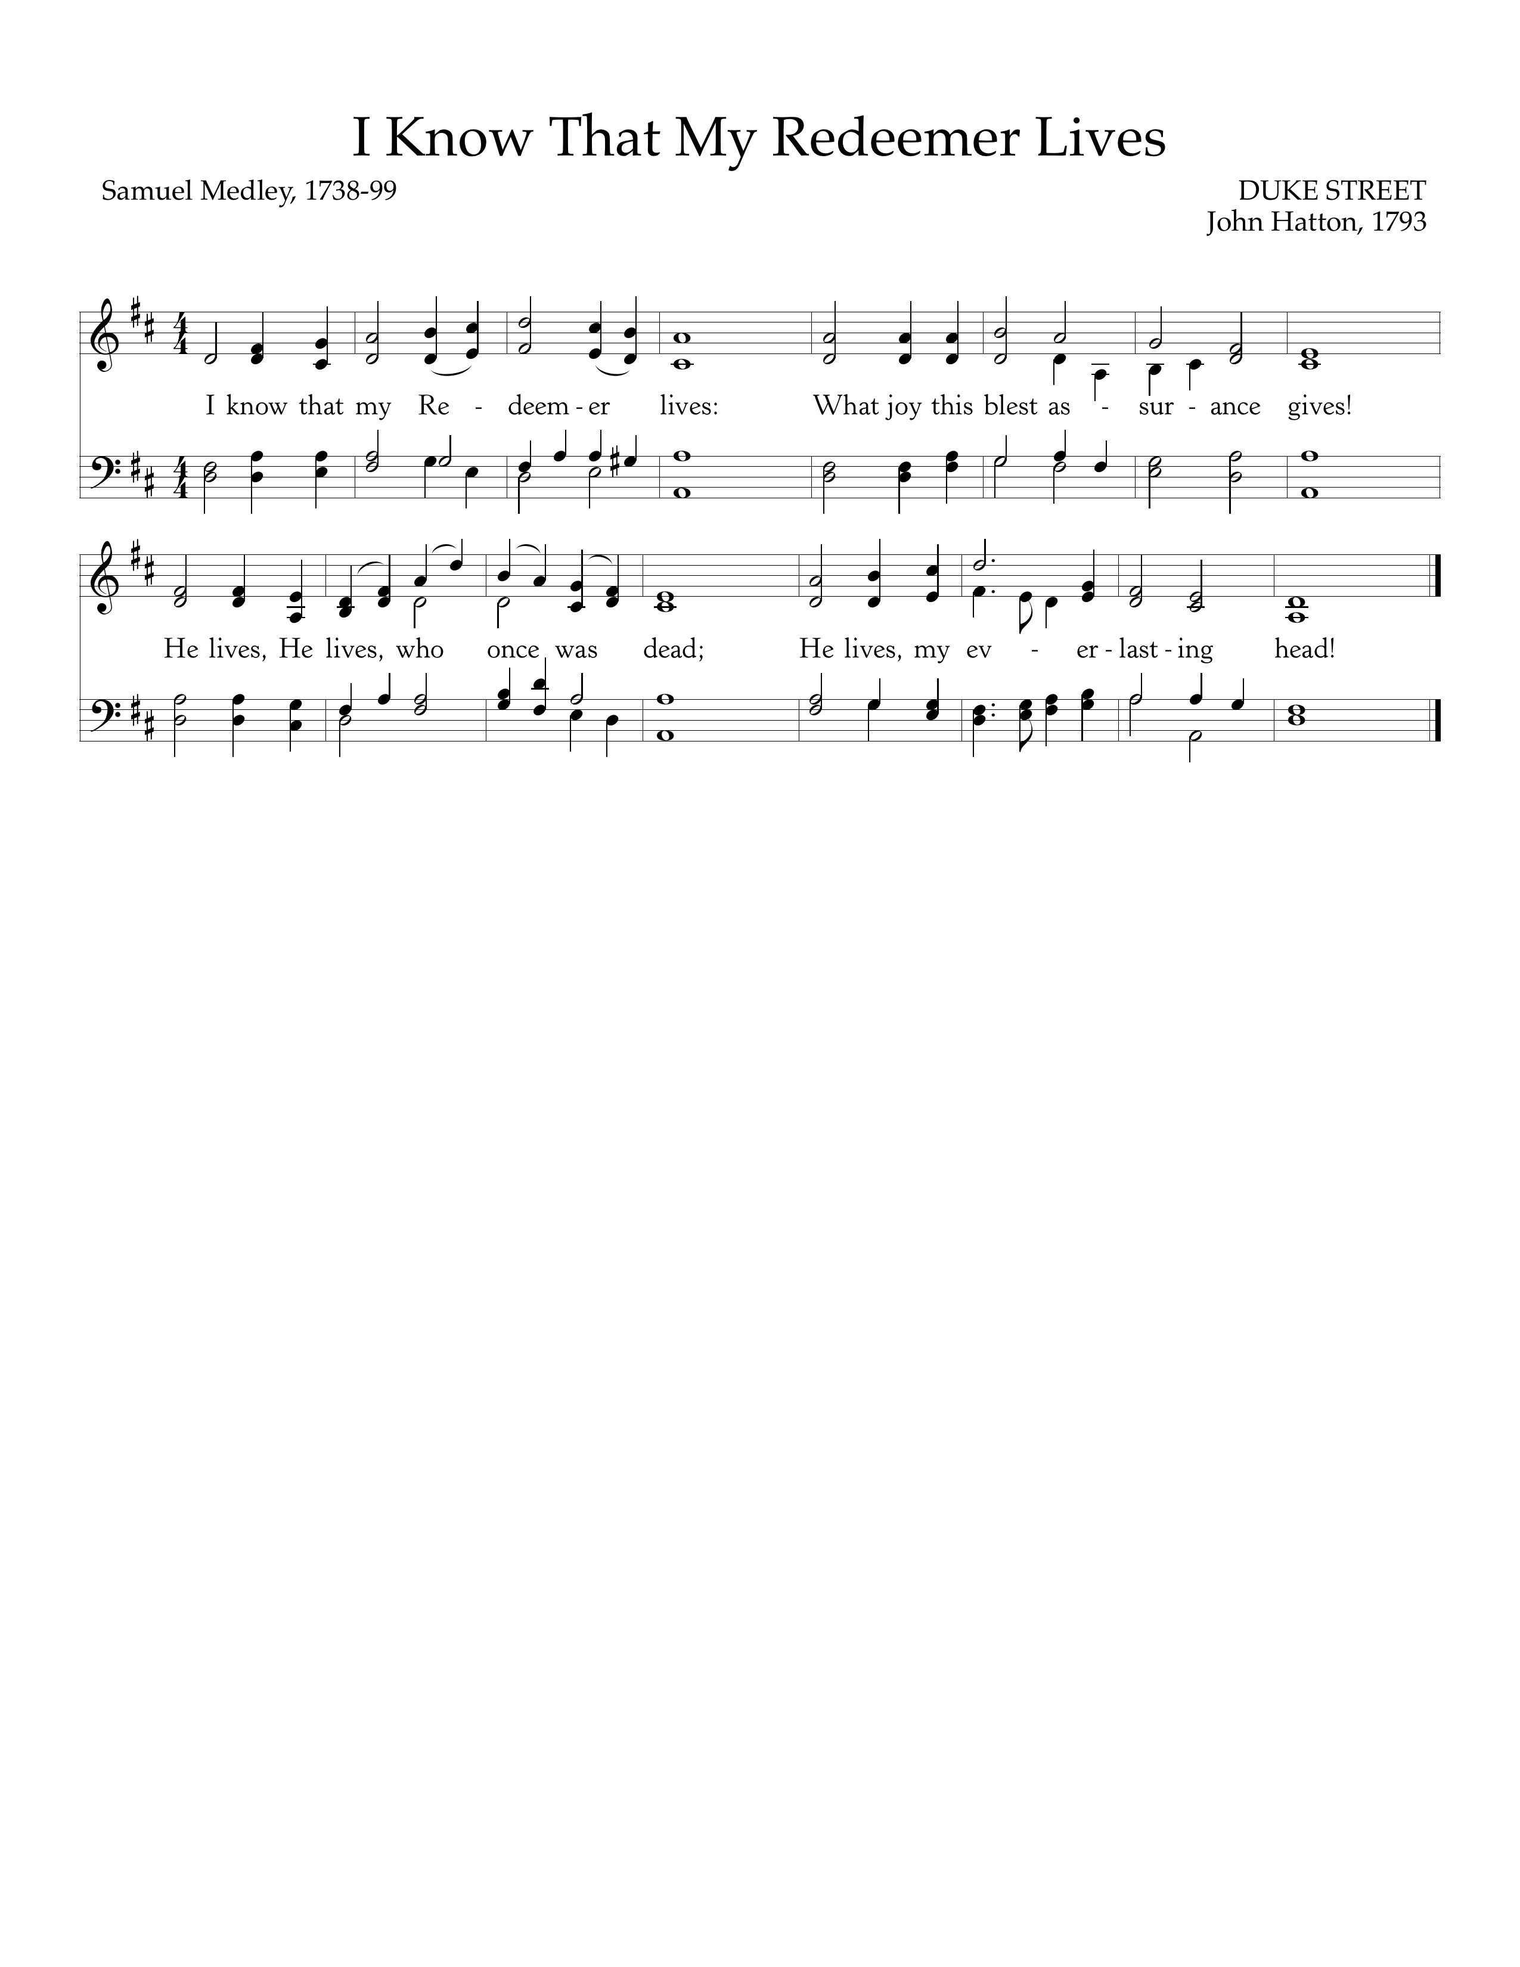**

Text: Samuel Medley, 1738-99; Music: Duke Street, John Hatton, 1793.

**Call to Worship—Psalm 148:1-5, 7-8, 13**

Pastor: Praise the Lord! Praise the Lord from the heavens; praise him in the heights!

**All: Praise him, all his angels; praise him, all his hosts!**

Pastor: Praise him, sun and moon, praise him, all you shining stars!

**All: Praise him, you highest heavens, and you waters above the heavens!**

Pastor: Praise the Lord from the earth, you great sea creatures and all deeps,

fire and hail, snow and mist, stormy wind fulfilling his word!

**All: Let them praise the name of the Lord! For he commanded and they were created.**

Pastor: Let them praise the name of the Lord, for his name alone is exalted;

his majesty is above earth and heaven.

**Hymn of Praise—Let Us Love and Sing and Wonder**

**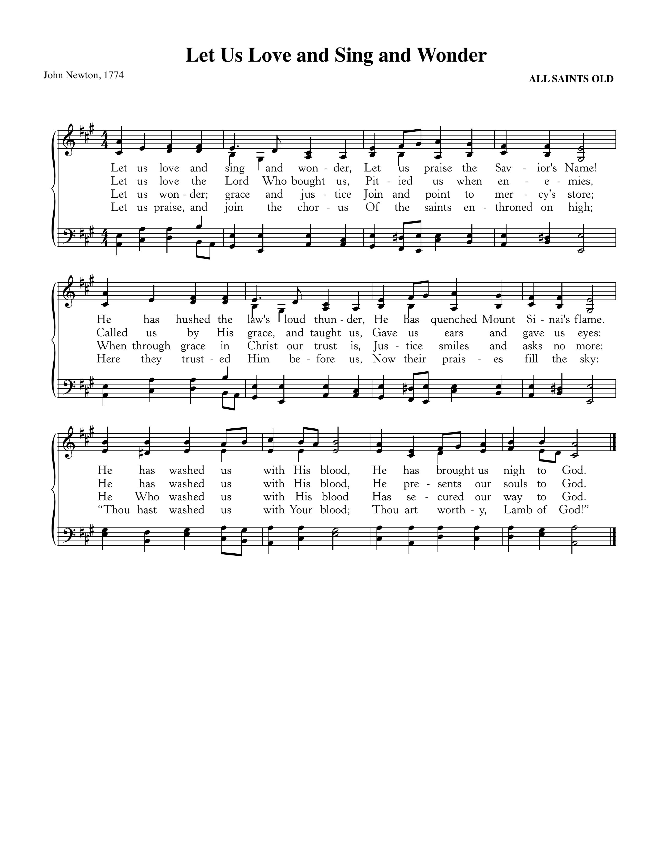**

Text: John Newton, 1774; Music: All Saints Old

**Hymn of Praise—Praise, My Soul, the King of Heaven**

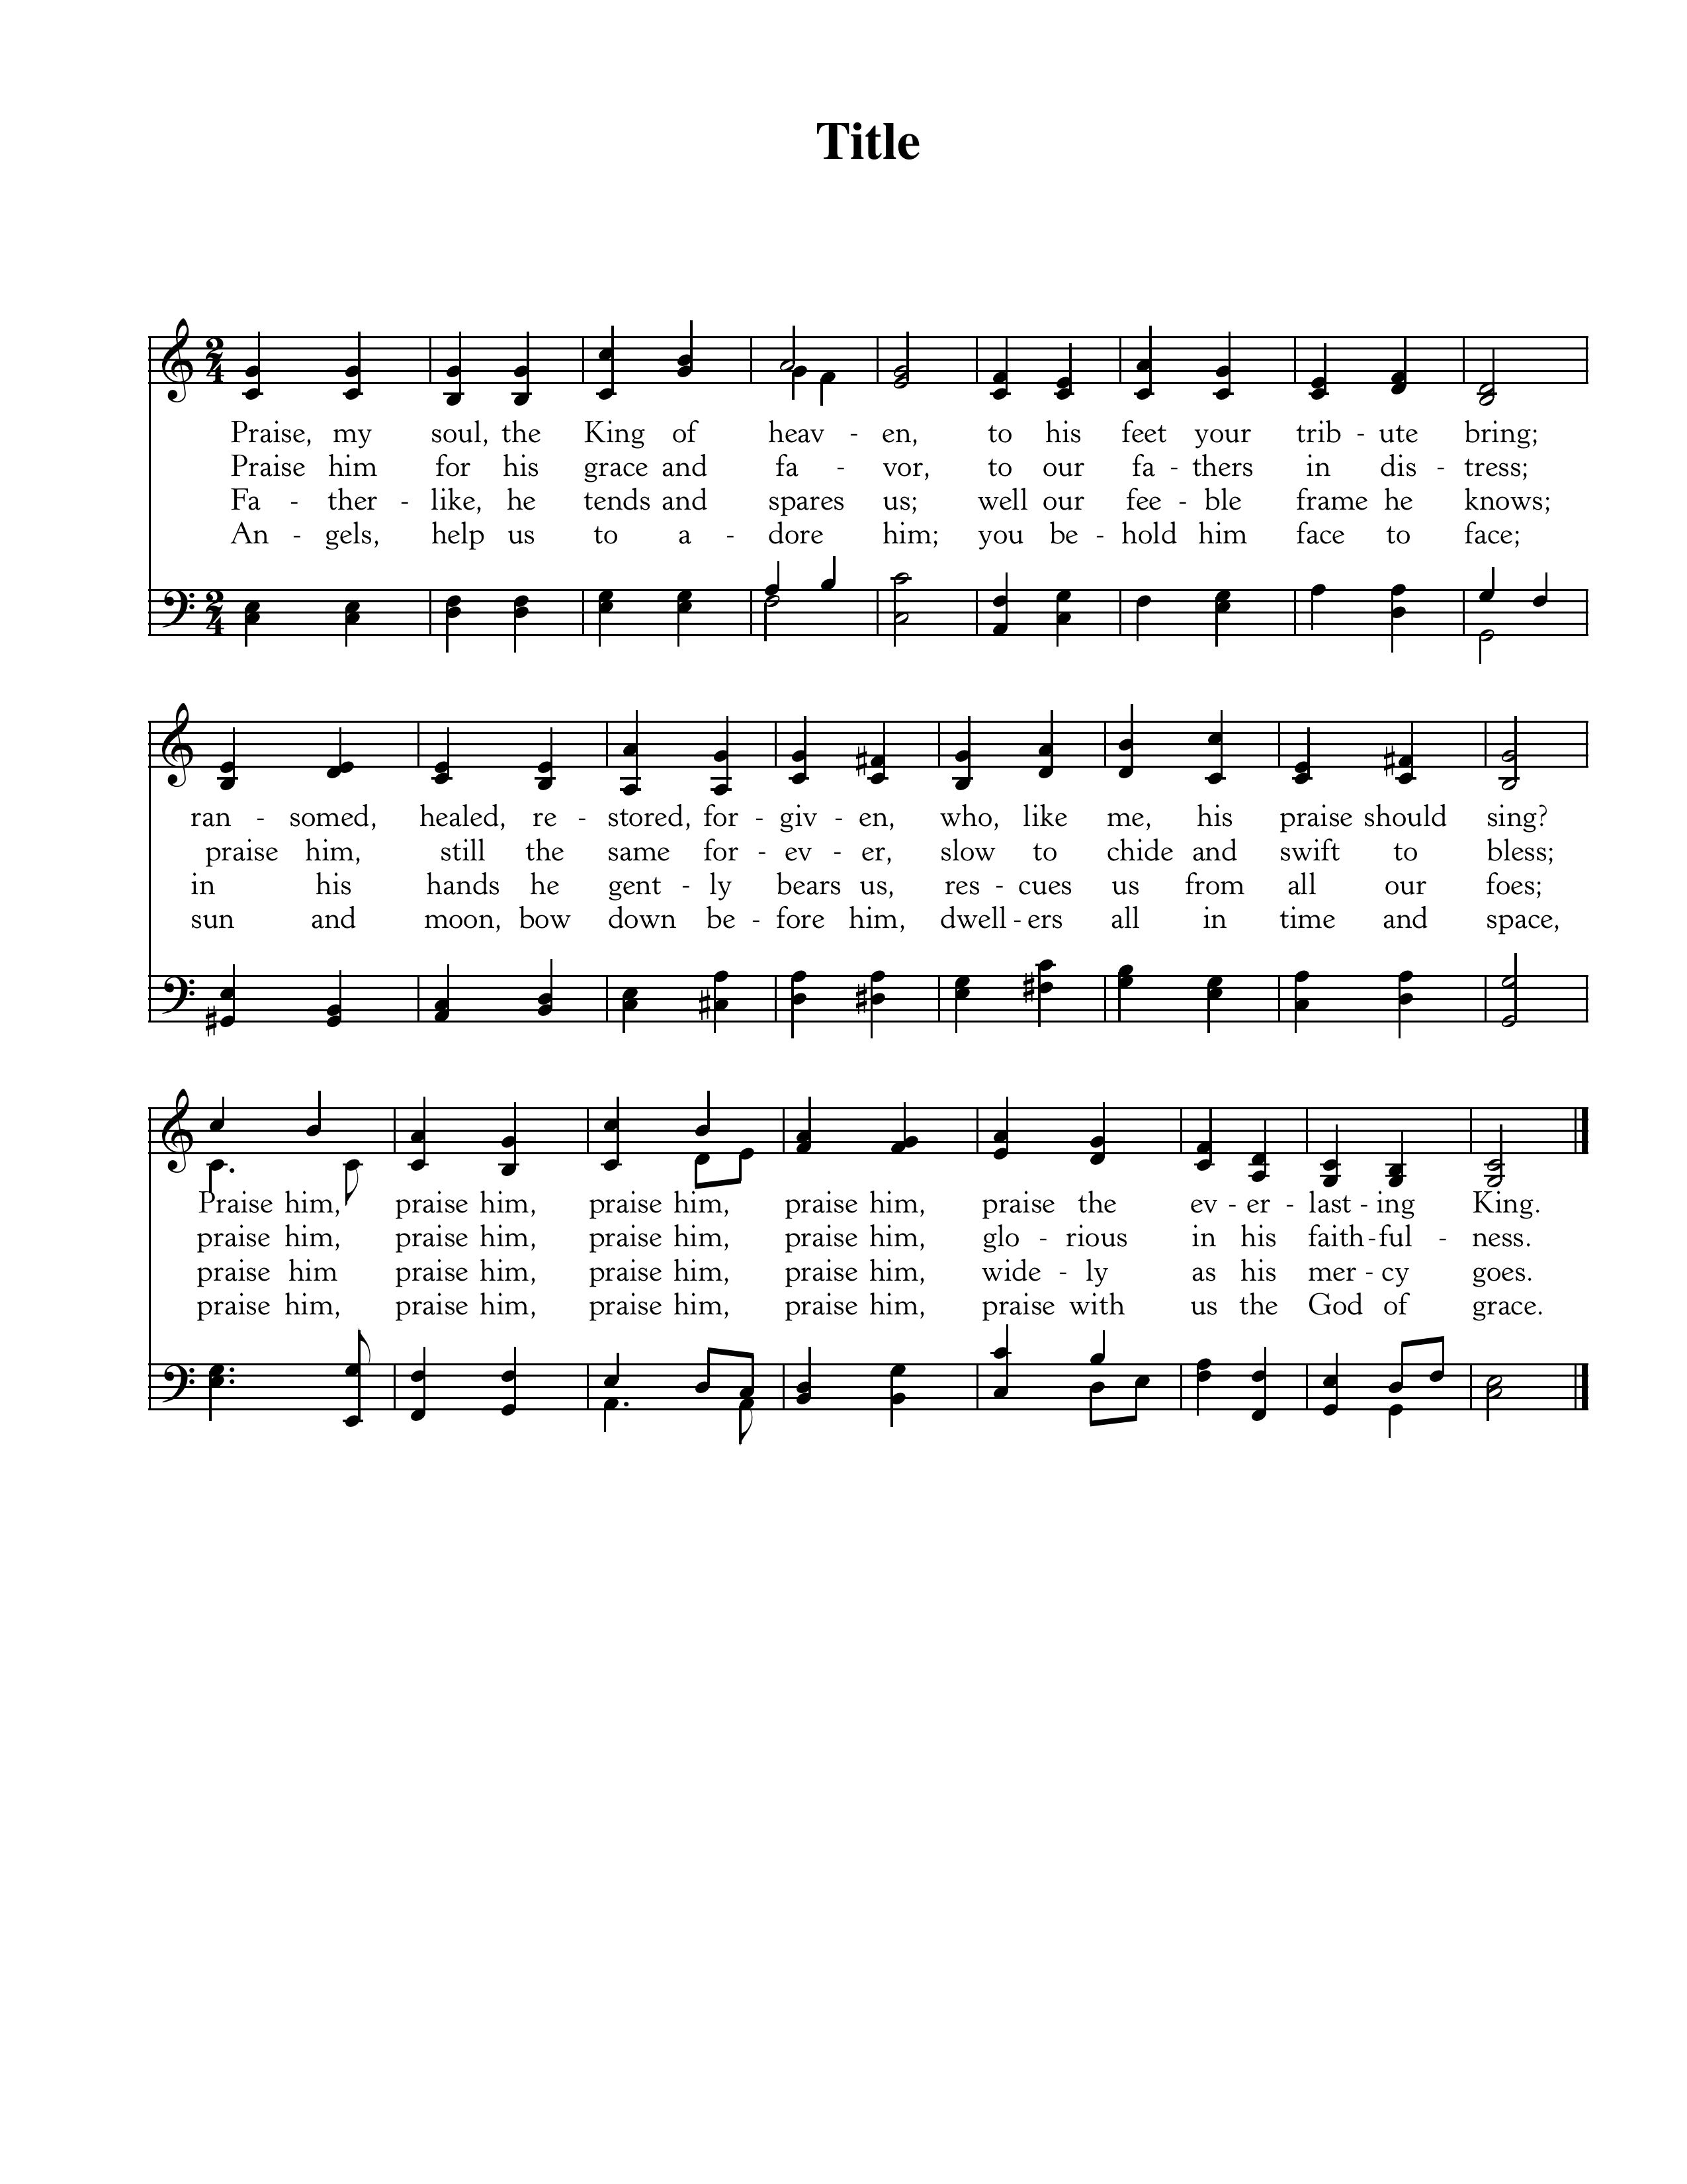



Text: From Psalm 103, Henry F. Lyte, 1834; Music: Praise My Soul, John Goss, 1869.

*+++Latecomers Please Wait to be Seated+++*

**Old Testament Reading—Psalm 104:1-9**

*The Lord is King over His creation; He alone “upholds the universe by the Word of His power.”*

**1**Bless the Lord, O my soul! O Lord my God, you are very great!

You are clothed with splendor and majesty,

**2**covering yourself with light as with a garment,stretching out the heavens like a tent.

**3**He lays the beams of his chambers on the waters;

he makes the clouds his chariot; he rides on the wings of the wind;

**4**he makes his messengers winds,his ministers a flaming fire.

**5**He set the earth on its foundations,so that it should never be moved.

**6**You covered it with the deep as with a garment;the waters stood above the mountains.

**7**At your rebuke they fled;at the sound of your thunder they took to flight.

**8**The mountains rose, the valleys sank downto the place that you appointed for them.

**9**You set a boundary that they may not pass,so that they might not again cover the earth.

Elder: This is the Word of the Lord.

**All: Thanks be to God.**

God Calls His People to Confession, Repentance & Reconciliation

*The People of God respond to His Word by confessing their sins, repenting of their sinful ways, and seeking God’s favor through the reconciling work of Jesus, the Son of God.*

**Sung Response—Lamb of God**

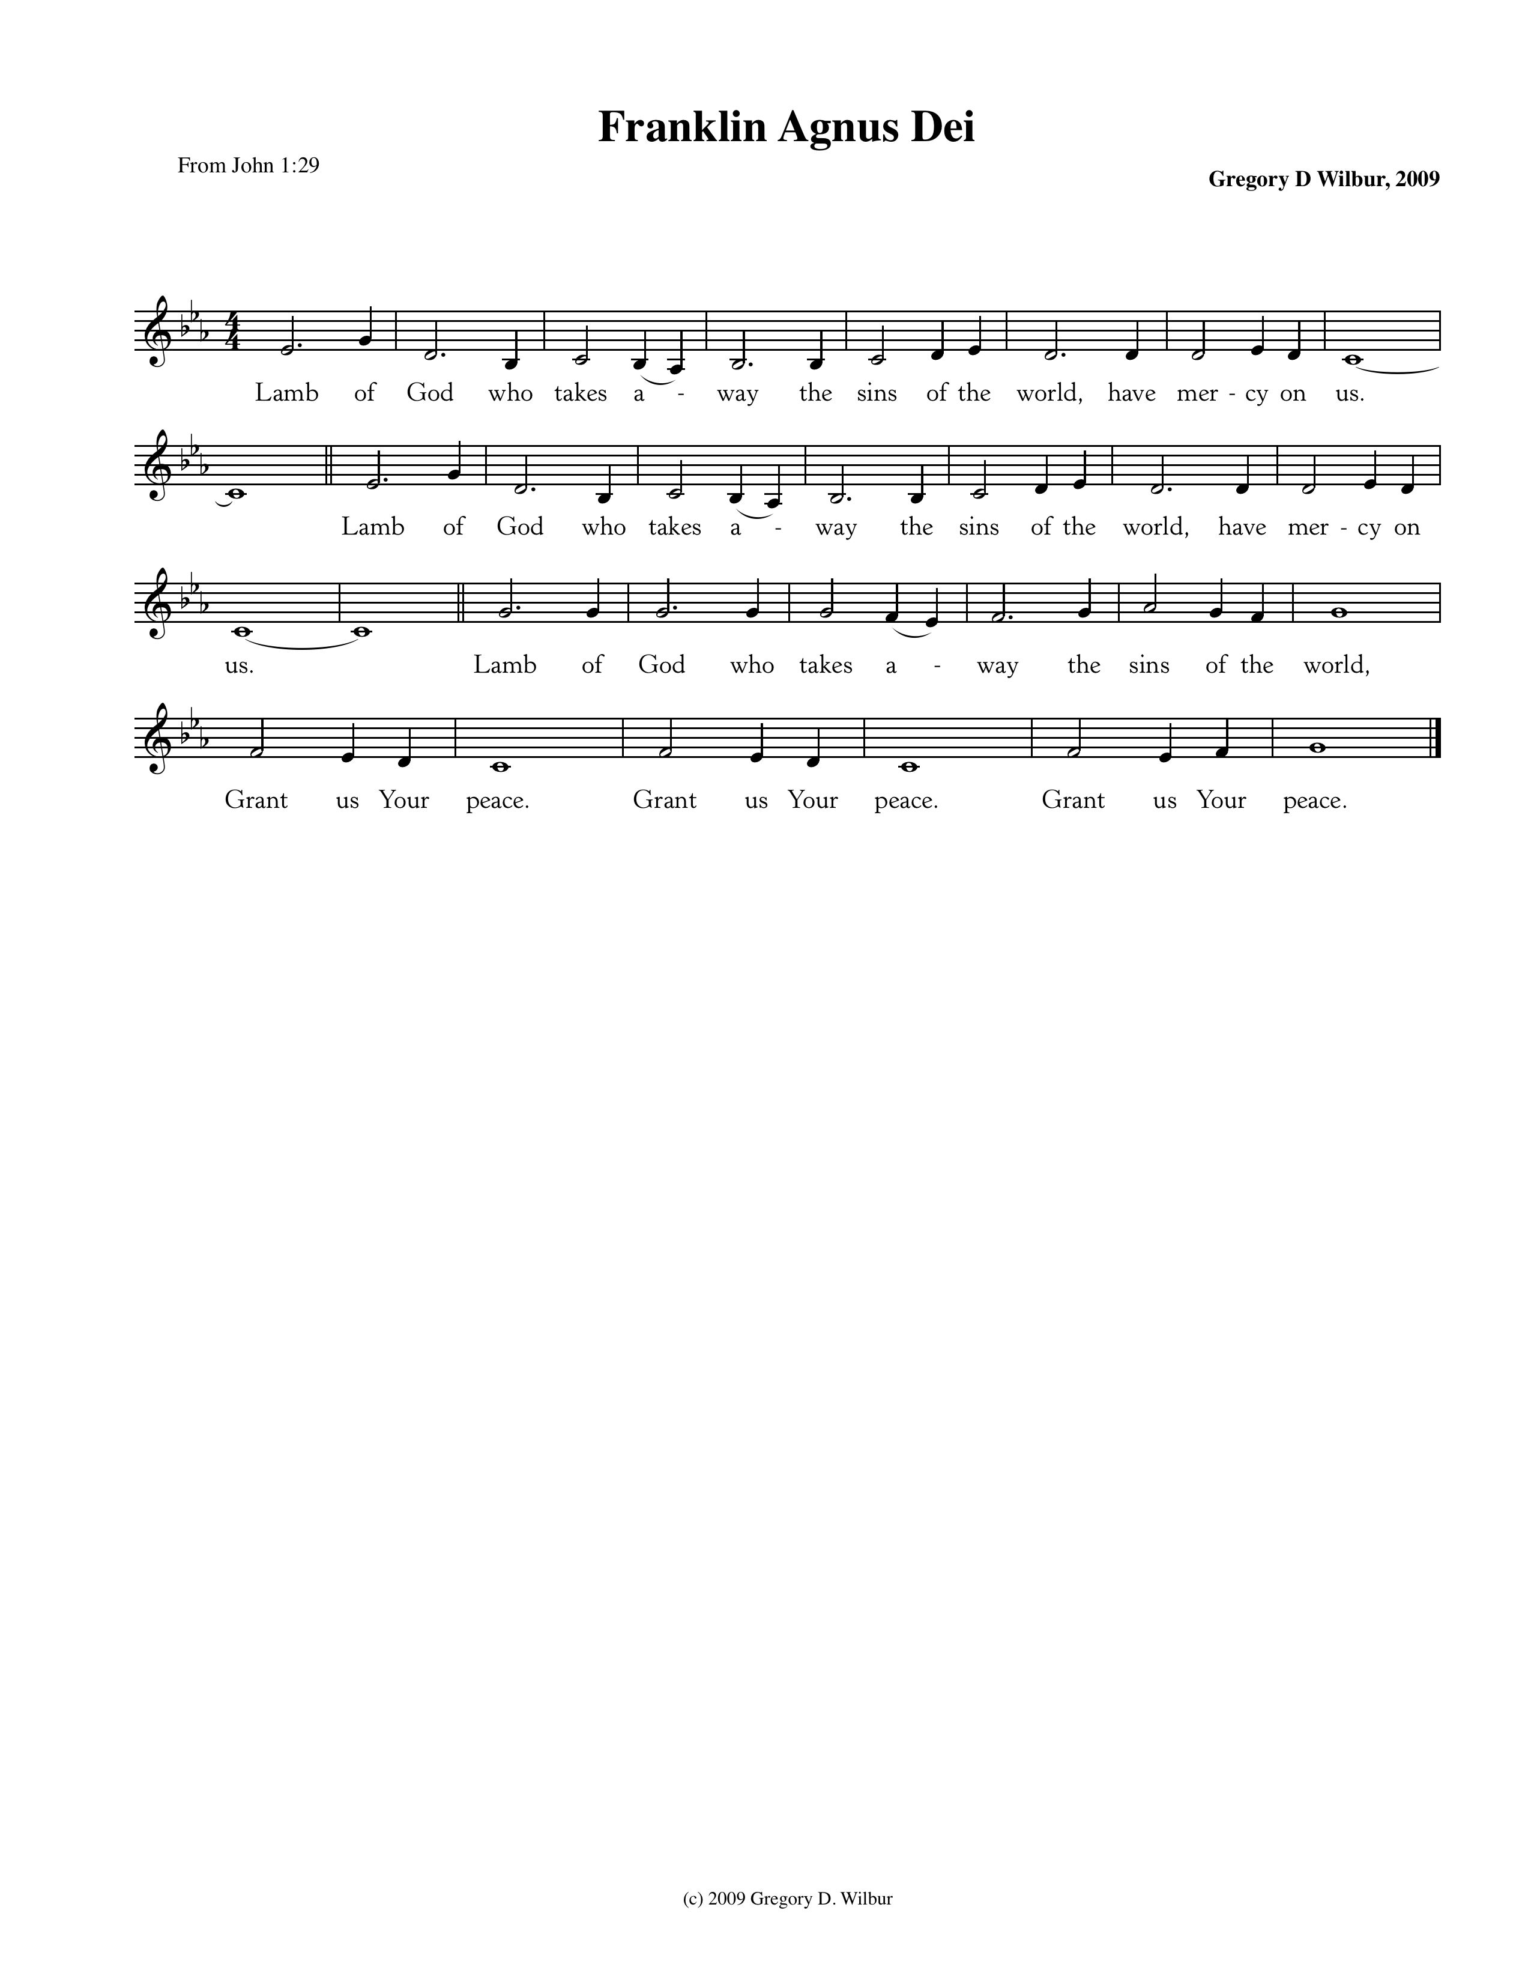

Text: John 1:29; Music: Franklin Agnus Dei, Gregory D Wilbur, 2009. ©2009 Greyfriars Press.

**Corporate Confession of Sin—based on Psalm 25**

Pastor: Lord, we come confessing. To you, O Lord, we lift up our souls.

Our God, in you we trust.

Let us not be put to shame; let not our enemies triumph over us.

**All: Make us to know Your ways and teach us Your paths.**

**Lead us in Your truth and teach us.**

Pastor: You are the God of our salvation. May we wait for you all the day long.

Remember Your mercy, O Lord, and Your steadfast love,

for they have been from of old.

**All: Remember not the sins of our youth and our transgressions;**

**according to Your steadfast love remember us,**

**for the sake of Your goodness, O Lord!**

Pastor: For Your name’s sake, O Lord, pardon our guilt, for it is great.

**All: Consider our afflictions and our troubles, and forgive all our sins.**

Pastor: You lead the humble in what is right. May we be humble; teach us Your way.

**All: All of Your paths are steadfast love and faithfulness,**

**for those who keep Your covenant and Your testimonies.**

**Silent Prayers of Confession**

**Assurance of Pardon—Ephesians 2:8-9**

For by grace you have been saved through faith. And this is not your own doing; it is the gift of God, not a result of works, so that no one may boast.

*+++Latecomers are Welcome to be Seated+++*

**Hymn of Praise—It Is Well**



Text: Horatio G. Spafford, 1873; Music: Ville Du Havre, Philip P. Bliss, 1876.

**Resurrection Stories—Damaris King**

God Teaches Us Through His Word

**The Reading of the Word—Genesis 8:20-9:19**

20Then Noah built an altar to the Lord and took some of every clean animal and some of every clean bird and offered burnt offerings on the altar. 21And when the Lord smelled the pleasing aroma, the Lord said in his heart, “I will never again curse the ground because of man, for the intention of man’s heart is evil from his youth. Neither will I ever again strike down every living creature as I have done. 22While the earth remains, seedtime and harvest, cold and heat, summer and winter, day and night, shall not cease.”

9 And God blessed Noah and his sons and said to them, “Be fruitful and multiply and fill the earth. 2The fear of you and the dread of you shall be upon every beast of the earth and upon every bird of the heavens, upon everything that creeps on the ground and all the fish of the sea. Into your hand they are delivered. 3Every moving thing that lives shall be food for you. And as I gave you the green plants, I give you everything. 4But you shall not eat flesh with its life, that is, its blood. 5And for your lifeblood I will require a reckoning: from every beast I will require it and from man. From his fellow man I will require a reckoning for the life of man.

6“Whoever sheds the blood of man,

    by man shall his blood be shed,

for God made man in his own image.

7And you, be fruitful and multiply, increase greatly on the earth and multiply in it.”

8Then God said to Noah and to his sons with him, 9“Behold, I establish my covenant with you and your offspring after you, 10and with every living creature that is with you, the birds, the livestock, and every beast of the earth with you, as many as came out of the ark; it is for every beast of the earth. 11I establish my covenant with you, that never again shall all flesh be cut off by the waters of the flood, and never again shall there be a flood to destroy the earth.” 12And God said, “This is the sign of the covenant that I make between me and you and every living creature that is with you, for all future generations: 13I have set my bow in the cloud, and it shall be a sign of the covenant between me and the earth. 14When I bring clouds over the earth and the bow is seen in the clouds, 15I will remember my covenant that is between me and you and every living creature of all flesh. And the waters shall never again become a flood to destroy all flesh. 16When the bow is in the clouds, I will see it and remember the everlasting covenant between God and every living creature of all flesh that is on the earth.” 17God said to Noah, “This is the sign of the covenant that I have established between me and all flesh that is on the earth.”

Leader: The grass withers, the flower fades;

**All:** **But the Word of our God will stand forever.**

**Sermon—New Beginnings: A Study of Genesis, pt 13**

*The Covenant with Noah*—Nate Shurden, *Pastor*

**Sung Response—Teach Me, O Lord, Thy Way of Truth, Vs 1**

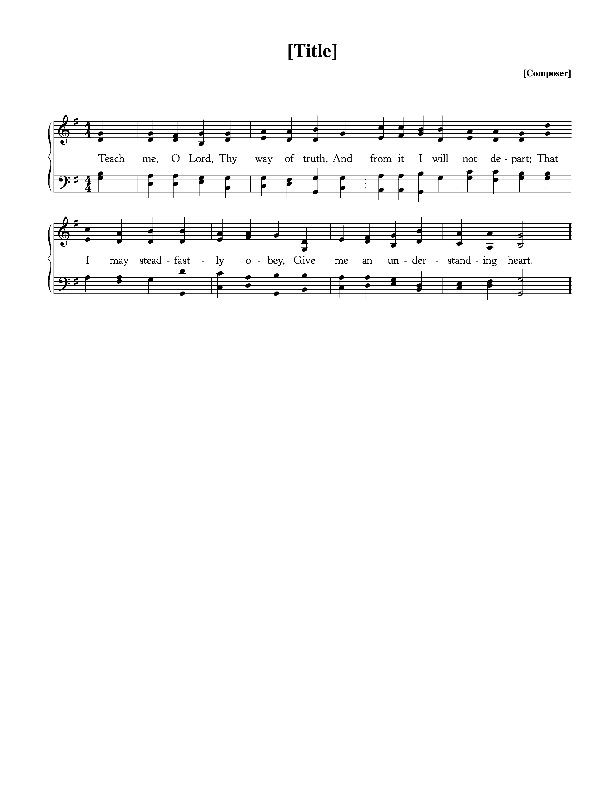

Text: Joseph P. Holbrook, ca. 1878; Music: Tallis’ Canon, Thomas Tallis, ca, 1567.

**Profession of Faith—The Apostles’ Creed**

We believe in God, the Father Almighty, the Creator of heaven and earth,

And in Jesus Christ, His only Son, our Lord,

who was conceived of the Holy Spirit, born of the Virgin Mary,

suffered under Pontius Pilate, was crucified, died, and was buried.

He descended into hell. On the third day He rose again from the dead.

He ascended into Heaven

and now sits at the right hand of God the Father Almighty,

from whence He shall come to judge the living and the dead.

We believe in the Holy Spirit, the holy catholic\* church,

The communion of saints, the forgiveness of sins,

The resurrection of the body, and the life everlasting. Amen.

*\* “Catholic” refers to the universal church of God’s people throughout all time and from all places*

**Sursum Corda**

Pastor: The Lord be with you.

**People: And also with you.**

Pastor: Lift up your hearts.

**People: We lift them up to the Lord.**

Pastor: Let us give thanks to the Lord our God.

**People: It is right to give Him thanks and praise.**

Pastor: It is right, and a good and joyful thing, always and everywhere to

give thanks to You, Father Almighty, Creator of heaven and earth.

**Sung Response—Holy God We Praise Your Name, Vs 4**

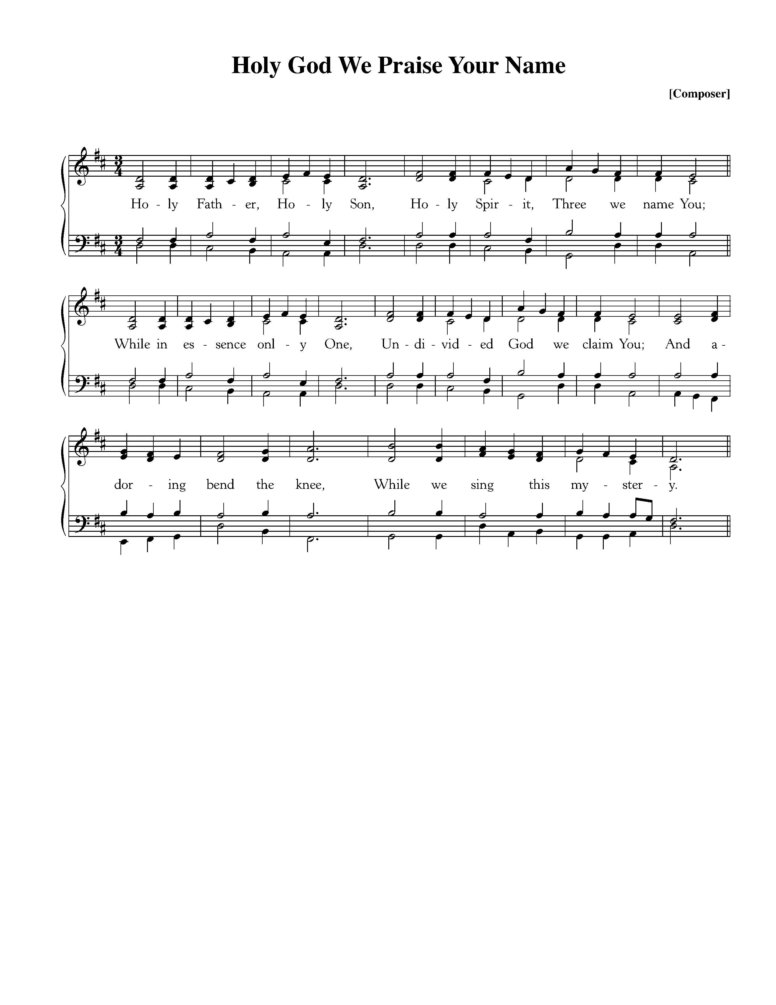

Text: Based on *Te Deum*, 4th c., Attr Ignace Franz, 1774; Music: Groser Gott, *Katholisches Gesangbuch,* 1774.

**Words of Institution and the Lord’s Table**

**Guidelines for the Lord’s Supper**

*The Lord’s Supper is the family meal for Christians. We invite all baptized Christians who are members of a congregation that proclaims the gospel, and who are at peace with God and with their neighbor, and who seek strength to live more faithfully for Christ to join us.*

*If you are not a Christian, or if you are not prepared to share in this meal, we encourage you to spend this time in prayer. You can find some sample prayers on the next page. We hope that this time is helpful to you as you consider your relationship with Jesus Christ and with His people, the church.*

*At Cornerstone, we come forward to receive communion. You may take the bread at the first table and then proceed to either side for the wine/grape juice.*

**Hymn of Praise—Come Down, O Love Divine**

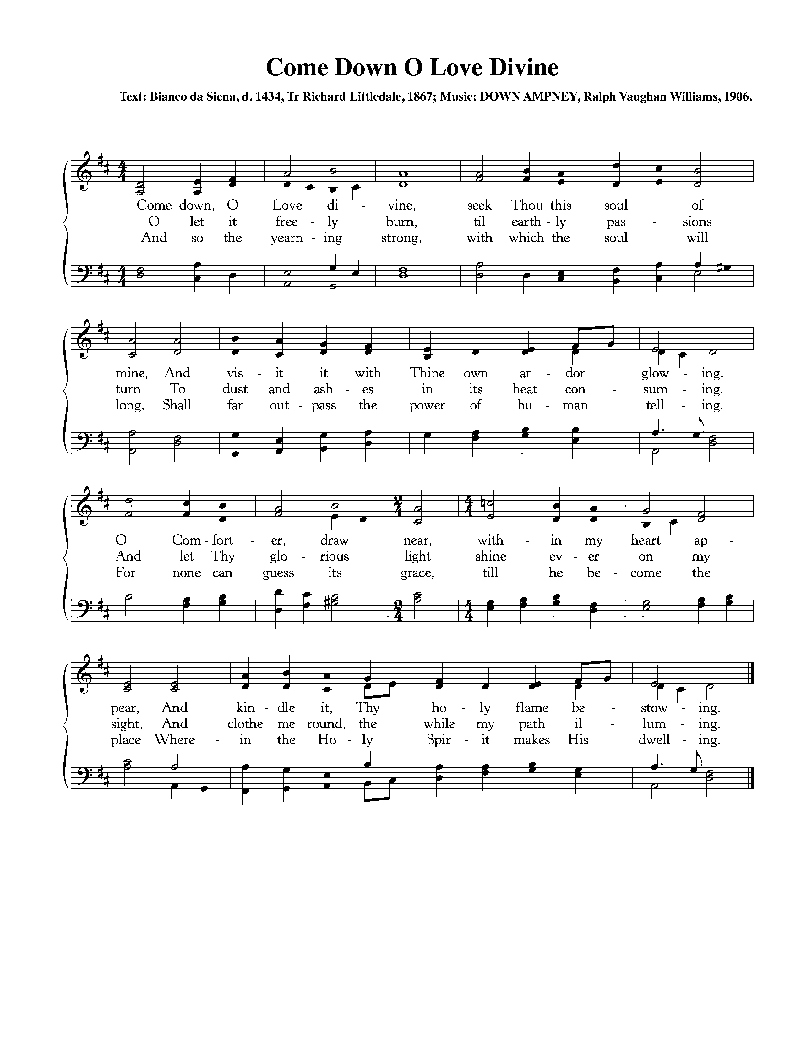

Text: Bianco da Siena, d. 1434, Tr Richard Littledale, 1867; Music: Down Ampney, Ralph Vaughan Williams, 1906.

**Prayers for Those Not Taking the Lord’s Supper**

If you are not able to partake in the Lord’s Supper today, please use this time to meditate on one of the following prayers.

*Prayer for Those Searching for Truth.* Lord Jesus, you claim to be the way, the truth, and the life. Grant that I might be undaunted by the cost of following you as I consider the reasons for doing so. If what you claim is true, please guide me, teach me, and open me to the reality of who you are. Give me an understanding of you that is coherent, convincing, and that leads to the life you promise. Amen.

*Prayer of Belief.* Lord Jesus Christ, I admit that I am weaker and more sinful than I ever dared admit, but through you I am more loved and accepted than I ever dared hope. I thank you for paying my debt on the cross, taking what I deserved in order to offer me complete forgiveness. Knowing that you have been raised from the dead, I turn from my sins and receive you as my Savior and Lord. Amen.

*Prayer of Commitment.* Lord Jesus, you have called us to follow you in baptism and in a life of committed discipleship through membership in your church. Grant that I may take the necessary steps to be one with your people, and live in the fullness of your Spirit. Amen.

**Hymn of Communion—Dear Refuge of My Weary Soul**



CCLI #11121087 Text: Annie Steele, 1716-1778; Music: Matt Merker, © 2013

God’s People Respond in Grateful Praise

**Prayer of Thanksgiving and Intercession**

The Lord’s Prayer

Our Father, who art in heaven, Hallowed be thy Name.

Thy kingdom come. Thy will be done, On earth as it is in heaven.

Give us this day our daily bread. And forgive us our debts, As we forgive our debtors.

And lead us not into temptation, But deliver us from evil.

For Thine is the Kingdom, and the power, and the glory, forever. Amen.

**Hymn of Praise——My Hope is Built on Nothing Less**

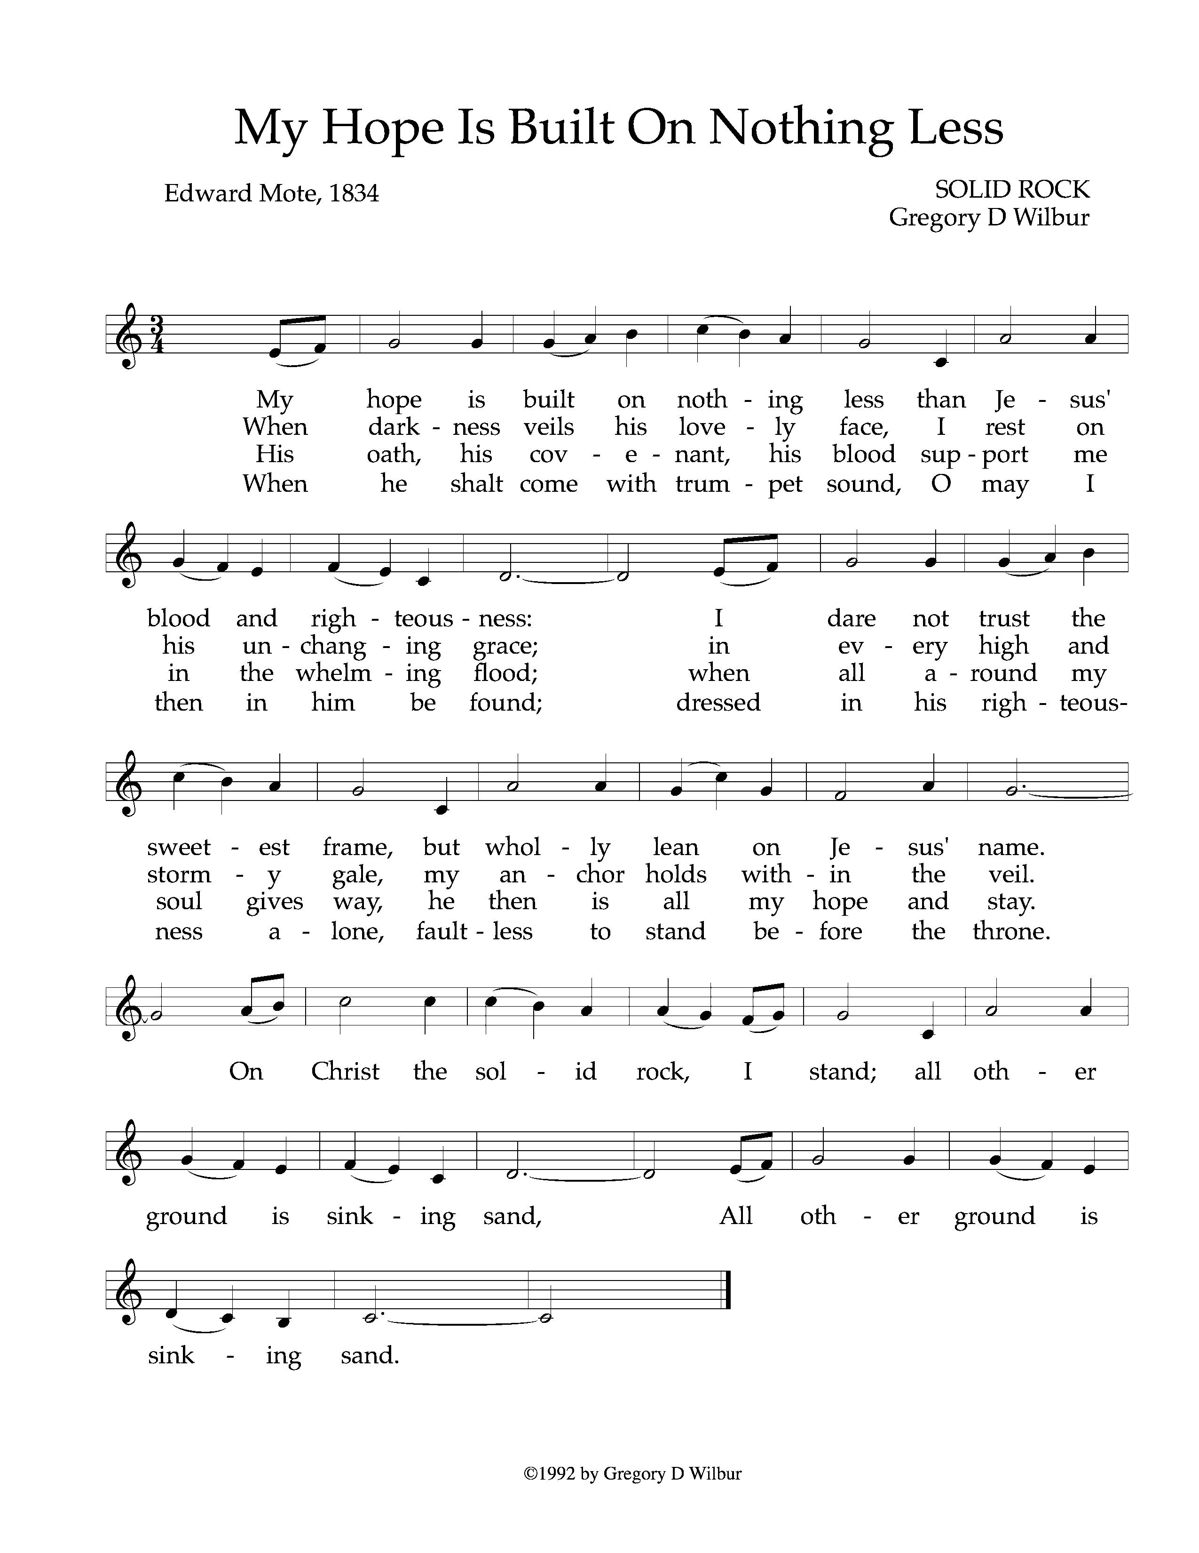

Text: Edward Mote, 1834: Music: Solid Rock, Gregory Wilbur, 1992. © 1992 Greyfriars Press. Used by Permission.

God Sends His People Out to Be Light in the Darkness

*After calling His people into His presence, forgiving their sins, instructing them in His Word, and providing a foretaste of the marriage supper of the Lamb, God sends His people into the world to show His light in the darkness.*

**Benediction—Jude 20-21**

But you, beloved, building yourselves up in your most holy faith and praying in the Holy Spirit, keep yourselves in the love of God, waiting for the mercy of our Lord Jesus Christ that leads to eternal life. *Amen.*

**Sung Response—Barocha (Numbers 6:24)**

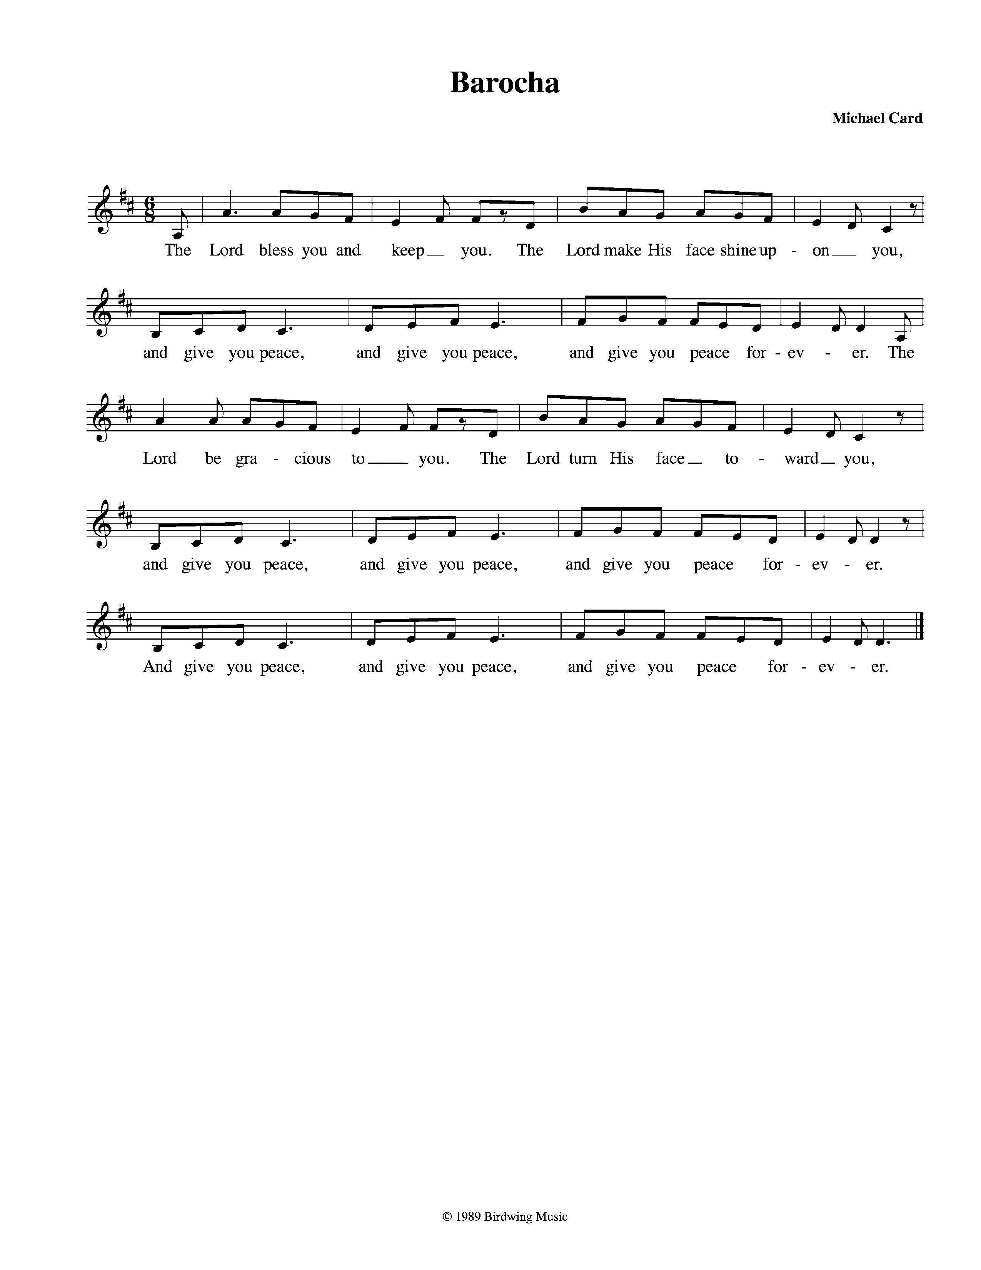

CCLI #11121087 © 1989 Birdwing Music; Text and Music: Michael Card, 1989.

**Prayer Focus—**GraceWorks

GraceWorks was founded in 1995 when concerned local church leaders realized Williamson County needed a central place to send people who needed help with food, clothing and financial assistance.  By pooling church resources with private and public sectors, GraceWorks has been able to provide more help for many needs to better serve our community, rather than duplicating efforts. Currently GraceWorks provides assistance in twenty different programs, under hunger prevention, family support, educational programs and seasonal needs.  Through its many programs, GraceWorks fulfilled 46,665 needs in 2016.  Cornerstone has supported GraceWorks since our church was established and many of our members have been involved in this important ministry to our community.

* Prayers for our homeless neighbors and those struggling to maintain their housing.
* Prayers of gratitude for those who give sacrificially to the mission of GraceWorks.
* Prayers for continued involvement from our church partners, and new partnership opportunities with other churches seeking to serve our community together.
* Prayers for more regular volunteers to help in the stores and sorting donations.

**Liturgical Calendar**

God built within His people an innate desire to celebrate, to mark seasons and events, to set up “stones of remembrance” so that we do not forget His goodness and promises. One method that the Church has used over time is dividing each year according to the events in the life of Christ—a reminder of redemptive history. Although the Church Calendar is not prescribed by Scripture, it can be a useful framework or tool to help walk our hearts through the Gospel every year.

The major divisions of the liturgical year are:

* **Advent**—The four Sundays leading to Christmas; preparation for the coming of Christ and the need for a Savior
* **Christmas** and the Twelve Days—Celebration of the Incarnation and the Gift of Christ, our Redeemer
* **Epiphany**—January 6; Coming of the Magi for Christ is the Light of the World; Hope for the Gentiles; Kingship of Christ
* **Lent**—from Ash Wednesday to Easter; repentance and reflection; recognition that our sinfulness leads to the cross; intentional time to exercise the disciplines of grace
* **Holy Week**—Palm Sunday, Maundy Thursday, Good Friday; Jesus as King, Priest, Prophet; The remembrance that the shedding of blood was necessary for the forgiveness of sins
* **Easter**—Resurrection of the Living Lord; the conquering of death and sin
* **Ascension**—Christ in Power at the right hand of the Father; Christ interceding as the Mediator
* **Pentecost**—Coming of the Holy Spirit and the birth of the Church; God sends out His people as the Church
* **Ordinary Time**—The weeks between Pentecost and Advent; Living in light of the Gospel as the Church

**Home Fellowship Groups**

**River Landing**—Jim & Gwen Smith

Second and Fourth Sundays, 6:00pm, Smith’s house, Book discussion

**West Nashville**—Andy & Katie Patton

Every other Sunday, 5:00pm, Patton’s house, Sermon discussion

**Upper Room**—Bob & Cindi Wolk

First and Third Sundays after Second service at Cornerstone, Sermon discussion

**Liberty Pike**—Dan Fiedler & Carl Ware

Second and Fourth Sundays, 4:30-6:30pm, Ware’s house, Sermon discussion

**Grassland**—Steve Green & John Marquardt

First and Third Tuesdays, 6:30pm, Green’s house, sermon discussion and studying James

**South Franklin**—John & Allison Millard

Every other Sunday, 5:00pm, Millard’s House, Sermon discussion

**East Franklin**—Mark & Lindsey Elliott

First, Second, and Third Sundays after the Second Service, Elliott’s house, Sermon discussion

**Fieldstone/Cottonwood**—Greg & Sophia Wilbur

Second, Third, and Fourth Sundays, 5:00pm, Wilbur’s house, Sermon discussion

**Downtown**—Joe & Josephine Haworth

Second and Fourth Mondays, 6:30-8:00pm, Cornerstone Third Floor, Sermon discussion

Taking the Message Home

Today’s message, “The Covenant with Noah” is taken from Genesis 8:20-9:17. Please take time to discuss the questions below with your family, friends, or Home Fellowship Group (HFG).

* Why is it noteworthy that the first thing Noah does when he exits the ark is offer burnt offerings to the Lord?
* How has man’s relationship to the animal kingdom changed from Genesis 1 to Genesis 9? What does this change teach us?
* The theme of covenant is woven throughout the Scripture (Genesis 15:1-21, Exodus 20:1-21, 2 Samuel 7:1-17, Jeremiah 31:31-40, Matthew 26:26-29, Hebrews 8:8-12). What is the biblical definition of a covenant? Why is it significant that God relates to His people in a covenantal way?
* Covenants in the Scripture usually have an attending sign. What is the attending sign of the Noahic covenant and what is its significance?
* In Christ, you are in covenant with God. How does this change the way you understand yourself and life? If you were to live with a greater sense of being in covenant with God, what difference might that make in your daily life? Take some time to reflect on this and discuss with your HFG.
* How is the gospel on display in Genesis 8:20-9:17?

Cornerstone Presbyterian Church

**Presbyterian Church in America**

**Pastor**: Nate Shurden (618-4707 Office) or nate@cstonepres.org

**Assistant Pastor**: Tony Giles (430-8801) or tony@cstonepres.org

**Worship and Chief Musician**: Greg Wilbur (512-4156) or greg@cstonepres.org

**Office Administrator:** Susan Bumpus (618-4707) or office@cstonepres.org

**Home Fellowship Coordinator:** Bob Wolk or HFG@cstonepres.org

**Women’s Ministry:** Marijean Green and Mary Lynn Giles at women@cstonepres.org

**Men’s Ministry:** Terry Cheney (579-7089) or men@cstonepres.org

**Youth Director:** Christian Brewer (887-9576) or youth@cstonepres.org

**Children’s Director:** Martha Brooks (591-1683) or elementary@cstonepres.org

**Nursery Coordinator:** Christy Shurden or [nursery@cstonepres.org](mailto:vangordenlinda@yahoo.com)

**Prayer Requests:** prayer@cstonepres.org

**Ruling Elders**

Randy Allen (260-1884) Steve Green (504-8733) Brian Phillips (429-8125)

Terry Cheney (579-7089) Joe Haworth (289-7543) Jim Smith (347-4188)

Chuck Emerson: *Emeritus* (943-8443) Jim Payne (497-0613) Greg Wilbur (512-4156)\*

**Deacons**

Clint Branch (516-9855) Jim Robinson (587-0442) David Steffens (557-5316)\*

Gene King (806-3726) Todd Russell (319-4803) Larry Thompson (901-734-1520)

cornerstone_C-cross Crimson Gold Sm.tifKevin McClung (243-9228) Marty Smith (767-2240)Bob Vermilye (599-9577)

\*On Sabbatical

Post Office Box 407 Franklin, Tennessee 37065

www.cornerstonepresfranklin.org (615) 618-4707

*All Scripture quotations from the English Standard Version*