Service of Celebration and Gospel Renewal

Ordinary Time—Sundays of Pentecost

15 September 2013

Worship Notes

With the theme of *Abiding in Christ*, this morning we emphasize the aspect of abiding in the love of Christ (v.9). The **Call to Worship** this morning is from **Psalm 33** as we rejoice in the fact that the eye of the Lord is on those who “hope in his steadfast love.” With **Come, Thou Fount of Every Blessing,** we sing of being fixed on the mount of “God’s unchanging love” even as we pray that He will keep us from wandering away from that love. In **Come, Ye that Love the Savior’s Name,** we pray that we would long to love Him even as the angels do and that He would bring to life our songs through His love.

The **New Testament Reading** from **I John 3** reminds us that we know what love is only if we look to Christ as our example—he who laid down his life for us. The **Prayer of Confession** from **Psalm 31** sets the context of a God who knows the distress of our souls and our iniquity, yet He loves us, and we can rejoice in that love.

The following hymn, **How Deep the Father’s Love for Us,** resonates with the vastness and cost of God’s love—it is not a promiscuous love but rather a love that required the blood of Christ in order to bring reconciliation. This theme continues in our first **Communion Hymn, O Love of God**—a love that is beyond all knowledge and thought, that is changeless, eternal, and infinite. The second hymn is **Approach My Soul the Mercy Seat** and the “wondrous love” that bled and died and bore the cross and shame for our redemption.

It is fitting that we conclude with **What Wondrous Love is This** and the freedom from death and gift of eternity that are ours since our Savior has borne the dreadful curse for my soul.

*—Greg Wilbur*

**God Calls His People to Worship**

*It is God Himself who calls His people to worship. We do not call ourselves, but it is the King who opens His gates and beckons us into his courts.*

**Prelude. Announcements & Preparation**

**Introit—Crown Him with Many Crowns, Vs 7**

**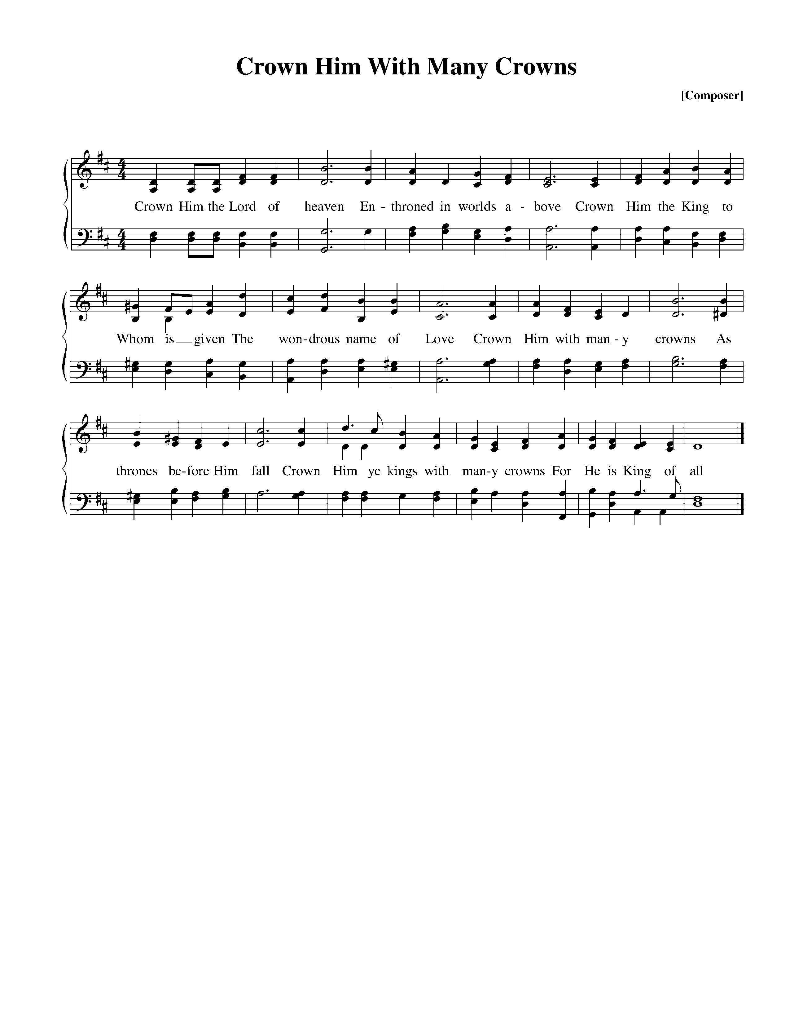**

Text: Matthew Bridges, 1852; Music: Diademata, George J. Elvey, 1868.

**Call to Worship—from Psalm 33:18-22**

Pastor: Behold, the eye of the Lord is on those who fear him,

**All: On those who hope in his steadfast love.**

Pastor: That he may deliver their soul from death and keep them alive in famine.

**All: Our soul waits for the Lord: He is our help and our shield.**

Pastor: For our heart is glad in him, because we trust in his holy name.

**All: Let your steadfast love, O Lord, be upon us, even as we hope in you.**

**Hymn of Praise—Come, Thou Fount**

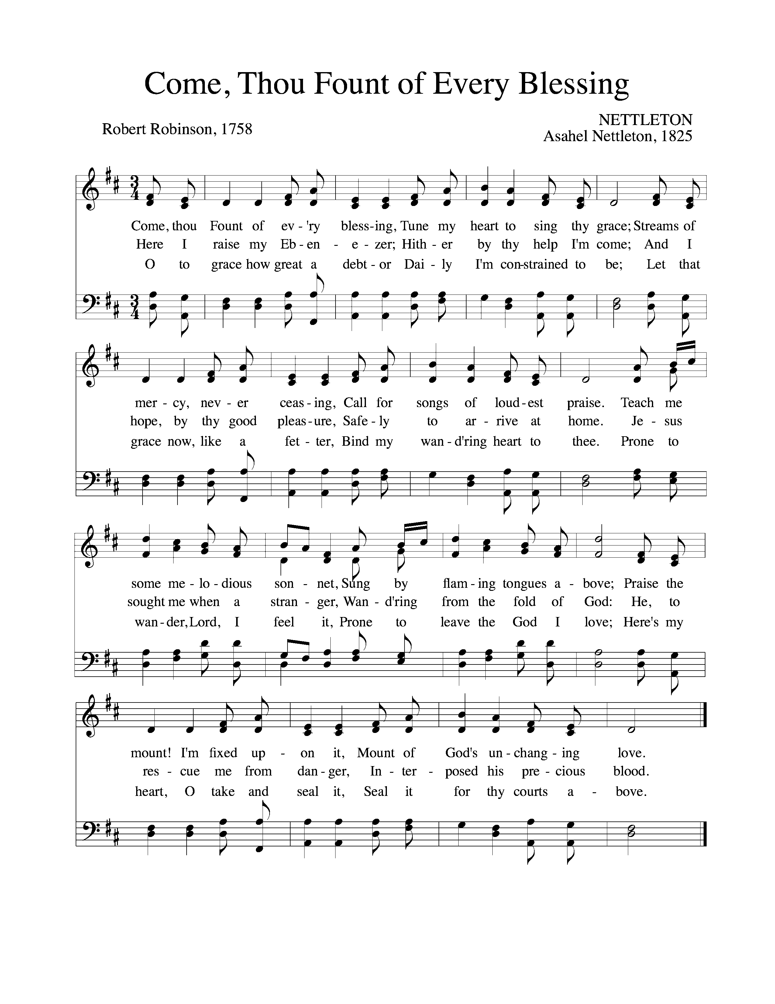

Text: Robert Robinson, 1758; Music: Nettleton, Asahel Nettleton, 1825.

**Hymn of Praise—Come, Ye that Love the Savior’s Name**

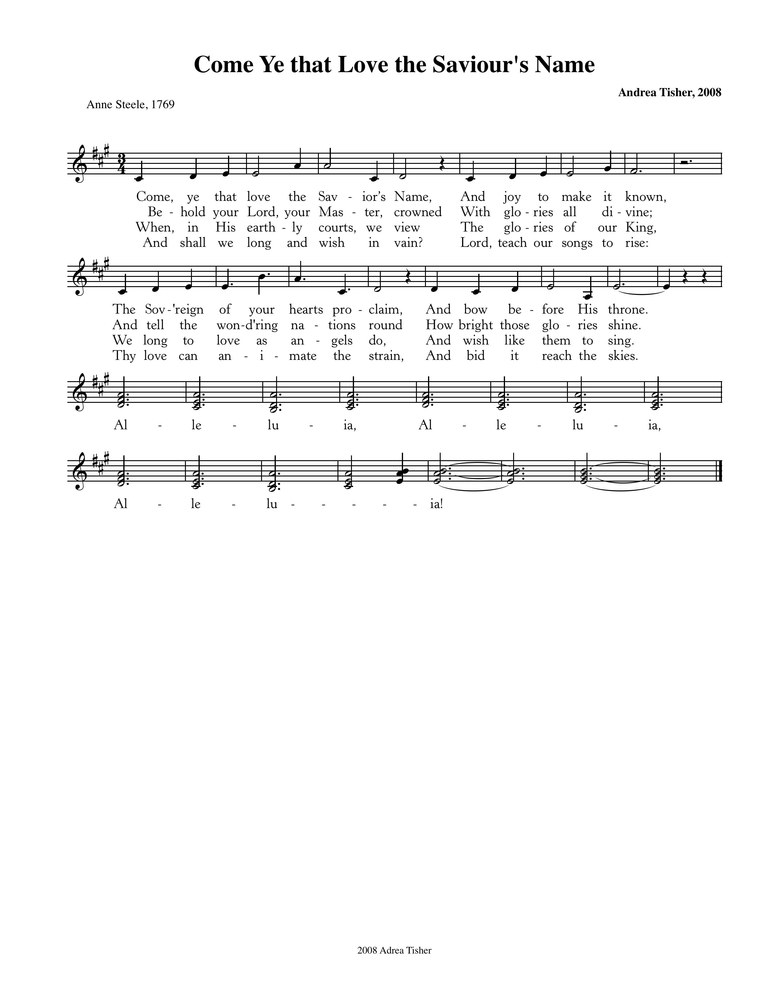

CCLI #11121087 ©2008 Andrea Tisher, Text: Anne Steele, 1769; Music: Andrea Tisher, 2008.

*(Please be seated)*

**New Testament Reading—I John 3:11-18**

*Love One Another*

**11**For this is the message that you have heard from the beginning, that we should love one another. **12**We should not be like Cain, who was of the evil one and murdered his brother. And why did he murder him? Because his own deeds were evil and his brother’s righteous. **13**Do not be surprised, brothers,that the world hates you. **14**We know that we have passed out of death into life, because we love the brothers. Whoever does not love abides in death. **15**Everyone who hates his brother is a murderer, and you know that no murderer has eternal life abiding in him.

**16**By this we know love, that he laid down his life for us, and we ought to lay down our lives for the brothers. **17**But if anyone has the world’s goods and sees his brother in need, yet closes his heart against him, how does God’s love abide in him? **18**Little children, let us not love in word or talk but in deed and in truth.

Elder: This is the Word of the Lord.

**All: Thanks be to God.**

God Calls His People to Confession, Repentance, and Reconciliation

*The People of God respond to His Word by confessing their sins, repenting of their sinful ways, and seeking God’s favor through the reconciling work of Jesus, the Son of God.*

**Sung Response—Hear My Prayer (from Psalm 86)**

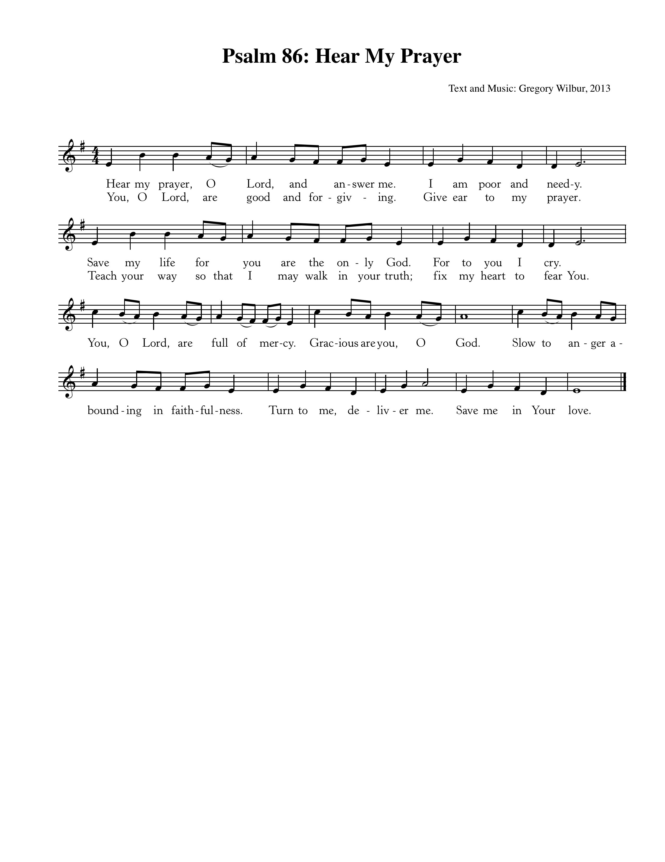

Text & Music: Greyfriars Press, 2013. Used by permission.

**Corporate Prayer of Confession—based on Psalm 31:7, 9-10, 23-24**

Pastor: O Lord, we come confessing. We rejoice in Your steadfast love,

because You have seen our afflictions;

**All: You know the distress of our souls.**

Pastor: Be gracious to us, O Lord, for we are in distress;

**All: Our eyes are wasted from grief; our souls and bodies also.**

Pastor: For our lives are spent with sorrow, and our years with sighing;

**All: Our strength fails because of our iniquity, and our bones waste away.**

Pastor: Love the Lord, all you his saints! The Lord preserves the faithful.

**All: But He abundantly repays the one who acts in pride.**

Pastor: Be strong, and let your heart take courage, all you who wait for the Lord!

**Sung Response—Kyrie**

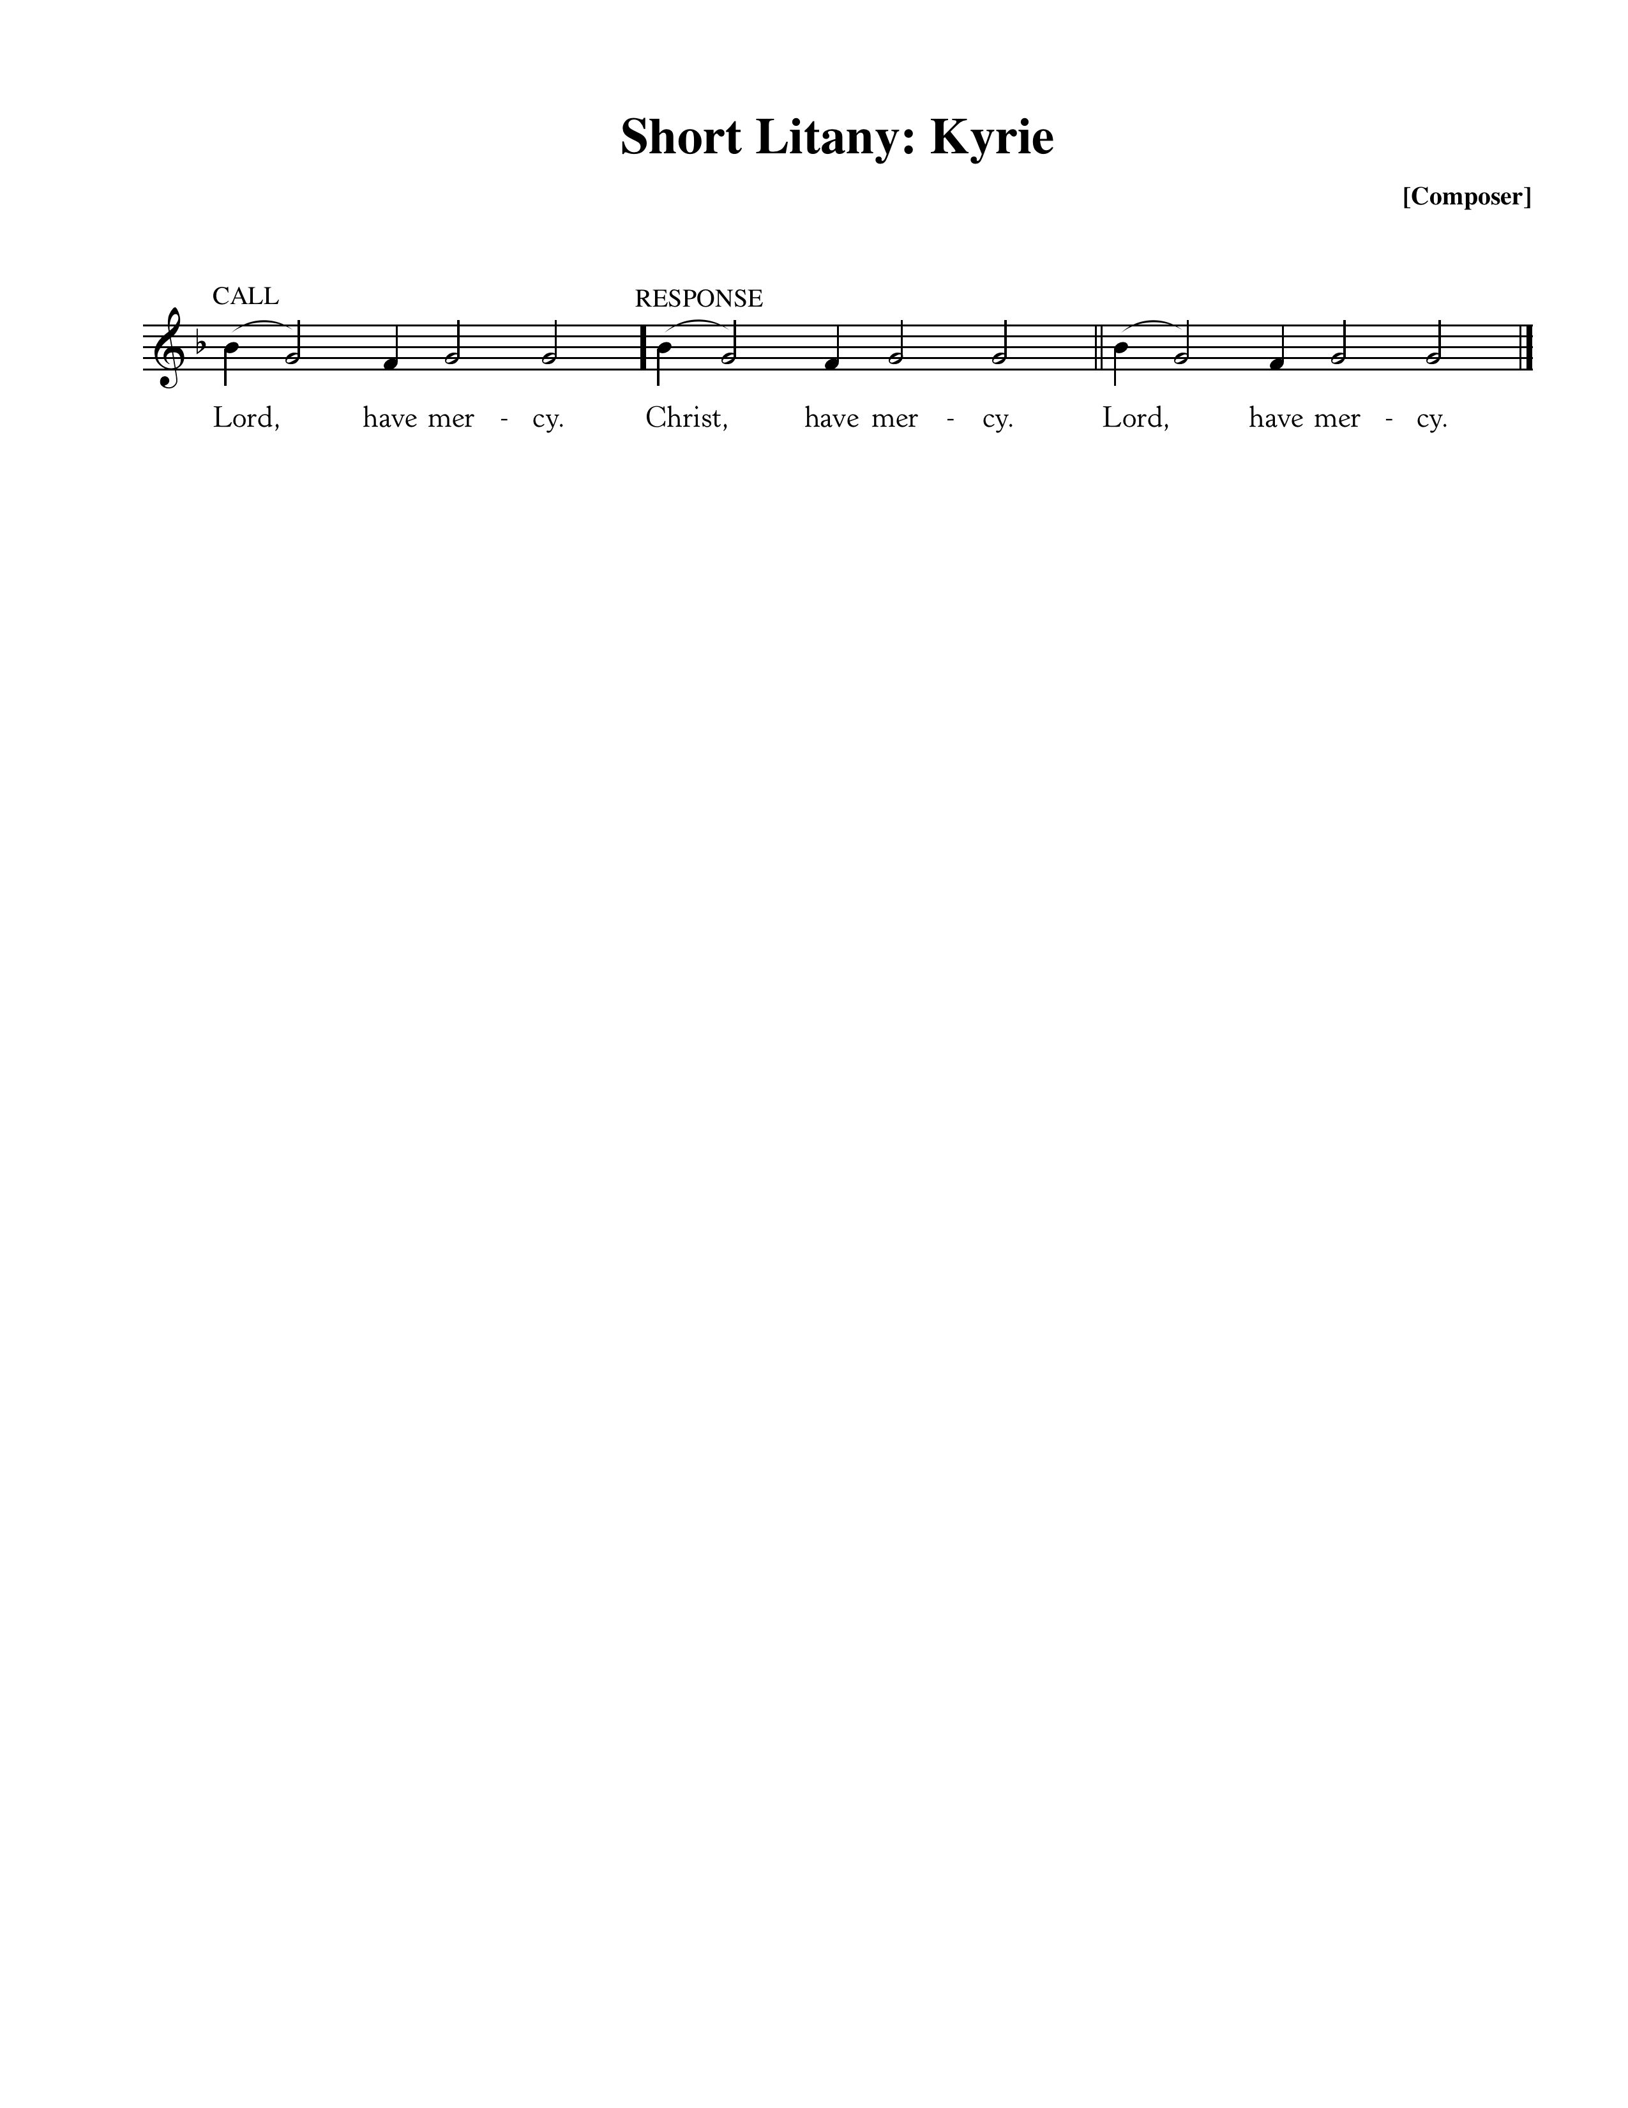

**Silent Prayers of Confession**

**Assurance of Pardon—Titus 3:4-7**

But when the goodness and loving kindness of God our Savior appeared, he saved us, not because of works done by us in righteousness, but according to his own mercy, by the washing of regeneration and renewal of the Holy Spirit, whom he poured out on us richly through Jesus Christ our Savior, so that being justified by his grace we might become heirs according to the hope of eternal life.

**Hymn of Praise—How Deep the Father’s Love For Us**



CCLI #11121087 ©1995 Thankyou Music; Text and Music: Stuart Townend, 1995.

**Introduction of New Members**

First Service: Melanie Dock, Tim & Tammy McCoy

Second Service: Scott & Rebecca Keliher, Andrew Ansley

**The Reading of the Word—John 15:1-11**

“I am the true vine, and my Father is the vinedresser. **2**Every branch in me that does not bear fruit he takes away, and every branch that does bear fruit he prunes, that it may bear more fruit. **3**Already you are clean because of the word that I have spoken to you. **4**Abide in me, and I in you. As the branch cannot bear fruit by itself, unless it abides in the vine, neither can you, unless you abide in me. **5**I am the vine; you are the branches. Whoever abides in me and I in him, he it is that bears much fruit, for apart from me you can do nothing. **6**If anyone does not abide in me he is thrown away like a branch and withers; and the branches are gathered, thrown into the fire, and burned. **7**If you abide in me, and my words abide in you, ask whatever you wish, and it will be done for you. **8**By this my Father is glorified, that you bear much fruit and so prove to be my disciples. **9**As the Father has loved me, so have I loved you. Abide in my love. **10**If you keep my commandments, you will abide in my love, just as I have kept my Father’s commandments and abide in his love. **11**These things I have spoken to you, that my joy may be in you, and that your joy may be full.

Elder: The grass withers, the flower fades;

**All: But the Word of our God will stand forever.**

**Sermon—Abiding in Christ: Three Essential Marks for Maturing Christians, Pt 3**

*Love & Obey Christ in the Love & Obedience of Christ* **—**Nate Shurden, Pastor

**Sung Response—Doxology**

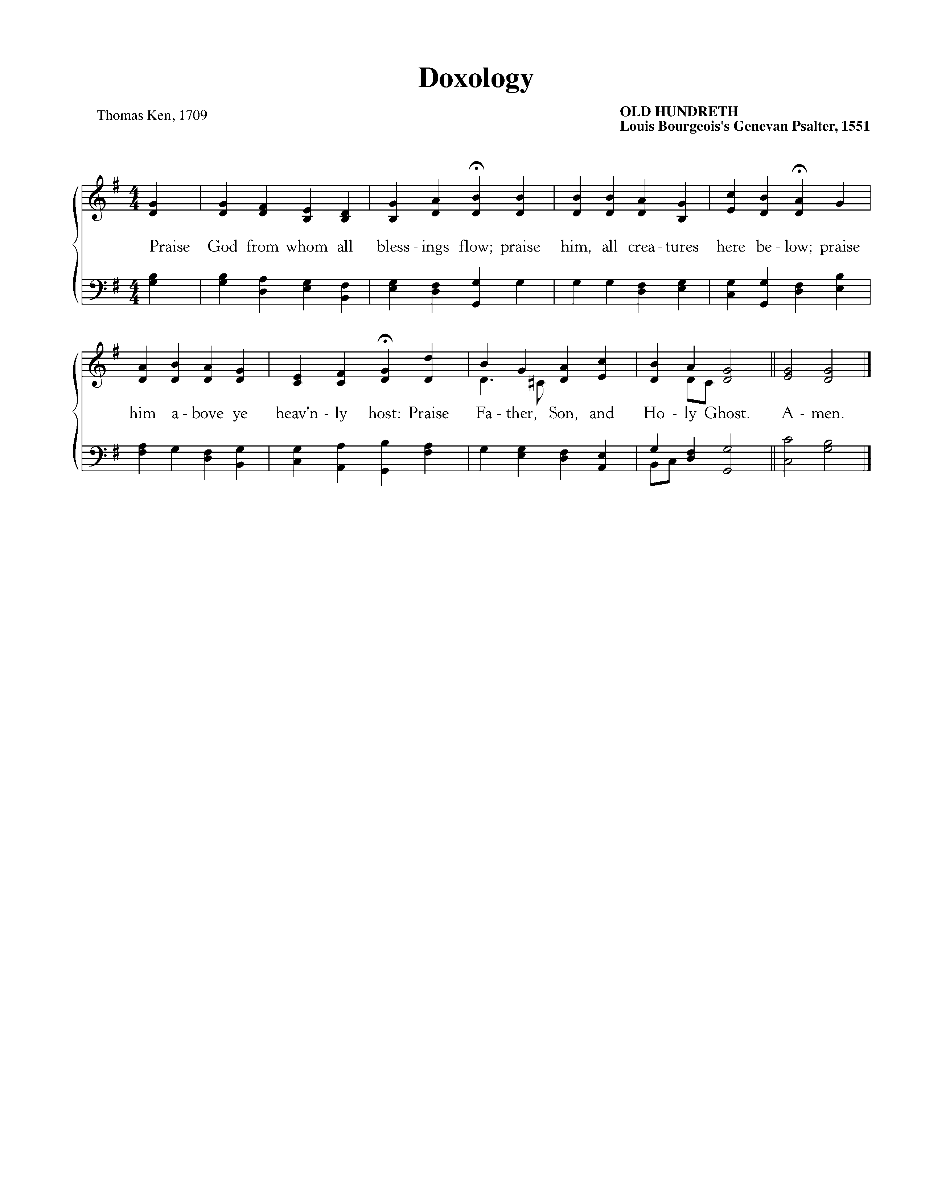

Text: Thomas Ken, 1709; Music: Old Hundredth, Louis Bourgeois’s *Genevan Psalter*, 1551.

The Sacrament of the Lord’s Supper

*God offers to His people the gift of communion with Him through the grace of the sacrament and we respond in thanksgiving.*

**Sursum Corda**

Elder: The Lord be with you. **People: And also with you.**

Elder: Lift up your hearts. **People: We lift them up to the Lord.**

Elder: Let us give thanks to the Lord our God. **People: It is right to give Him thanks and praise.**

Elder: It is right, and a good and joyful thing, always and everywhere to give thanks to You,

Father Almighty, Creator of heaven and earth.

**Sung Response—Sanctus**

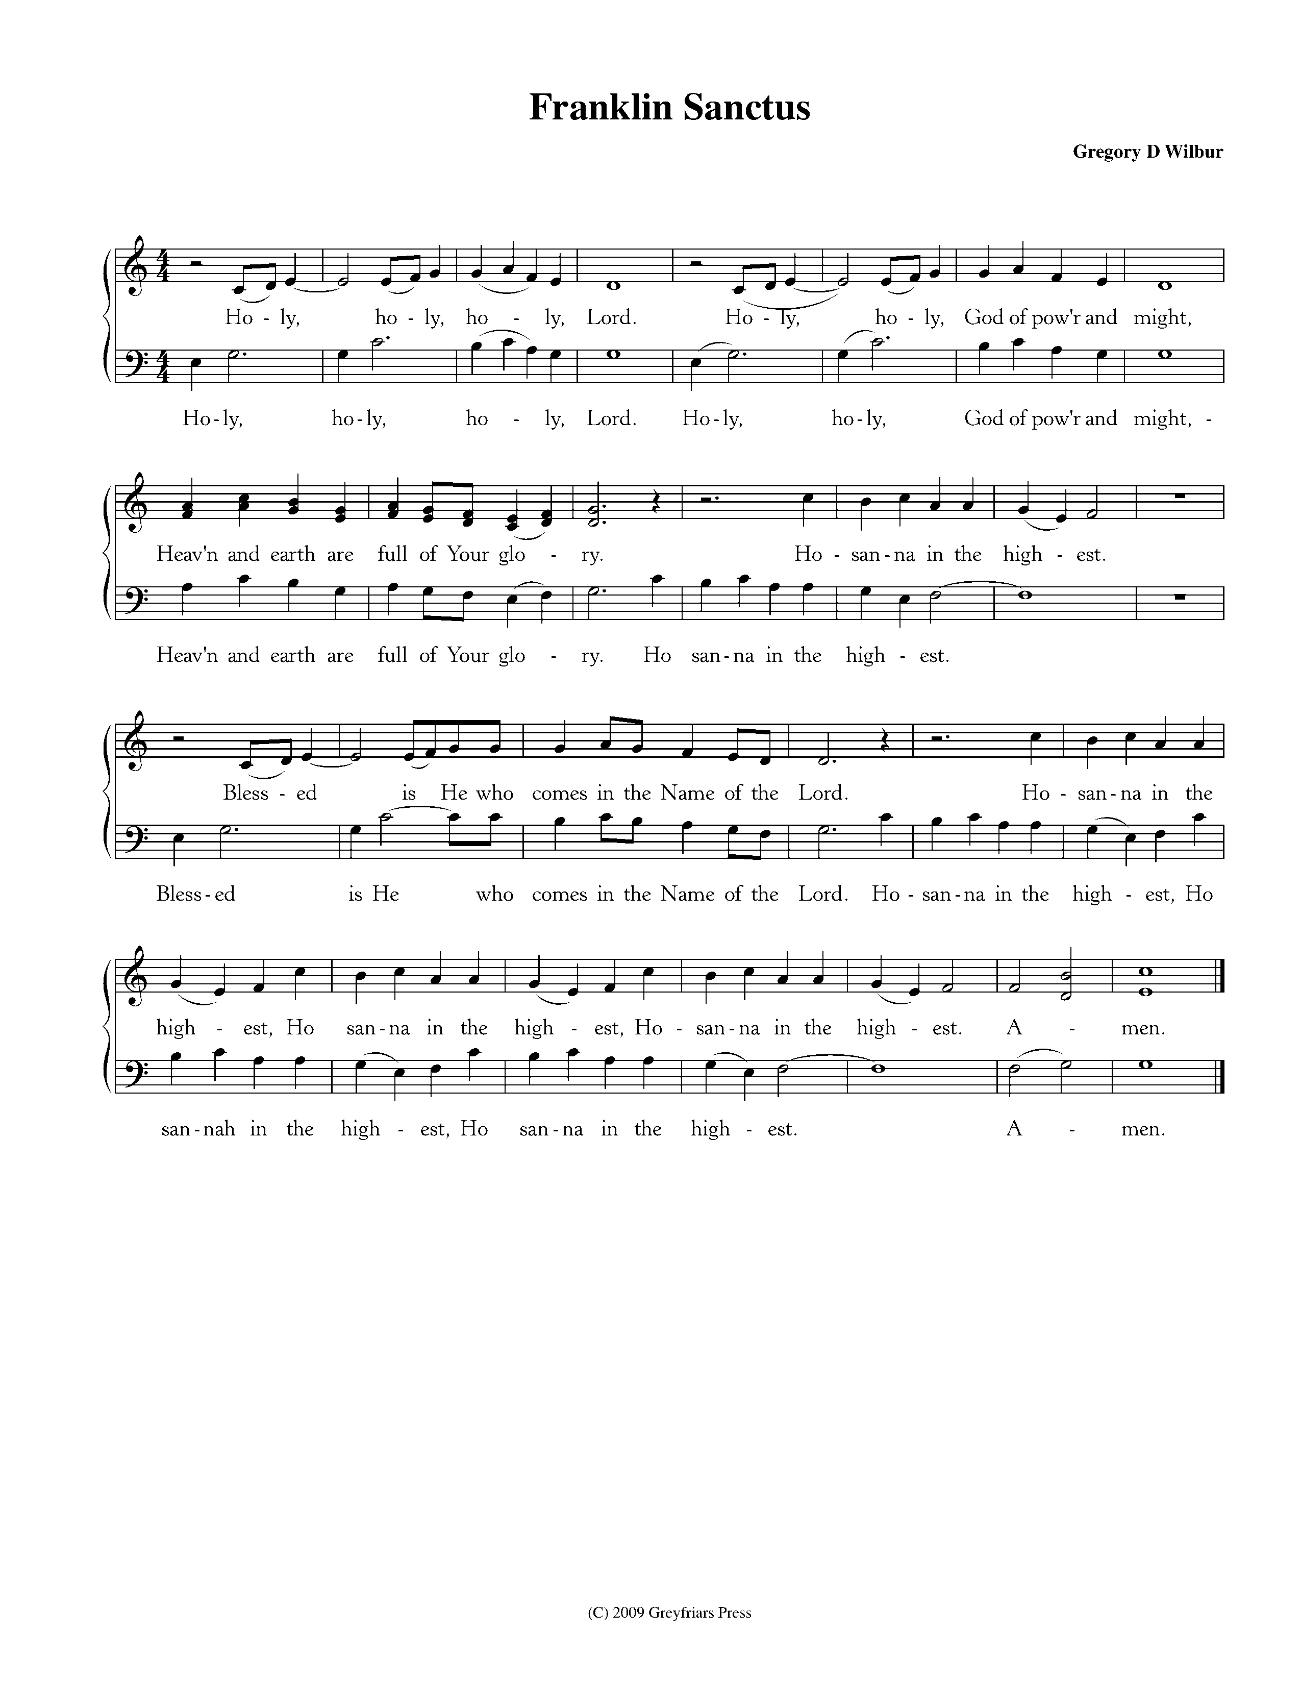

Women

Men

CCLI #11121087 Text: Is 6:3, Rev 4:8, Mt 21:9; Music: Franklin Sanctus, Gregory D Wilbur, 2009. ©2009 Greyfriars Press.

**Profession of Faith—The Apostles’ Creed**

We believe in God, the Father Almighty, the Creator of Heaven and Earth,

And in Jesus Christ, His only Son, our Lord: who was conceived of the Holy Spirit,

Born of the Virgin Mary, Suffered under Pontius Pilate,

Was crucified, died and was buried. He descended into Hell.

On the third day he rose again from the dead.

He ascended into Heaven and now sits at the right hand of God the Father Almighty;

From whence He shall come to judge the living and the dead.

We believe in the Holy Spirit; The one holy Church—both visible and invisible;

The communion of saints; the forgiveness of sins;

The resurrection of the body; and the life everlasting. Amen.

**Words of Institution and the Lord’s Table**

*Having confessed our sins and made a good profession of faith, God's Table is open to all those “faithfully-fenced" members of the covenant community. Please come forward to partake of this means of grace. You may take the bread at the first table and then proceed to either side for the wine/grape juice.*

**Hymn of Communion—O Love of God**

**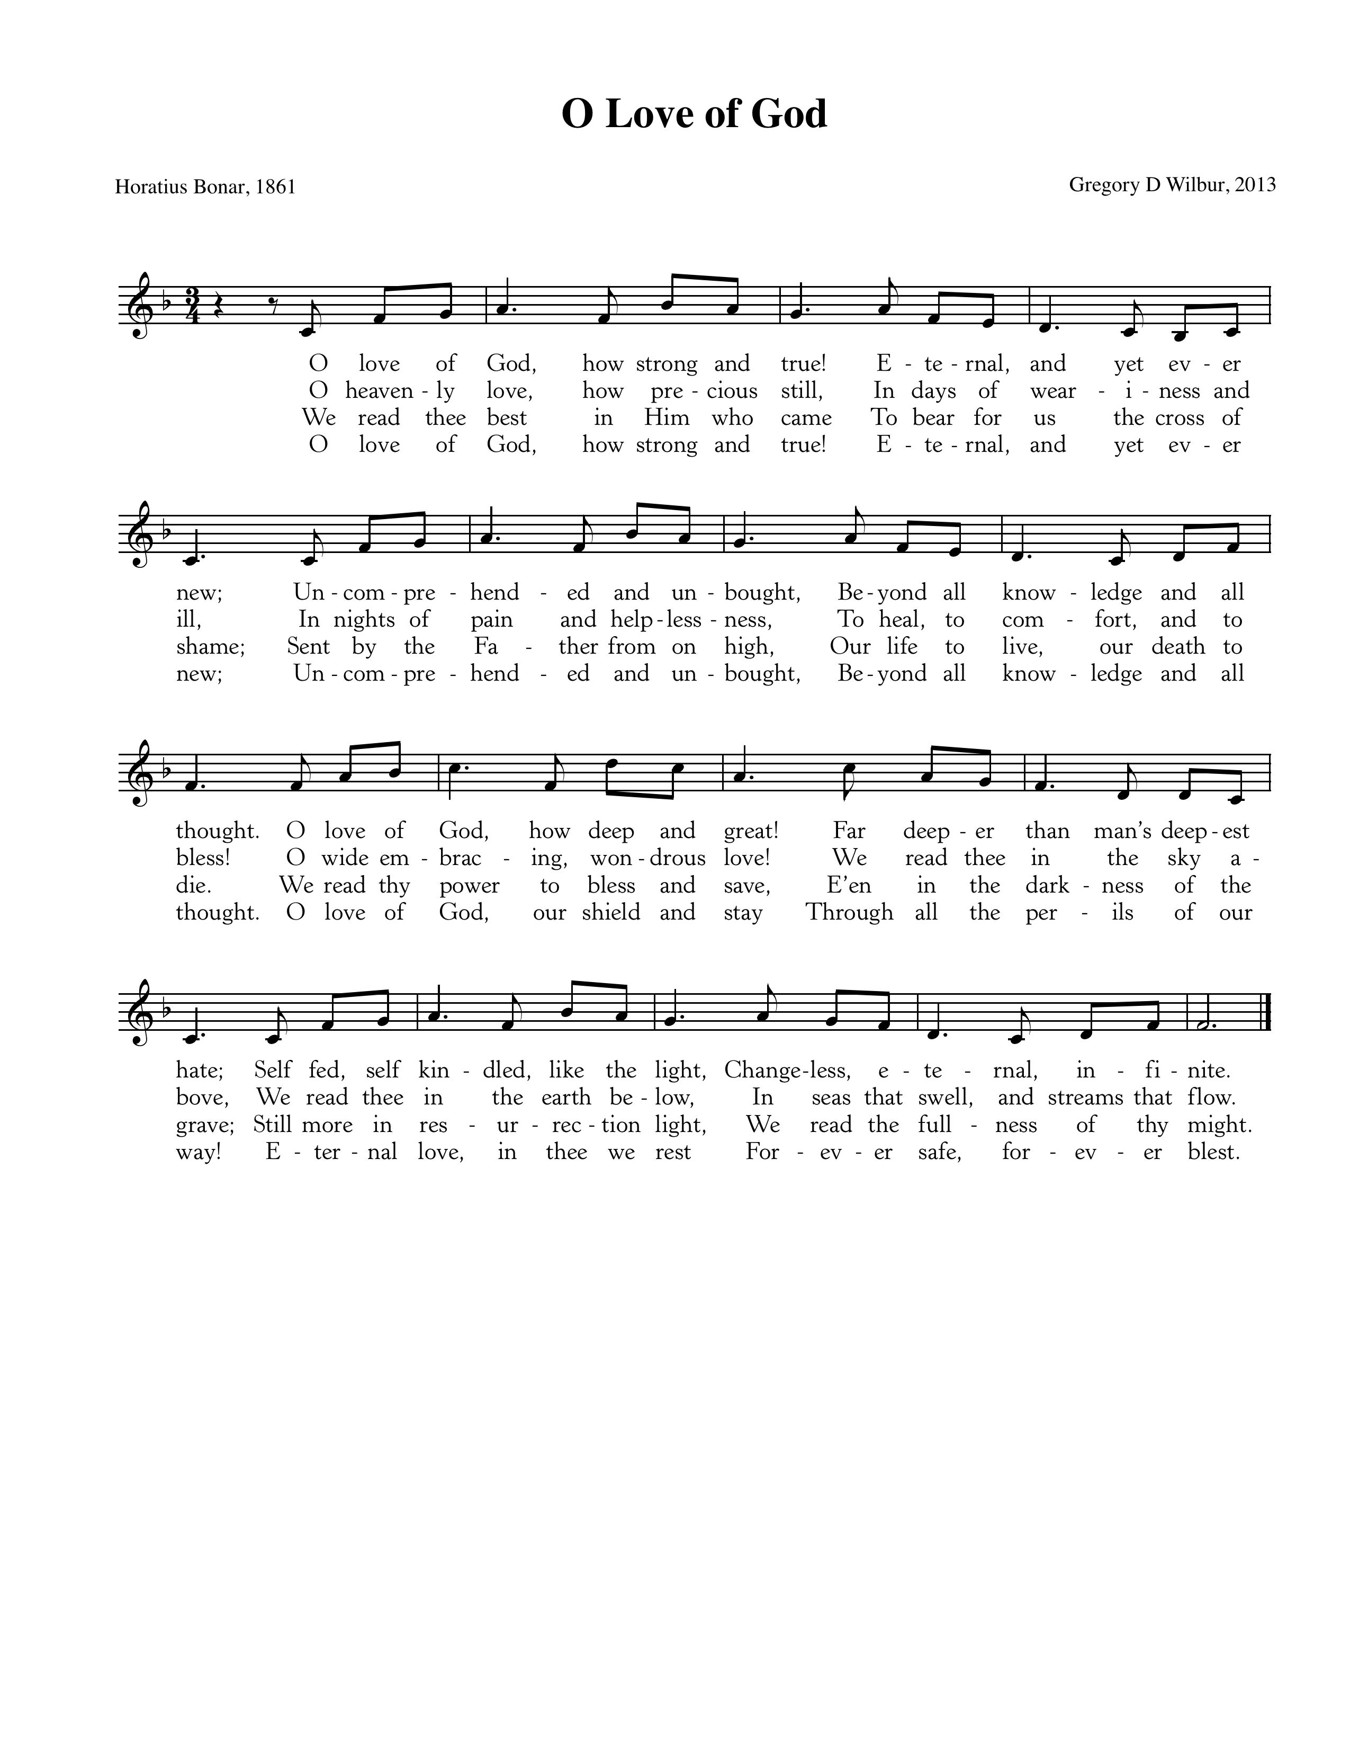**

Text: Horatius Bona, 1861; Music: © 2013 Greyfriars Press.

**Hymn of Communion—Approach, My Soul, the Mercy Seat**

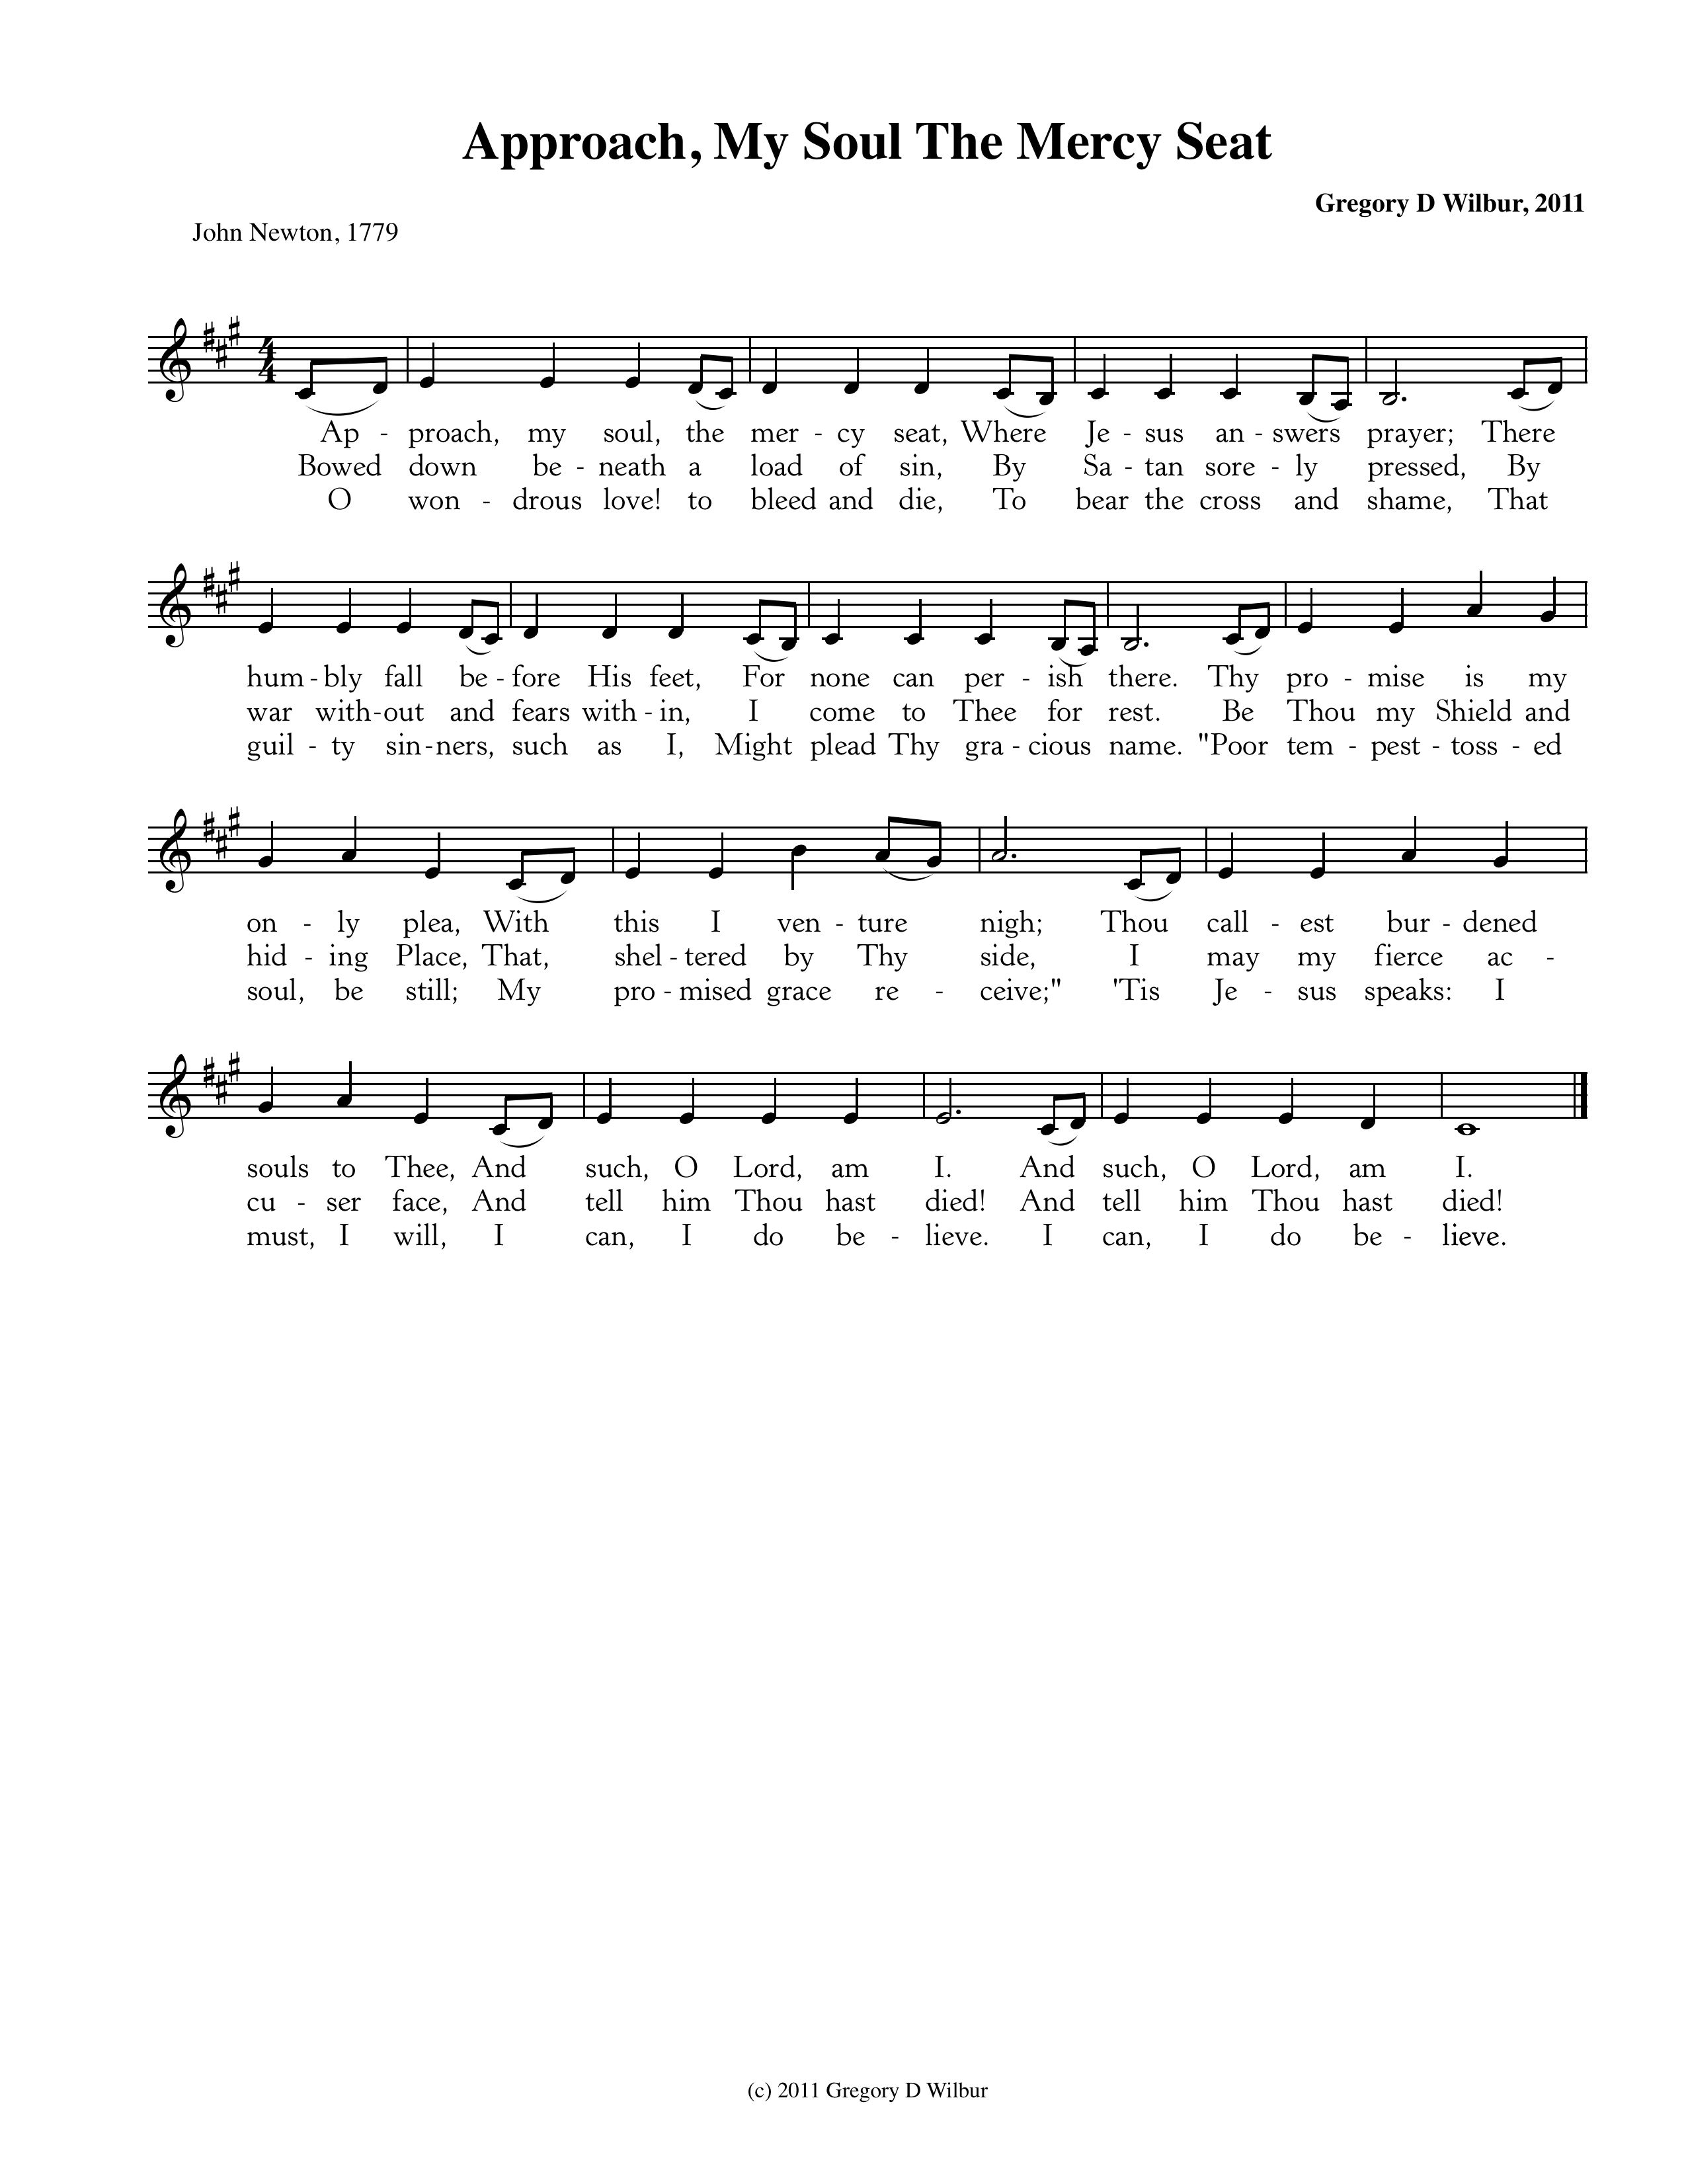

Text: John Newton, 1779; Music: Approach My Soul, Gregory Wilbur, 2011. ©2011 Greyfriars Press

God’s People Respond in Grateful Praise

**Prayer of Thanksgiving and Intercession**

The Lord’s Prayer

Our Father, who art in heaven, Hallowed be thy Name.

Thy kingdom come. Thy will be done, On earth as it is in heaven.

Give us this day our daily bread. And forgive us our debts, As we forgive our debtors.

And lead us not into temptation, But deliver us from evil.

For Thine is the Kingdom, and the power, and the glory, forever. Amen.

**Hymn of Promise—What Wondrous Love is This**

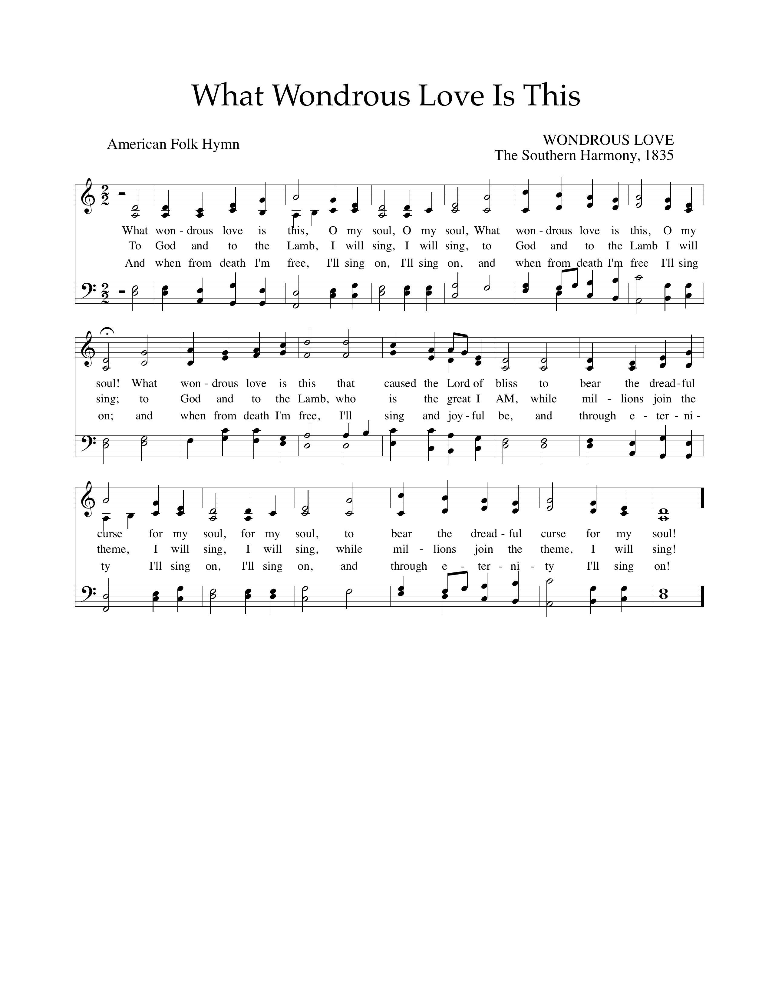

Text: American Folk Hymn; Music: Wondrous Love, *Southern Harmony,* 1835.

God Sends His People out

*After calling His people into His presence, forgiving their sins, instructing them in His Word, and providing a foretaste of the marriage supper of the Lamb, God sends His people into the world to show His light in the darkness.*

**Benediction—based on I Timothy 1:13-14**

Follow the pattern of the sound words that you have head, in the faith and love that are in Christ Jesus. By the Holy Spirit who dwells within us, guard the good deposit entrusted to you. *Amen.*

**Sung Response—Christ Be With Me (*from* St. Patrick’s Breastplate)**

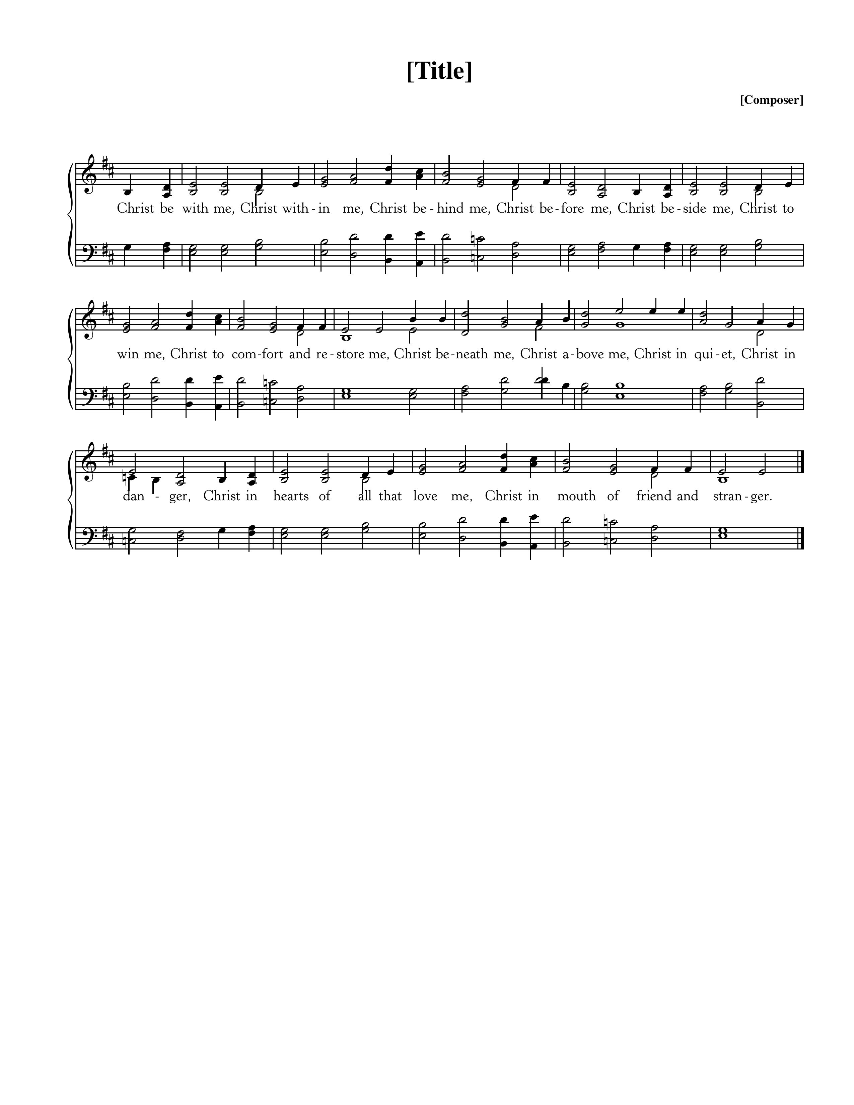

Text: *Atomriug indui niurt tren,* St. Patrick, 372-466, Trans by Cecil Frances Alexander, 1818-95;

Music: St. Patrick Clonmacnoise, Traditional Irish Hymn Melody.

**Home Fellowship Groups**

[Chuck Emerson](mailto:emersonbrntwd@aol.com?subject=HFG" \t "_blank) 943-8443 or emersonbrntwd@aol.com, 2nd and 4th Sundays 5:00 p.m., Steffens’ house.

[Cy Fenton](mailto:cyfenton@gmail.com?subject=HFG" \t "_blank) 500-5304 or cyfenton@gmail.com, Sundays after church, Fenton’s house.

[Stacy McGuire](mailto:stacy.a.mcguire@gmail.com?subject=HFG" \t "_blank) 591-9462 or stacy.a.mcguire@gmail.com, Sundays after church, upstairs at Cornerstone.

[Greg Wilbur](mailto:greg.wilbur@gmail.com?subject=HFG" \t "_blank) 512-4156 or greg@cstonepres.org, 2nd, 3rd, and 4th Sundays at 5:00 p.m., Wilbur’s house.

[Jim Smith](mailto:Jims@svmic.com?subject=HFG" \t "_blank) 491-8855 or jims@svmic.com, 2nd and 4th Sundays at 6:00 p.m., Smith’s house.

\*\*\*New Group: Mike and Mel Payne, 615-618-3299 or meljpayne@gmail.com

Today is our third installment in the sermon series, “Abiding in Christ: Three Essential Marks for Maturing Christians.” The first week we saw the Biblical necessity of Christian maturity. Last week we explored how Christ is the only true source of our Christian maturity. Today we are considering what it means to abide in the love of Christ and keep His commandments as the leading expression of our Christian maturity.

* I John 4:19 says, “We love because he first loved us.” Why is the order important? What does it imply?
* Taking into consideration the answer above, what does it mean to *abide* in the love of Christ?
* What is the relationship of love and obedience (commandment keeping) according to Jesus?
* Does everybody who obeys God’s commands necessarily love God? If we disobey God, does that mean we do not love God?
* How is Christ’s love and obedience to His Father’s commands a gospel call to rest in Christ?
* How is Christ’s love and obedience to His Father’s commands a gospel call to discipline in Christ?

Cornerstone Presbyterian Church

**Presbyterian Church in America**

**Pastor**: Nate Shurden (618-4707 Office) or nate@cstonepres.org

**Worship and Chief Musician**: Greg Wilbur (512-4156) or greg@cstonepres.org

**Administrative Assistant:** Susan Bumpus (618-4707) or office@cstonepres.org

**Home Fellowship Coordinator:** Randy Allen (260-1884) or randmanrx@gmail.com

**Nursery Coordinator:** Linda VanGorden (406-4431) or [vangordenlinda@yahoo.com](mailto:vangordenlinda@yahoo.com" \t "_blank)

**Elementary Discipleship Coordinator:** Lorrie Mathews (429-8355) or lorriegm@gmail.com

**Ruling Elders**

Terry Cheney (579-7089) Cy Fenton (500-5304) Jim Smith (347-4188)

Chuck Emerson: *Emeritus* (661-9273) Stacy McGuire (339-3900) Greg Wilbur (512-4156)

**Deacons**

Clint Branch (516-9855) Kevin McClung (243-9228) Larry Thompson (901-734-1520)

Joe Haworth (289-7543) David Steffens (513-4873) Bob Vermilye (599-9577)

Riley May (866-8662)

Post Office Box 407 h Franklin, Tennessee 37065 h

www.cornerstonepresfranklin.org h (615) 618-4707

*All Scripture quotations from the English Standard Version*